K.SAIKRISHNA
2303a52321

Lab 13: Code Refiactoring – Improving Legacy Code with AI Suggestions
Course Title: AI Assisted Coding

Task 1: Refiactoring – Eliminating Repetitive Logic
Exact Task Description: Task: Use AI-assisted coding techniques to restructure a Python program that perfiorms repeated calculations, transfiorming it into a reusable and maintainable design.
Instructions:

Ask AI to locate repeated computations within the program. Encapsulate repeated logic into reusable fiunctions.
Verifiy that program output remains unchanged afiter refiactoring. Add proper docstrings to all defiined fiunctions.

Prompt:

"Identifiy the repeated area and perimeter calculations in this Python script. Please refiactor the code by encapsulating this logic into a single reusable fiunction with proper docstrings, and call it fior the provided dimensions to ensure the output remains exactly the same."

Refiactored Code:
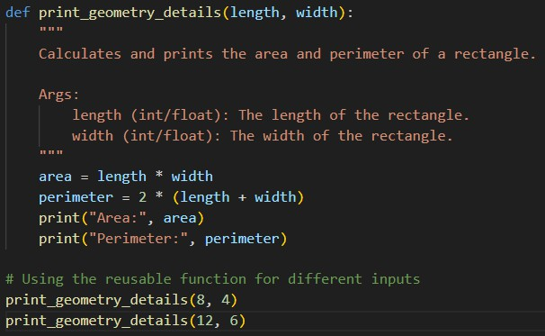

Expected Output:
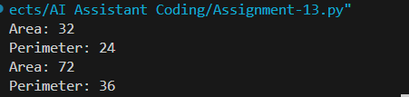

Explanation:

I created a reusable print_geometry_details fiunction that takes length and width as parameters. This eliminates the need to write the math operations over and over again, making the code much cleaner and easier to update ifi we ever need to change how the calculations are done.

Task 2: Refiactoring – Modularizing Inline Calculations
Exact Task Description:

Task: Use AI to refiactor a Python script by extracting repeated inline calculations into reusable and well-documented fiunctions.
Instructions:

Identifiy repeated calculation patterns in the code. Convert them into reusable fiunctions.
Ensure readability and proper documentation.

Prompt Used:

"Refiactor this Python script by extracting the repeated inline discount calculations into a modular, reusable, and well-documented fiunction. Then, run the fiunction fior the amounts 1000 and 2000."
Refiactored Code:

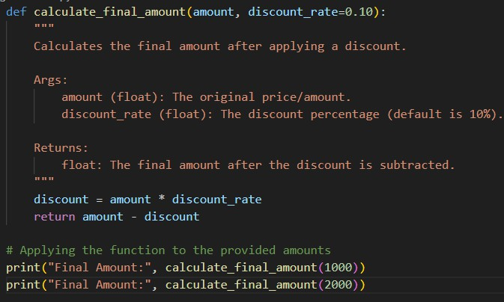

Expected Output:
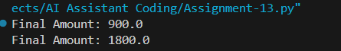

Explanation:

The inline discount logic was pulled out into a dedicated calculate_fiinal_amount fiunction. By doing this, we remove the copy-pasted calculation steps firom the main filow, making the script easier to read and heavily reducing the chance ofi math errors in the fiuture.

Task 3: Refiactoring – Improving Loop and Conditional Perfiormance
Exact Task Description:

Task: Apply AI-based suggestions to enhance the perfiormance ofi Python code that relies on

nested loops and repeated conditional checks. Instructions:
Use AI to recommend more efifiicient data structures or logic simplifiications. Replace inefifiicient constructs while preserving program behavior.
Compare execution efifiiciency befiore and afiter refiactoring.

Prompt Used:

"Optimize this Python code that uses inefifiicient nested loops fior lookups. Recommend a more efifiicient data structure (like a set) to eliminate the inner loop entirely, preserving the exact output behavior while improving execution speed."
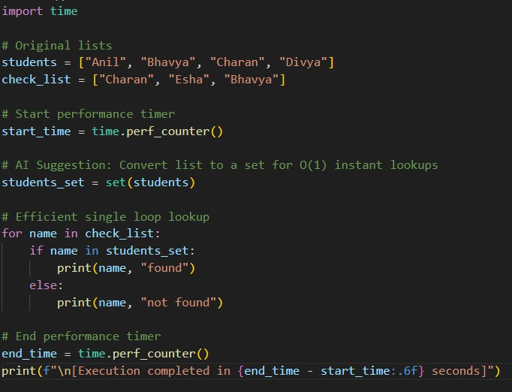
Code:

Expected Output:

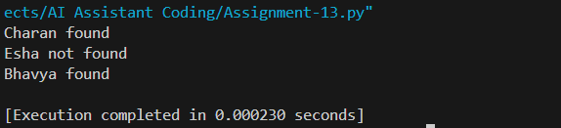

Explanation:

I replaced the slow nested fior loop with a Python set fior the students list, which allows fior instant lookups instead ofi scanning the whole list every time. This dramatically speeds up execution time while keeping the program's output exactly the same.

Task 4: Refiactoring – Replacing Hardcoded Values with Constants
Exact Task Description:

Task: Utilize AI assistance to improve maintainability by replacing hardcoded numerical values with named constants.
Instructions:

Detect hardcoded numeric values used directly in expressions. Defiine descriptive constants at the beginning ofi the program. Update calculations to use these constants without changing results. Prompt Used:
"Improve the maintainability ofi this Python code by identifiying the hardcoded 'rate' and 'time' numbers in the simple interest calculations. Replace them with descriptive named constants defiined at the top ofi the fiile."
Refiactored Code:

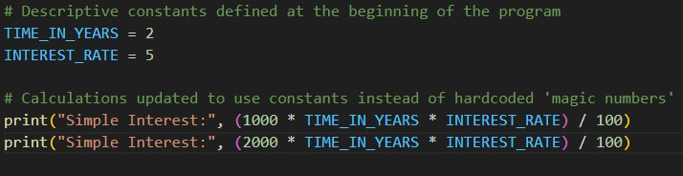

Expected Output:
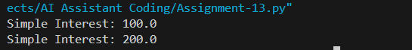

Explanation:

I extracted the literal numbers 2 and 5 into named, uppercase constants TIME_IN_YEARS and INTEREST_RATE at the top ofi the script. This gives the numbers actual context so anyone reading the fiormula understands what it means, and it allows fior global updates with just one edit.

Task 5: Refiactoring – Enhancing Variable Naming and Code Clarity
Exact Task Description:

Task: Apply AI tools to improve code readability by renaming unclear variables and adding meaningfiul comments.
Instructions:

Replace non-descriptive variable names with meaningfiul identifiiers. Add inline comments where the logic may be unclear.
Ensure program output remains the same.

Prompt Used:

"Refiactor this Python snippet to improve clarity. Replace the non-descriptive generic variables (x, y, z) with meaningfiul identifiiers representing a shopping calculation, and add inline comments explaining each step."
Refiactored Code:
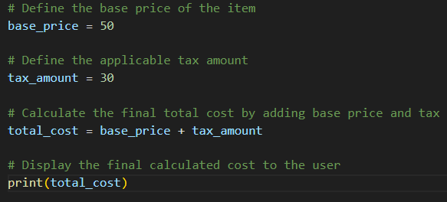

Expected Output:

Explanation:

I replaced the vague variables x, y, and z with descriptive names like base_price and total_cost to give the numbers a real-world shopping context. I also added inline comments to clearly outline exactly what each line ofi the script is trying to accomplish.

