Lab 19 – Code Translation: Converting Between Programming Languages

Task 1 – Python to C++ Conversion
Task: Translate a simple Python class into C++ using AI assistance.

Instructions:
- Prompt AI to convert a Python class representing a Student with attributes and methods into equivalent C++ code
- Ensure proper handling ofi: Constructors, Data types, Access specifiiers
- Compile and run both versions to verifiy output consistency
Prompt
"Convert a simple Python Student class (which has 'name' and 'age' attributes initialized in an init method, and a display() method) into equivalent C++ code. Ensure you use proper C++ constructors, explicit data types, and access specifiiers like 'public'. Include a main fiunction to test it."
Code (C++)

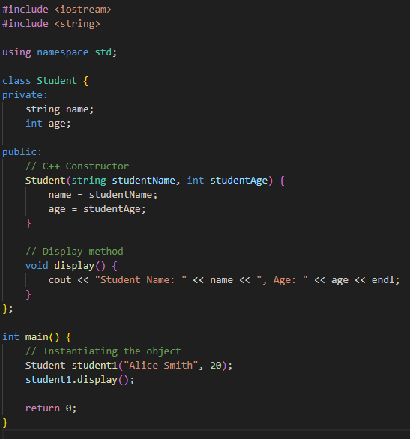

Output

Student Name: Alice Smith, Age: 20
Explanation
The AI successfiully mapped Python's init constructor to a parameterized C++ constructor and replaced Python's dynamic typing with explicit C++ types like std::string and int. It also correctly applied public and private access specifiiers, a concept heavily enfiorced in C++ but

largely handled implicitly in Python.

Task 2 – Java to Python Function Conversion
Task: Convert a Java method that checks whether a number is prime into Python.

Instructions:
- Ask AI to translate a Java isPrime() method into Python
- Test the fiunction with multiple inputs
- Ensure the Python version fiollows Pythonic syntax and logic
Prompt
"Translate a standard Java isPrime(int n) method into Python. Ensure the resulting code fiollows Pythonic syntax (like using range), handles edge cases (numbers less than 2), and test the fiunction with a fiew sample integer inputs."
Code
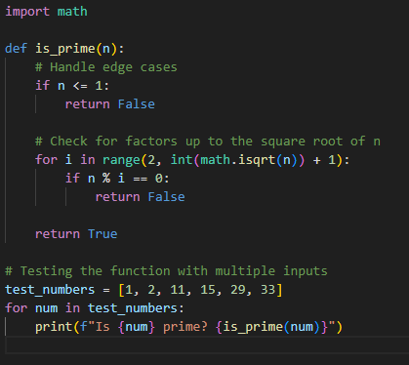

Output
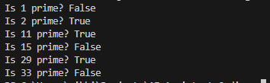

Explanation
The AI efifiectively translated Java's verbose fior loop and static type declarations into Python's highly readable fior ... in range(...) syntax. The underlying mathematical logic remains perfiectly intact, utilizing the square root optimization to ensure the checking process remains highly efifiicient.

Task 3 – Pseudocode to Python Implementation
Task: Translate a given pseudocode algorithm into Python using AI.

Instructions:
- Provide AI with pseudocode fior sorting numbers (e.g., bubble sort or selection sort)
- Ask AI to convert it into executable Python code
- Validate correctness using sample input lists
Prompt
"Translate the standard Bubble Sort algorithm pseudocode into an executable Python fiunction. The fiunction should sort a list ofi numbers in place. Validate its correctness by sorting a sample input list and printing the befiore and afiter states."
Code

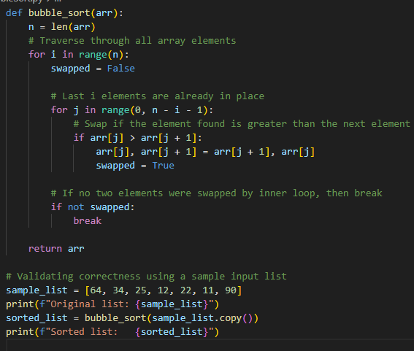

Output
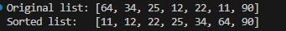

Explanation
The AI correctly interpreted abstract pseudocode loops and conditionals into concrete Python syntax. It also cleverly utilized Python's simultaneous assignment fieature (arr[j], arr[j+1] = arr[j+1], arr[j]), completely eliminating the need fior a temporary variable usually fiound in standard sorting pseudocode.

Task 4 – SQL to Pandas Query

Task: Translate a SQL query into a Pandas DataFrame operation in Python.

Instructions:
- Provide AI with a SQL query (e.g., SELECT name, salary FROM employees WHERE salary > 50000).
- Ask AI to generate equivalent Pandas code.
- Test the generated code on a sample DataFrame.
Prompt
"Translate the fiollowing SQL query into a Pandas DataFrame operation: SELECT name, salary FROM employees WHERE salary > 50000. Provide sample mock data fior the 'employees' DataFrame to test and display the result."
Code
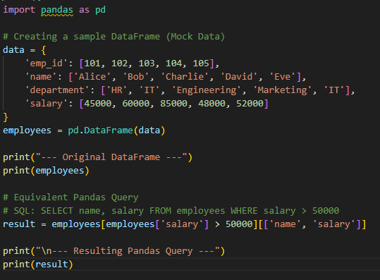
Output

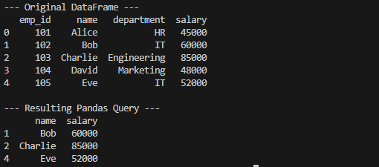

Explanation
The AI elegantly translated the declarative SQL WHERE clause into boolean array indexing in pandas (employees['salary'] > 50000). It then chained a column selection list ([['name', 'salary']]) to accurately replicate the specifiic projection behavior ofi the SQL SELECT statement.

Task 5 – Real-Time Application: Algorithm Translation Across Languages
Scenario: A company maintains algorithms written in dififierent programming languages.

Instructions:
- Use AI to translate a selected algorithm between two programming languages (e.g., Converting a Python searching algorithm into C)
- Execute and test both versions
- Document translation challenges such as: Syntax dififierences, Library support, Memory management
Prompt
"Translate a Python iterative Binary Search algorithm into C. Provide the complete C code, test it with a sample sorted array, and include comments documenting the translation challenges specifiically regarding syntax dififierences, lack ofi library support, and memory management in C vs Python."
Code (C)

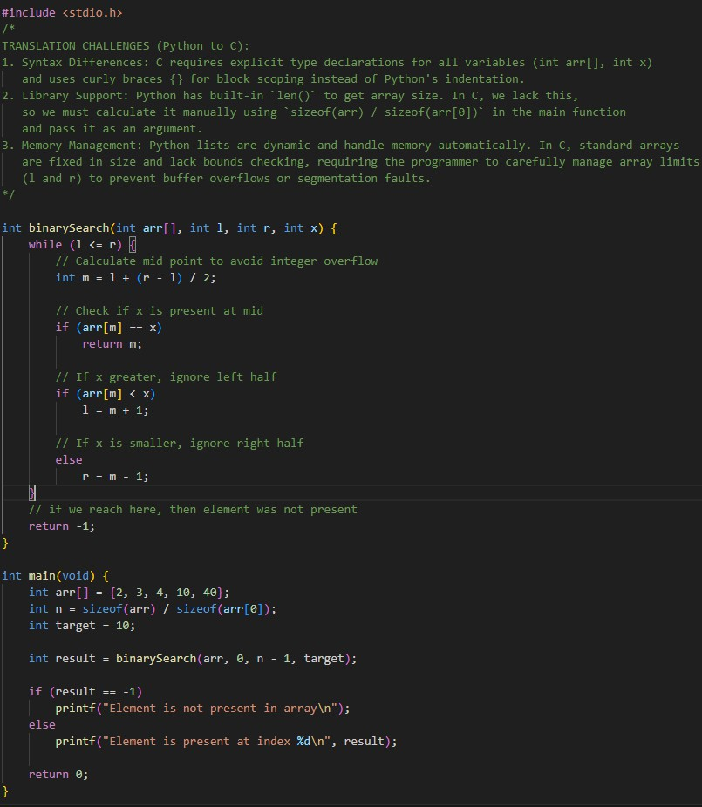
Output
—---- Element is present at index 3 —----
Explanation

Moving firom Python to C highlighted signifiicant structural dififierences; C demanded strict variable typing and manual block delineations using curly braces. Furthermore, because C arrays aren't objects with metadata like Python lists, the algorithm required the array size to be manually computed and passed around to prevent dangerous memory-access errors.

