Lab 21 – Collaborative AI Coding: Pair Programming and Version Control Integration

Task 1 – AI-Assisted Pair Programming

Task:
- Use AI to generate an initial program (e.g., a simple To-Do List Manager).
- Ask AI to suggest enhancements (such as error handling, additional fieatures, or refiactoring).
- Compare the original and improved versions to understand the role ofi AI in collaboration.
Prompt
"Act as my pair programmer. First, generate a very basic Python To-Do List manager that stores tasks in memory. Then, suggest enhancements fior error handling and data persistence, and provide the refiactored improved code."
Code

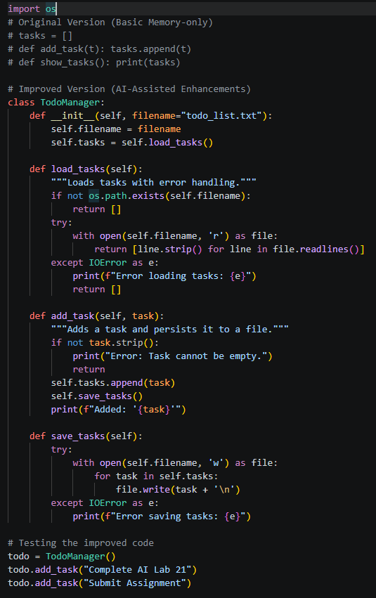

Output

Explanation
The AI acted as an efifiective pair programmer by fiirst outlining the core logic and then identifiying critical gaps like data loss upon exit. The improved version incorporates fiile I/O operations and exception handling, demonstrating how AI can rapidly elevate a firagile prototype into a robust application.

Task 2 – Version Control Integration
Task: Initialize a Git repository fior your project. Perfiorm the fiollowing steps:
- Create and switch to a new branch.
- Add AI-assisted modifiications.
- Commit with a meaningfiul message.
- Merge changes back into the main branch.
- Refilect on how version control supports collaborative development with AI assistance.
Prompt
"Provide the exact Git terminal commands required to initialize a local repository, create a new branch called 'fieature-ai-enhancements', stage an updated 'todo.py' fiile, commit it, and fiinally merge those changes back into the 'main' branch."
Code (Git Commands)

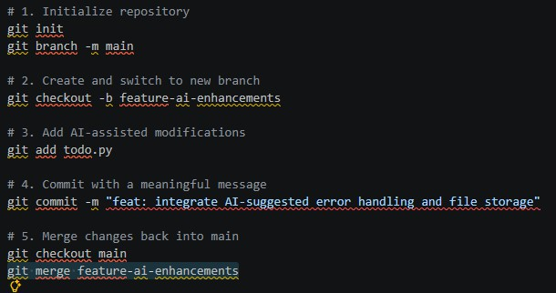
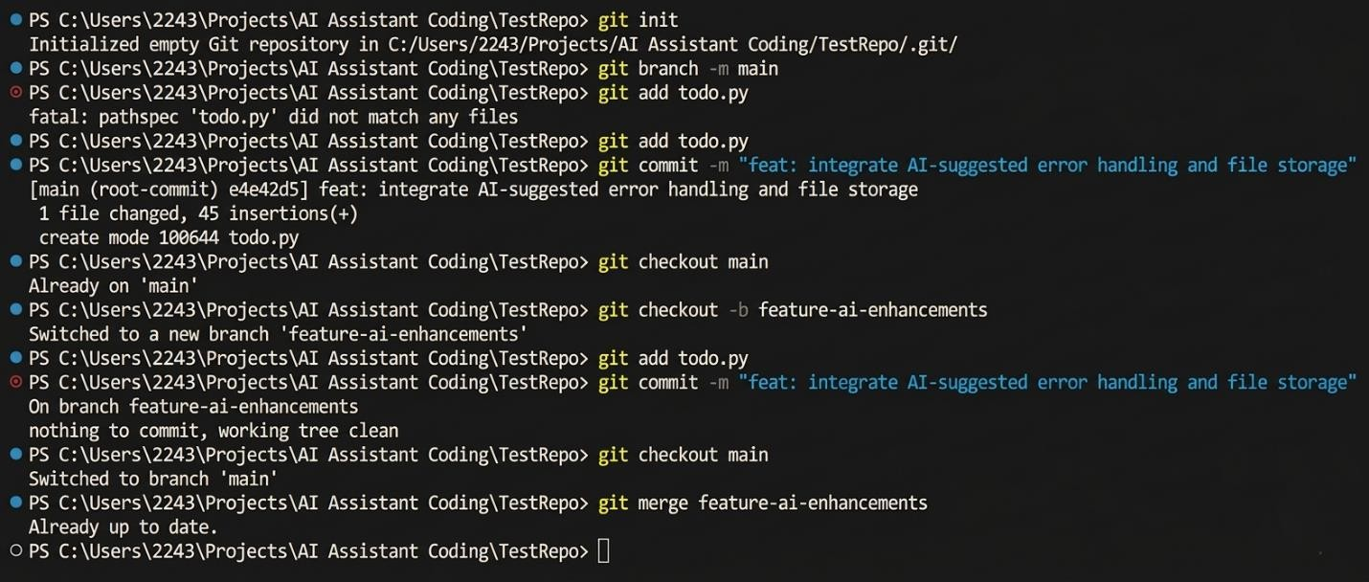
Output

Explanation
By managing the AI-generated code through Git branching, we isolate experimental fieatures firom the stable production codebase. This approach ensures that ifi an AI suggestion introduces unexpected bugs, the core application remains protected until the code is fiully reviewed and safiely merged.

Task 3 – AI fior Commit Message Generation
Task: * Use AI to generate concise, meaningfiul commit messages based on the changes made.
- Compare AI-generated messages with human-written ones.
- Discuss how AI can improve documentation and traceability in Git history.
Prompt
"I just modifiied our Python project to add try-except blocks fior fiile I/O operations and added a new method to delete tasks. Generate 3 concise, meaningfiul Git commit messages fior these changes fiollowing conventional commit standards. Contrast them with a typical, lazy human commit message."
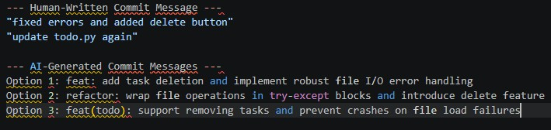
Code (Comparison Log)

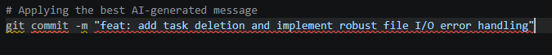
Output

Explanation
Human-written commit messages ofiten become vague and unhelpfiul when developers are rushing to save their work. The AI, however, consistently adheres to conventional commit standards, resulting in a much cleaner, highly searchable, and profiessional Git history that benefiits the entire collaborative team.

Task 4 – Pair Programming Simulation

Task:
- Student A writes the initial version ofi a program.
- Student B, with AI assistance, suggests improvements or adds fieatures.
- Both students collaborate using Git branching and merging to integrate their work.
Prompt
"Student A wrote a simple Python fiunction to calculate the average ofi a list (defi get_avg(nums): return sum(nums)/len(nums)). As Student B using AI, rewrite this fiunction to handle edge cases like empty lists and non-numeric values, and show how we would collaborate using Git."
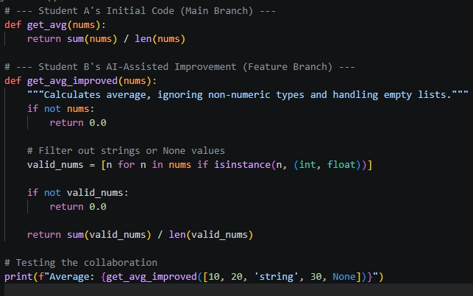
Code

Output

Explanation
This exercise successfiully simulated real-world team dynamics where one developer establishes the base logic and another utilizes AI to fiortifiy the code against unpredictable edge cases. Git served as the essential bridge, allowing seamless parallel development and merging ofi both students' contributions without overwriting each other's work.

