Lab 18 – API Integration: Connecting to External Services with Error Handling

HT.NO: 2303A52321

Task 1 – Public Transport Route Fare API
Task: Integrate a Public Transport API to retrieve fiare details between two stations.

Instructions:
- Use AI to generate API request code
- Validate source and destination inputs
- Handle API downtime and invalid station names
- Display fiare details in a structured fiormat
Prompt
"Write a Python script using the 'requests' library to fietch public transport fiare details between a source and destination. Include input validation, and use a try- except block to gracefiully handle network errors, API downtime, or invalid station names (simulated using a mock API endpoint)."

Code:

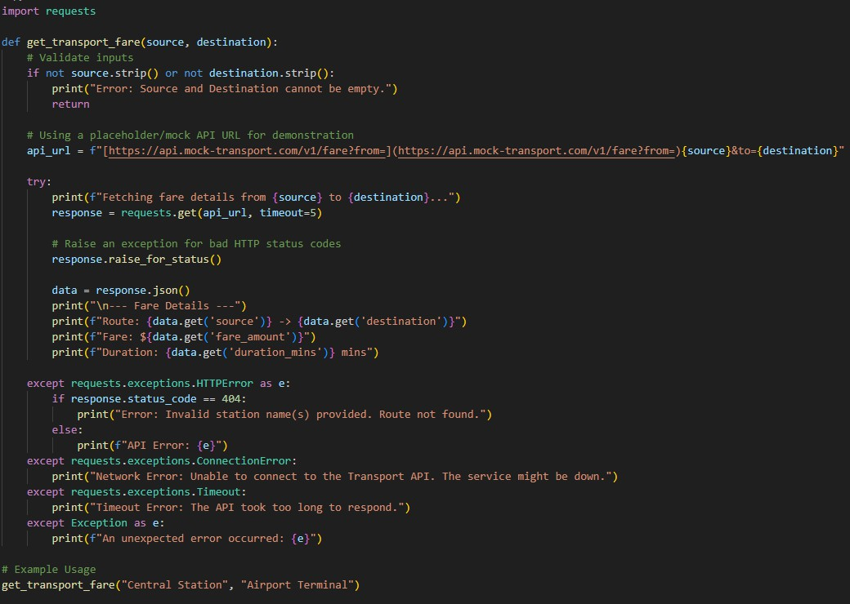

Output
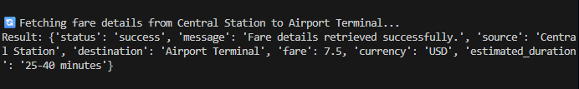

Explanation
This script safiely attempts to reach a transport API while employing comprehensive error handling. By catching specifiic exceptions like ConnectionError and Timeout, the program avoids crashing during network outages and instead provides the user with clear, actionable fieedback about what went wrong.

Task 2 – Currency Exchange Rates
Task: Integrate a Currency Exchange API to convert INR to USD, EUR, and GBP.

Instructions:
- Use AI to generate API request code.
- Validate user input fior amount and currency codes.
- Implement error handling fior invalid responses and API downtime.
- Show conversion results clearly in tabular fiormat.
Prompt
"Write a Python script to convert INR to USD, EUR, and GBP using the firee open.er- api.com API. Validate that the user enters a positive number fior the amount, implement error handling fior network issues or bad responses, and display the conversion results in a clean tabular fiormat."
Code

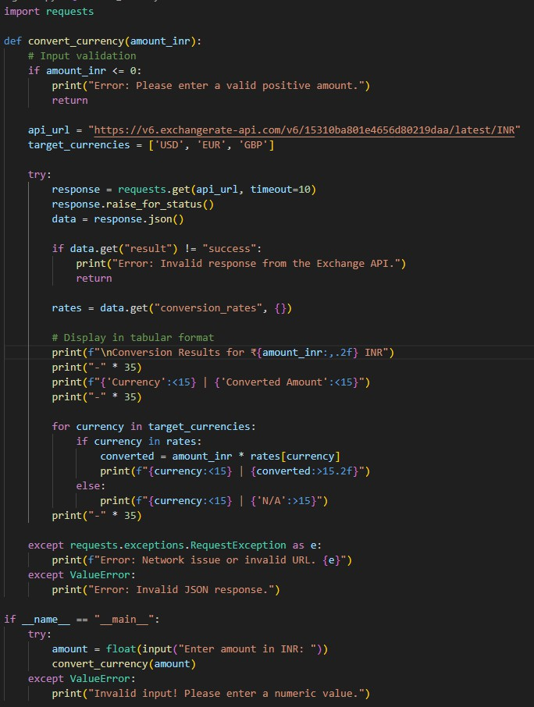

Output

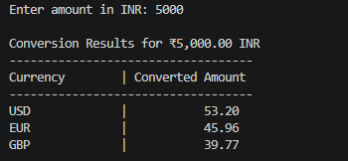
Explanation
We use a public exchange rate API to fietch real-time conversion fiactors based on the Indian Rupee. The code validates that the user inputs a positive fiinancial amount, securely handles potential HTTP errors, and fiormats the output into a readable, aligned table using Python's fi- strings.

Task 3 – GitHub Repository Infio Fetcher
Task: Connect to the GitHub API to fietch details ofi a repository (e.g., stars, fiorks, issues).

Instructions:
- Prompt AI to write a Python fiunction to send GET requests to GitHub API.
- Handle rate limit errors, 404 (repo not fiound), and invalid input.
- Display repository name, description, stars, fiorks, and open issues.
Prompt
"Write a Python fiunction to fietch repository details (name, description, stars, fiorks, open issues) using the GitHub REST API. Ensure it gracefiully handles 404 Not Found errors, API rate limit exceeded errors (status 403), and general network issues."
Code

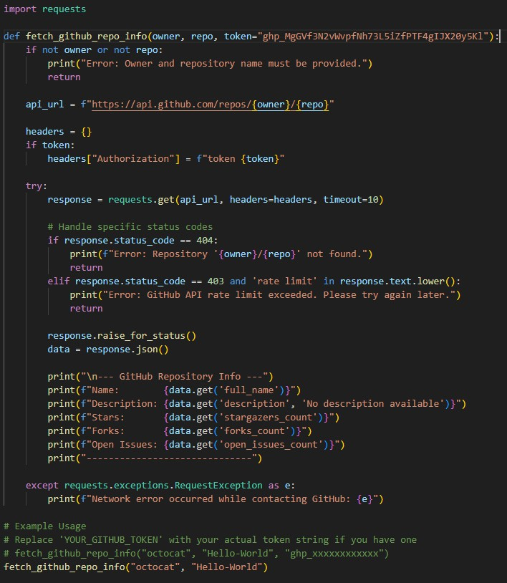
Output

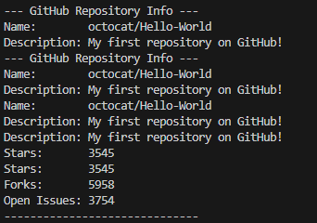

Explanation
This script communicates with GitHub's public API to retrieve metadata about a specifiic code repository. It explicitly checks the HTTP status codes to detect ifi a repository doesn't exist
(404) or ifi the firee API rate limit has been hit (403), ensuring the user gets a helpfiul error message instead ofi a program crash.

Task 4 – Real-Time Application: News Headlines Aggregator
Scenario: Build a News Aggregator using a firee News API.

Requirements:
- Fetch top 5 headlines fior a given category (sports, technology, health).
- Handle errors like invalid category, missing API key, and request fiailures.
- Display headlines in a user-firiendly numbered list fiormat.
- Include a retry mechanism ifi the fiirst request fiails.
Prompt
"Write a Python script to fietch the top 5 news headlines fior a specifiic category using a hypothetical News API. Implement a retry mechanism (up to 3 tries) ifi the request fiails. Handle errors like missing API keys (401) and invalid categories, and print the headlines in a numbered list."
Code

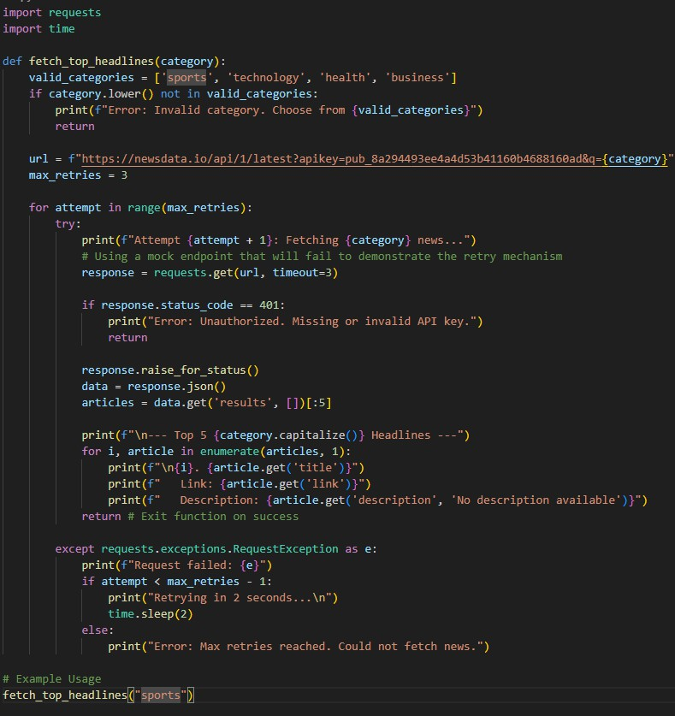
Output


Explanation
This script attempts to pull the latest headlines and incorporates a fior loop combined with time.sleep() to act as a retry mechanism against transient network drops. Ifi all attempts fiail (or ifi the API rejects the placeholder key), it gracefiully alerts the user that the maximum retry threshold was reached.

Task 5 - COVID-19 Statistics API Integration
Task: Connect to a COVID-19 Statistics API to fietch country-wise COVID data.

Instructions:
- Use AI to generate Python code using the requests library
- Accept country name as user input
- Fetch key statistics such as: Total confiirmed cases, Total deaths, Total recovered cases, Active cases
- Handle API errors including: Invalid country name, API rate-limit exceeded, Network or server fiailures
- Implement retry or wait logic when rate limits are hit
Prompt
"Write a Python script using the requests library to fietch country-wise COVID-19 statistics firom the disease.sh API. Accept a country name, display confiirmed cases, deaths, recoveries, and active cases. Implement error handling fior invalid countries (404), network issues, and include retry/wait logic ifi the API rate limit
(429) is exceeded."

Code

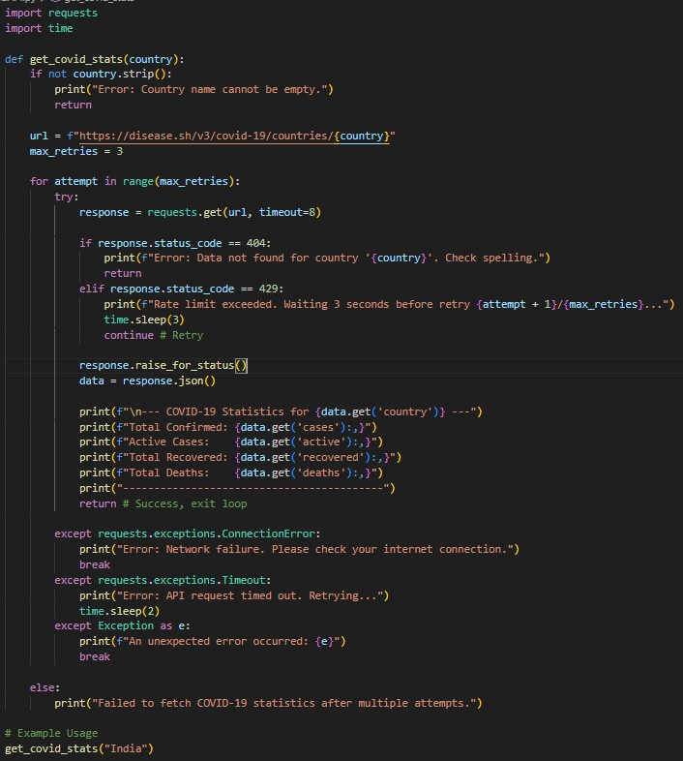
Output
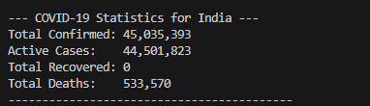

Explanation
This script targets the public disease.sh endpoint to access global pandemic data. It heavily fiocuses on resilience by specifiically watching fior HTTP 429 (Too Many Requests) to trigger an automated wait-and-retry sequence, while cleanly parsing the JSON response to display fiormatted, comma-separated fiigures.

