ASSIGNMENT-14.3

Batch-37
2303A52321

Task 1: AI-Assisted Personal Portfolio Website
Scenario
A student wants to showcase academic projects, technical skills, and contact
information through a personal portfolio website. AI tools are used to speed up
development while maintaining quality and customization.
Tasks
1. Use GitHub Copilot to generate a semantic HTML structure with
sections:
o Home
o About
o Projects
o Contact
2. Ask Copilot to suggest responsive CSS using Flexbox or Grid.
3. Customize AI-generated CSS to add:
o Hover effects on project cards
o Smooth scrolling navigation
Expected Outcome
• Clean and well-structured portfolio website
• Responsive layout for desktop and mobile screens
• Interactive project cards

Prompt:-

<!--Generate a semantic HTML5 personal portfolio website with sections: Home, About, Projects, and Contact, including a navigation bar linking to each section. Create responsive CSS using Flexbox or Grid so it works on desktop and mobile screens. Add hover effects on project cards and implement smooth scrolling navigation.-->
<!-- add bright and style the css and add some example matters in portfolio it look like real and working kind of portfolio i want -->

Output:-
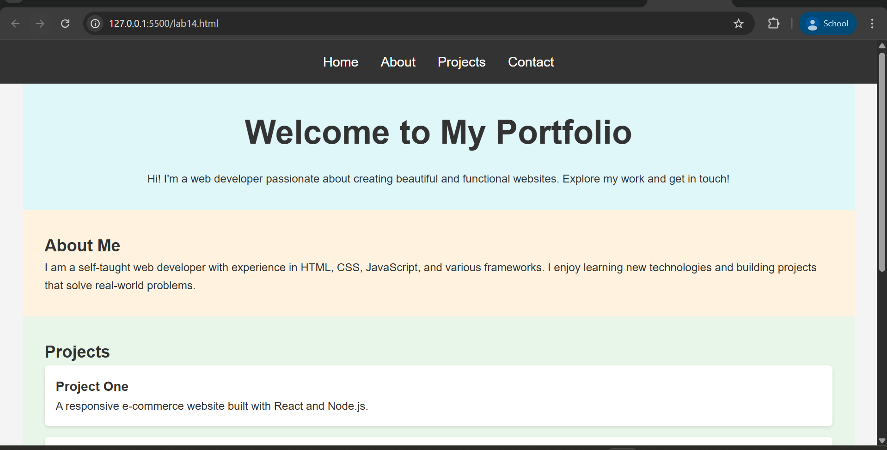
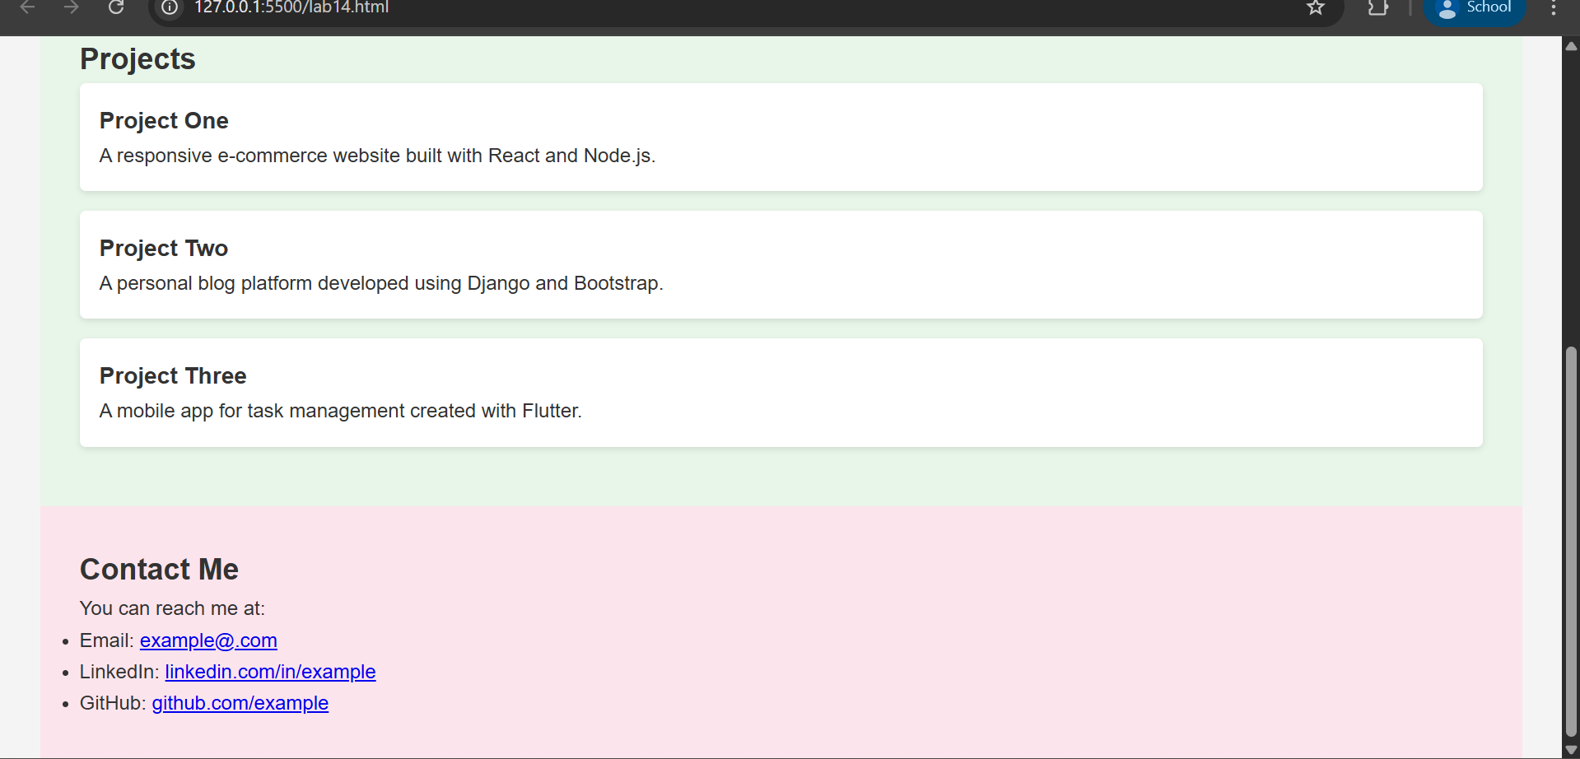

Task 2: AI-Generated Restaurant Landing Page
Scenario
A local restaurant requires a simple yet attractive landing page to display its
offerings. The developer uses AI assistance to rapidly generate UI components.
Tasks
1. Use Copilot to create a navigation bar with links:
o Home
o Menu
o Gallery
o Contact
2. Generate a menu section styled with CSS cards.
3. Implement a JavaScript-based image slider for the gallery using Copilot
suggestions.
4. Customize animations or transitions for better user experience.
Expected Outcome
• Fully functional restaurant landing page
• Responsive navigation bar
• Working image slider with smooth transitions

Prompt:-

<!--
Generate a simple restaurant landing page using HTML, CSS, and JavaScript.
Include a responsive navigation bar with links: Home, Menu, Gallery, and Contact.
Create a Menu section styled with CSS card layouts for food items.
Implement a JavaScript image slider for the Gallery with smooth transitions.
Add basic animations or hover effects to improve user experience and make the page responsive for desktop and mobile screens. now use different colour for css styling and make it look like real restaurant landing page and add some example matters in menu and gallery section to make it look like real and working kind of restaurant landing page i want
-->

Website ➖

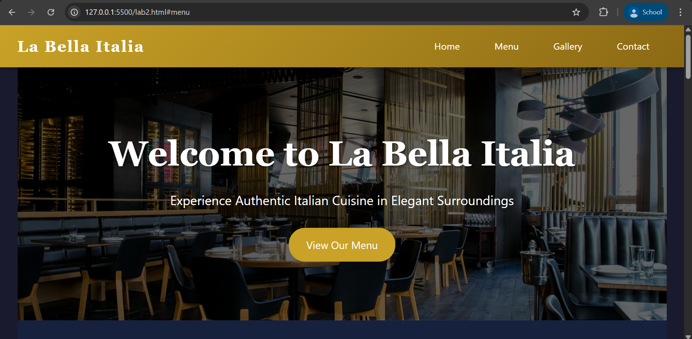

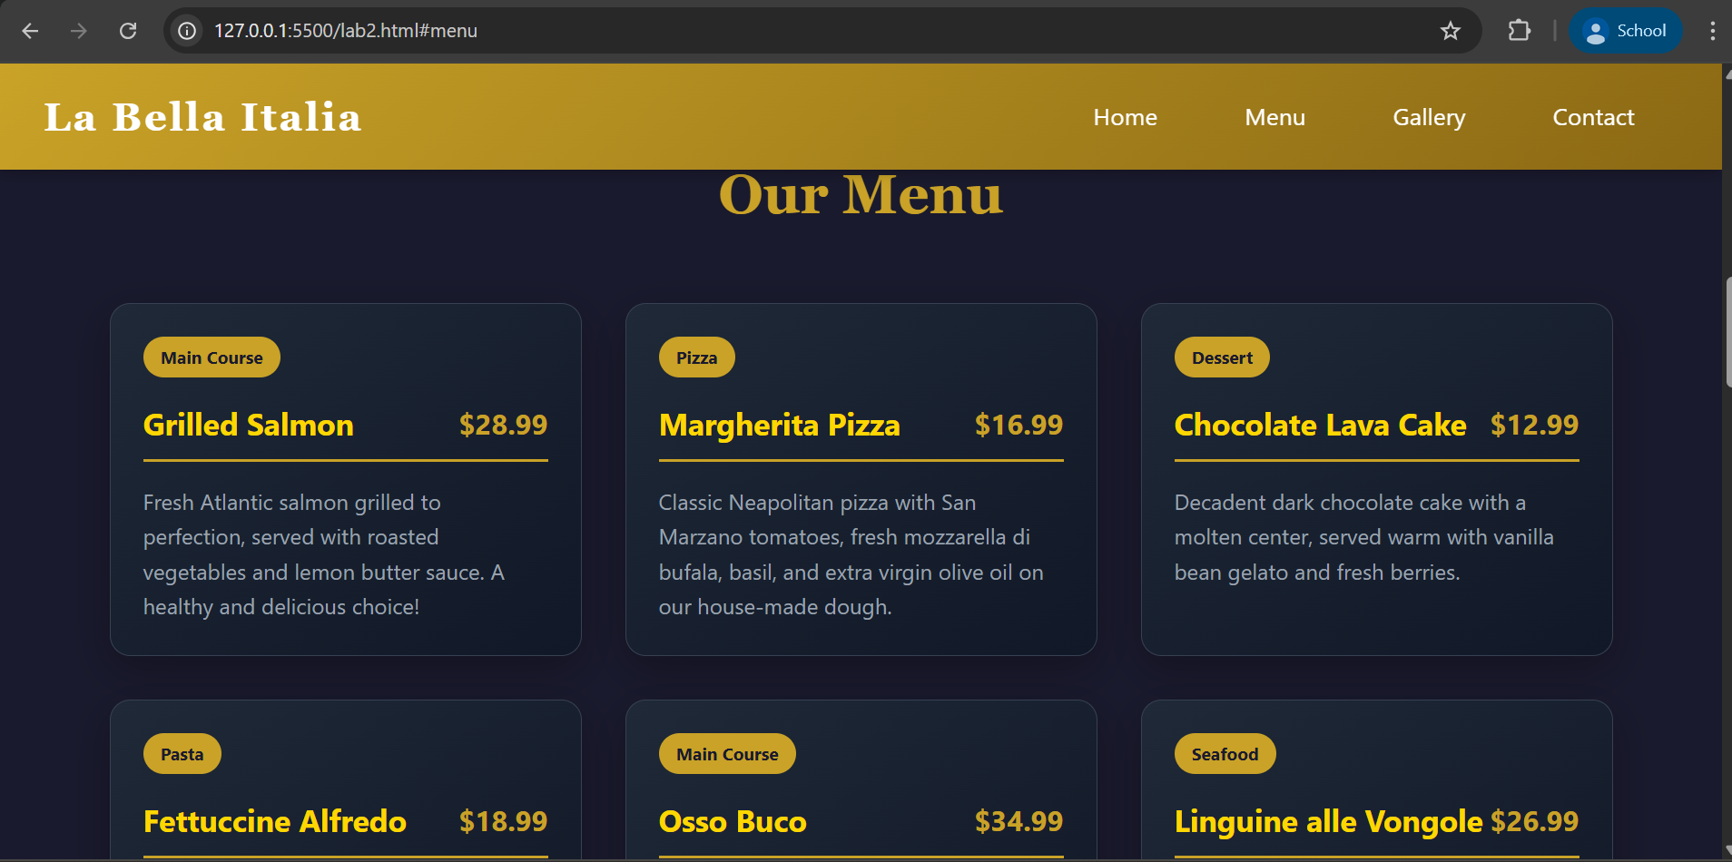

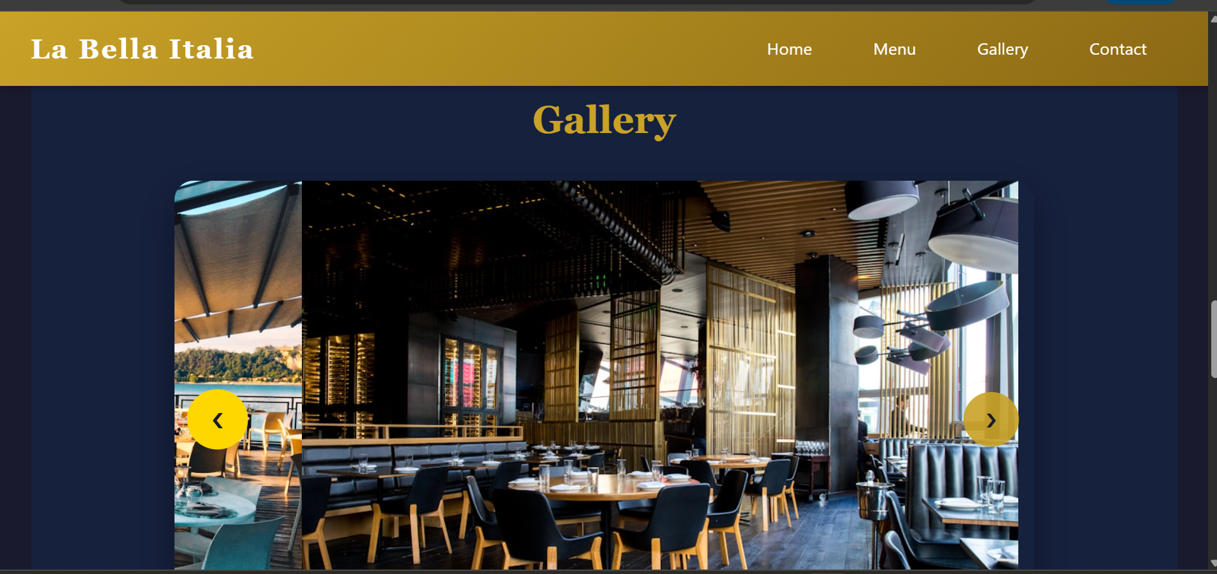
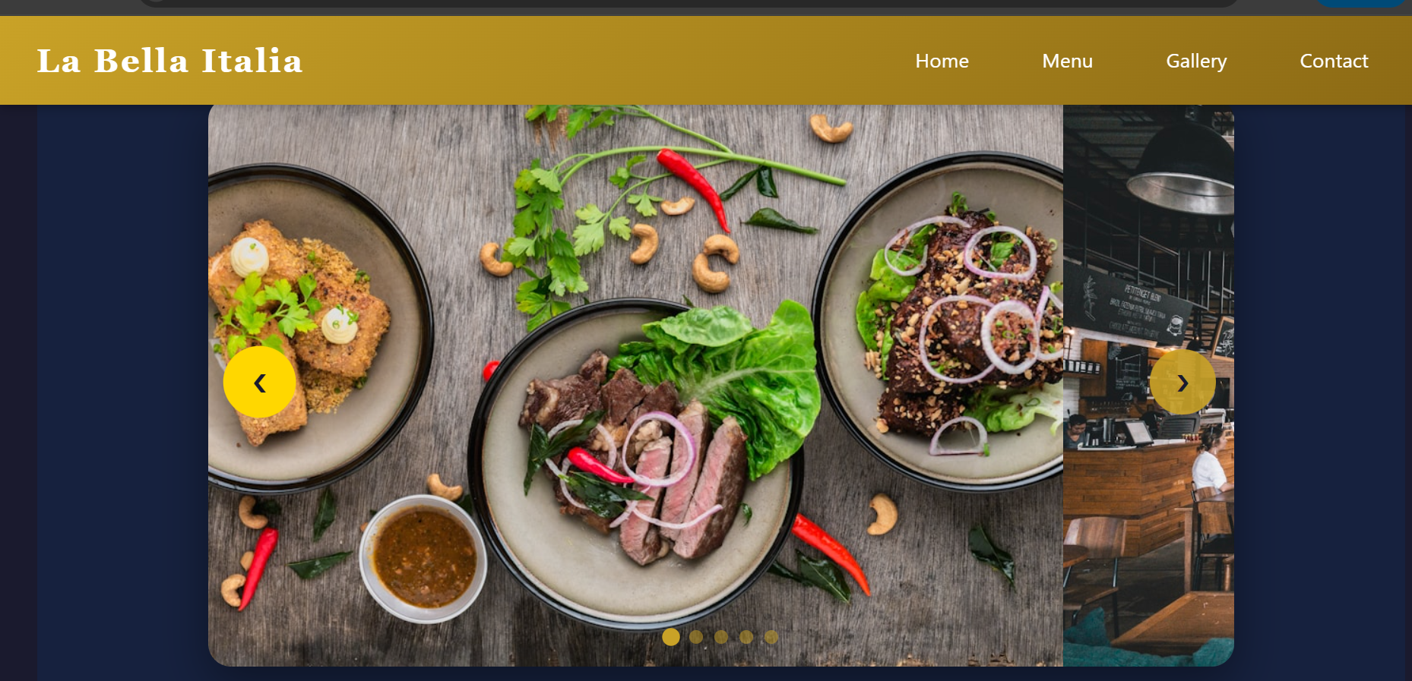
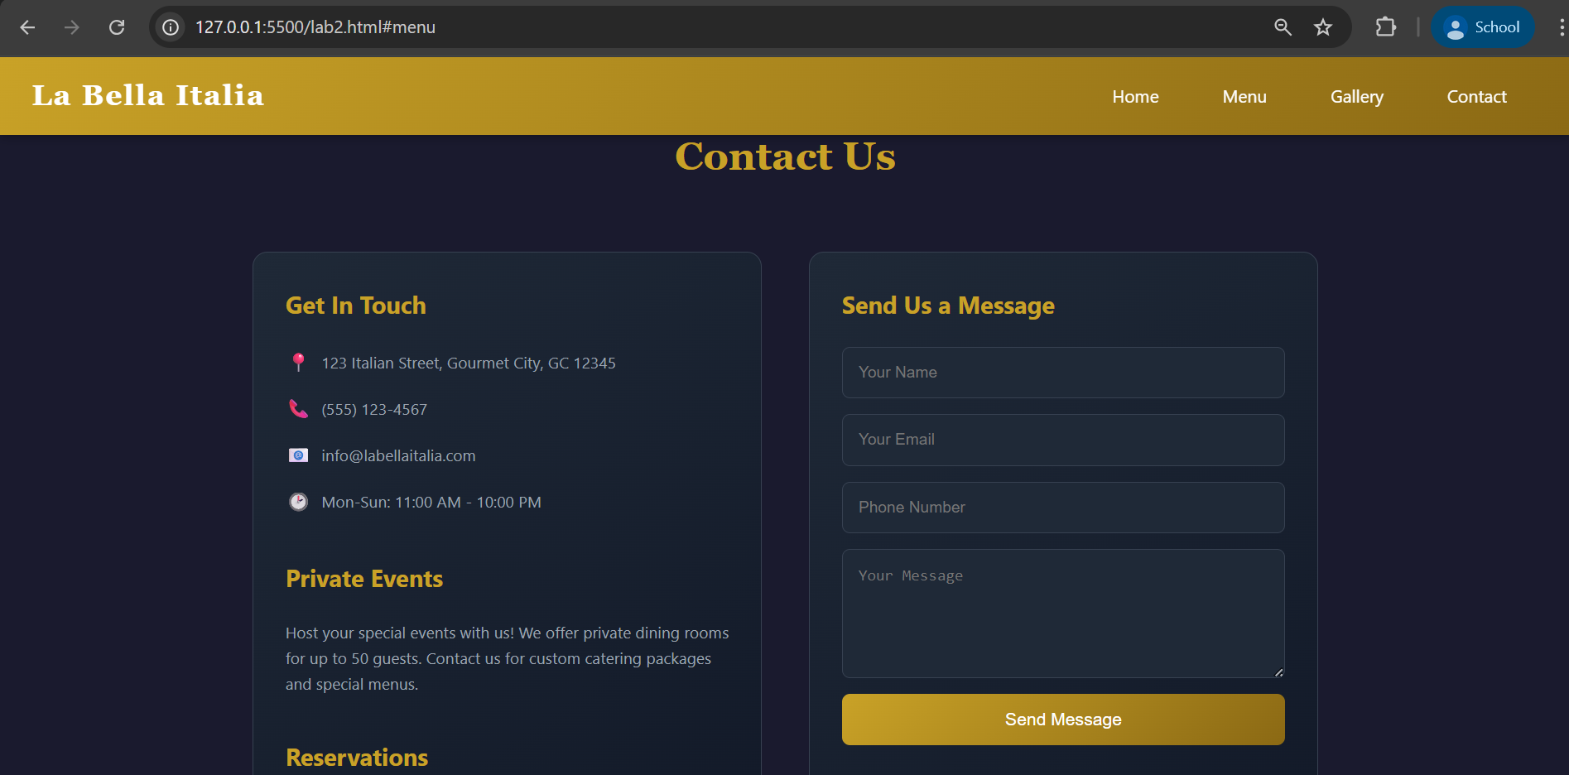

Task 3: AI-Powered Event Registration Form
Scenario
SR University is hosting a technical fest and requires an online registration form
with real-time validation to ensure accurate user input.
Tasks
1. Ask Copilot to generate an HTML form with the following fields:
o Name
o Email
o Phone Number
o Department
o Event Selection
2. Use AI assistance to style the form using CSS for readability and
accessibility.
3. Implement JavaScript validation using Copilot:
o Email format validation
o Phone number length validation
o Required field checks
Expected Outcome
• User-friendly and visually appealing form
• Real-time validation messages
• Prevention of invalid submissions

Prompt:-

<!--
Generate an event registration form for a technical fest using HTML, CSS, and JavaScript.
The form should include fields: Name, Email, Phone Number, Department, and Event Selection.
Style the form using CSS for good readability, accessibility, and responsive design.
Implement JavaScript validation with real-time messages for email format validation, phone number length validation, and required field checks to prevent invalid submissions.
-->

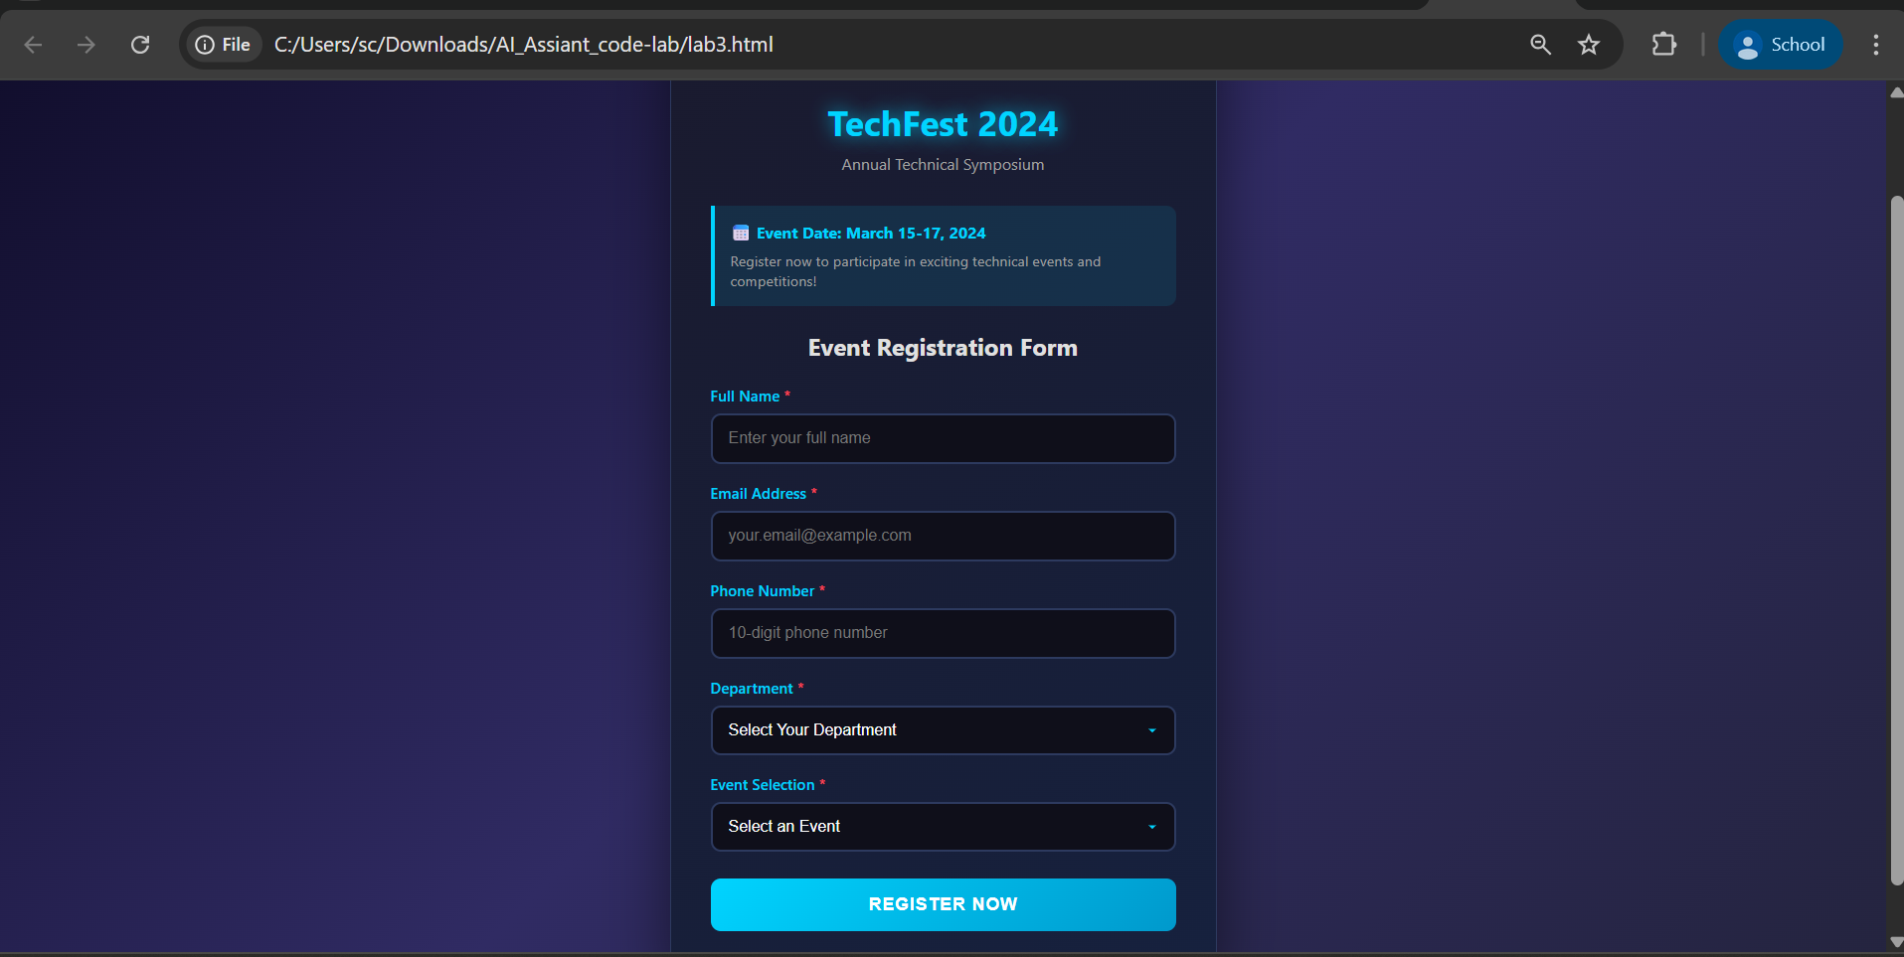

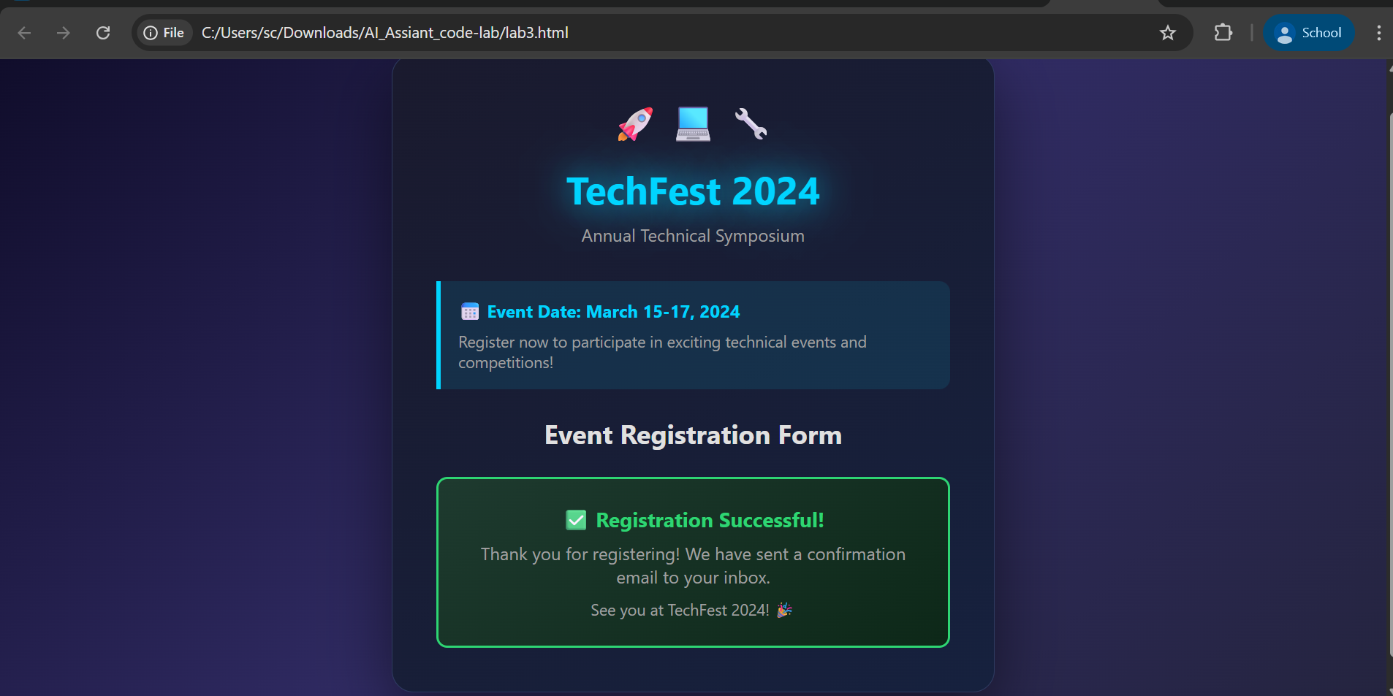

Task 4: AI-Assisted E-Commerce Product Page
Scenario
A startup is developing a basic e-commerce product page to showcase products
and manage simple cart functionality.
Tasks
1. Use Copilot to generate a grid-based product catalog using HTML and
CSS.
2. Implement an “Add to Cart” feature using JavaScript.
3. Modify AI-generated code to include:
o Cart item counter at the top-right corner
o Visual feedback when a product is added
Expected Outcome
• Functional product catalog
• Working cart counter
• Interactive user experience

Prompt:-
<!--

Generate a basic e-commerce product page using HTML, CSS, and JavaScript.
Create a grid-based product catalog layout using CSS Grid or Flexbox to display products with images, names, prices, and an "Add to Cart" button.
Implement an Add to Cart feature using JavaScript with a cart item counter displayed at the top-right corner of the page.
Add visual feedback such as a highlight or animation when a product is added to the cart and ensure the page is responsive.
-->

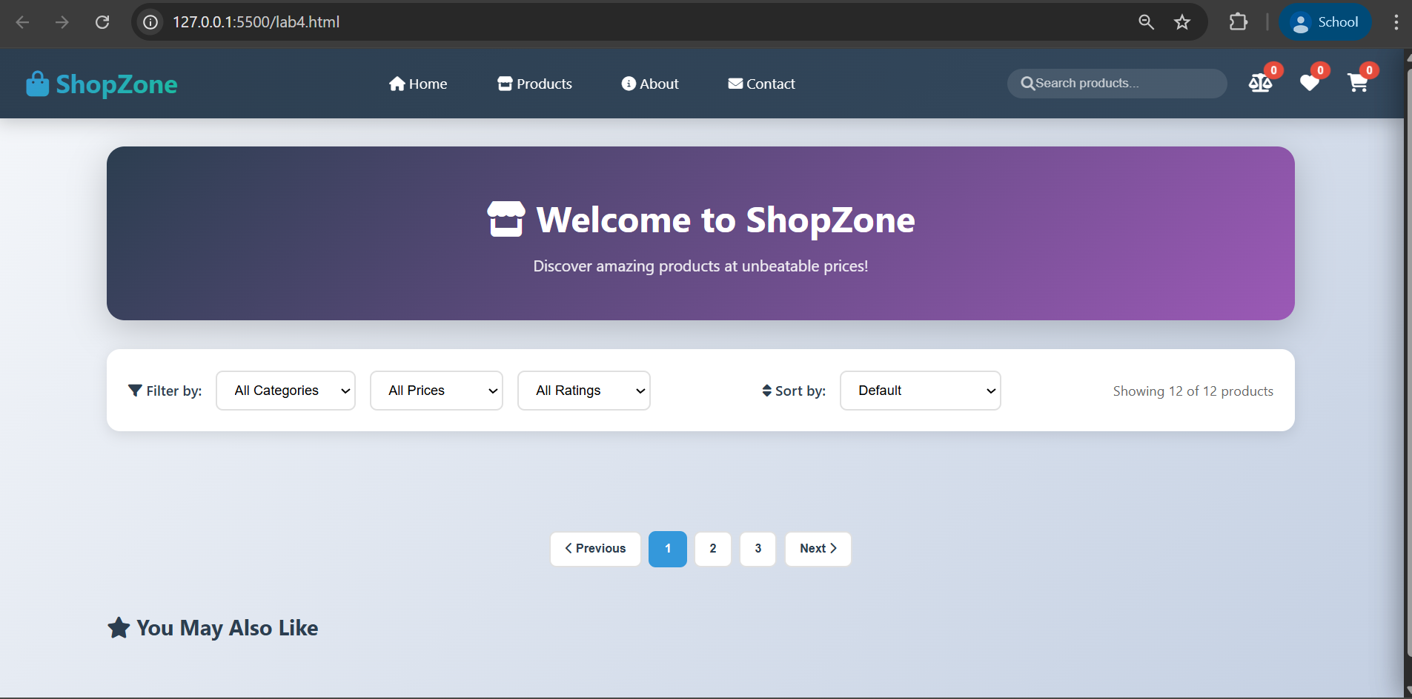

Task 5: Create a Responsive Web Page Layout
Instructions:
• Design a basic web page layout with a header, main content area, and
footer using HTML and CSS
Use AI to assist in generating responsive CSS for different screen sizes.
• Ensure the layout is clean and visually organized.
Expected Output:
• A responsive web page with:
• Header with navigation links
• Main section with placeholder text/images
• Footer with copyright or contact info
• Layout adapts correctly to desktop, tablet, and mobile screen sizes.

Prompt:-

Generate a responsive web page using HTML and CSS.
Include a header with navigation links, a main section with placeholder text and images, and a footer with copyright or contact information.
Use responsive CSS with Flexbox or Grid and media queries so the layout adapts properly for desktop, tablet, and mobile screen sizes while keeping the design clean and visually organized.

