Assignment – 11.2
2303A52321
Task Description -1 – (Stack Using AI Guidance)
• Task: With the help of AI, design and implement a Stack data
structure supporting basic stack operations.
Expected Output:
• A Python Stack class supporting push, pop, peek, and empty-
check operations with proper documentation.
Prompt:
Design and implement a Stack data structure in Python using a class-based approach. The stack should support basic operations such as push, pop, peek, and checking whether the stack is empty. Ensure the program takes user input to perform these operations through a simple menu-driven interface. Include proper documentation and comments to clearly explain the purpose and functionality of each method.
Code:
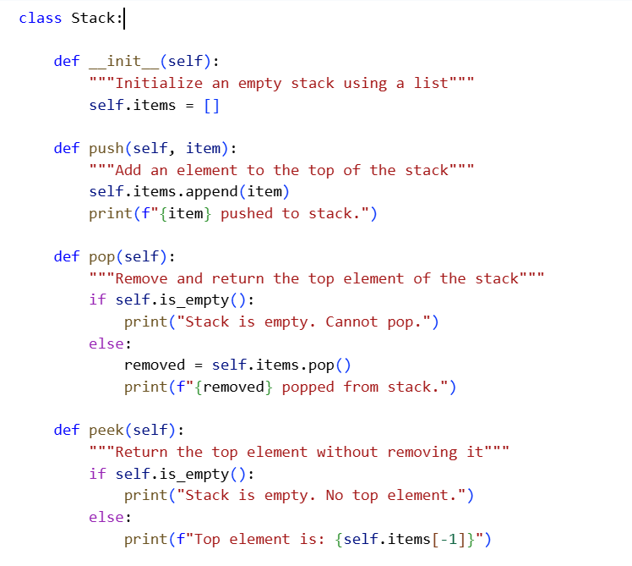

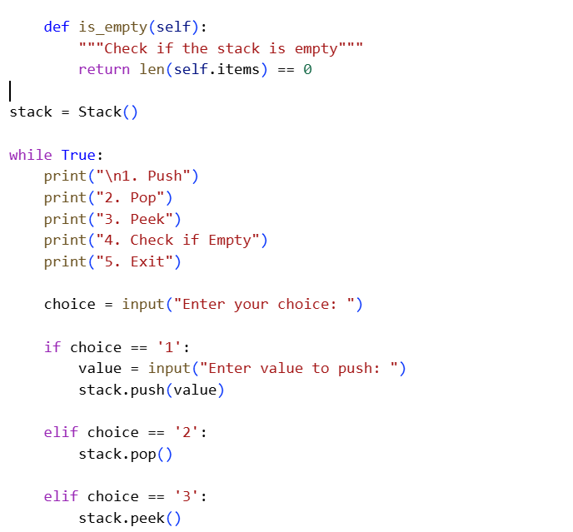
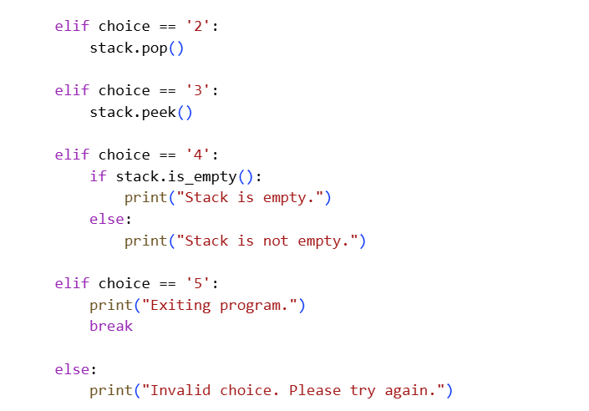

Output:
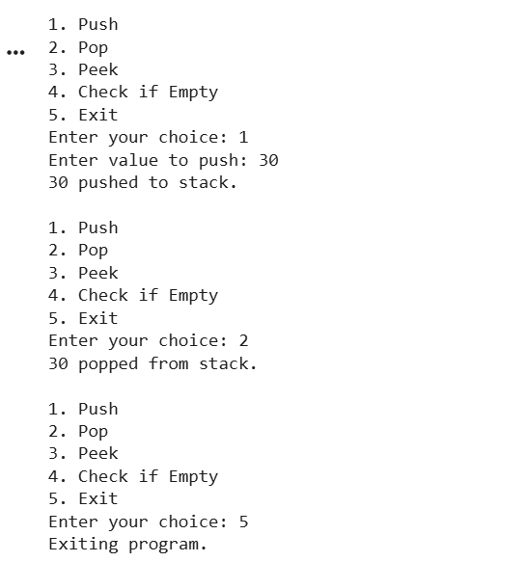
Explanation of code:
The program defines a Stack class that follows the LIFO (Last In, First Out) principle using a Python list to store elements. The __init__ method initializes an empty list, while the push method adds elements to the top of the stack using append(). The pop method removes the top element using pop() after checking whether the stack is empty. The peek method displays the top element without removing it, and the is_empty method returns True if the stack has no elements. A menu-driven loop allows the user to interactively perform stack operations until they choose to exit the program.
Task Description -2 – (Queue Design)
• Task:Use AI assistance to create a Queue data structure
following FIFO principles
Expected Output:
• A complete Queue implementation including enqueue, dequeue,
front element access, and size calculation
Prompt:
Design and implement a Queue data structure in Python using a class that follows the FIFO (First In, First Out) principle. The queue should include operations such as enqueue, dequeue, accessing the front element, and calculating its size. Provide a complete, well-documented implementation with clear comments explaining each method.
Code:
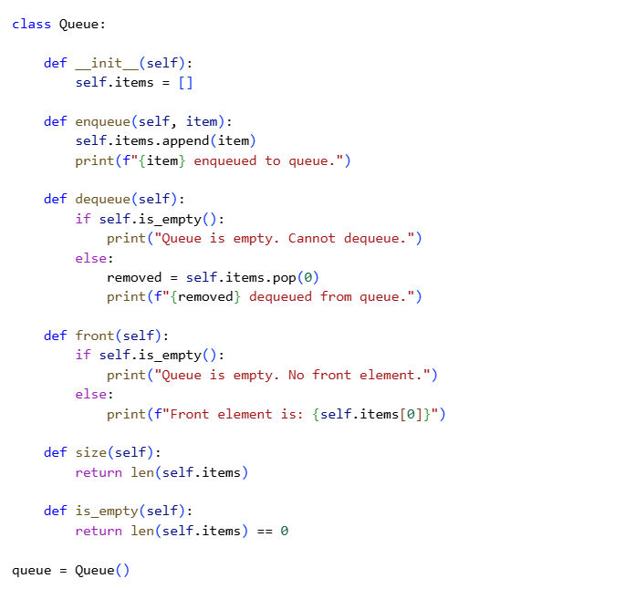

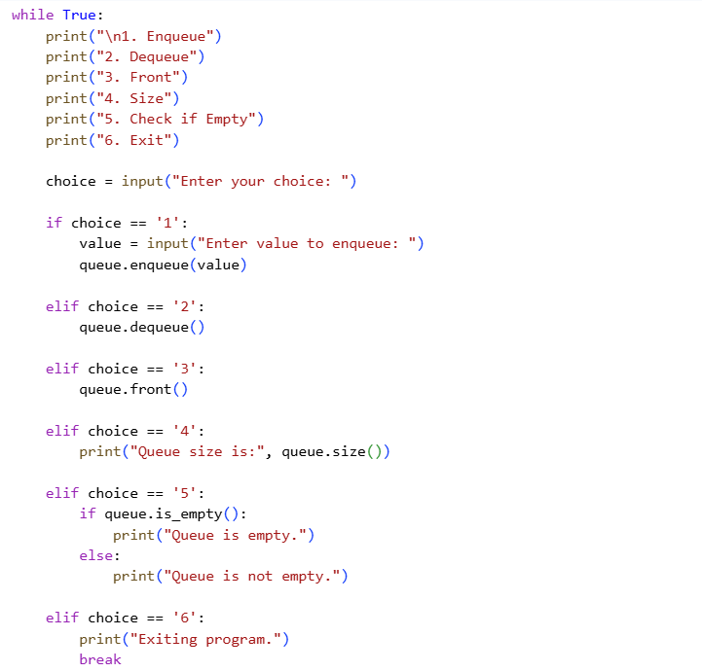

Output:
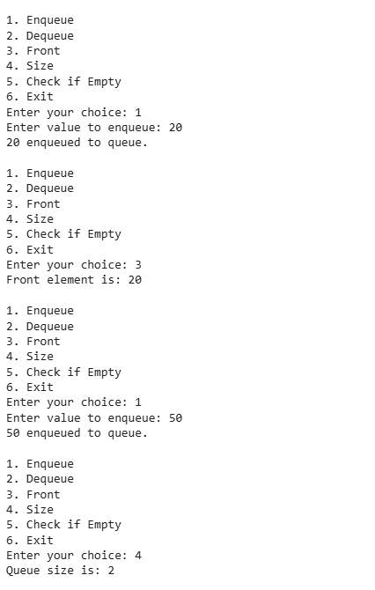
Explanation of code:
The program defines a Queue class that follows the FIFO (First In, First Out) principle using a Python list to store elements. The enqueue method adds elements to the rear of the queue using append(), while the dequeue method removes the front element using pop(0) after checking if the queue is empty. The front method displays the first element without removing it, and the size method returns the total number of elements in the queue. A menu-driven loop allows the user to perform queue operations repeatedly until they choose to exit the program.
Task Description -3 –(Singly Linked List Construction)
• Task: Utilize AI to build a singly linked list supporting insertion
and traversal.
Expected Output:
• Correctly functioning linked list with node creation, insertion
logic, and display functionality.
Prompt:
Design and implement a singly linked list in Python using a class-based approach. The linked list should support node creation, insertion of elements, and traversal to display all nodes. Provide a correctly functioning implementation with clear structure and proper comments explaining the logic.
Code:
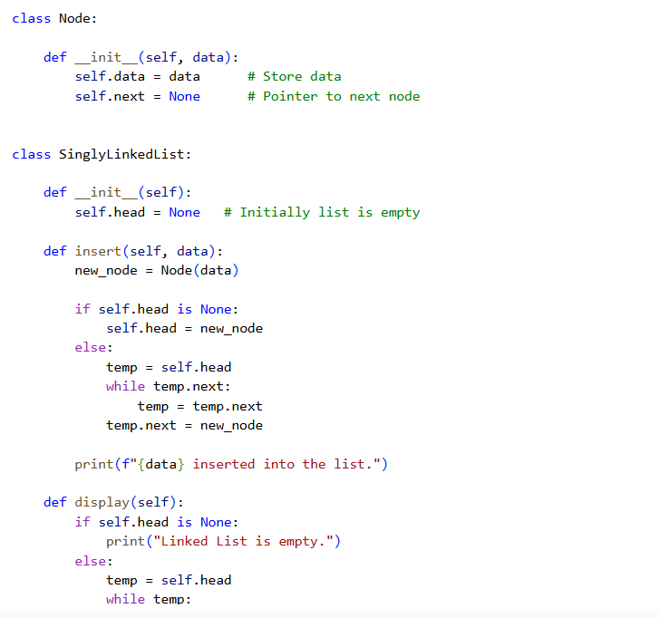
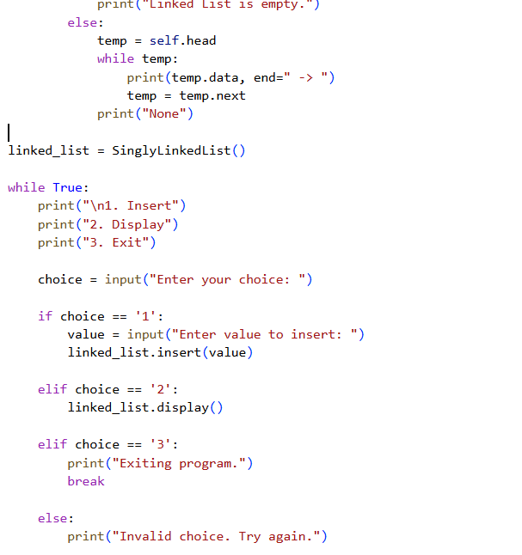
Output:
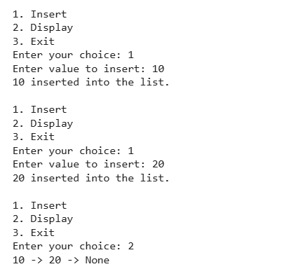

Explanation of code:
The program defines a Node class to store data and a reference to the next node, and a SinglyLinkedList class to manage the list operations. The insert method creates a new node and adds it at the end of the list by updating the next pointer, while the display method traverses from the head node and prints each element until it reaches None. A simple menu-driven loop allows the user to insert elements and display the linked list interactively.
Task Description -4 – (Binary Search Tree Operations)
• Task: Implement a Binary Search Tree with AI support focusing
on insertion and traversal.
Expected Output:
• BST program with correct node insertion and in-order traversal
output.
Prompt:
Design and implement a Binary Search Tree (BST) in Python using a class-based structure. The BST should support node insertion following BST properties and perform in-order traversal to display elements in sorted order. Provide a correctly functioning implementation with clear logic and proper comments explaining the operations.
Code:
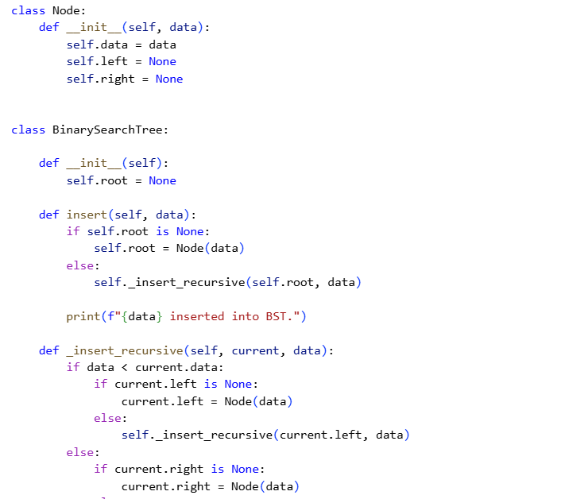

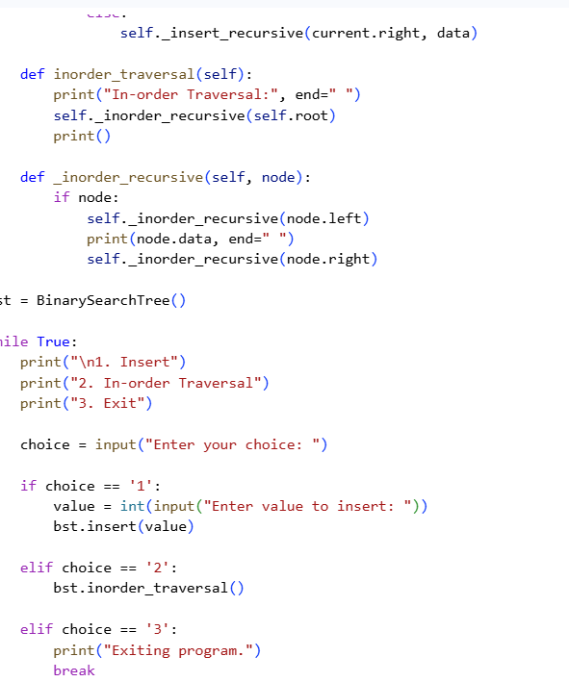
Output:
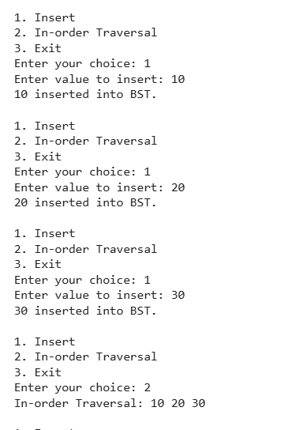
Explanation of code:
The program defines a Node class to represent each element in the Binary Search Tree, containing data and references to left and right child nodes. The BinarySearchTree class manages the tree, where the insert method places new values according to BST rules (smaller values go to the left, larger values go to the right) using a recursive helper function. The inorder_traversal method performs a Left → Root → Right traversal, which prints the elements in sorted order.
Task Description -5 – (Hash Table Implementation)
• Task: Create a hash table using AI with collision handling
Expected Output:
• Hash table supporting insert, search, and delete using chaining
or open
Prompt:
Design and implement a Hash Table in Python with proper collision handling using chaining or open addressing. The hash table should support basic operations such as insert, search, and delete. Provide a complete and correctly functioning implementation with clear structure and comments explaining the logic.
Code:
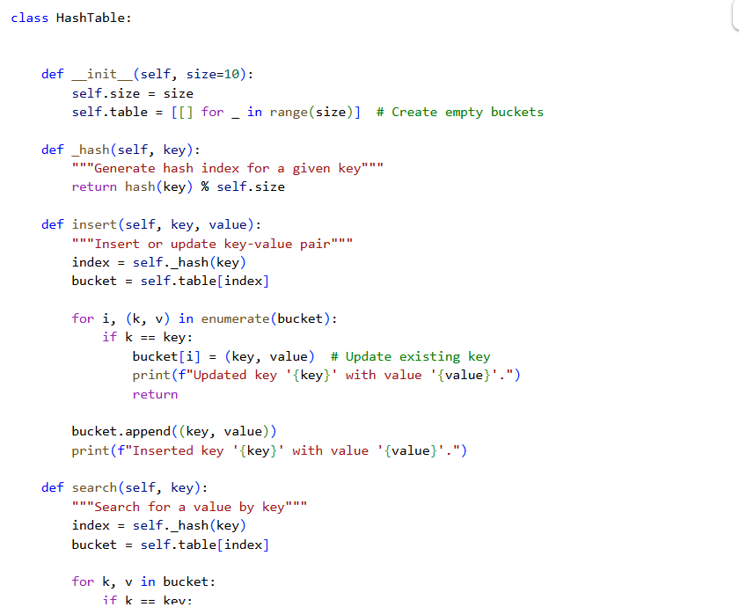

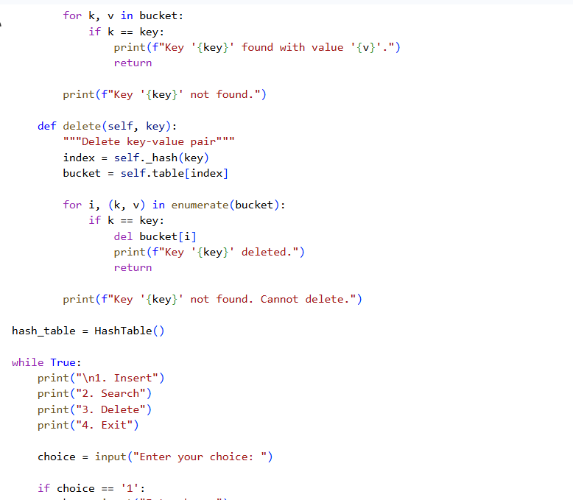
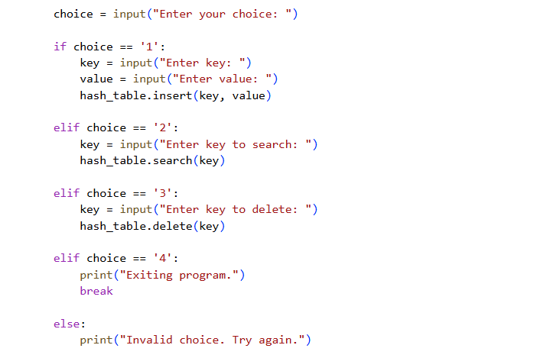
Output:

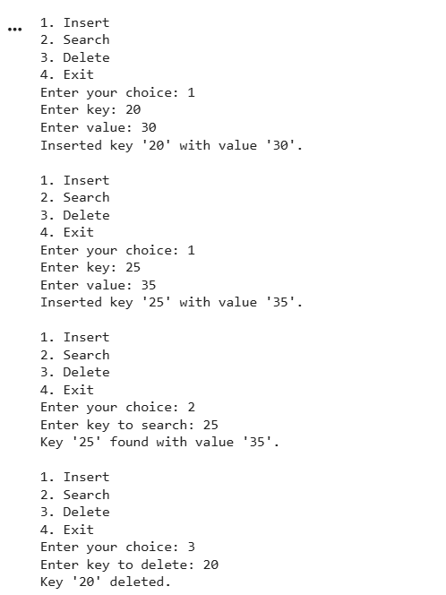

Explanation of code:
The program defines a HashTable class that uses a list of buckets to store key-value pairs and handles collisions using chaining (each bucket is a list). The _hash method generates an index for a given key, and the insert, search, and delete methods perform operations by accessing the appropriate bucket and checking for matching keys. A menu-driven loop allows the user to interactively insert, search, and delete key-value pairs from the hash table.

