2303a52321
K.Saikrishna
Task Description-1 (Classes – Data Validation)
• Prompt AI to generate a Student class with attributes: name,
roll_no, and marks. Add a method is_pass() that returns whether
the student has passed (marks ≥ 40).
Expected Output-1
• Python class with constructor and validation logic
• Clear method implementation returning pass/fail status
• Students analyze correctness and clarity of class design
Prompt:
Create a Python Student class with attributes name, roll_no, and marks.
Add data validation to ensure marks are between 0 and 100.
Implement an is_pass() method that returns pass/fail based on marks ≥ 40.
Code:
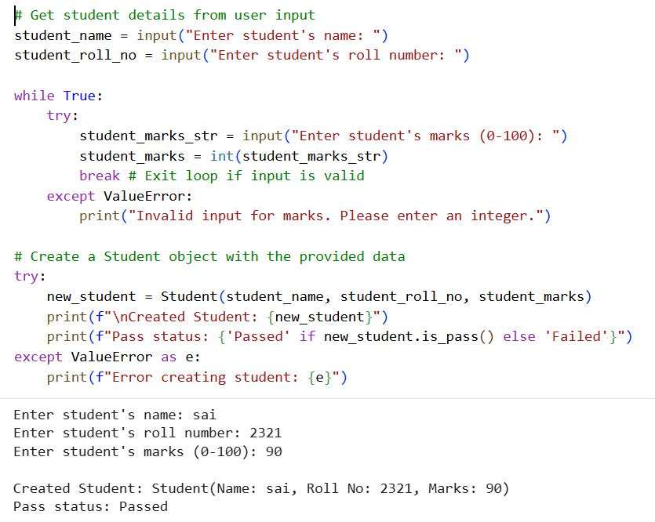
Explanation of code:
The program takes student name and roll number as input from the user.
It uses a while loop with try–except to ensure the marks entered are a valid integer.
Once valid marks are entered, a Student object is created using the provided data.
If the marks are invalid (outside allowed range), the constructor raises a ValueError.
Finally, the code prints the student details and whether the student has passed or failed.
Observation:
The code demonstrates proper input handling by validating user-entered marks using a loop and exception handling, ensuring that only correct integer values are accepted. It then creates a Student object with validated data and safely handles errors raised due to invalid marks. Finally, the program clearly outputs the student details along with the pass or fail status, making the logic easy to understand and reliable.
Task Description-2 (Loops – Pattern Generation)
• Ask AI to generate a function that prints a right-angled triangle
star pattern using a for loop. Then regenerate the same pattern
using a while loop.
Expected Output-2
• Correct pattern output using both loop types
• Logical loop structure with proper conditions
Prompt:
Create a Python function to print a right-angled triangle star pattern using a for loop.
The pattern should display increasing stars on each line.
Regenerate the same star pattern using a while loop.
Ensure both implementations use correct loop conditions and logic.
Code:
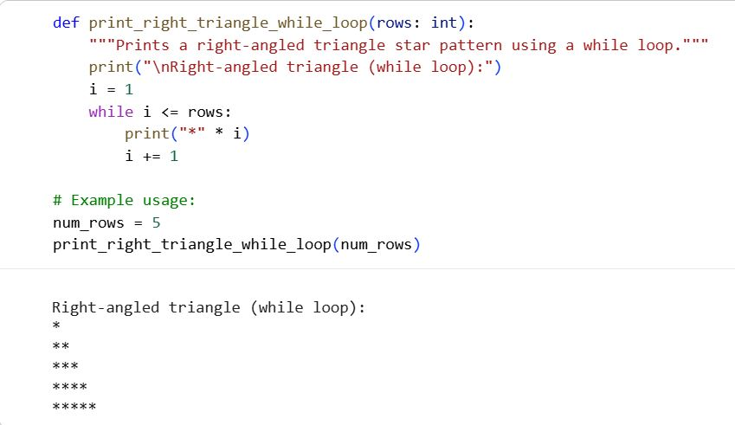

Using for loop
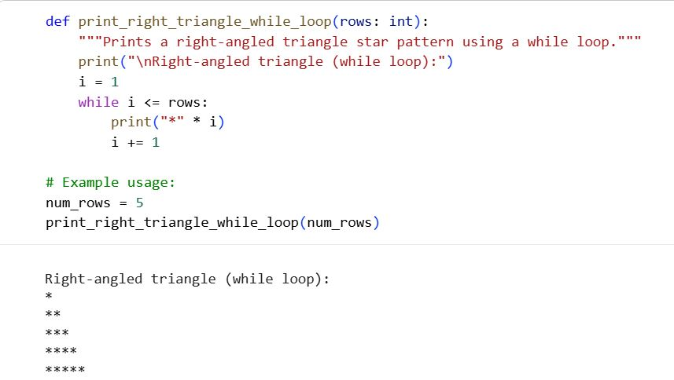
Explanation of code:
The function prints a right-angled triangle star pattern using a while loop based on the given number of rows.
A counter variable increases on each iteration to control how many stars are printed per line.
The loop stops when the counter exceeds the specified number of rows.
Observation:
The code correctly uses a while loop to generate a right-angled triangle pattern.
The loop control variable is properly initialized and updated to avoid infinite loops.
The logic is simple, readable, and produces the expected output.
Task Description-3 (Conditional Statements – Number Analysis)
• Ask AI to write a function that checks whether a given number
is positive, negative, or zero using if-elif-else. Test the function
Expected Output-3
• Function correctly classifies numbers
• Proper handling of all conditions
• Students analyze decision logic
Prompt:
Create a Python function that uses if–elif–else to check whether a number is positive, negative, or zero.
Test the function with multiple input values.
Ensure all conditions are handled correctly with clear decision logic. 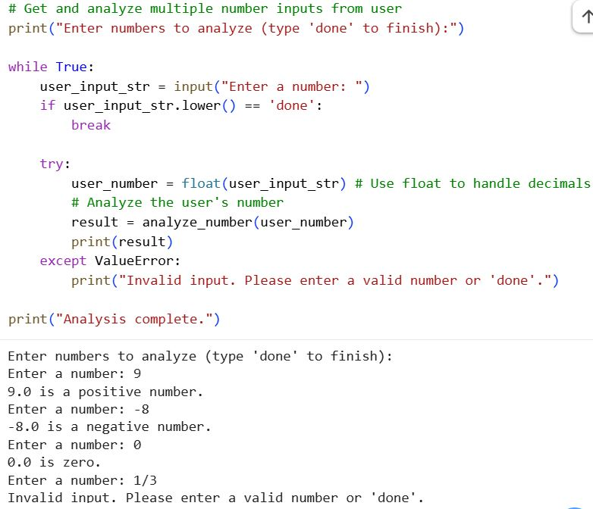
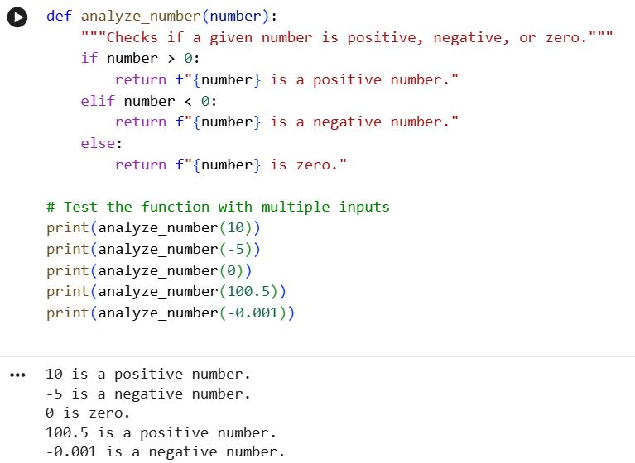
Explanation of code:
The function analyze_number uses conditional statements to check whether the given number is positive, negative, or zero.
It returns a descriptive message based on the result of the comparison.
The function is tested with multiple inputs, including integers and floating-point numbers.
This confirms that the logic correctly handles all possible numeric cases.
Observation:
The function correctly classifies numbers as positive, negative, or zero using clear conditional logic.
It works for both integers and decimal values, showing good input flexibility.
The output messages are clear and easy to understand, making the code student-friendly.
Task Description-4 (Nested Conditionals)
• Generate a function check_discount(age, is_member) that
determines discount eligibility:
• Age ≥ 60 → Senior discount
• Member → Additional discount
Use nested if statements.
Expected Output-4
• Python code using nested conditionals
• Clear explanation of decision flow
Prompt:
Create a Python function check_discount(age, is_member) using nested if statements to determine discount eligibility.
Apply a senior discount if age is 60 or above and an additional discount if the person is a member.
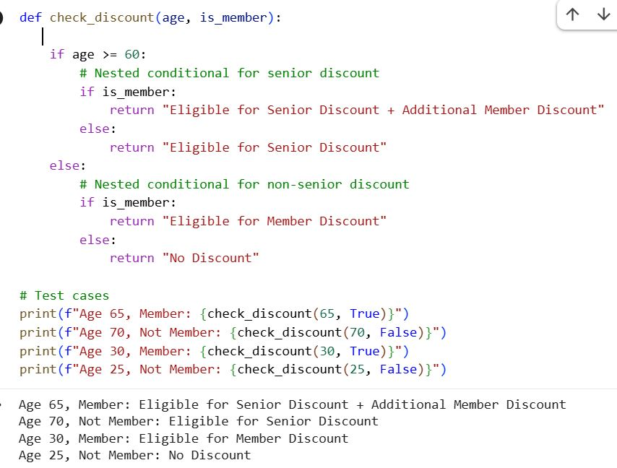
Explanation of code:
The function check_discount uses nested if statements to evaluate discount eligibility based on age and membership status.
It first checks whether the age is 60 or above to apply the senior discount, then checks membership for an additional benefit.
If the person is under 60, it separately evaluates whether a member discount applies.
Observation:
The code correctly applies nested conditionals to handle multiple discount criteria.
All possible combinations of age and membership are clearly evaluated and tested.
The logic is easy to follow and produces clear, meaningful output messages.
Task Description-5 (Class – Mathematical Opera)
• Ask AI to create a Circle class with methods to calculate area ()
and circumference () given the radius.
Expected Output-5
• Correct mathematical computation
• Well-structured class with methods
• Code explanation provided.
Prompt:
Create a Python class named Circle that takes the radius as input.
Add methods to calculate the area and circumference of the circle.
Code:
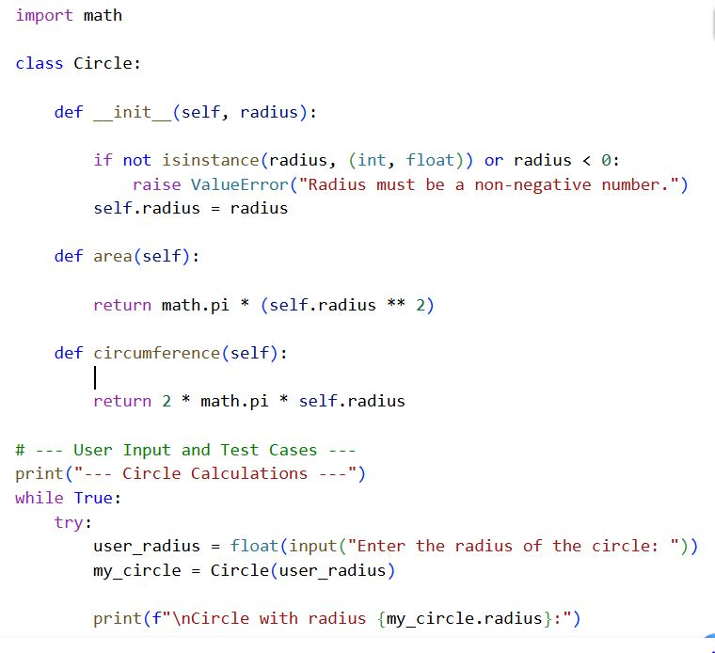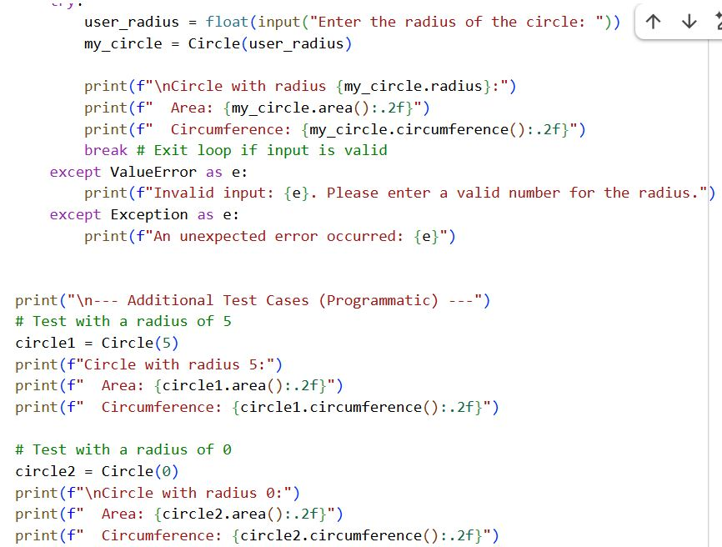
Output:
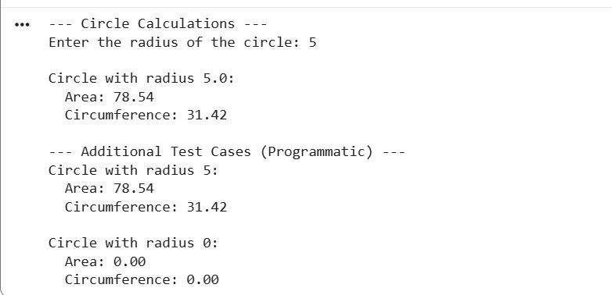

Explanation of code:
The code defines a Circle class that validates the radius and provides methods to calculate the area and circumference using mathematical formulas.
It uses input validation to ensure the radius is a non-negative number and raises an error for invalid values.

