Create Node and bring Back to online:

1)open Jenkins DashBoard and goto the Manage Jenkins Select the Manage Nodes and Clouds.

->create new node and click on permanent Agent option.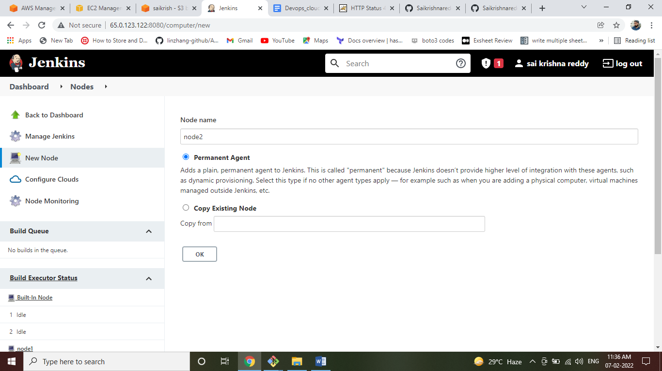

->after that here are the options you select:

* Number Of Executers=it is your choice ex=4
* Remote Root Directory = it is a path like which user you want to connect paths={root user=/root/, ec2-user=/home/ec2-user/}.
* Labels=give any name.
* Usage=don’t touch here.
* Launch Method=select:Launch Agents Via ssh
* 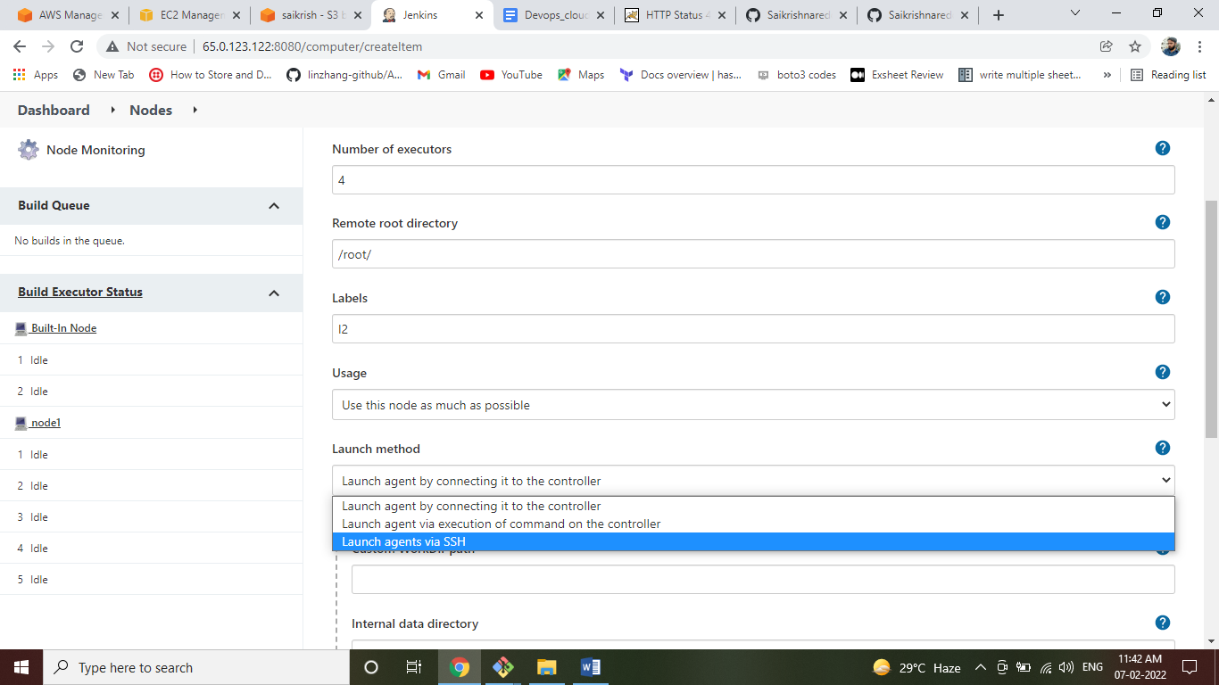
* Host=Give private ip of node ec2 mechine(which the user you want to connect)
* Select Credentials:give the credentials if there are otherwise you can upload here also.
* Host Key Verification Strategy=select Non Verifying Verification Strategy.
* 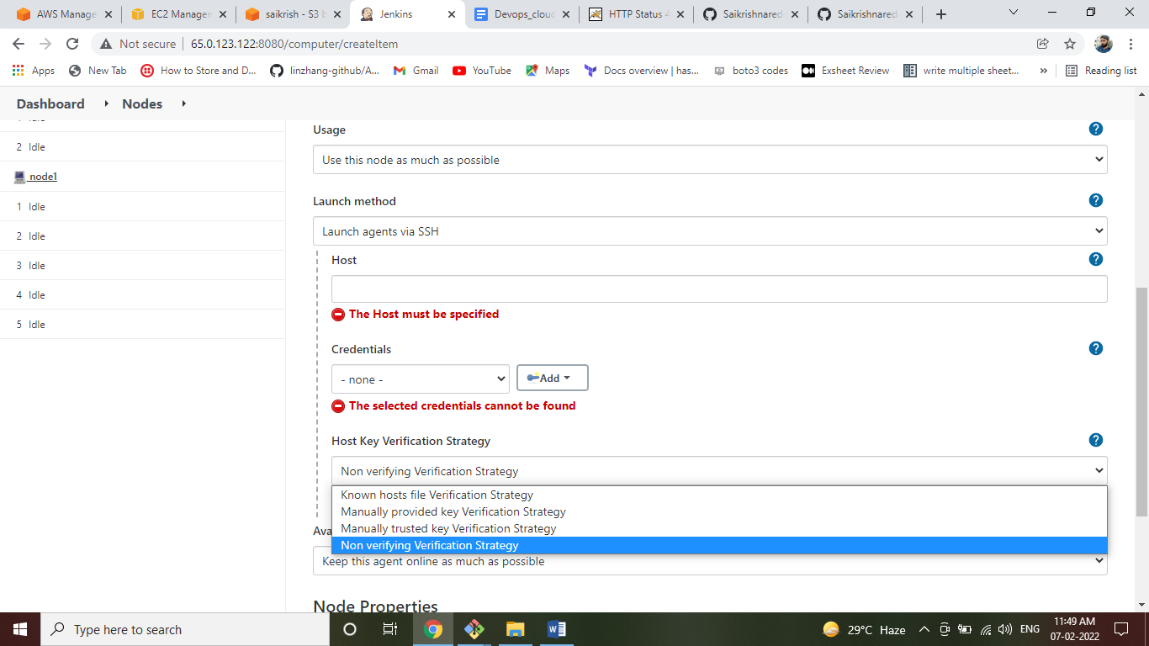

->copy the public key file(id_rsa.pub) to the node mchine where the location is .ssh/authorized_keys.

->install java in node server. {cmd:-amazon-linux-extras install java-openjdk11 –y }

->allow the Security Groups to a node machine from jenkins .

->Click on Refresh status in your nodes Panel

