Setup for vpc peering:

1)choose two accounts.

2)create your own vpc.and igw,subnet as well.

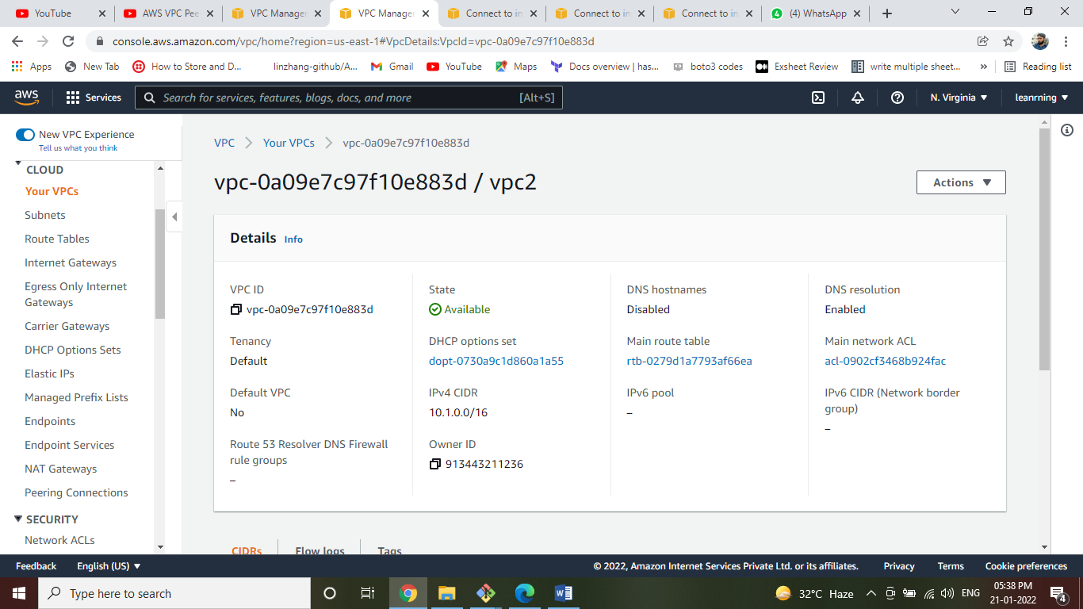

3)attach igw to specified vpcs.

4)create the vpc request peering to other account and accept the request in other account which is targeted vpc as well.

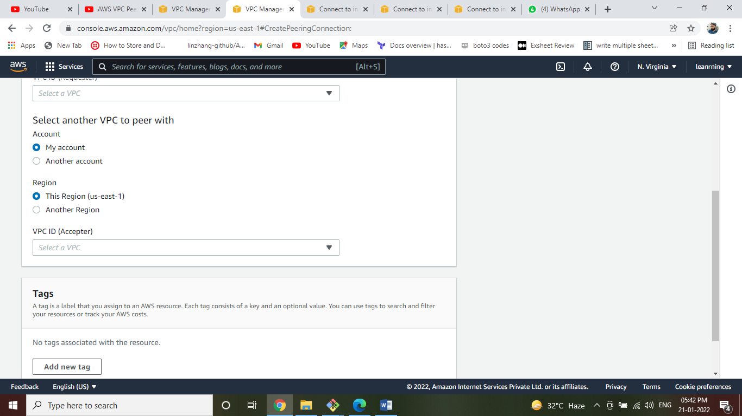

5)configure the route tables like(igw=give any where and attach igw), give cidr range of another account vpc which is requested by vpc peering like (peering=10.1.0.0/16 and attach peering) .

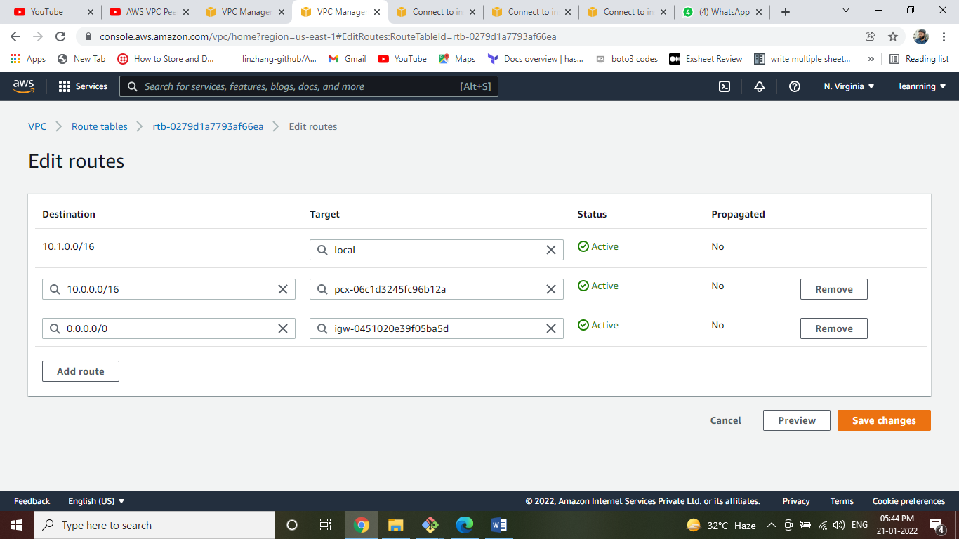

6)create ec2 instances in specified vpcs as well in both requested and accepted vpcs of different account.

7)ec2 security groups=

In both ec2s

Ssh-------22-------my ip

Ssh-------22-------cidr range of other vpc(which is in other account).

8)copy the pem file to one ec2. And ssh to that ec2 machine.

9)later to navigate the specified location where the pem file is located in that ec2.

10)bring the private ip of other account ec2 machine and ssh to that private machine

