Make Java Package:

---------------------------

1)Install the Maven in the Jenkins as well as nodes.

create a freestyle job.and add the Iam role to node machine.

2)Select options here:

* Source Code Management 🡪select Git option---enter git url.
* Select Branch
* Build Environment🡪 select the Execution Shell.
* Run the commands to make package.
* 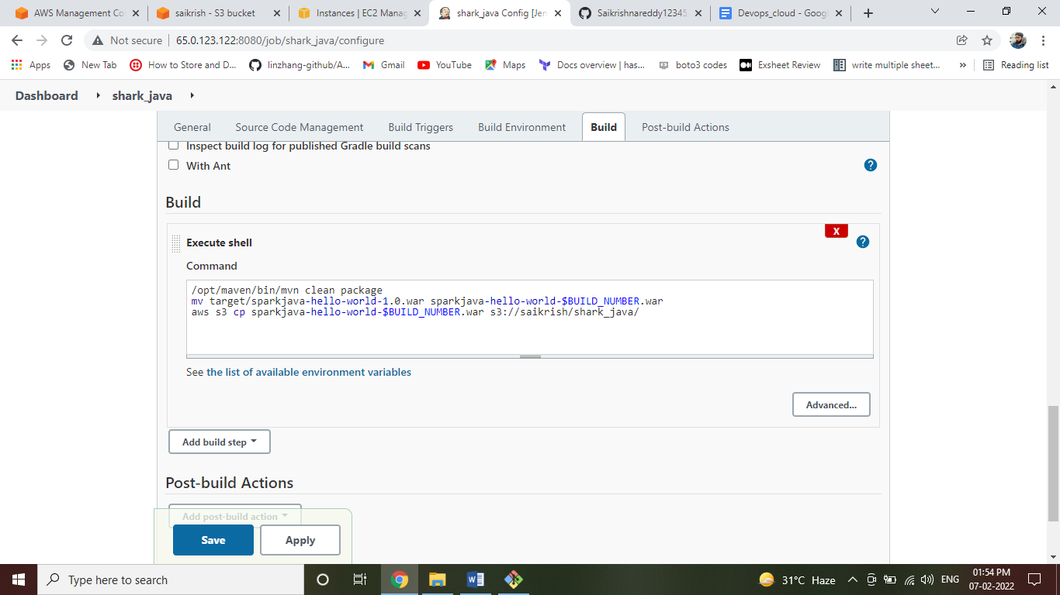
* Click on apply and save.
* Click on workspace and check the target folder.
* 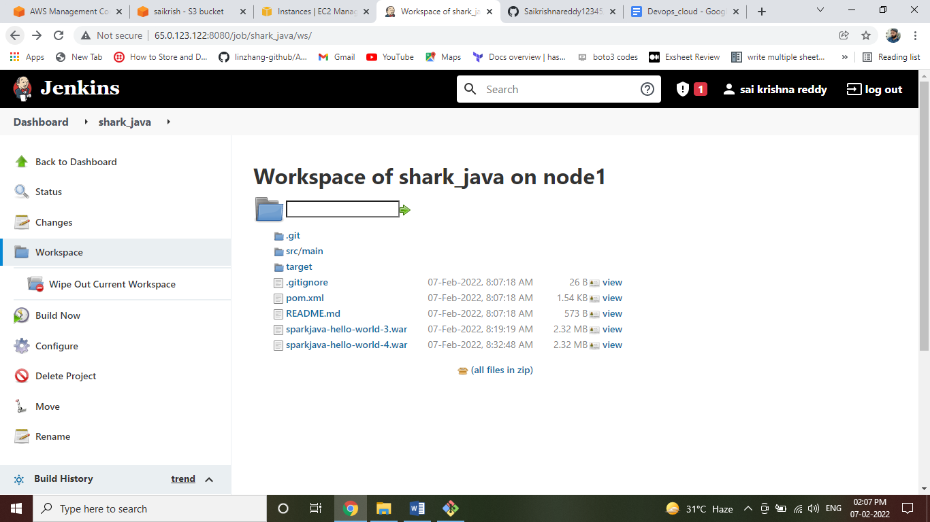
* Check artifactory whether the file is uploaded or not.
* 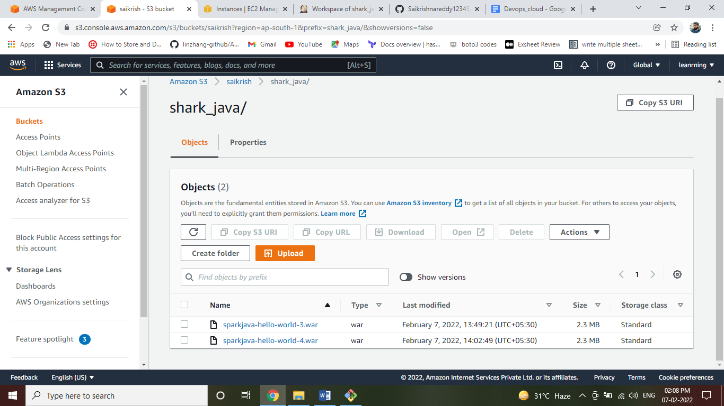

Deploy code from Artifactory to tomcat:-

---------------------------------------------------------

->create job as well as followed by above.

->in this job, avoid the source code management option.

->coming to Build Environment option select the Execution Shell🡪follow the below commands:

* rm -rf *
* aws s3 cp s3://saikrish/java_projects/spring-petclinic-$CHOICE.jar .
* ssh root@172.31.34.213 'rm -fr /opt/tomcat/webapps/*'
* scp spring-petclinic-$CHOICE.jar [root@172.31.34.213:/opt/tomcat/webapps/](mailto:root@172.31.34.213:/opt/tomcat/webapps/)
* 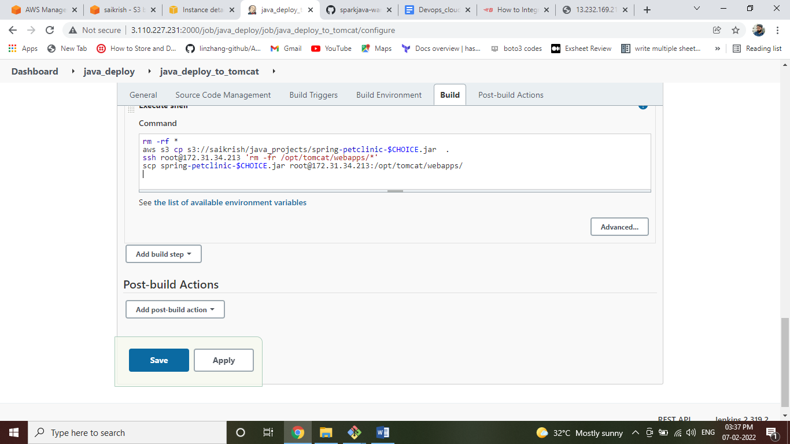

->access the tomcat page: like below

<http://13.232.169.218:8080/sparkjava-hello-world-8/hello>

**Java Deployment within one Job and triggered automatically:-**

🡪create job and add the github url.

🡪Select the Build triggers option select the Github hook trigger for GITscm polling.

🡪In Building Environment select Execution Shell. follow the below commands respectively.

* /opt/maven/bin/mvn clean package
* mv target/sparkjava-hello-world-1.0.war sparkjava-hello-world-$BUILD_NUMBER.war
* aws s3 cp sparkjava-hello-world-$BUILD_NUMBER.war s3://saikrish/shark_java/
* aws s3 cp s3://saikrish/shark_java/sparkjava-hello-world-$BUILD_NUMBER.war .
* ssh root@172.31.34.213 'rm -rf /opt/tomcat/webapps/*'
* scp sparkjava-hello-world-$BUILD_NUMBER.war [root@172.31.34.213:/opt/tomcat/webapps/](mailto:root@172.31.34.213:/opt/tomcat/webapps/)

🡪Access the Jenkins page: like this <http://13.232.169.218:8080/sparkjava-hello-world-8/hello>

🡪If you have any changes in SCM automatically I will build the job updated the url.