Visit the below link:

-----------------------

<https://help.talend.com/r/mup8qWz8cQ9XKNTAAN4~Tg/zOczPWm3KuUqQw78e5doMw>

follow the below commands simultaneously:

touch /etc/systemd/system/tomcat.service

chmod 664 /etc/systemd/system/tomcat.service

#(the script is available in the above link)

vim /etc/systemd/system/tomcat.service

#(copy the script in the above location which has given by above link)

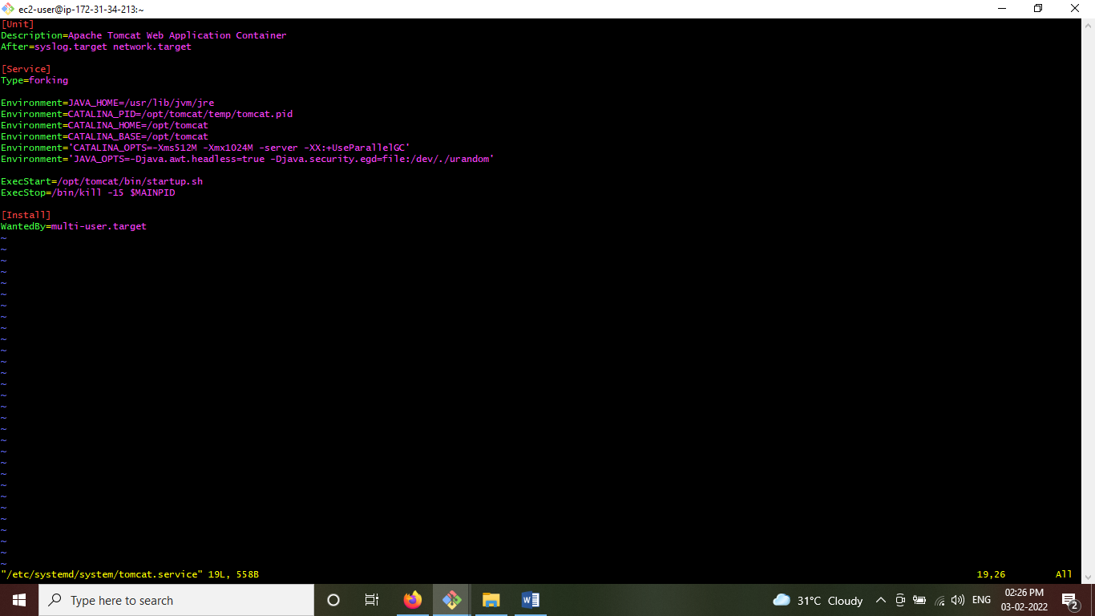

chmod 664 /etc/systemd/system/tomcat.service

systemctl daemon-reload

systemctl start tomcat.service

systemctl status tomcat

systemctl stop tomcat

systemctl status tomcat

systemctl start tomcat

systemctl status tomcat

systemctl stop tomcat

ps -ef | grep tomcat

systemctl start tomcat

systemctl status tomcat

ps -ef | grep tomcat

commands history:-

