Wordpress setup:

Follow the below commnds:-

yum install httpd -y

yum install php-mysql -y

amazon-linux-extras install php7.3 -y

cd /var/www/html/

wget http://wordpress.org/latest.tar.gz

tar -zxvf latest.tar.gz

systemctl enable httpd

systemctl start httpd

[Note:-if the page is not worked properly. Stop the pache,

And remove the php(cmd:-yum remove php\*),again install the php and start the apache server.]

Secondary commands If the wordpress UI is not worked properly:-

yum remove php\*

systemctl stop httpd

amazon-linux-extras install php7.3 -y

systemctl start httpd

mysql setup:

1)Fill the Details as shown below picture.

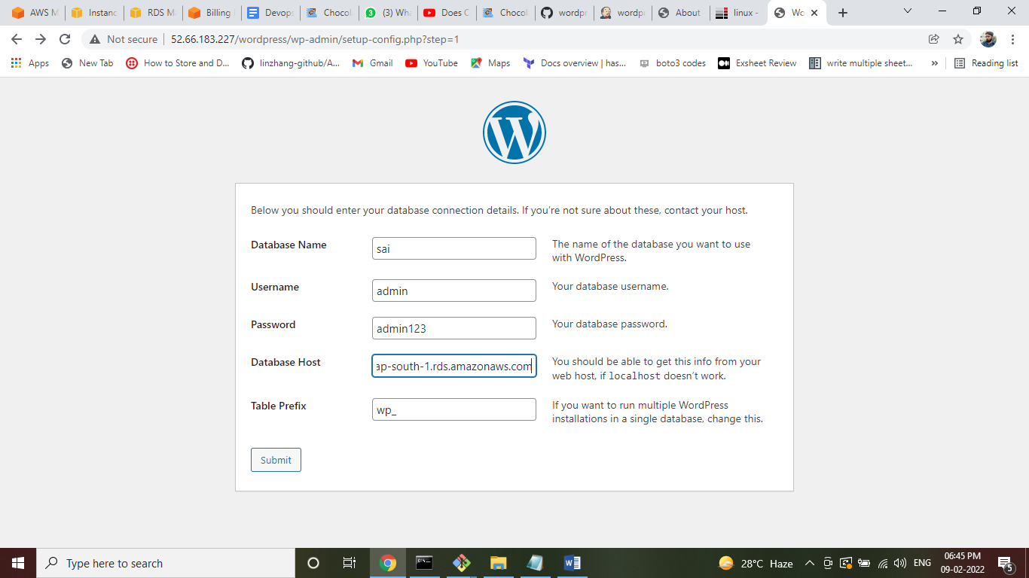

2)rename the file which is wp-config-sample.php as wp-config.php

And also replace the content of the wp-config.php file which is already generated by wordpress UI.

This data is comes after finishing of the above step.

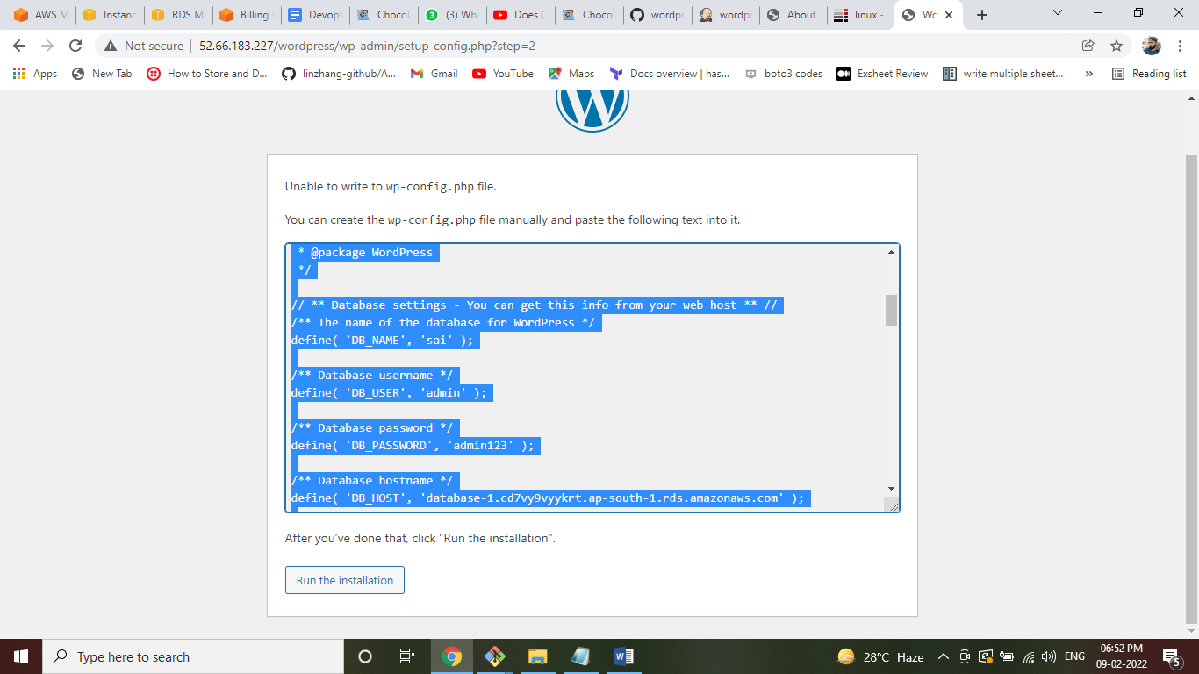  
3)Log into the wordpress.

