1. Launch one Linux instance in aws.

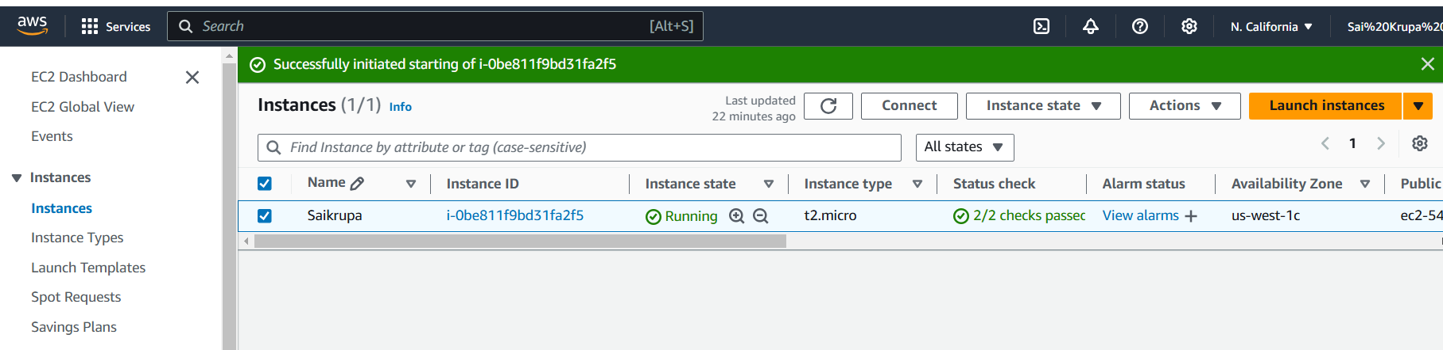

1. Create on file with name Techie_horizon

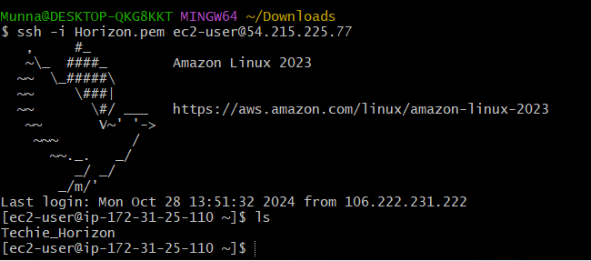

1. Copy the file "Techie_Horizon" from aws instance to windows machine.



1. Install Jenkins in the server created in step 1.

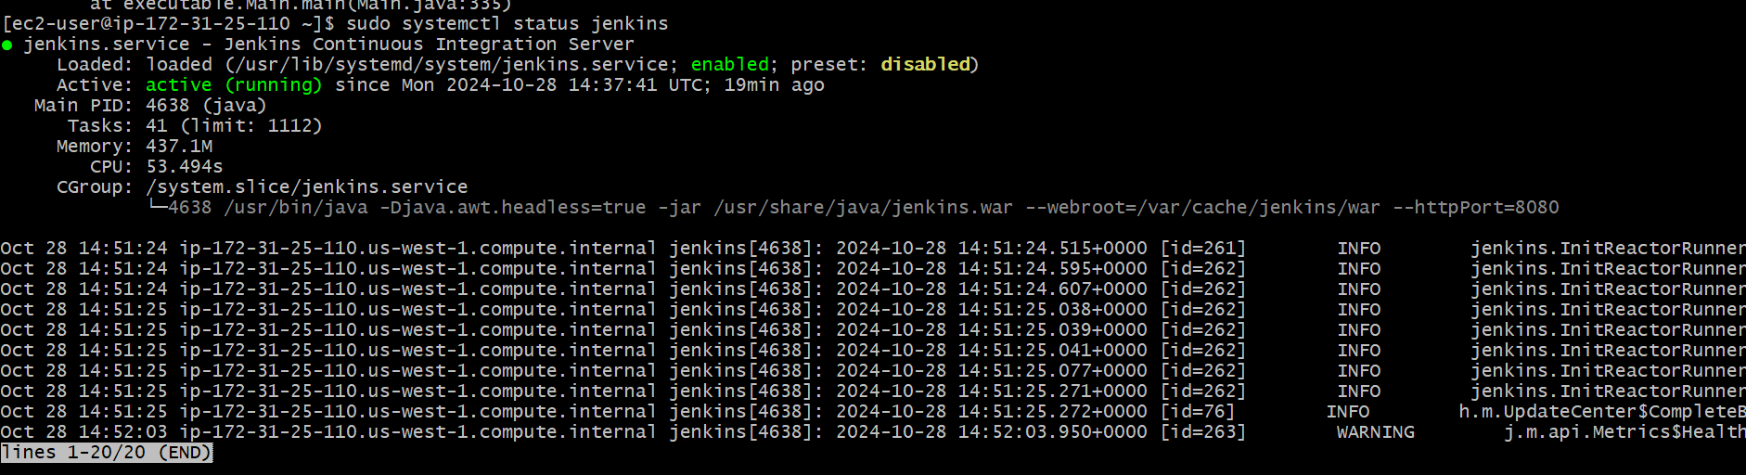

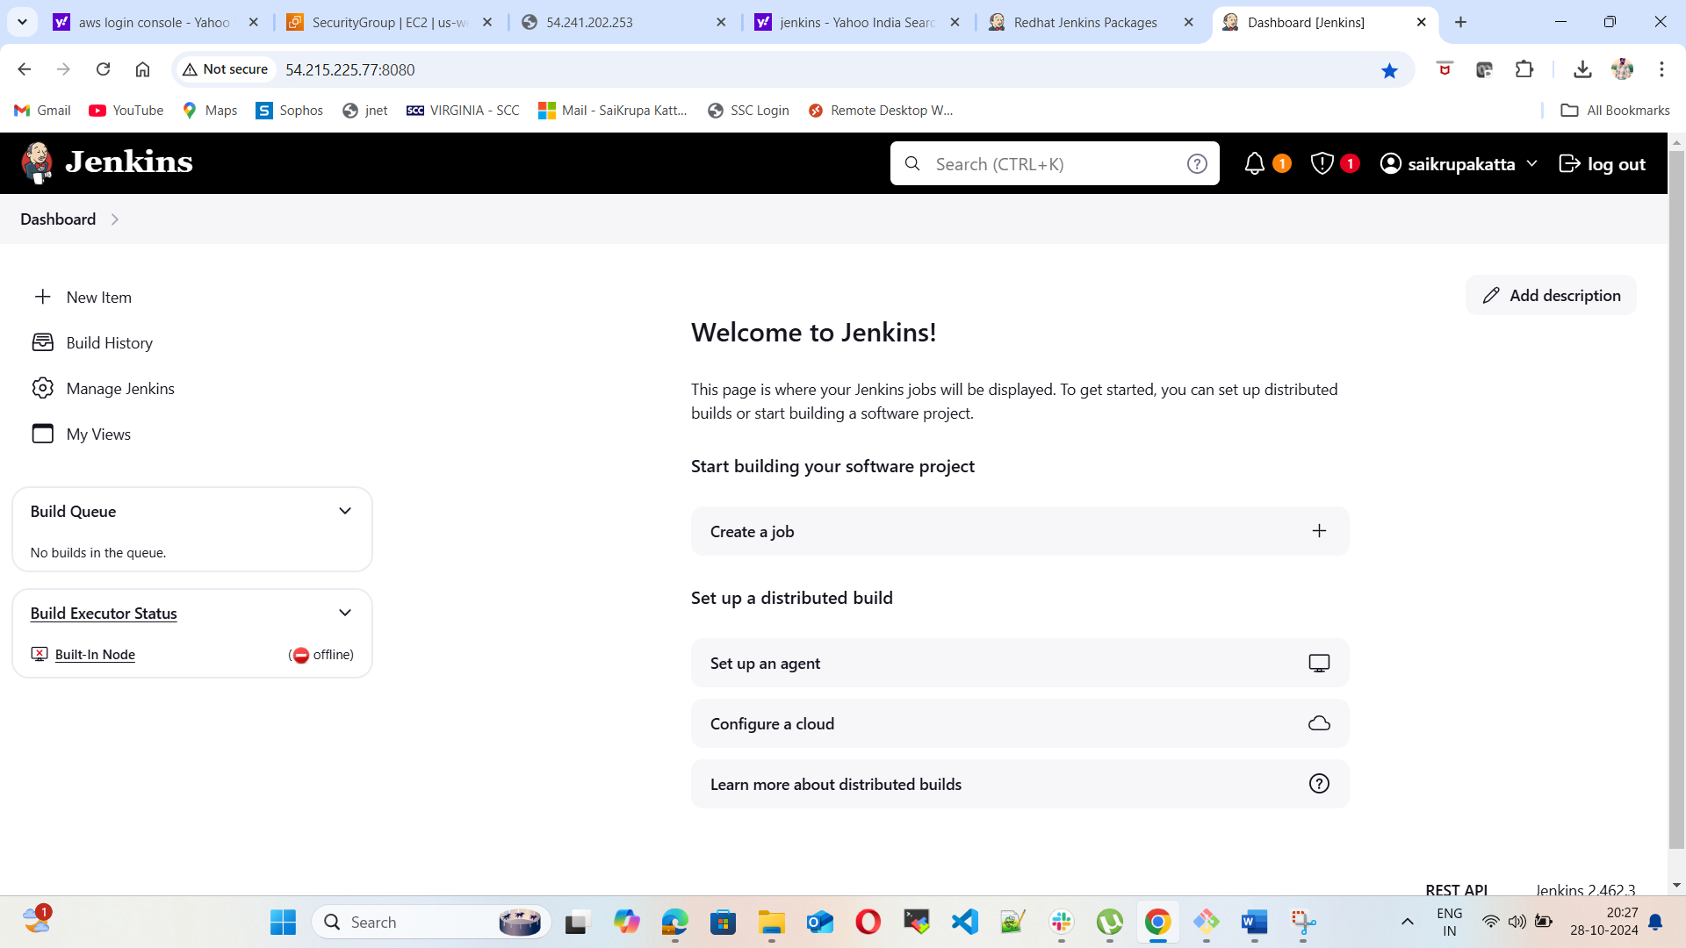

1. Install httpd,nginx,Apache Tomcat.

