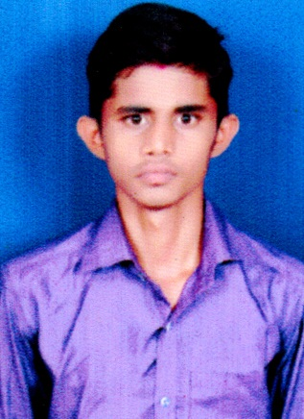**SANJEEVU SAI KUMAR**

**Email : sanjeevusaikumar63@gmail.com**

**Contact :** +91 7670964110

**LinkedIn** **:** <https://www.linkedin.com/in/sanjeevu-sai-kumar>-550b13250

**OBJECTIVE**

Aspiring for a challenging job at a reputable firm that will allow me to grasp the field of overall quality management of projects while also contributing to the organization’s growth and development.

**ACADEMIC QUALIFICATIONS**

|  |  |  |  |
| --- | --- | --- | --- |
| Academic Qualification | University/Board | Year | Percentage /CGPA |
| B.Tech. (IT) | JNTUGV | 2025 | 8.76 CGPA |
| Intermediate | Board of Intermediate Education,  AP | 2021 | 90.5% |
| SSC | Board of Secondary Education, AP | 2019 | 9.3 CGPA |

**TECHNICAL SKILLS**

**Programming :** Python, Java, C,C++

**Development :** HTML, CSS

**Database :** MySQL

**Operating Systems :** Windows

**PROJECT EXPERIENCE**

**Data analysis using python: |** Feb 2023 – Mar 2023

In this project, I have successfully completed Exploratory Data analysis of the famous IRIS Dataset

Using python as part of My Skill oriented courses at Aditya Institute of Technology Management.

**INTERNSHIP EXPERIENCE**

**Community Internship:**

This is mainly to find and resolve the problems in rural areas. There we find some technological issues and we resolve those by using our limited resources .

**CERTIFICATIONS**

* **Basics of python** issued by Infosys spring board.
* **Fundamentals of c** issued by Infosys spring board.

**CO CURRICULAR ACTIVITIES**

* Completed a Course on Python Fundamentals provided by Infosys.
* Participated in Query Designer held by our college.

**EXTRA CURRICULAR ACTIVITIES**

* An active member of Developers Club.
* Participated in Various Sports Meets held at village level.
* An active member of NSS.

**PERSONAL DETAILS**

**Father Name :** Sanjeevu Srinivasarao

**Date of Birth :** 21th June 2004

**Languages Known :** English, Telugu

**Hobbies/Interests :** Playing games, Blogging

**Address         :**  D/no- 1-45, Marripadu (Village), Marripadu (Post),

                            Santhabommali (Mandal), Srikakulam (District),

                            Andhra Pradesh (State), Pin code: 532211.

**Date:** 04/07/2023 

**Place:** Tekkali Signature