UNIX
(Version: 1.5)
Lab Book




Document Revision History

Date | Revision No. | Author | Summary of Changes
 | 1 | Veena Deshpande | New course creation
30-Sept-2009 | 2 | Kishori Khadilkar | Revamped as per new template
20-June-2011 | 3 | Rathnajothi Perumalsamy | Revamped as per Integrated syllabus
30-Sep -2013 | 4 | Amit Sali | Lab for SVN(subversion) is added.
9-Mar-2015 | 5 | Vishal Pachpute | Lab for AWK is added.

Table of Contents
Document Revision History 2
Table of Contents 3
Getting Started 4
Overview 4
Setup Checklist 4
Instructions 4
Learning More (Bibliography if applicable) 4
Lab 1. Connecting to the Unix Server 5
1.1: Connecting to the Unix Server 5
1.2: Logging out of the system 5
Lab 2. UNIX File System 6
2:1 Viewing the File System: 6
Lab 3. UNIX Basic Commands 7
3.1: Executing UNIX basic commands 7
Lab 4. I/O Redirection and Piping 10
4.1: Using Pipes and Filters: 10
Lab 5. Vi Editor 11
5.1: Working wth Vi Editor 11
Lab 6. Bash Shell 12
6.1: Working with shell 12
Lab 7. Access Permissions 13
Lab 8. Process 14
Lab 9. Essential Commands 15
Lab 10. Pattern Matching Using grep,egrep,fgrep 16
Lab 11. SED Commands 17
Lab 12. Miscellaneous Commands 18
Lab 13. AWK 19
Lab 14. Shell Script 19
14.1: Writing Shell-Scripts 19
Lab 15. Source Code Control System 22
15.1: Repository Creation 22
15.2: Initial Project Setup 22
15.3: Creating the working copy of project (Check out) 23
15.4: Modifying, updating, creating new file in the project 24
15.5: The lock-modify-unlock Cycle 25
11.6: <TODO> Working on SVN 25

Getting Started

Overview
This lab book is a guided tour for learning Unix. It comprises ‘To Do’ assignments. Follow the steps provided and work out the ‘To Do’ assignments.

Setup Checklist
Here is what is expected on your machine in order for the lab to work

Minimum System Requirements
- Intel Pentium 90 or higher (P166 recommended)
- Microsoft Windows 95, 98, or NT 4.0, 2k, XP.
- Memory: 32MB of RAM (64MB or more recommended)

Please ensure that the following is done:
- A text editor like Notepad is installed.
- Participants should be able to connect to UNIX server through telnet (IP address : 192.168.224.34)

Instructions
- For all coding standards refer Appendix A. All lab assignments should refer coding standards.
- Create a directory by your name in drive <drive>. In this directory, create a subdirectory html_assgn. For each lab exercise create a directory as lab <lab number>

Learning More (Bibliography if applicable)
- UNIX Concepts and Application by Sumitabha Das
- The Unix Programming Environment", by Kernighan and Pike.
- UNIX Primer Plus, Third Edition. Don Martin, Stephen Prata, Mitchell Waite, Michael Wessler, and Dan Wilson
- Advanced Unix : a programmer's guide / Stephen Prata

Connecting to the Unix Server

Goals | - Learn to connect to the Unix server  - Learn to log out of the Unix server
Time | 15 min

1.1: Connecting to the Unix Server
Step 1: Enter your login name and password to login to the UNIX system.

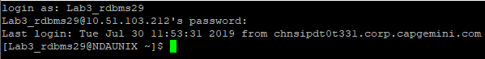

1.2: Logging out of the system
Step 1: Type the exit command at $ prompt or else, press ctrl and d together to log out.

1.3: Change your password
$ passwd
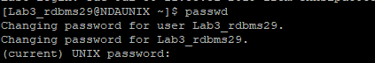

1.4: Unix Architecture
1. Draw the architecture of UNIX operating system
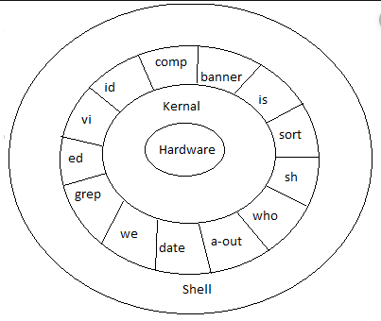

2. Describe above various components in brief.a

Unix is an Operating System which is truly the base of all Operating Systems like Ubuntu, Solaris, POSIX, etc.

- Layer-1: Hardware –
It consists of all hardware related information.

- Layer-2: Kernel –
It interacts with hardware and most of the tasks like memory management, task scheduling, and management are done by the kernel.

- Layer-3: Shell commands –
Shell is the utility that processes your requests. When you type in a command at the terminal, the shell interprets the command and calls the program that you want.
There are various commands like cp, mv, cat, grep, id, wc, nroff, a.out and more.
- Layer-4: Application Layer –
It is the outermost layer that executes the given external applications.

UNIX File System

Goals | - Learn to grant and to remove permissions and to view the file system
Time  Lab Setup | 15 min  Telnet with Unix Server

2.1: Viewing the File System and Granting/Removing Permissions

(Note: Create required files if doesn’t exists.)
$ls –l
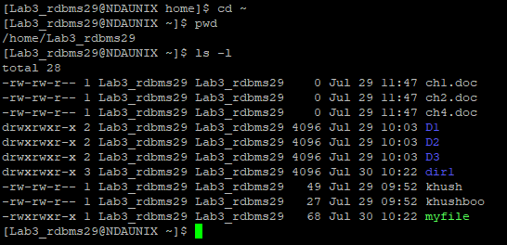

2.2: Change the directory to root directory. Check the system directories, like bin, etc, usr etc
$ cd $ ls -l
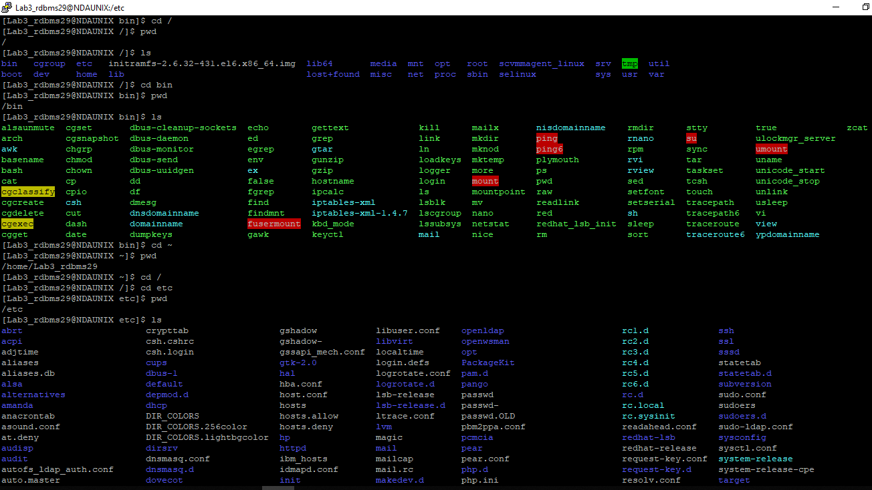

Lab 3. UNIX Basic Command

Goals | - Learn to use basic Unix commands
Time  Lab Setup | 100 min  Telnet with Unix Server

3:1 Executing basic commands:
- To display the current working directory, the command is:
pwd
The output is as follows.
/home/trg1

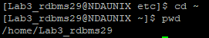

- Display the path to and name of your HOME directory.
$ cd ~
$ pwd
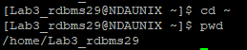

- Display the login name using which you have logged into the system
$whoami
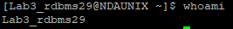

- Display the hidden files of your current directory.
$ ls -a

- List the names of all the files in your home directory.
$ cd ~
$ pwd
$ ls
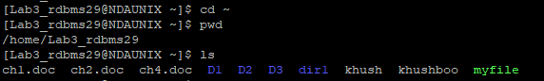

- Using the long listing format to display the files in your directory.

$ cd ~
$ pwd
$ ls -la
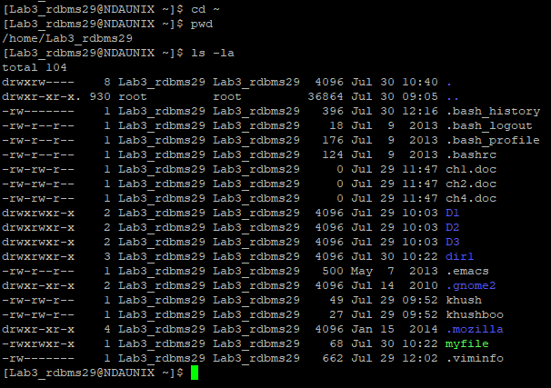

- List the files beginning with chap followed by any number or any lower case alphabet. (Example, it should display all files whose names are like chap1, chap2, chap3 ……., chapa,ahapb,chapc,……..)

- ls chap*
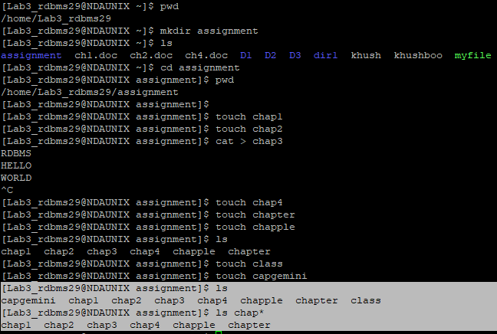

- Give appropriate command to create a directory called C_prog under your home directory. (Note: Check the directory using ls)
$ mkdir C_prog
$ ls
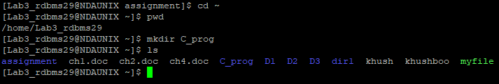

- Create the following directories under your home directory. (Note: Check using ls)
newdir
newdirectory
$ cd ~
$ mkdir newdir newdirectory
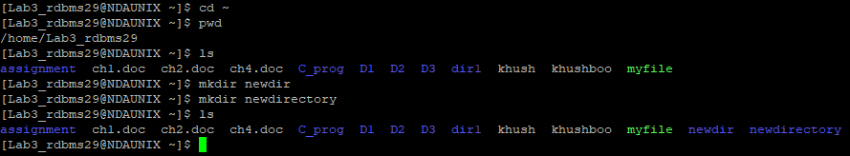

- List the names of all the files, including the contents of the sub directories under your home directory.
$ ls -R
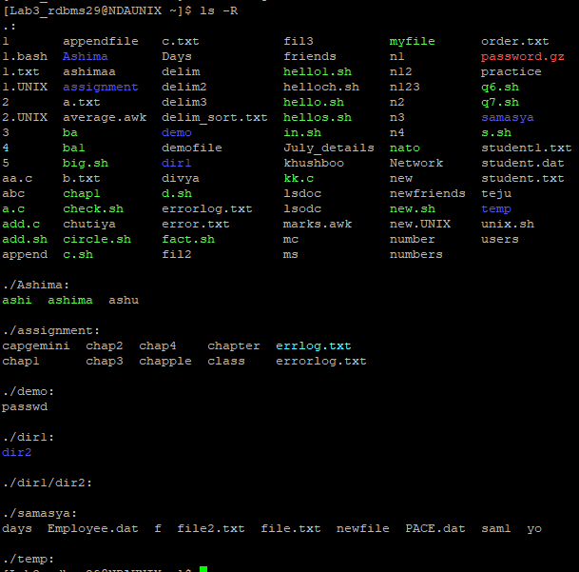

- Remove the directory called newdirectory from your working directory.
$ rmdir newdirectory
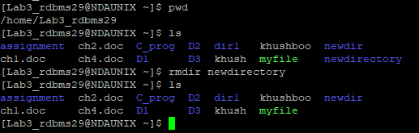

- Create a directory called temp under your home directory.
$ mkdir temp
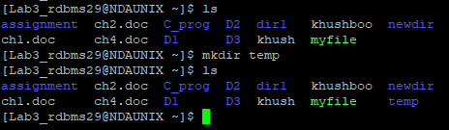

- Remove the directory called newdir under your home directory and verify the above with the help of the directory listing command.
$rmdir newdir
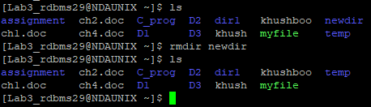

- Create another directory directorynew under the temp directory.
$ mkdir directorynew
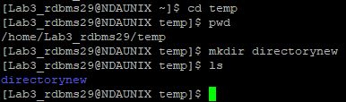

- Change the directory to your home directory.
$ cd ~
$ pwd
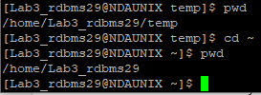

- From your home directory, change the directory to directorynew using relative and absolute path.
ABSOLUTE PATH:
$ cd /home/Lab3_rdbms29/temp/directorynew

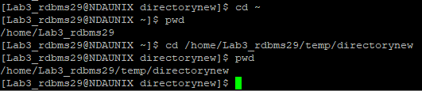

RELATIVE PATH:
$ cd temp/directorynew

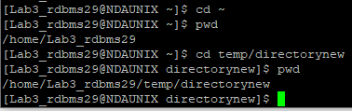

- Remove the directory called c_prog, which is in your home directory.
$ rmdir C_prog
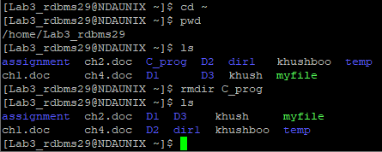

- Change to the directory /etc and display the files present in it.

$ cd ~
$ cd /etc

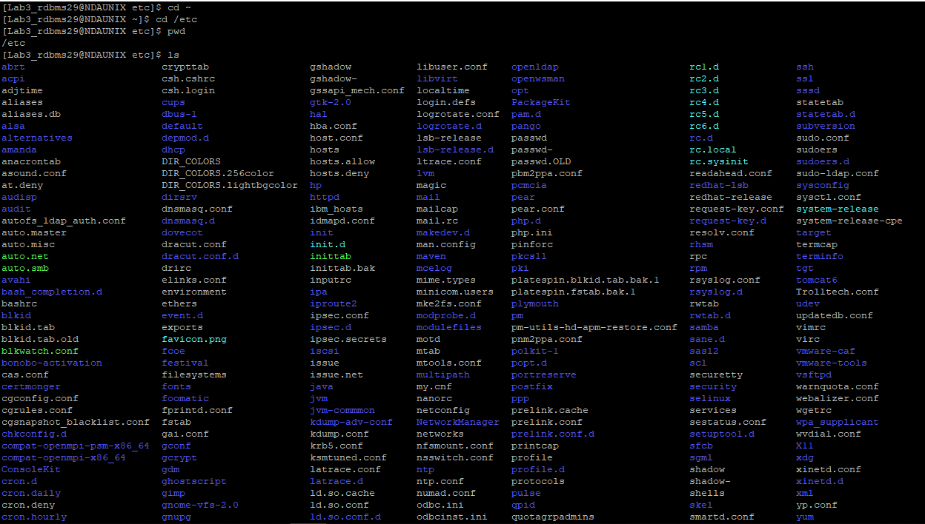

- List the names of all the files that begin with a dot in the /usr/bin directory.
$ cd /usr/bin $ls .* | more
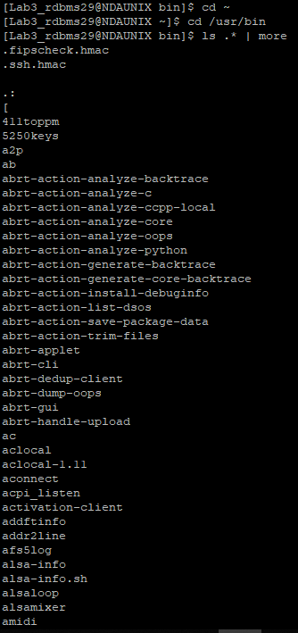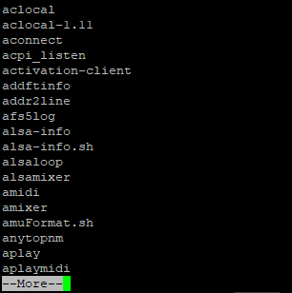
- Create a file first.unix with the following contents.
$ cat first.unix
Hi! Good Morning everybody.
Welcome to the First exercise on UNIX.
Hope you enjoy doing the assignments.
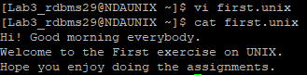

- Copy the file first.unix in your home directory to first.unics.
(Note: checked using ls, first.unix file also should exist along with first.unics)
$ cp first.unix first.unics
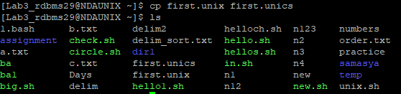

- List the contents of first.unix and first.unics with a single command.
$ cat first.unix first.unics
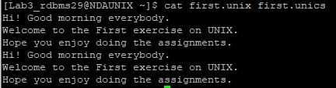

- Create a new directory under the temp directory.
$ mkdir newdir
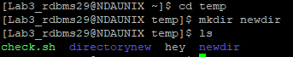

- From your home directory, copy all the files to the directory created under the temp sub directory.
$ cp * /home/Lab3_rdbms29/temp/newdir
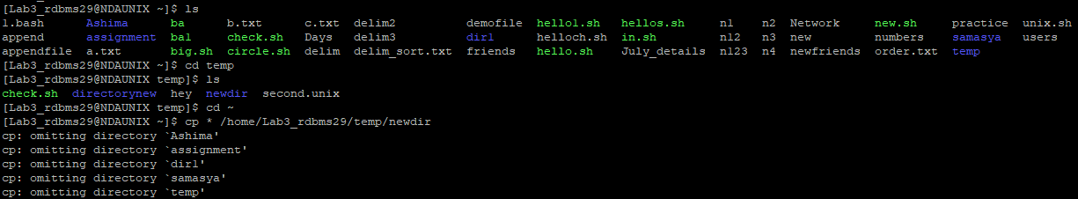

- Move the file first.unix to the directory temp as second.unix
$ mv first.unix temp/second.unix
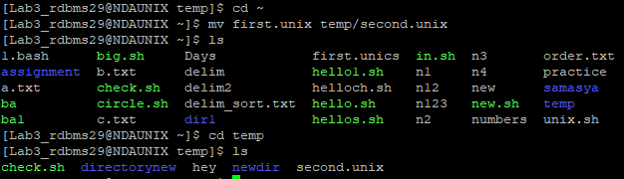

- Remove the file called first.unics from the home directory.
$ rm first.unics
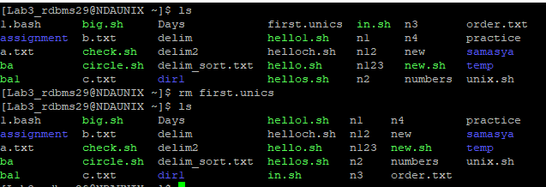

- Change your directory to temp and issue the command rm *. What do you observe?
$ rm *
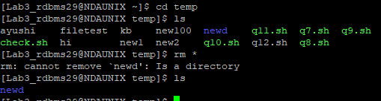

- Move all files whose names end with a, c and o to the HOME directory.
$ mv *[aoc] /home/Lab3_rdbms29
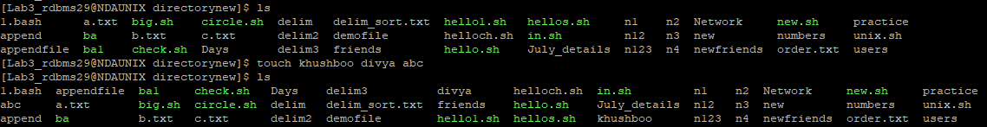
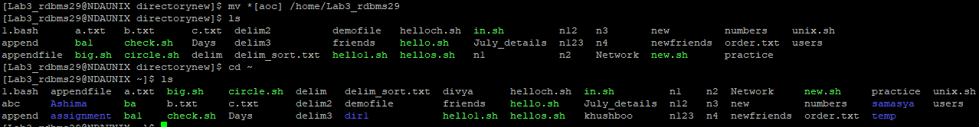

- Copy all files that end with a ‘UNIX’ to the temp directory.
$ cp *.UNIX temp
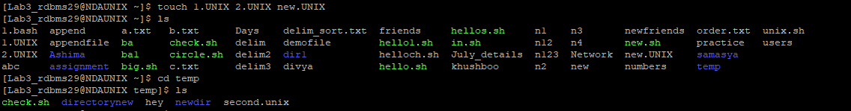
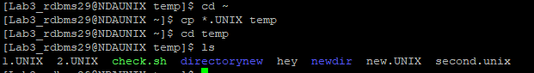

- Issuing a single command, remove all the files from the directory temp and the directory itself.
$ rm -R
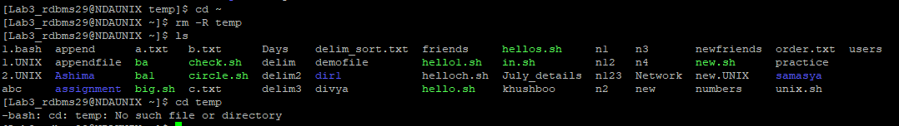

- Try commands cp and mv with invalid number of arguments and note the results.
$ cp Days copy1 copy2 copy3
$ mv Days copy1 copy2 copy3
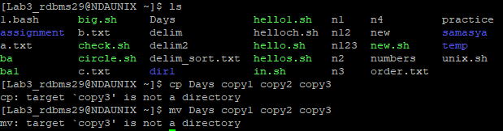

- Use the cat command to create a file friends, with the following data:
Madhu 6966456 09/07/68
Jamil 2345215 08/09/67
Ajay 5546785 01/04/66
Mano 7820022 09/07/68
David 8281292 09/09/60
Simmi 7864563 12/12/70
Navin 2224311 30/05/68
The fields should be separated by a tab.
$ cat > friends
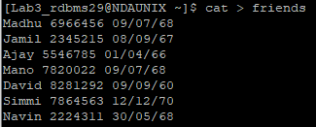

- Display contents of the file friends.
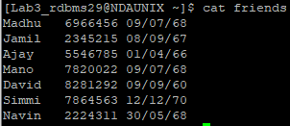
- Copy contents of friends to newfriend without using the cp command.
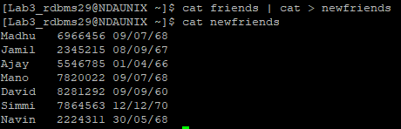

- Display contents of the file friends and newfriends in a single command.
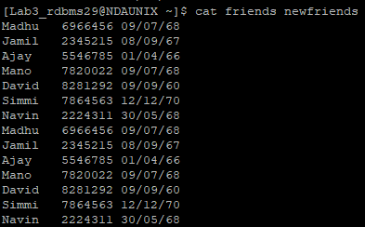

- Find all users currently working on the system and store the output in a file named as users.
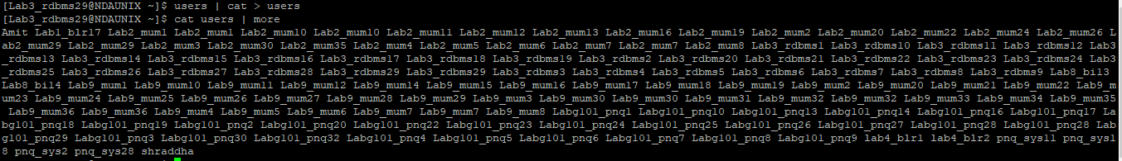

- Append contents of friends file to the file, users.
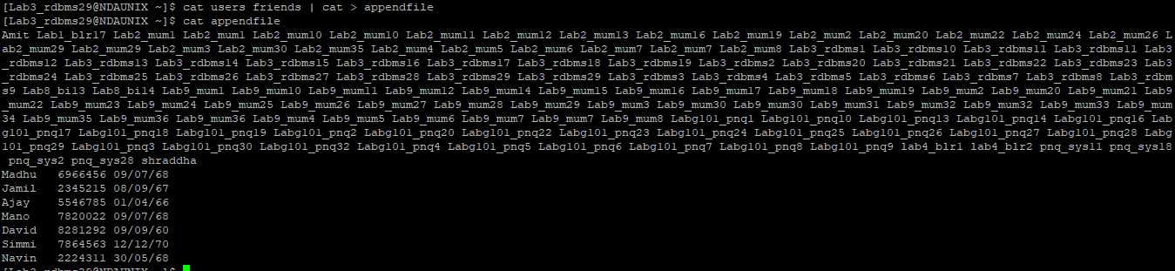

- Display current system date and time and record your observations. How is the time displayed?
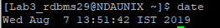

- Display calendar for the month and year of your birth.
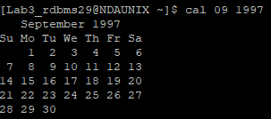

- Try following commands and record your observations.
date “+ %”
date “+%m”
date “+%D”
date “+%/%Training Activity”
date “+%Training Activity”
date “+%r”

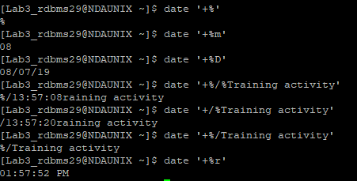

Lab 4 . I/O redirection and Piping
Goals | - Learn to use Pipes & I/O in UNIX
Time  Lab Setup | 45 min  Telnet with Unix Server

4.1: Using Pipes and Filters:

1: Redirect the content of the help document ls, into a file called as lsdoc. 2: Display the content of the lsdoc page wise.
man ls > lsdoc

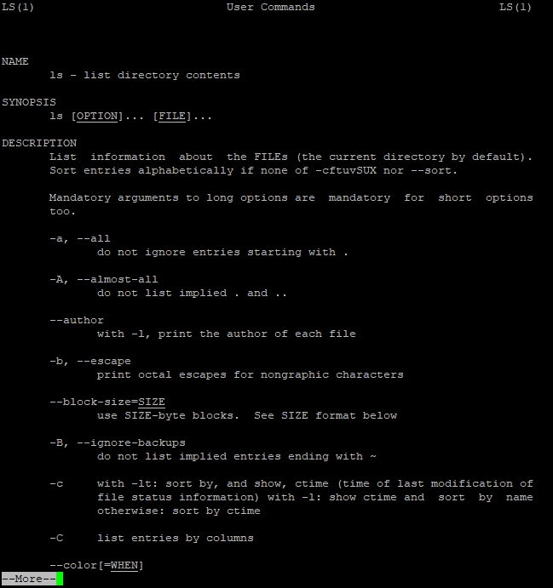

2: Display the content of the lsdoc page wise.
solution;
cat lsdoc | less
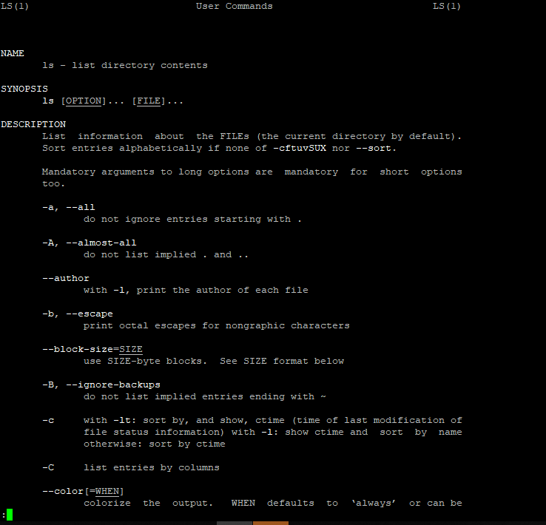

3: Create a file data.txt using input redirection.
cat friend > data.txt

4: Display data.txt.
solution:
cat data.txt
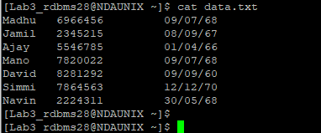

5: Remove the file data.txt.
solution:
rm data.txt
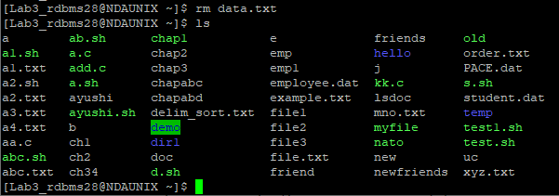

6: Use error redirection to display data.txt, if any error stores it in errorlog.txt
solution:
cat data.txt 2> errorlog.txt

7: Display errorlog file.
solution:
cat errorlog.txt
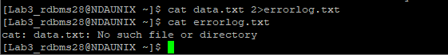

Lab 5 .Vi Editor

Goals | Work with Vi Editor in Unix
Time  Lab Setup | 30 min  Telnet with Unix Server

5.1: Working wth Vi Editor
- Create a file using Vi. Enter the following text:
A network is a group of computers that can communicate with each other, share resources, and access remote hosts or other networks. Netware is a computer network operating system designed to connect, manage, and maintain a network and its services. Some of the network services are Netware Directory Services (NDS), file system, printing and security.

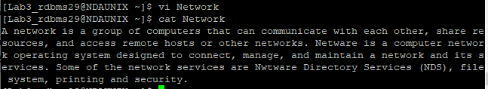

- Change the word “Netware” in the second line to “Novell Netware”.
:s/Netware/Novell Netware/
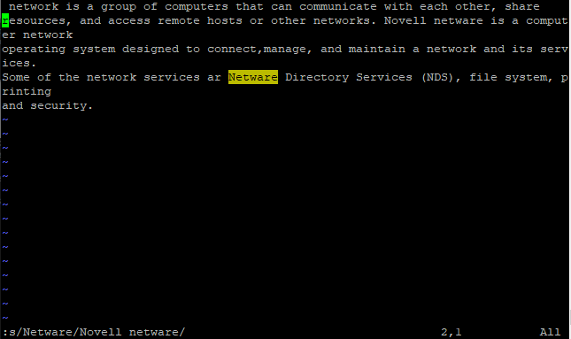

- Insert the text “(such as hard disks and printers)” after “share resources” in the first line.
solution:
s/share resources /&(such as hard disks and printers)
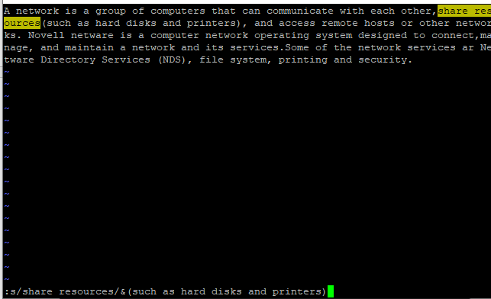

- Append the following text to the file:
“Managing NDS is a fundamental administrator role because NDS provides a single point for accessing and managing most network resources.”
solution:
:s/$/ Managing NDS is a fundamental administrator role because NDS provides a single point for accessing and managing most network resources.: Create the data files, used in the previous lab sessions using vi editor.

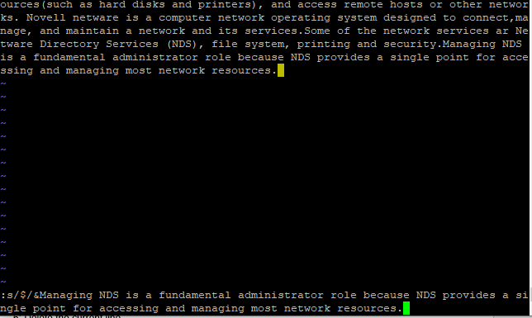

Lab 6 .Bash Shell

Goals | Understanding Shell
Time  Lab Setup | 30 min  Telnet with Unix Server

6.1: Working shell
Type some text on the shell separated by space
1: Move cursor one word back
H is used to move cursor one word back.

2: Move cursor one word forward
L is used to move cursor one word forward.

3: Move cursor to the first character
I is used to Move cursor to the first character

4: Move cursor to the end
A is used to move cursor to end

5: Delete the current line
dd is used to delete the current line.

3: Display history of command used so far.
$ history | more

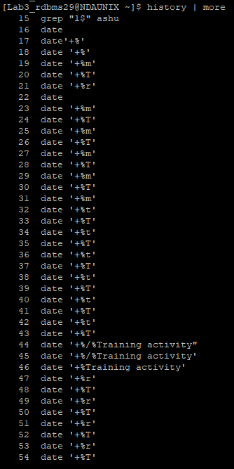

4: Search ls command in history file
$ history | grep ‘ls’
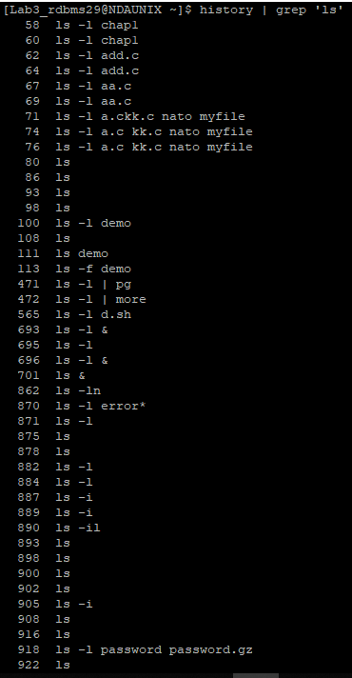

5: Repeat the last command

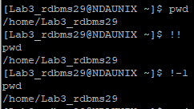

6: Execute 3rd command from history file.

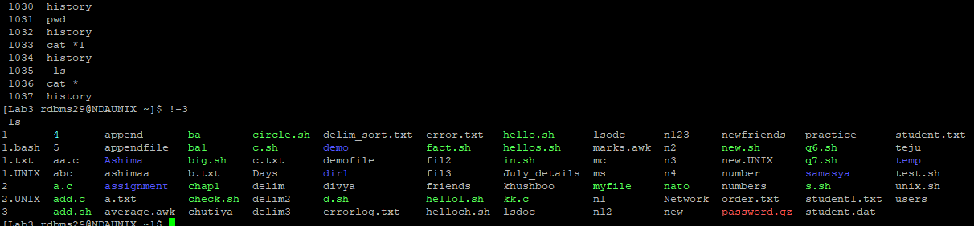

7: What are the different shells available.

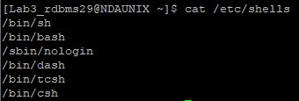

Lab 7 .Access Permission

Goals | Understanding access permission
Time  Lab Setup | 50 min  Telnet with Unix Server

7.1: Create an empty file “demofile” and perform following instruction
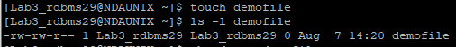

- Revoke read permission from owner and use cat command.
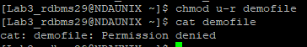

- Revoke write permission from owner and open using vi editor and add some contain in it.
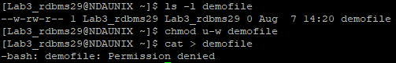

- Add read and write permission to owner.
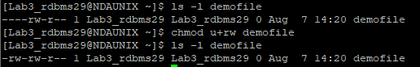

- Revoke write and execute from other and group

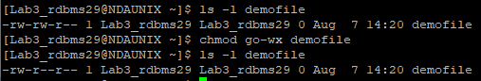

- Add write permission to group only

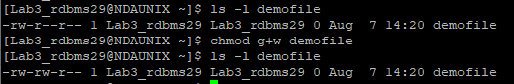

- Assign read permission to all

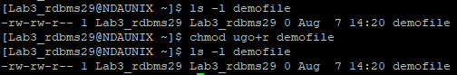

- Revoke read permission from others

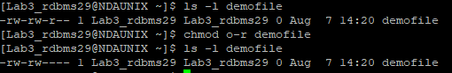

- Give the execute permission for the user for a file chap1
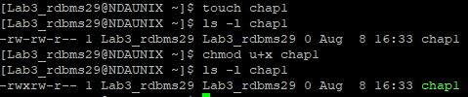
- Give the execute permission for user, group and others for a file add.c
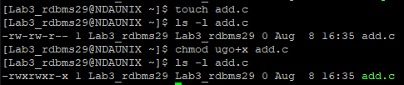
- Remove the execute permission from user, give read permission to group and others for a file aa.c
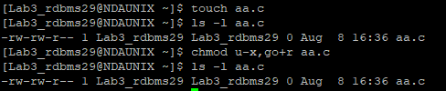

- Give execute permission for users for a.c, kk.c, nato and myfile using single command
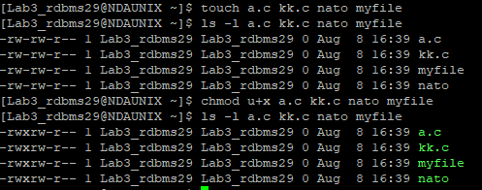

7.2: Create an directory “demo” and copy /etc/passwd file in it

- Display contents of demo

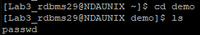

- Delete passwd file from demo directory

Lab 8 .Process

Goals | Understanding process
Time  Lab Setup | 60 min  Telnet with Unix Server

8.1: Using Process-Related Commands
- Find out the PID of the processes that are activated by you

ps
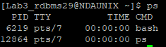

- Find out the information about all the processes that are currently active
ps –u
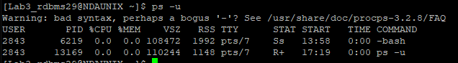

- Start a different process in the background. Find out the status of the background process using the PID of the same.
ls –l &
ps 7856
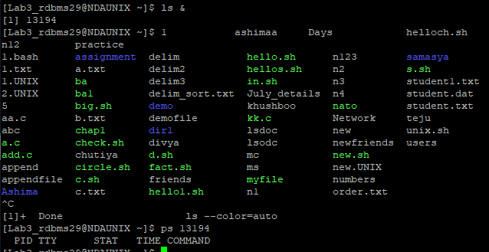

- Run a job in background
ping www.google.com &
ps

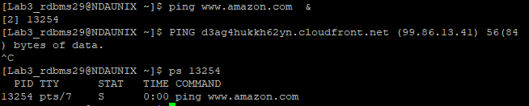

- Bring a last background job in fore ground
fg
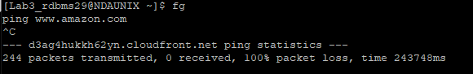

- Run 3 jobs in background and bring first job in foreground
ping www.google.com &
ping www.yahoo.com &
ping www.amazon.com &
ps
fg %1

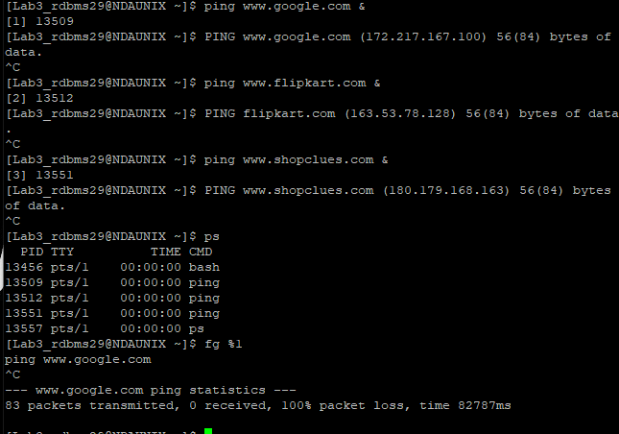

- Stop current job
Ctrl + z

- Start stopped job
Bg

- Run a job
ping www.amazon.com &
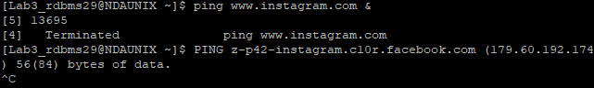

- Kill last job

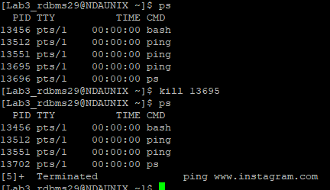

Lab 9 .Essential Command

Goals | Understanding commands
Time  Lab Setup | 30 min  Telnet with Unix Server

9.1: Some more commands
1. Check the file type using “file” command on directory and errorlog file

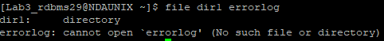

- Search for a file name as “errorlog.txt”

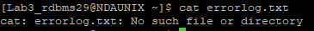

3: Search for a file name “demo”

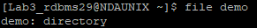

3. Create a file “student.txt” as follows

name marks grade
ramesh 79 A+
suresh 88 A++
rajat 25 C
suraj 65 A
manoj 55 B
rahul 87 A++
manoj 56 B
suraj 45 B

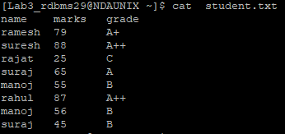

- Sort according to student name

tail -8 student.txt | sort

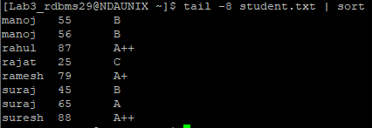

- Sort on 3rd character of name

tail -8 student.txt | sort -k1.3

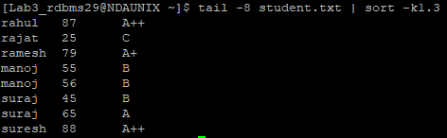

- Display data sorted as per the marks

tail -8 student.txt | sort -k2n

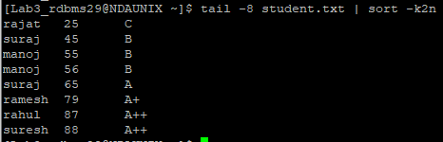

- Sort data based on 1st and 3rd column

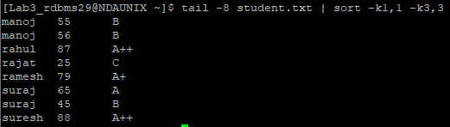

- Display duplicate names

$ tail -8 student1.txt | cut -d' ' -f1 | sort | uniq -d

- Display uniq names

$ tail -8 student1.txt | cut -d' ' -f1 | sort | uniq -u

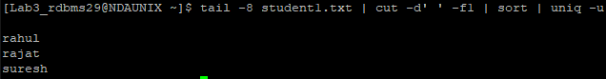

$ tail -8 student1.txt | cut -d' ' -f1 | sort –u

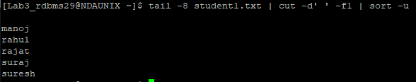

Lab 10 . Pattern Matching Using grep,egrep,fgrep
Goals | Understanding grep family
Time  Lab Setup | 50 min  Telnet with Unix Server

10.1: Create a file student.dat with following data

name surname marks grade
rameshchandra mane 79 A+
suresh bahrti 88 A++
rajat bhosle 25 C
suraj pancholi 65 A
manoj sharma 55 B
rahul varma 87 A++
manoj pandey 56 B
suraj rajguru 45 B

- Display all names starting with s

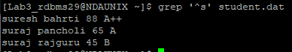

- Display whose name ending with e or i

$ cut -d' ' -f1 student.dat | egrep [ei]$

- Display who got 65 marks

$ grep "65" student.dat

- Display data of records whose surname is Sharma or Varma

$ egrep 'sharma|varma' student.dat

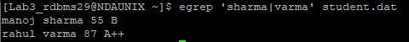

- Display who got grade A only

$ egrep 'A$' student.dat

- Display whose 3rd character of name is r

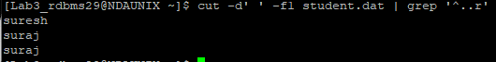

- Display whose second character is a or r or t

$ tail -8 student.dat | cut -d' ' -f1 | grep ^.[art]

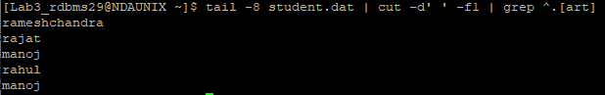

- Display names whose length is exactly 5 character.

$ grep '^.....[ ]' student.dat | cut -d' ' -f1

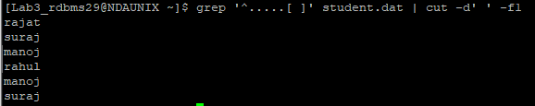

- Display names whose length is more than 6 character

$ cut -d' ' -f1 student.dat | grep '.......'

- Display name whose marks are ending with 6

$ cut -d' ' -f1-3 student.dat | grep '6$'

- Display grade with A+ only

Lab 11 . SED Commands

Goals | Learn to use SED Commands in Unix
Time  Lab Setup | 45 min  Telnet with Unix Server

11.1: Using SED Commands
- Create a file “Employee.dat” with text as follows.

James 76382 PACE Chennai
John 34228 GRIT Hyderabad
Peter 22321 GE Bangalore
Albert 32342 GRIT Pune
Mathew 23222 PACE Mumbai
Richard 23232 ACS Pune

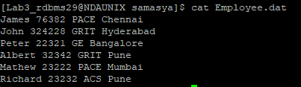

- Write a sed command to print only the lines starting at line 2 and ending with the letters “Pune”
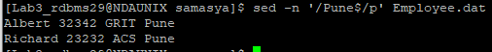

- Write a sed command that will display the top 5 lines from the file

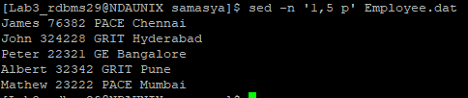

- Write a sed command that will substitute the word “Chennai” for "Pune" used in all instance of the word
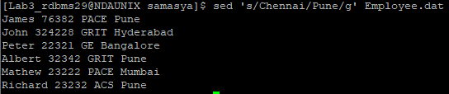

- Write a sed command that will replace occurrence of the character e with the string UNIX in all lines. (Use –e option)

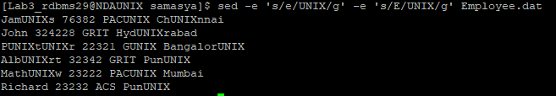

- Write a sed command to delete blank lines
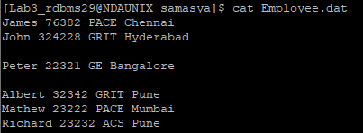
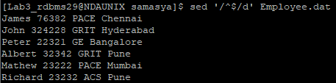

- Write a sed command to delete lines from 3 to 5
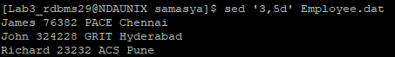

2: Create a new file “PACE.dat which has only the lines that contain the word “PACE” from Employee.dat
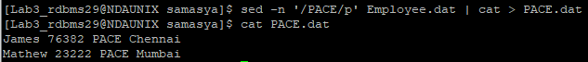

Lab 12 . Miscellaneous Commands

Goals | Commands ,filters and compression in Unix
Time  Lab Setup | 50 min  Telnet with Unix Server

11.1: Create an alias to ls –s
alias KHUSHBOO=’ls –l’ 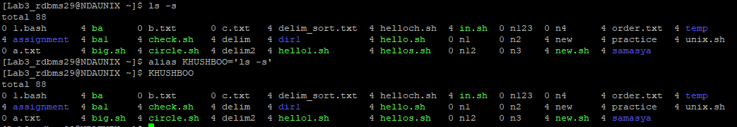

11.2: Display all alias in a session
alias
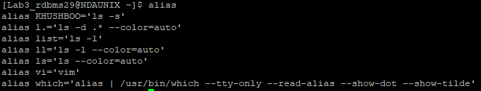

11.3: Remove an alias which we have created in 11.1
unalias KHUSHBOO
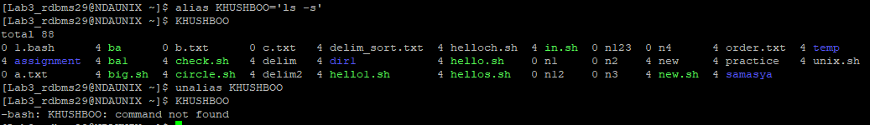

11.4 Display the count of people currently login in system
who | wc -c

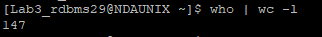

11.5: Display your own user login details
whoami

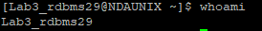

11.6: Display two file contain separated by deliminator “:” using paste command
Paste –d’:’ Days numbers

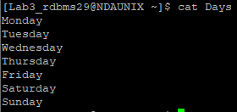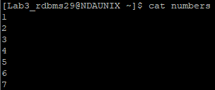
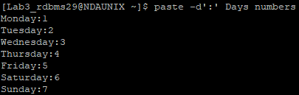

11.7: Display first 5 lines o file /etc/passwd file
cat /etc/passwd | head -3

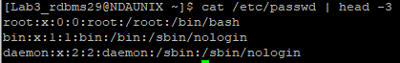

11.8.: Display all lines except last 3 lines from file /etc/passwd

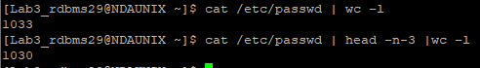

11.9: Display last 20 lines from file /etc/passwd.
cat /etc/passwd | tail -20
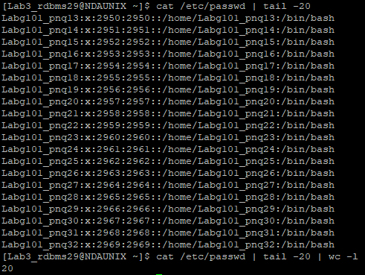

11.10: Display 7th line only from /etc/passwd file
cat /etc/passwd | sed –n ‘7p’

11.12: What is the difference between find and locate.

locate uses a prebuilt database, which should be regularly updated, while find iterates over a file system to locate files. Thus, locate is much faster than find , but can be inaccurate if the database -can be seen as a cache- is not updated (see update db command).

11.13: Perform addition, subtraction, multiplication and division using bc command.
a=100
b=50
echo $a + $b | bc
echo $a - $b | bc
echo $a \* $b | bc
echo $a / $b | bc

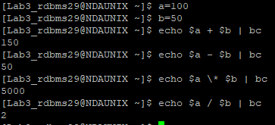

11.14: Display addition of two values using expr command

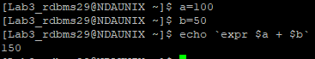

11.15: Display factors of 20

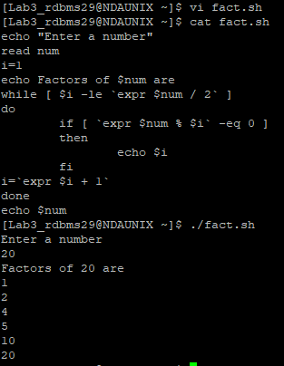

11.16: Create one hard link to an errorlog.txt file and one soft link to errorlog.txt file.
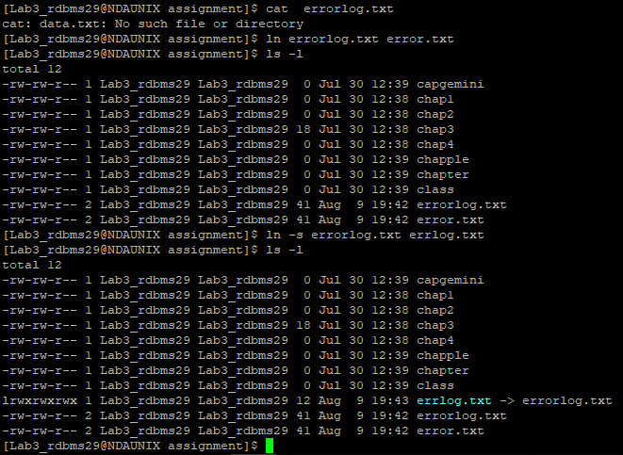

11.17: Now display inode number of hard link, soft link and errorlog.txt file

$ ls -i

11.18 Delete errolog.txt and display contents using hard link. Then delete hard link.

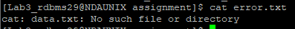

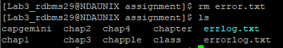

11.19 Display contents using soft link.

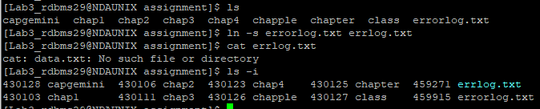

11.20: Copy /etc/passwd file in your home directory. Check the size .Compress the file using compress and pack and check the size of it.

$ cp /etc/passwd password
$ gzip password
$ ls -l password.gz

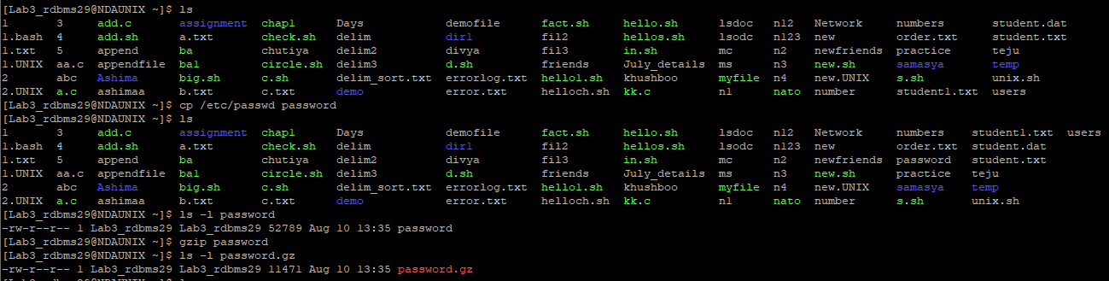

11.21: Check the disk size.

$ df

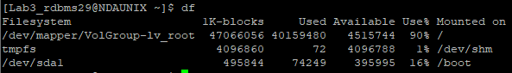

Lab 13 . AWK

Goals | Learn to write awk scripts
Time  Lab Setup | 90 min  Telnet with Unix Server

13.1: Writing awk-Scripts
1. Consider the results are stored in following format:

EmpID Name Subject Marks(/50)
E001 Nilesh Unix 30
E002 Nilesh DSA 20
Like these you have 10 records ( 5 of DSA and 5 of Unix)
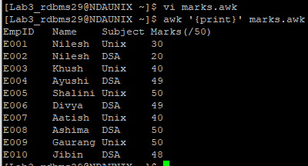
Calculate the avg score secured in Unix and DSA and the first 2 topers in Unix and DSA each.
echo Average score is:
awk -F'\t' '$3=="Unix"{x+=$4;} $3=="DSA"{y+=$4}END{print "Unix: "x "\nDSA: "y}' marks.a
echo Toppers in Unix are:
awk -F'\t' '/Unix/' marks.awk | sort -rnk4 | head -2
echo Toppers in DSA are:
awk -F'\t' '/DSA/' marks.awk | sort -rnk4 | head -2
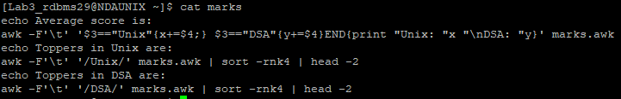
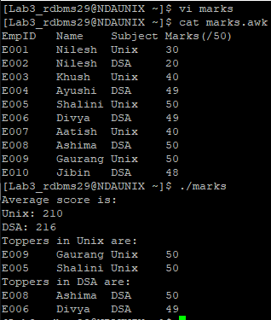

3. Consider a text file containing the records (colon separated fields) in the format:

EmpName:EmpId:Subject:ObtMarks:TotMarks:Result
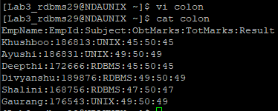
Write a script to get the result of “UNIX” Subject in the format (Considering the data file has TotMarks=50 for UNIX)
EmpName:ObtMark:MarksOutof35

$ awk -F: 'BEGIN{print "EmpName:ObtMark:MarksOutof35"} '/UNIX/' {printf "%-s:%d:%d\n", $1,$4,$6/50*35}' colon
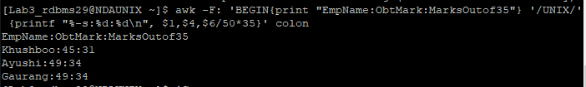
The header of the report must contain total marks and the tailor must specify the percentage result for that subject.
$ awk -F: 'BEGIN{print "\ntotal marks = 35 \nEmpName:ObtMark:MarksOutof35"} '/UNIX/' {printf "%-s:%d:%d\n", $1,$4,$6/50*35}''/UNIX/ {x+=$6;}END{print "Percentage is " (x/((NR-4)*50))*100}' colon

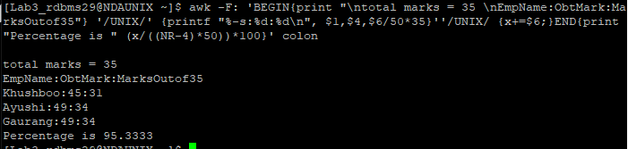
Also generate another summary result containing total number of participants appeared, total number of participants passed, and Name of the participants ranked Ist IInd, IIIrd with their total score.

4 Consider the Arizona roaster as an input data file for this exercise. Using any combination of the text-processing utilities listed below, write a one-line shell command that performs each of the following tasks
- reports the number of players on the roster
$ awk 'END{print NR}' 1.awk
- displays the roster in order by jersey number
$ awk '{print $0}' | sort 1.awk
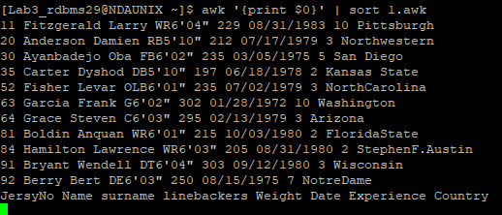
- displays the roster in alphabetical order by surname
$ awk '{print $0}' | sort -k3 1.awk
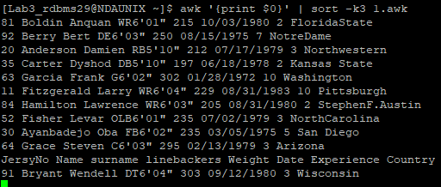
- displays the heaviest five players
$ tail -n+2 1.awk |awk '{print $0}' | sort -rk5 | head -5
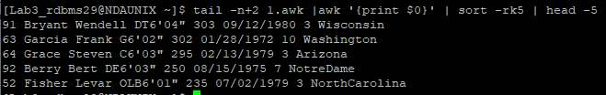
- displays all players who attended Wisconsin
The Roaster is given below:-

JersyNo|Name,surname |linebackers|Weight | Date | Experience| Country
20 | Anderson, Damien |RB 5'10" | 212 | 07/17/1979 | 3 |Northwestern
30 | Ayanbadejo, Oba |FB 6'02" | 235 | 03/05/1975 | 5 |San Diego
92 | Berry,Bert |DE6'03" | 250| 08/15/1975 | 7 |NotreDame
81 | Boldin,Anquan |WR6'01" |215 | 10/03/1980 |2 | FloridaState
91 | Bryant,Wendell |DT6'04" |303| 09/12/1980 | 3 | Wisconsin
35 | Carter,Dyshod |DB5'10" |197 | 06/18/1978 |2 | Kansas State
52 | Fisher,Levar |OLB6'01" |235 | 07/02/1979 |3| NorthCarolina
11 | Fitzgerald,Larry |WR6'04" |229| 08/31/1983 |10 |Pittsburgh
63 |Garcia,Frank |G6'02" | 302| 01/28/1972|10|Washington
64 |Grace,Steven |C6'03" |295| 02/13/1979 | 3|Arizona
84 |Hamilton,Lawrence |WR6'03" |205 |08/31/1980 |2|StephenF.Austin
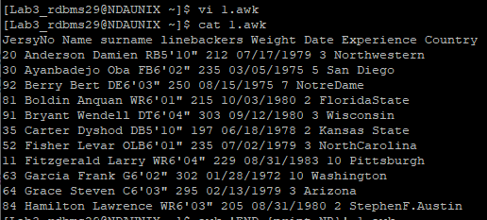

Lab 14. Shell Script

Goals | Learn to write simple shell scripts
Time  Lab Setup | 300 min  Telnet with Unix Server

14.1: Writing Shell-Scripts
- Display the Primary and Secondary prompt. Change the primary prompt to your name: temporarily

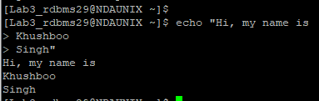

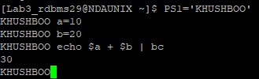

2: As soon as you login, the prompt should be changed to your name: also the name of the home directory should be automatically displayed.

3: Check the content of the Environmental variable SHELL.

4: Try the below exercise and check the output.

Note: Type every line and press enter, do not type the entire code in a vi editor.

$continent=”Africa”
$echo “$continent”
----------→ Africa
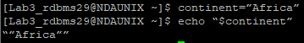

$sh
$echo “$continent”
------------→ No Response
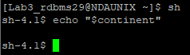

$continent=”Asia”
$echo “$continent”
------------→ Asia
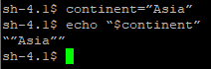

$ctrl + d
$echo “$continent”
------------→ Africa

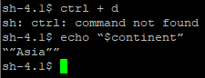

$sh
$echo “$continent”
------------→ No Response
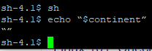

$ctrl + d
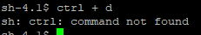

5: Try the below exercise and check the output. (Export variables)

Note: Type every line and press enter, do not type the entire code in a vi editor.

$continent=”Africa”
export continent
$echo “$continent”
------------→ Africa
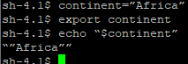
$sh
$echo “$continent”
------------→ Africa
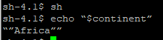

$continent=”Asia”
$echo “$continent”
------------→ Asia
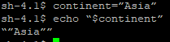

$ctrl + d
$echo “$continent”
------------→ Africa
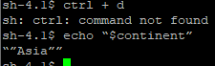

6: Write a shell script that takes the user name as input and reports whether he / she has logged in or not.

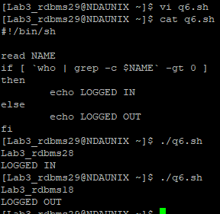

7: Write a shell script to display the file name and its contents of all the files that is there in the current directory.

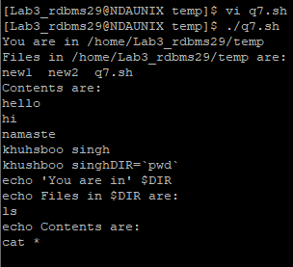

8: Write a shell script, which will take a file name as argument and check whether the file exists and display its access permissions for user.

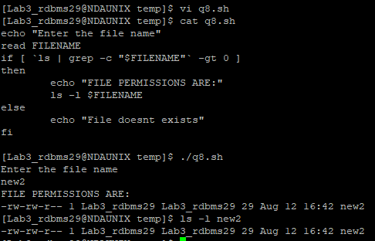

9: Pass three numbers as command line arguments and display the largest number in the given three numbers.

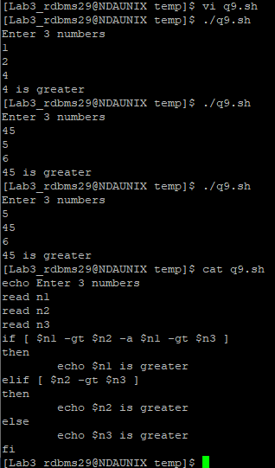

10: Write a shell script which will accept a pattern and a file name. The pattern will be searched in the file provided. Display appropriate messages and perform necessary validations on file.

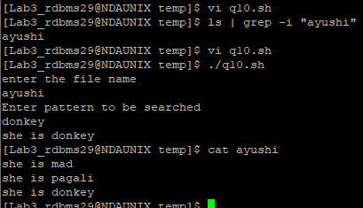

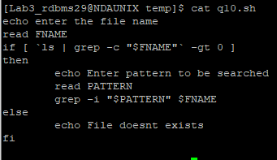

11: To create a menu program for
a) creating a file,
b) Creating a directory,
c) copying a file,
d) moving a file. (use functions)
  - If the file exists already give the appropriate message
  - If the dir exists already give the appropriate error message
  - Source file should exist if not give a message, It should have read permission if not another message, Destination file either there or not, if not there then create it and copy it. If there, then ask whether to overwrite or not, if yes then overwrite it or else give a message file exists already and not overwritten.

12: Write a function yesno() to display question to user and accept answer as y/n. If answer to the question is y the function should return 0 otherwise 1.
Use yesno functions for asking different questions. Question will be passed as parameter to the function.
Accept filename from user check whether it is file or directory. Use yesno() function to display question do you really want to delete file? If the ans is y, then delete the file or directory.

13: Write a shell script to store names of four employees and check whether those employees are currently logged in or not. Display appropriate message.

14: Accept the user's first and last name and the echo the entire name along with some suitable comment.
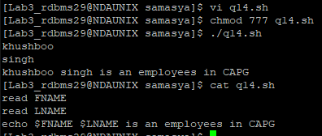

15: List all files that have been modified today.

16: Display long listing of only the regular files in the current directory.

17: Display details of all files in the 2 “paths” accepted from user. The display should be screen by screen.
18: Let the script display its name and its PID.

19: Get the concatenated o/p of 2 files into a third file: Take 3 command line arguments: The first argument is the name of a destination file, and the other two arguments are names of files whose contents are to be placed in the destination file.

Stretched Assignments:

20: Write a menu driven shell program to:
a. Display calendar of current month
- Search for a pattern in all the files/subdirectories from current directory.
- Count the no. of directories / sub directories in current directory

21: Display day of week for a given date. (ddmmyyyy)
If day is Monday, display message “Monday Blues”
Friday display message “yeh! It’s week end.”
Similarly display different messages for each day of the week.

22: Display the contents of all .lst files in the current directory.

23: Design a simple calculator, which will add/subtract/multiply/divide 2 numbers.
eg. cal 10 20 + will give o/p as 30.

24: For a student file with the following fields, rollno, name, marks, Generate 2 files ‘Pass’ and ‘Fail’ containing records of student who have passed or failed. Also count the number of students who have passed or failed.

25: Accept a date string from terminal and display employees born after the input date.

Lab 15 .Source Code Control System

Goals | - Learn the concept of version management  - Understand the steps involved in version management using SVN as a tool
Time  Lab Setup | 90 min  Linux Operating System and SVN client

11.1: Repository Creation
This is a Linux Administrator task and assumes that he has created the repository at location “/home/demo_project_repository”.

11.2: Initial Project Setup
Option 1: Using System administrator/ Normal User (If the project is newly started)
Creating a folder
[root@pace ~]# svn mkdir file:///home/demo_project_repository/Analysis -m "Creating Project Analysis directory"

Committed revision 1.

Deleting a folder
[root@pace ~]# svn rm file:///home/demo_project_repository/Analysis -m "Removing Project Analysis directory"

Committed revision 2.

Checking log file
[root@pace ~]# svn log file:///home/demo_project_repository
----------------------------------------------------------------
r2 | root | 2013-09-30 09:47:17 +0530 (Mon, 30 Sep 2013)| 1 line
Removing Project Analysis directory
----------------------------------------------------------------
r1 | root | 2013-09-30 09:46:49 +0530 (Mon, 30 Sep 2013)| 1 line
Creating Project Analysis directory
----------------------------------------------------------------

Option 2: Using client (if the directory structure of project is already defined)
Note: - This activity is call project import
Initial project directory structure at client side
[testuser1@pace project]$ tree -a
.
|-- Analysis
| |-- ReadMe.txt
| `-- Software_Requirement_Specification.docx
|-- Coding
|-- Design
| |-- High_Level_Design_1.2.docx
| `-- Low_Level_Design_1.2.docx
|-- Query_Tracking_Sheet
|-- Testing
| `-- test_case-lv1.0.xls
`-- Timesheet

Importing the Initial Project to Repository
[testuser1@pace project]$ svn import /home/testuser1/project file:///home/demo_project_repository -m 'Initial import'
Adding /home/testuser1/project/Query_Tracking_Sheet
Adding /home/testuser1/project/Coding
Adding /home/testuser1/project/Analysis
Adding /home/testuser1/project/Analysis/Software_Requirement_Specification.docx
Adding /home/testuser1/project/Analysis/ReadMe.txt
Adding /home/testuser1/project/Timesheet
Adding /home/testuser1/project/Design
Adding /home/testuser1/project/Design/High_Level_Design_1.2.docx
Adding /home/testuser1/project/Design/Low_Level_Design_1.2.docx
Adding /home/testuser1/project/Testing
Adding /home/testuser1/project/Testing/test_case-lv1.0.xls

Committed revision 3.

The project was imported to the SVN, now delete the local directories

11.3: Creating the working copy of project (Check out)
Login to the client, go to the folder where working copy is to be created and fire the following commands
[testuser2@pace project]$ ls -a
. ..
[testuser2@pace project]$ svn checkout file:///home/demo_project_repository
A demo_project_repository/Query_Tracking_Sheet
A demo_project_repository/Analysis
A demo_project_repository/Analysis/Software_Requirement_Specification.docx
A demo_project_repository/Analysis/ReadMe.txt
A demo_project_repository/Coding
A demo_project_repository/Timesheet
A demo_project_repository/Design
A demo_project_repository/Design/High_Level_Design_1.2.docx
A demo_project_repository/Design/Low_Level_Design_1.2.docx
A demo_project_repository/Testing
A demo_project_repository/Testing/test_case-lv1.0.xls
Checked out revision 3.
[testuser2@pace project]$ tree ./demo_project_repository
./demo_project_repository
|-- Analysis
| |-- ReadMe.txt
| `-- Software_Requirement_Specification.docx
|-- Coding
|-- Design
| |-- High_Level_Design_1.2.docx
| `-- Low_Level_Design_1.2.docx
|-- Query_Tracking_Sheet
|-- Testing
| `-- test_case-lv1.0.xls
`-- Timesheet

11.4: Modifying, updating, creating new file in the project
Login to the client, go to the folder where working copy is stored, do the changes and fire the following commands
[testuser2@pace demo_project_repository]$ cd Analysis
[testuser2@pace Analysis]$ touch SignOff.doc
[testuser2@pace Analysis]$ touch Open_Item.doc
[testuser2@pace Analysis]$ vi ReadMe.txt
[testuser2@pace Analysis]$ svn status
? SignOff.doc
? Open_Item.doc
M ReadMe.txt
[testuser2@pace Analysis]$ cd ..
[testuser2@pace demo_project_repository]$ svn add Analysis/SignOff.doc Analysis/Open_Item.doc
A Analysis/SignOff.doc
A Analysis/Open_Item.doc
[testuser2@pace demo_project_repository]$ svn commit -m 'User Confirmation Document Added'
Adding Analysis/Open_Item.doc
Sending Analysis/ReadMe.txt
Adding Analysis/SignOff.doc
Transmitting file data ...
Committed revision 4.

11.5: The lock-modify-unlock Cycle
Login to the client with user1, go to the folder where working copy is stored, lock the file on which user1 want to work
[testuser1@pace demo_project_repository]$ svn lock Analysis/ReadMe.txt -m "Locking a File for Change"
'ReadMe.txt' locked by user 'testuser1'.

Login to the client with user2, go to the folder where working copy is stored, try to change the same file which has been locked by user1.
[testuser2@pace demo_project_repository]$ cd Analysis
[testuser2@pace Analysis]$ vi ReadMe.txt
[testuser2@pace Analysis]$ svn commit -m 'User Confirmation Document Added'
Sending Analysis/ReadMe.txt
Transmitting file data .svn: Commit failed (details follow):
svn: User testuser2 does not own lock on path '/Analysis/ReadMe.txt' (currently locked by testuser1)

Now user1 can either perform the changes in the file and commit it (This will automatically release the lock) or just unlock the file so that user2 will start working on it.
[testuser1@pace demo_project_repository]$ svn unlock Analysis/ReadMe.txt
'ReadMe.txt' unlocked.

Now user2 can perform the changes and commit it.
[testuser2@pace Analysis]$ svn commit -m 'User Confirmation Document Added'
Sending Analysis/ReadMe.txt
Transmitting file data .

