Unleashing the potential of our youth:student performance analysis

1.INTRODUCTION

The potential of our youth is a force to be reckoned with. They possess the energy, creativity, and passion that can drive our societies towards a brighter future. However, this potential often remains untapped, hindered by various obstacles and limited opportunities. It is crucial for us to unleash the potential of our youth, as their contributions are vital in shaping our world.

The youth of today are faced with countless challenges, including high rates of unemployment, inadequate access to quality education, inequality, and a lack of resources. These obstacles prevent them from realizing their full potential and hinder their ability to thrive. As a result, they may become disillusioned, disengaged, or even resort to negative behaviors.

By unleashing the potential of our youth, we empower and equip them with the necessary tools and opportunities to succeed. Investing in their education, providing mentorship, and creating platforms for their voices to be heard are crucial steps towards unlocking their talent and potential. Additionally, promoting entrepreneurship, innovation, and social change among young people can foster a culture of empowerment and enable them to make a positive impact on society.

Unleashing the potential of our youth is not only beneficial for individuals, but also for the overall development and progress of our communities and nations. When given the proper resources and support, young people can become drivers of economic growth, agents of social change, and catalysts for innovation. Their fresh perspectives, open-mindedness, and willingness to take risks can tackle longstanding issues and bring about much-needed transformation.

Furthermore, empowering our youth instills a sense of purpose and belonging, fostering their personal growth and well-being. By creating a nurturing environment that values their ideas, talents, and aspirations, we cultivate a generation of confident, resilient, and responsible individuals who are ready to take on the challenges of the future.

In conclusion, unleashing the potential of our youth is not only a moral imperative but also a strategic investment for a brighter future. Through providing them with the necessary tools, opportunities, and support, we can harness their incredible energy, creativity, and passion to build more inclusive, prosperous, and sustainable societies. Let us empower our youth and pave the way for a world where their potential knows no bounds.

Purpose:

The purpose of unleashing the potential of our youth is to empower and support the younger generation in reaching their full capabilities and making a positive impact on the world.

By providing them with opportunities, resources, and guidance, we aim to nurture their talents, skills, and passions, helping them grow into confident and successful individuals.

This not only benefits the youth themselves but also contributes to the overall development and progress of society as a whole

LITERATURE SURVEY

In order to unleash the potential of our youth, it is crucial to provide them with a diverse range of opportunities and resources. One powerful tool in this regard is literature. Conducting a literature survey can offer our youth numerous benefits and contribute to their overall development. Here are some key offerings that a literature survey can provide:

1. Broadening knowledge: Literature exposes young individuals to a wide array of ideas, cultures, perspectives, and experiences. It helps expand their understanding of the world and promotes cultural literacy.

2. Fostering critical thinking: Reading and engaging with literature encourages youth to analyze and interpret text, develop their own opinions, and think critically about the issues and themes presented in the books. This ability to think critically is a valuable skill in all areas of life.

3. Enhancing empathy and understanding: Literature often portrays diverse characters and their struggles, promoting empathy and understanding. It can help young individuals develop a deeper appreciation for different viewpoints, cultures, and backgrounds, contributing to a more inclusive and compassionate society.

4. Developing linguistic abilities: Engaging with literature exposes youth to a rich vocabulary, different writing styles, and complex sentence structures. Reading various genres can significantly enhance their reading and writing skills.

5. Encouraging creativity and imagination: Literature sparks creativity and imagination by presenting fantastical worlds, complex characters, and thought-provoking scenarios. It challenges youths to think beyond the confines of reality and explore innovative ideas.

6. Promoting emotional intelligence: Literature often delves into the depths of human emotions, helping youth understand their own feelings and those of others. It provides an avenue for discussing and normalizing emotions, enhancing emotional intelligence.

PROPOSED SOLUTION:

To unleash the potential of our youth, we propose a comprehensive approach that focuses on providing them with the necessary resources, support, and guidance to excel in various aspects of their lives. This includes:

1. Education and Skill Development: Enhancing access to quality education and providing skill development opportunities are crucial in equipping the youth with the knowledge and abilities necessary for their personal and professional growth. This can be achieved through investments in education infrastructure, teacher training programs, vocational training initiatives, and internships/apprenticeships.

2. Mentorship and Guidance: Establishing mentorship programs where experienced professionals and community leaders can guide and inspire the youth is essential. This mentorship should focus on career guidance, personal development, and leadership skills. Additionally, career counseling services can help students better understand their strengths and passions, facilitating informed choices about their academic and career paths.

3. Entrepreneurial Support: Encouraging entrepreneurship among the youth can unleash their innovative potential and create job opportunities. Providing access to startup incubators, entrepreneurial training programs, and financial support can help young people turn their ideas into successful businesses.

4. Mental and Emotional Health Support: Addressing the mental and emotional well-being of our youth is crucial. By increasing access to professional counseling services, raising awareness about mental health issues, and promoting positive coping mechanisms, we can help young individuals navigate the challenges they face and build resilience.

5. Community Engagement and Participation: Promoting active engagement of youth in community initiatives, volunteering opportunities, and leadership roles fosters their sense of responsibility, empathy, and social awareness. Encouraging their meaningful participation in decision-making processes at local, national, and global levels not only empowers them but also allows their opinions and perspectives to shape policy-making.

By implementing these proposed solutions, we can create an environment that not only recognizes and supports the potential of our youth but also actively nurtures their growth and helps them become the driving force for positive change in society.

By identifying with characters who face personal challenges and triumphs, youth can learn valuable life lessons and gain insights into their own lives. Literature introduces them to different role models and can serve as a source of motivation and inspiration.

Overall, a literature survey offers youth an enriching and transformative experience. By engaging with diverse texts, they can broaden their horizons, develop critical thinking skills, foster empathy, enhance creativity, and grow into well-rounded individuals.

THEORETICAL ANALYSIS

BLOCK DIAGRAM:

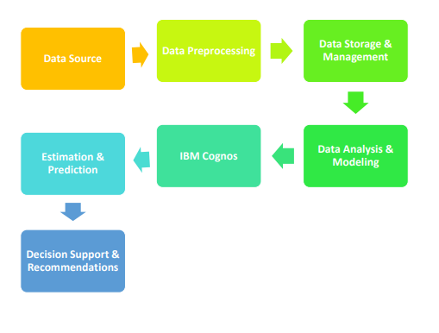

Theoretical Analysis for Unleashing the Potential of Our Youth:

1. Cognitive Development: This theory emphasizes the importance of providing challenging and stimulating environments for youth to enhance their cognitive abilities and intellectual growth. By offering educational programs, problem-solving activities, and critical thinking opportunities, we can promote their cognitive development and unlock their potential.

2. Self-Determination Theory: This theory suggests that self-motivation and personal fulfillment are crucial factors in boosting youth potential. By fostering an environment that supports autonomy, competence, and relatedness, we can encourage youth to pursue their passions and interests, ultimately maximizing their potential.

3. Social Learning Theory: According to this theory, youth learn and develop through observation, imitation, and modeling behaviors of others. By providing positive role models and mentors, we can expose youth to successful individuals who can inspire and guide them in realizing their potential.

4. Growth Mindset Theory: This theory emphasizes the belief that intelligence and abilities can be developed through effort, practice, and learning from failures. By instilling a growth mindset in youth, we can teach them to embrace challenges, persevere, and continuously improve, enabling them to reach their full potential.

5. Positive Psychology: This branch of psychology focuses on promoting well-being, resilience, and happiness. By emphasizing positive emotions, character strengths, and meaningful relationships, we can cultivate a positive mindset in youth, empowering them to thrive and unleash their potential.

These theoretical frameworks offer valuable insights into the factors that can fuel the growth and potential of our youth. Implementing strategies and programs based on these theories can create a supportive and nurturing environment for youth to explore their talents, develop their skills, and contribute meaningfully to society.

HARDWARE/SOFTWARE:

Hardware Requirements

To unleash the potential of our youth, certain hardware requirements need to be met. These requirements may vary depending on the specific initiatives and programs being implemented. However, some common hardware requirements may include:

1. Computers/Laptops: Access to computers or laptops is essential for digital literacy and skills development. They allow youth to learn coding, graphic design, video editing, and other technical skills. Additionally, computers enable access to online learning platforms and resources.

2. Internet Connectivity: Reliable and high-speed internet connectivity is crucial for accessing online educational materials, participating in virtual classes or webinars, and exploring various learning opportunities. It facilitates global connection and collaboration.

3. Mobile Devices: Many youth have easy access to smartphones, making mobile devices an accessible tool for learning and engagement. Mobile apps can be developed to provide educational content, skill-building exercises, and interactive learning experiences.

4. Projector/Interactive Whiteboards: These multimedia tools enhance the learning experience by enabling interactive lessons, visual presentations, and group activities. They make education engaging, allowing for creative expression and critical thinking.

5. Audio-Visual Equipment: Digital cameras, microphones, and recording devices are useful for capturing youth's creative projects, presentations, and performances. They facilitate sharing and showcasing their work to a wider audience.

6. Maker Spaces: Equipping dedicated spaces with hardware like 3D printers, laser cutters, and woodworking tools allows youth to engage in hands-on learning and practical experimentation. It nurtures creativity, problem-solving skills, and innovation.

7. Gaming Consoles/Virtual Reality (VR) Headsets: Gaming consoles and VR headsets can be utilized for educational purposes, such as immersive learning experiences, simulation training, and gamified skill development.

Software requirements

To unleash the potential of our youth, the following software requirements are essential:

1.Learning Management System (LMS): An LMS is necessary to provide a virtual platform for youth to access educational resources, courses, and training materials. It should support features like content management, assessments, discussion forums, and progress tracking.

2. Content Creation Tools: Software tools like video editors, graphic design software, and interactive presentation tools are needed to create engaging and interactive learning materials. This will help in delivering content that is visually appealing and maintains the interest of the youth.

3. Collaboration Tools: To foster teamwork and collaborative learning, software tools like project management platforms, video conferencing tools, and instant messaging applications are required. This will enable youth to collaborate, communicate, and exchange ideas effectively.

4. Assessment and Evaluation Software: Software tools for creating and administering assessments, quizzes, and exams, as well as analyzing and tracking student progress, are crucial. These tools should provide detailed reports and insights to help identify areas of improvement and personalized learning paths.

5. Gamification Platforms: Gamification software can be used to transform learning into a more engaging and enjoyable experience. Gamification elements like badges, leaderboards, and rewards can motivate and encourage youth to actively participate and progress in their learning journey.

6. Mobile Apps: With the increasing use of mobile devices, having mobile applications that provide access to educational content and resources is essential. These apps should be user-friendly, responsive, and compatible with different operating systems.

7. Data Analytics Tools: Data analytics tools will help collect and analyze data on the performance and learning progress of youth. This data can be used to identify trends, measure the effectiveness of interventions, and make data-driven decisions for improving the learning experience.

8. Data Security: With the importance of protecting youth's information and data privacy, software systems should have robust security measures in place. This includes encryption, secure access controls, regular data backups, and compliance with data protection regulations.

Overall, a combination of these software requirements will help unleash the potential of our youth by providing them with a dynamic and innovative learning environment.

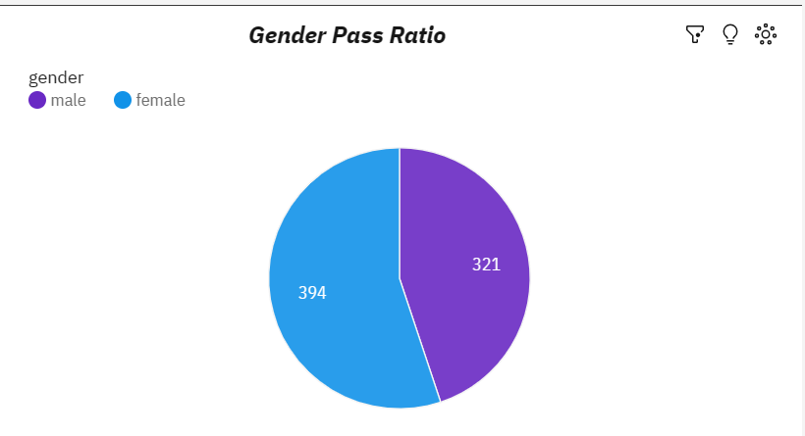

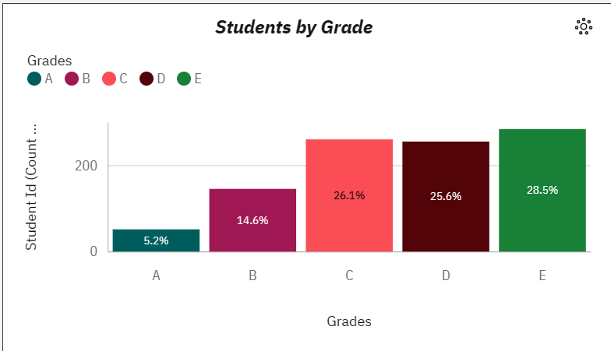

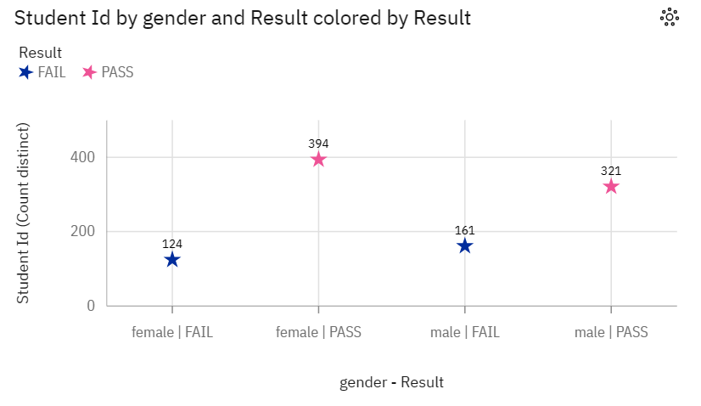

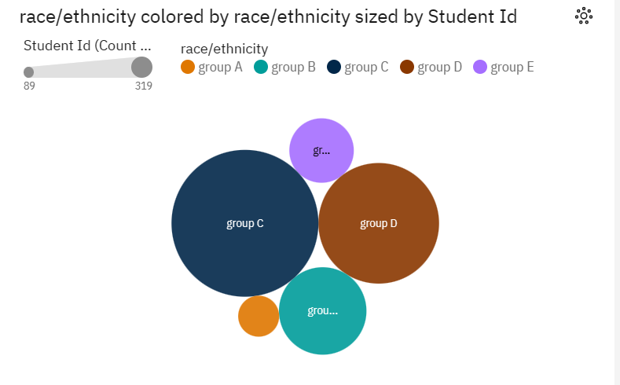

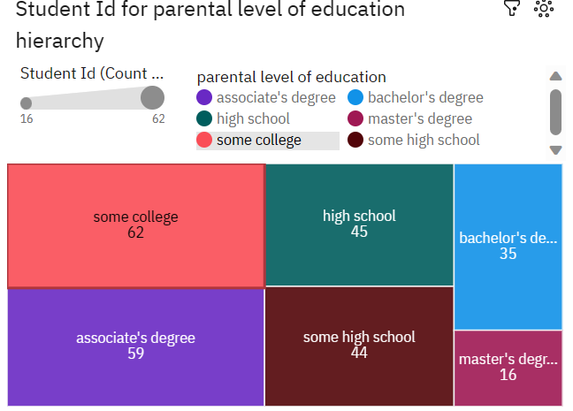

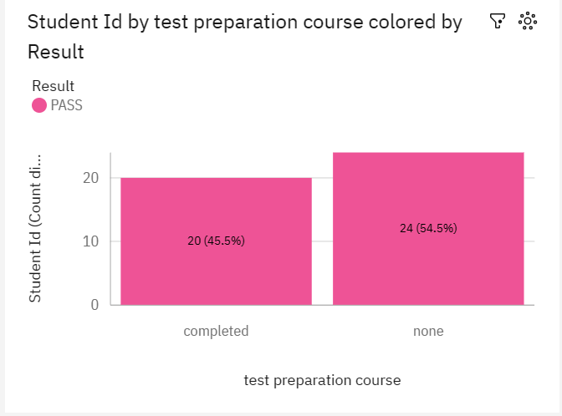

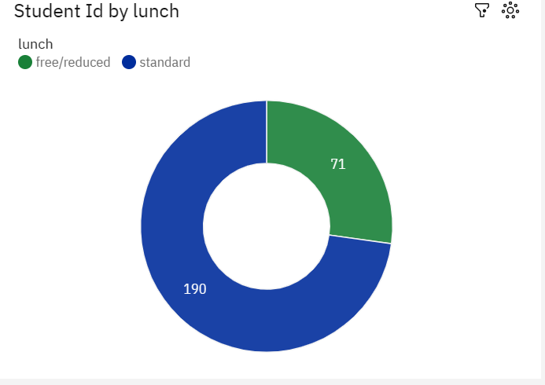

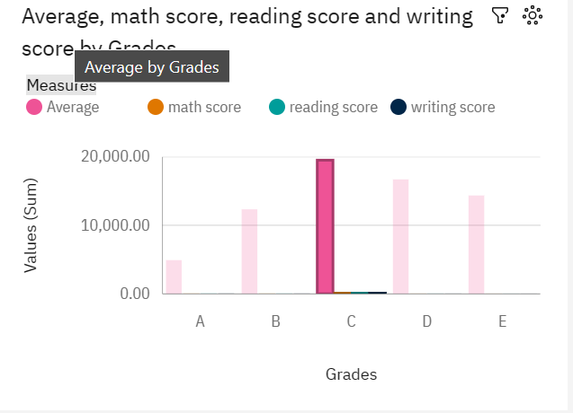

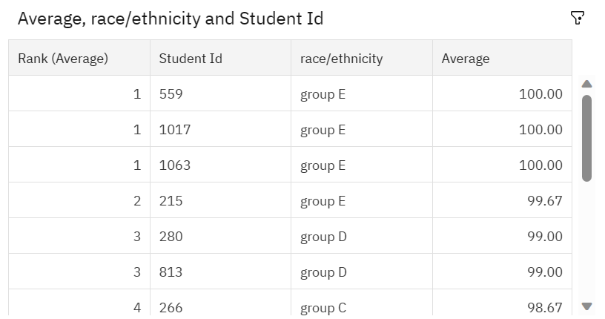

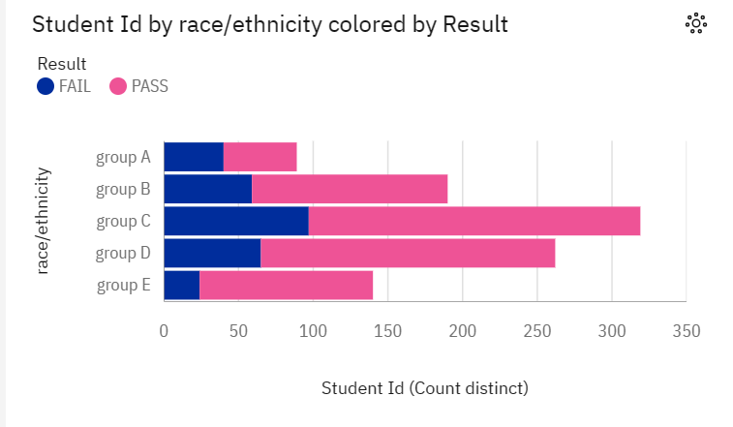

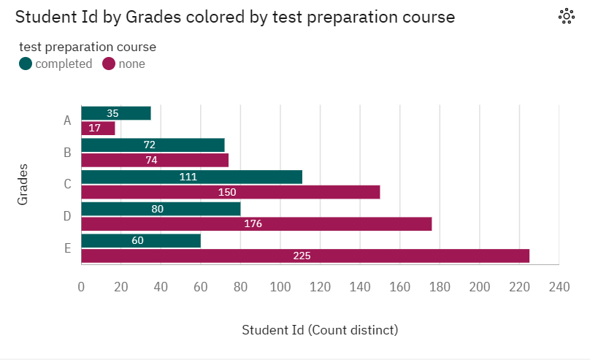

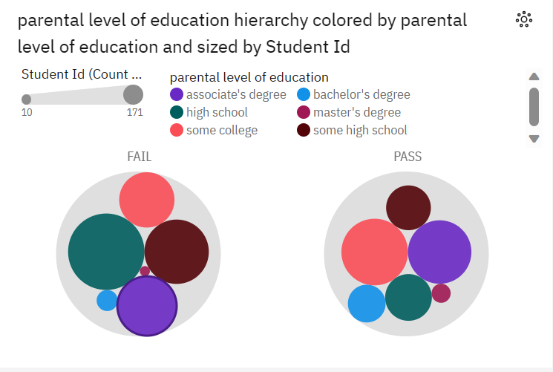

ADVANTAGES AND DISADVANTAGES

Advantages:

There are several advantages to unleashing the potential of our youth:

1. Economic growth: By investing in the potential of young people, we can ensure that they have the skills and knowledge necessary to contribute to economic growth. This can lead to job creation, increased productivity, and innovation, ultimately benefiting the entire society.

2. Social development: When young people are given opportunities to develop their talents and abilities, they are more likely to become active and engaged members of society. They can contribute to community development, participate in civic activities, and advocate for social change.

3. Addressing societal challenges: Young people have fresh perspectives and innovative ideas that can help tackle societal challenges such as poverty, inequality, and climate change. By nurturing their potential, we can tap into their creativity and problem-solving skills to find new solutions to these complex issues.

4. Empowerment and personal growth: Unleashing the potential of our youth means providing them with opportunities for personal growth and empowerment. This can improve their self-confidence, resilience, and sense of purpose, leading to overall well-being and a positive outlook on life.

5. Cultural and artistic expression: Young people are often at the forefront of cultural and artistic expression. By supporting their talents in areas such as music, art, dance, and literature, we can foster creativity and enrich our cultural heritage.

6. Generation of future leaders: Investing in youth development means nurturing the next generation of leaders. By providing them with education, mentorship, and leadership opportunities, we can ensure a smooth transition of power and create a pool of competent and ethical leaders who can drive positive change in various sectors.

7. Inclusion and diversity: Unleashing the potential of our youth means ensuring that every young person, regardless of their background or circumstances, has equal access to opportunities. This promotes inclusion, diversity, and social cohesion, benefiting both individuals and society as a whole.

Overall, unleashing the potential of our youth can lead to a better and more prosperous future for everyone. It allows us to tap into their energy, enthusiasm, and creativity, and empower them to make a positive impact on the world.

While unleashing the potential of our youth is often seen as a positive goal, there can also be disadvantages associated with it. Some of the potential drawbacks are:

1. Inadequate support systems: If the youth's potential is unleashed without sufficient support systems in place, they may feel overwhelmed or unprepared for the responsibilities and expectations placed upon them. This can lead to high levels of stress, burnout, and even mental health issues.

2. Increased competition: Unleashing the potential of our youth can lead to a highly competitive environment. As more young people strive to fulfill their potential, the competition for limited resources such as educational opportunities and job openings can intensify. This may create a greater disparity between those who successfully unleash their potential and those who are left behind.

3. Loss of childhood: Intense focus on unleashing youth potential can push children and teenagers to prioritize achievement and success over their personal development and well-being. This can result in the loss of a carefree childhood or adolescence, as they are constantly under pressure to excel in various domains.

4. Emphasis on conformity: In some cases, unleashing youth potential can result in a narrow focus on grades, test scores, and career success. This can lead to a homogenization of interests and talents, as students may feel compelled to pursue only those fields or activities that society deems as most promising. The diverse range of talents and skills that youth possess may be overlooked or undervalued.

5. Unrealistic expectations and pressure: Expecting too much from young individuals and constantly putting pressure on them to fulfill their potential can be detrimental. It can lead to anxiety, low self-esteem, and a fear of failure. Some youth may feel overwhelmed by the weight of expectations and may struggle to find their own path or passion.

6. Neglecting other important aspects of development: Unleashing youth potential should not solely focus on academic achievements or career success. It is crucial to consider holistic development, including emotional intelligence, social skills, personal values, and physical well-being. By solely emphasizing one aspect, we may neglect the development of other important qualities in youth.

Overall, while it is essential to encourage and empower young people to unleash their potential, it is equally important to ensure that adequate support, balance, and realistic expectations are provided to avoid potential disadvantages and negative consequences.

APPLICATIONS

1. Education: Developing innovative teaching methods and curriculum to engage students and foster their creativity, critical thinking, and problem-solving skills.

2. Mentorship programs: Creating platforms where experienced professionals can guide and inspire young individuals, providing them with practical knowledge, advice, and networking opportunities.

3. Entrepreneurship: Offering support and training for aspiring young entrepreneurs, helping them develop their business ideas, access funding, and navigate the challenges of starting a business.

4. Technology and coding programs: Introducing coding and programming courses in schools to equip students with essential digital skills, preparing them for the future job market.

5. Arts and culture initiatives: Promoting artistic expression and creativity through workshops, exhibitions, and events, allowing young people to explore their talents and contribute to the cultural scene.

6. Youth leadership programs: Empowering young individuals to take on leadership roles, develop their leadership skills, and initiate positive change in their communities.

7. Volunteering and community service: Encouraging young people to engage in volunteer work and community service activities, providing them with valuable experiences and opportunities to make a meaningful impact.

8. Sports and extracurricular activities: Investing in sports facilities, clubs, and organizations to promote physical fitness, teamwork, discipline, and camaraderie among young people.

9. Mental health support: Establishing programs that address the mental health needs of young individuals, providing counseling, workshops, and resources to help them cope with stress, anxiety, and other mental health challenges.

10. Youth empowerment conferences: Organizing conferences and seminars that bring together young individuals from diverse backgrounds, providing them with a platform to share ideas, collaborate, and learn from each other's experiences.

CONCLUSION

In conclusion, unleashing the potential of our youth is crucial for the progress and development of our society. By investing in their education, providing them with opportunities, and empowering them to pursue their passions, we can create a generation that is well-equipped to tackle the challenges of the future.

It is our responsibility as adults to nurture their talents, guide them towards productive paths, and inspire them to dream big. By doing so, we not only ensure their personal growth and success but also contribute to the betterment of the world at large.

Moreover, when we unleash the potential of our youth, we create a ripple effect that impacts our communities, economies, and future generations. They bring fresh perspectives, innovative ideas, and the energy needed to drive change and progress.

However, unleashing the potential of our youth cannot be done in isolation. It requires the collaboration of governments, educational institutions, businesses, and the wider community. Together, we must create an inclusive environment that fosters creativity, curiosity, and resilience, where every young person has an equal opportunity to thrive.

Investing in education, both formal and informal, is vital. It equips young people with the knowledge and skills needed to navigate an ever-changing world. Additionally, we must provide them with platforms where they can showcase their talents, express themselves creatively, and develop essential life skills such as critical thinking, problem-solving, and collaboration.

Moreover, youth empowerment programs and mentorship initiatives play a key role in unleashing their potential. By pairing them with experienced mentors who can provide guidance, support, and valuable connections, we can accelerate their personal and professional growth.

Lastly, it is essential to promote a culture of embracing failure and learning from mistakes. Encouraging the youth to take risks, pursue their passions, and overcome obstacles helps them build resilience, adaptability, and a growth mindset.

In conclusion, unleashing the potential of our youth is an investment in our future. By empowering them to reach their full potential, we not only ensure their personal growth and success but also contribute to the betterment of our society. Let us join hands to create a world where every young person can thrive and become the change-makers we need.

FUTURE SCOPE

The future scope of unleashing the potential of our youth is vast and promising. As advancements in technology and globalization continue to shape our world, the role of young people becomes even more crucial. Here are some areas where we can focus on to further unleash their potential:

1. Entrepreneurship and Innovation: Encouraging young people to become entrepreneurs and innovators is essential for economic growth and job creation. We need to provide them with resources, mentorship, and support to develop their ideas and turn them into successful ventures. Entrepreneurship education and startup incubation programs can play a significant role in nurturing their entrepreneurial spirit.

2. STEM Education: With the rapid advancements in science, technology, engineering, and mathematics (STEM), there is a growing demand for skilled professionals in these fields. By investing in STEM education, we can equip young people with the necessary knowledge and skills to excel in these areas. This will not only lead to personal growth but also contribute to scientific discoveries, technological advancements, and economic development.

3. Social and Environmental Activism: Young people are often at the forefront of social and environmental movements, advocating for change and addressing pressing global issues. Their passion and idealism can drive transformative action and inspire others to follow suit. By supporting youth-led activism and providing platforms to amplify their voices, we can create a more just, sustainable, and equitable world.

4. Mental Health and Well-being: The well-being of our youth is crucial for their overall development and success. It is important to prioritize mental health support, emotional intelligence training, and stress management techniques in educational institutions and communities. By equipping young people with the tools to manage their mental well-being, we can empower them to strive for success while maintaining a healthy work-life balance.

5. Leadership and Civic Engagement: Developing leadership skills and fostering civic engagement is key to creating responsible and active citizens. Youth leadership programs and platforms for participation in decision-making processes are vital for young people to develop a sense of agency and contribute to shaping their communities. Investing in leadership development initiatives will enable young people to become future leaders who address the pressing challenges of our society effectively.

6. Digital Literacy and Cybersecurity: The digital age brings both opportunities and challenges for young people. Enhancing digital literacy skills and promoting cybersecurity education is crucial to ensure their safe and responsible use of technology. Teaching them about online safety, privacy, and digital ethics will enable them to navigate the digital landscape confidently and make informed decisions.

Overall, the future scope of unleashing the potential of our youth lies in creating an inclusive and supportive ecosystem that promotes their growth, innovation, and well-being. By investing in their education, skills development, and empowerment, we are not only shaping a brighter future for them but also building a better world for all.