LAB-12

S559158

MANGA SAIKUMAR

GIT HUB:<https://github.com/Saikumar88941/s24db58Manga/blob/main/controllers/Sculptures.js>

RENDER: <https://s24db58manga.onrender.com>

SCREENSHOT-1

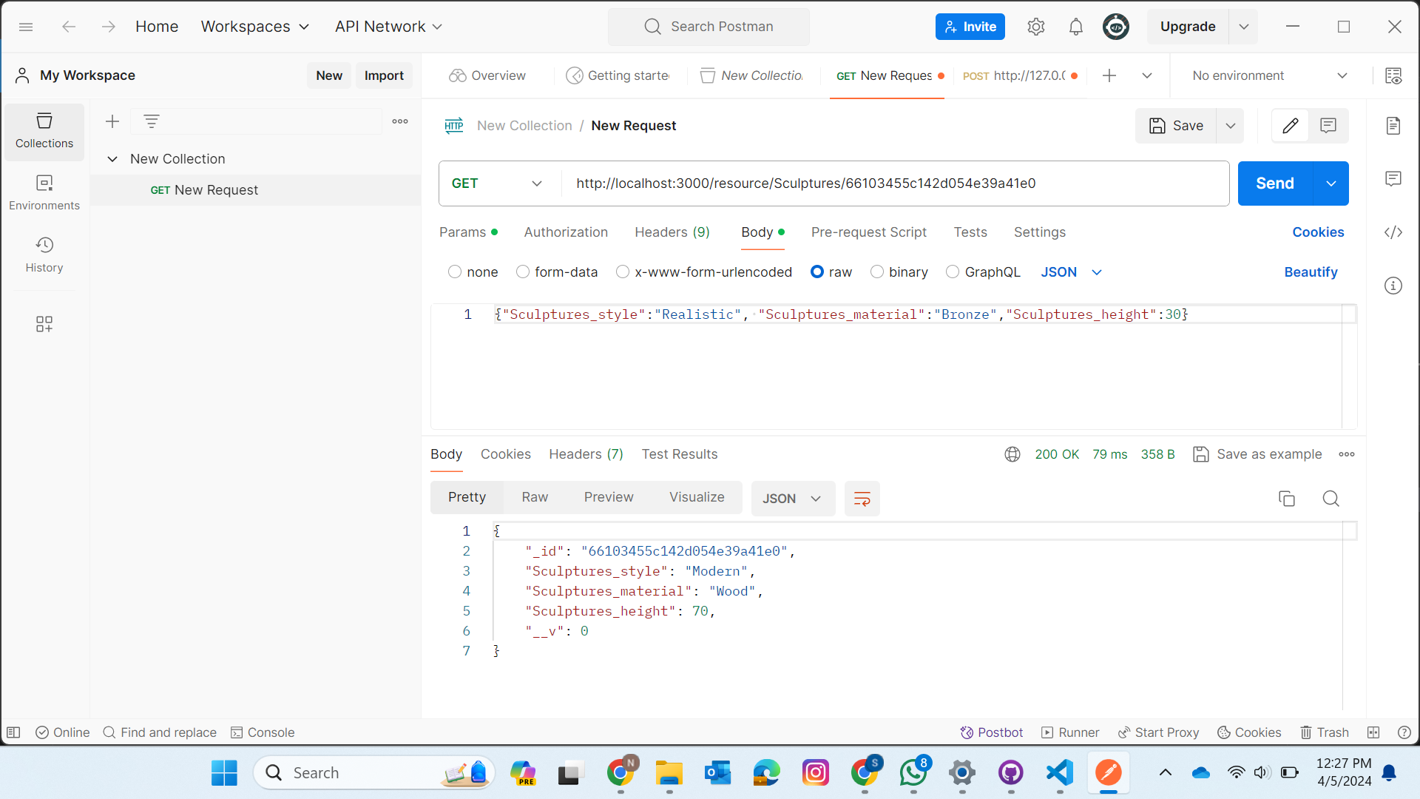

SCREENSHOT-2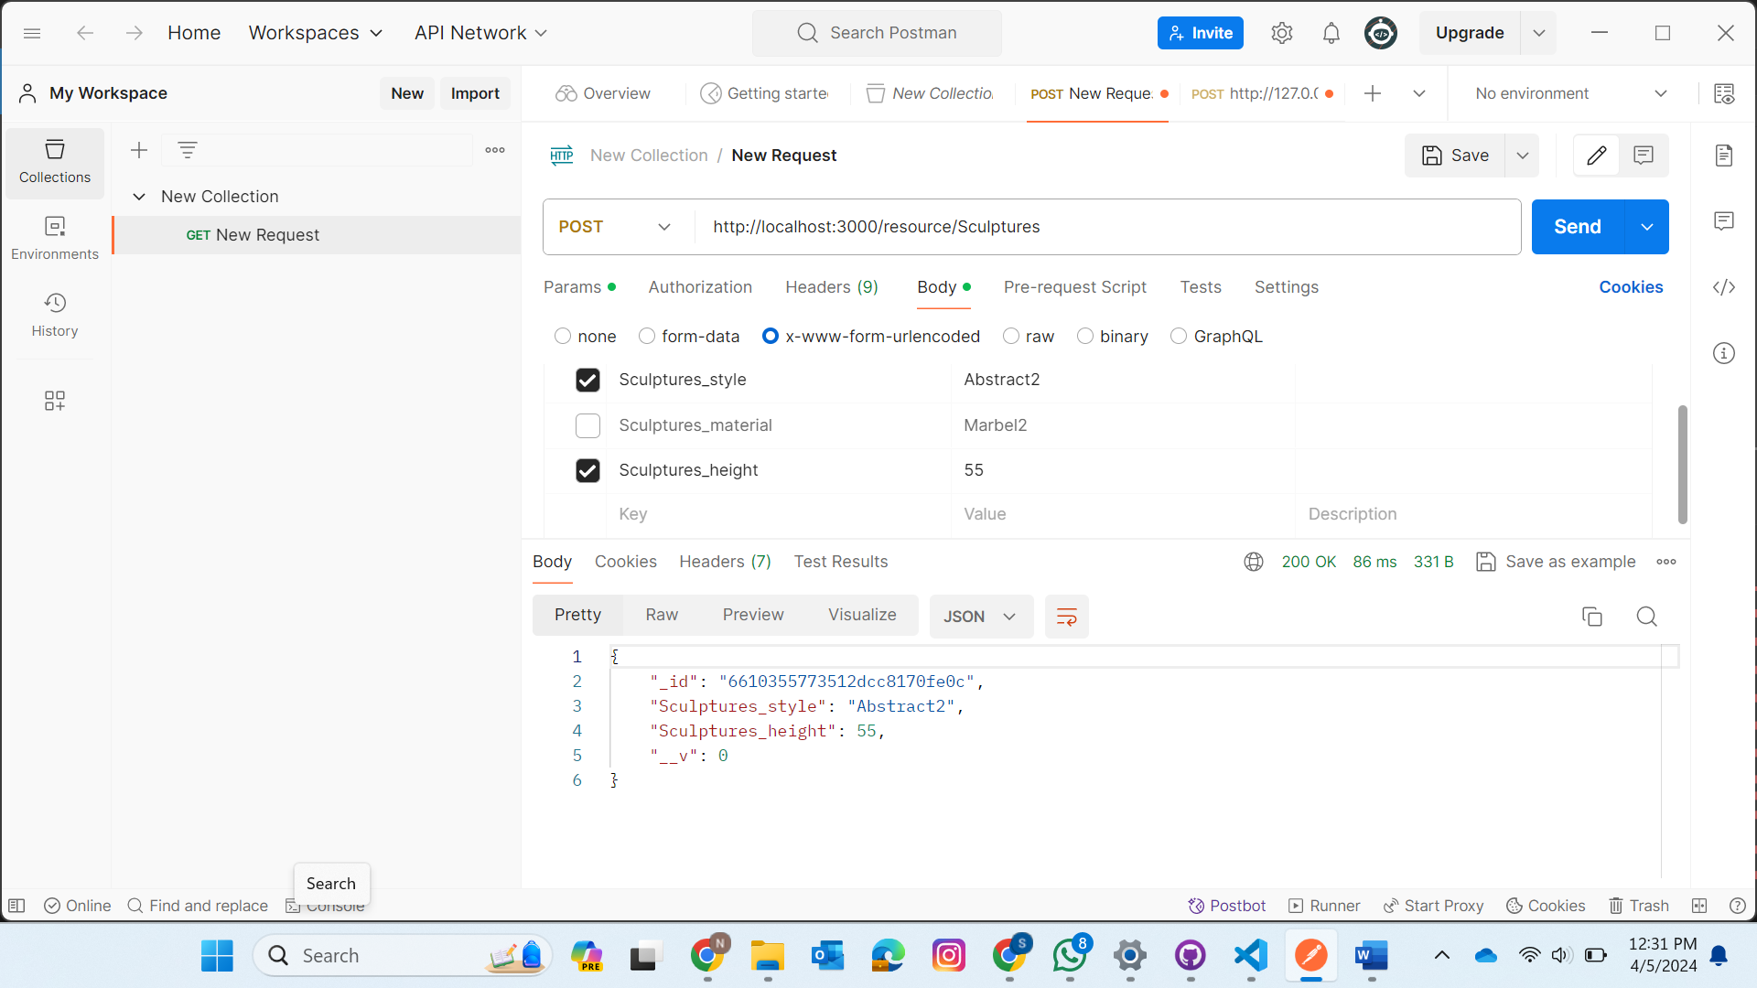

SCREENSHOT-3

