LAB-13

MANGA SAIKUMAR

S559158

GIT-HUB-LINK: <https://github.com/Saikumar88941/s24db58Manga>

RENDER-LINK: <https://s24db58manga.onrender.com>

Screen shot 1 on Browser with view of your collection with added buttons:

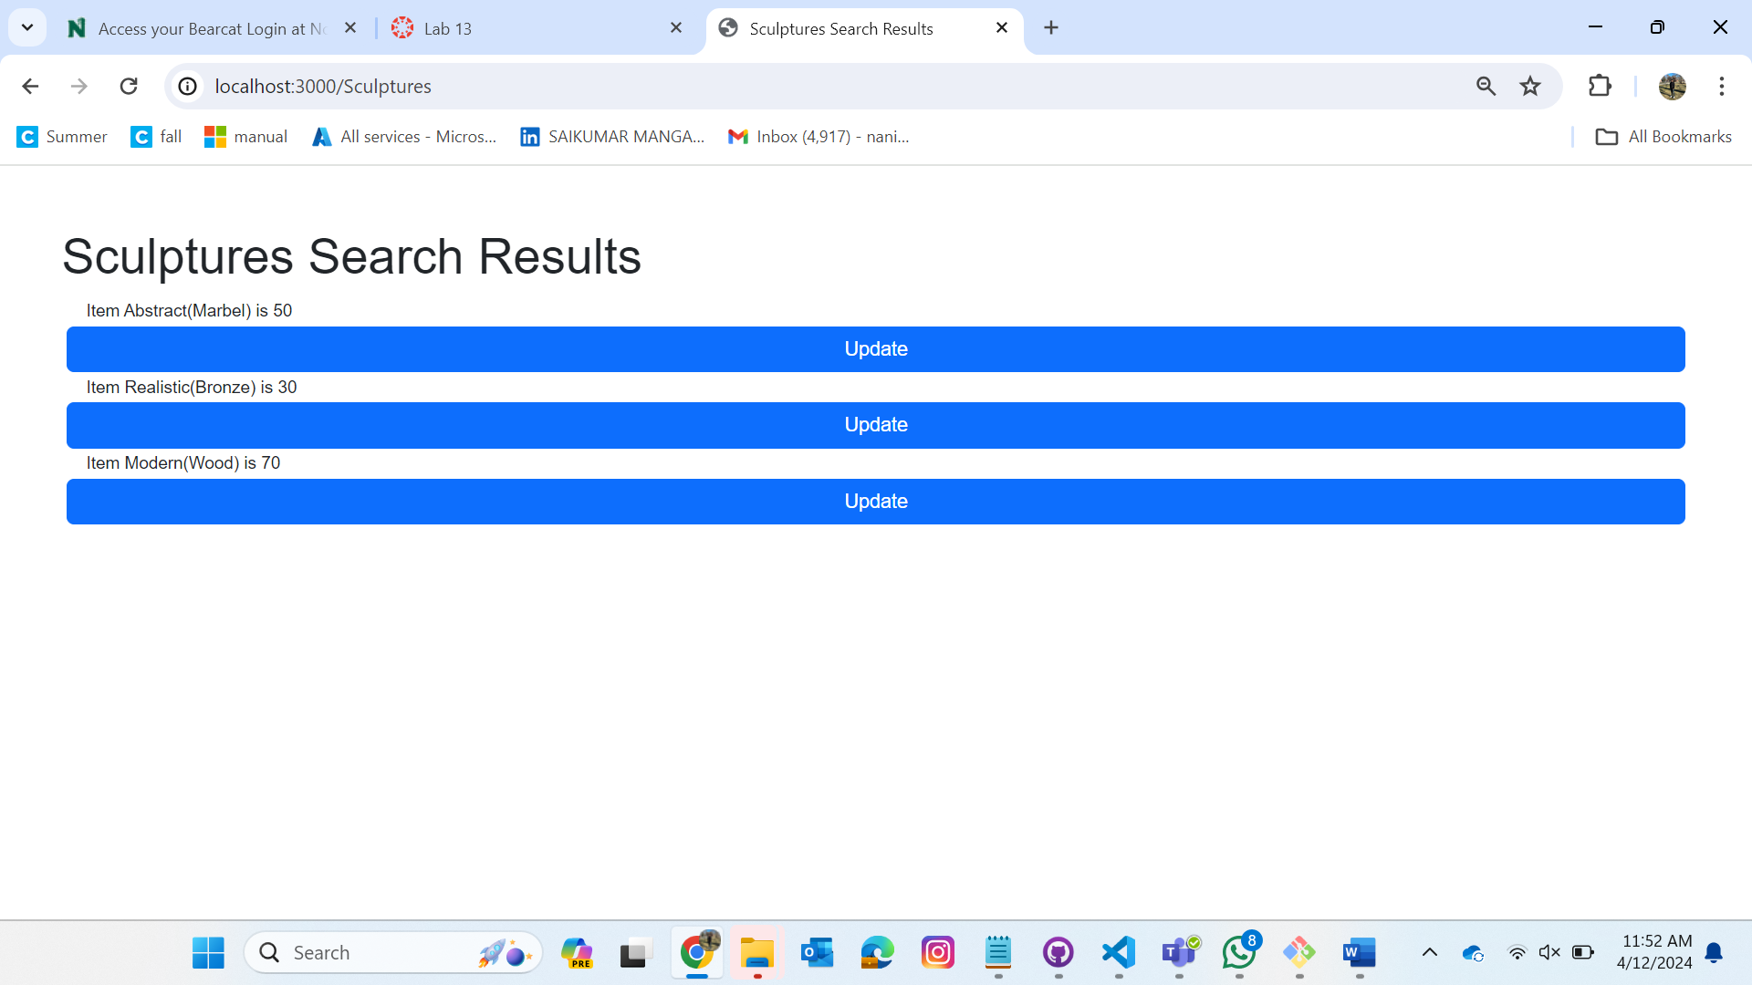

Screen shot 2/3 on VScode of app.js with the new code highlighted

