**Mobile Computing – iOS Fall’23**

**Section03 Exam02**

**50 Points**

**Please follow the following instructions to complete this assignment.**

1. Open Xcode from the launchpad of your Mac.
2. Click on create a new Xcode project. Select the iOS template and click on the App application.
3. Click on next which will prompt you to choose options for the project.
4. Provide product name as **LastnameExam02**, ““**edu.nwmissouri.fall23.cs44643**” for organization identifier, “**Storyboard**” as interface and “**Swift**” as the language.
5. Click on next and select an appropriate location to save your app and click on create. A project directory will be loaded.
6. From the project navigator click on “Main.storyboard” file, a blank mobile screen will be loaded, where the required fields for an app need to be added.

**The View**

2

1

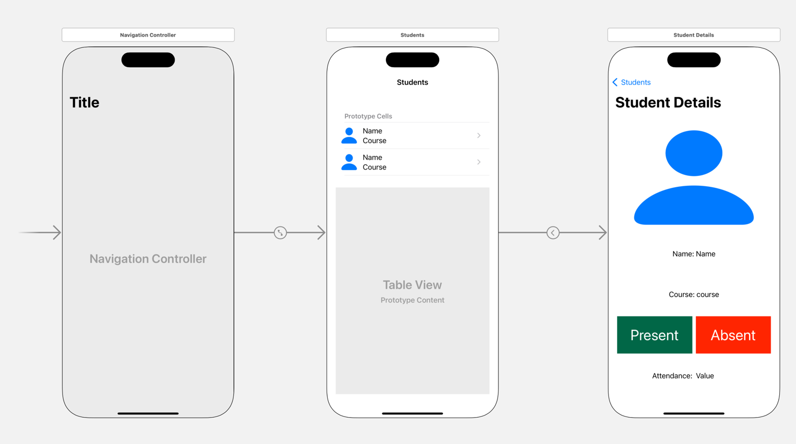

Figure 1 The View

1. Design the view as shown in Fig. 1 and apply auto layout wherever required. Use “person.fill” for the cell image view and student details default image view.

Table 1 The View Controllers

|  |  |
| --- | --- |
| **Screen** | **View Controller** |
| 1 | StudentsTVC |
| 2 | StudentDetailsVC |

1. Create classes as per Table 1 and assign them to proper view controllers in the storyboard.

**The Model**

Table 2 Test data for Graduate Students

|  |  |  |  |  |
| --- | --- | --- | --- | --- |
| **Student** | **Course** | **Days Present** | **Days Absent** | **Image Name** |
| John K. Carter | Mobile Computing - iOS | 18 | 2 | John |
| Jack P. Smith | Mobile Computing - Android | 15 | 5 | Jack |
| Rose L. Foreman | OOP - Java | 17 | 3 | Rose |
| Grace K. Smith | Advanced Database Systems | 12 | 8 | Grace |

Table 3 Test data for Undergraduate Students

|  |  |  |  |  |
| --- | --- | --- | --- | --- |
| **Student** | **Course** | **Days Present** | **Days Absent** | **Image Name** |
| James I. Ellen | History | 12 | 8 | James |
| Lily P. John | Piano 3 | 14 | 6 | Lily |
| Ruby O. Watkins | Computer Programming II | 16 | 4 | Ruby |
| Emma W. Wilkins | Data Structures | 19 | 1 | Emma |

1. Create a Swift file called Model that has the following struct.



1. Load the test data given in Tables 2 and 3 into AppConstants static properties using the structure Student.

**The Controller**

1. StudentsTVC

Table 4: UI elements configuration for StudentsTVC

|  |  |  |
| --- | --- | --- |
| **UI element** | **Purpose** | **Outlet/action name** |
| 1 Table View | To display a list of graduateStudents and underGraduateStudents Details | studentsTV |

* 1. Create outlets/actions as mentioned in Table 4 unless using a built-in table view controller.
  2. Design and display a list of students in different sections as shown in the sample output.
     1. Set table view cell height to 50.0
  3. Leading swipe on a student, should display an action that increments the number of days present value of the student by 1 if performed.
     1. Set contextual action background color to Green.
  4. Trailing swipe on a student, should display an action that increments the number of days absent value of the student by 1 if performed.
     1. Set contextual action background color to Red.
  5. On tapping a student, perform a segue to StudentDetailsVC.

1. StudentDetailsVC

Table 5: UI elements configuration for StudentDetailsVC

|  |  |  |
| --- | --- | --- |
| **UI element** | **Purpose** | **Outlet/action name** |
| 1 UIImageView | To display student’s image | studentImg |
| 1 UIlabel | To display student’s name | studentNameLBL |
| 1 UIlabel | To display course title | studentCourseLBL |
| 1 UIlabel | To display the number of days present | daysPresentLBL |
| 1 UIlabel | To display the number of days absent | daysAbsentLBL |
| 1 UIlabel | Attendance | n/a |
| 1 UIlabel | To display attendance percentage | attendancePercentageLBL |

* 1. Create outlets/actions as mentioned in Table 5.
  2. Design and display all the details of the selected student as shown in the sample output.

Table 6 UI elements customization for StudentDetailsVC

|  |  |  |  |  |  |  |
| --- | --- | --- | --- | --- | --- | --- |
| **Element** | **Corner Radius** | **Border Width** | **Border Color** | **Mask to Bounds** | **Clips to Bounds** | **Background color** |
| studentImg | 10.0 | 2.0 | Black | true | true | None |
| daysPresentLBL | #006747 |
| daysAbsentLBL | #FF2600 |

* 1. Apply the attributes given in Table 6 to the StudentDetailsVC’s UI elements.

$attendance percentage= \frac{days present}{days present+days absent} × 100.0$ (Equation 1)

* 1. Calculate and display student’s attendance percentage using Equation 1.
  2. Animate the alpha attribute of the studentImg from 0.0 to 1.0 when loading it.

**Submission:** Push your entire Xcode project to your private GitHub repo and submit your private

repository link on the Canvas via Text Entry.