**Team - 02**

**Restaurant Booking App Documentation**

**Git Link:** [**https://github.com/Sailaxmiveldanda/IOSProject_Team02.git**](%20https:/github.com/Sailaxmiveldanda/IOSProject_Team02.git)

**Team Members:**

Shilpa Yaramala (s559152) Contribution (33.3)

Email: [s559152@nwmissouri.edu](mailto:s559152@nwmissouri.edu)

Greeshma Jale (s555082) Contribution (33.3)

Email: [s555082@nwmissouri.edu](mailto:s555082@nwmissouri.edu)

Sailaxmi Veldanda (s560208) Contribution (33.3)

Email: [s560208@nwmissouri.edu](mailto:s560208@nwmissouri.edu)

**Libraries and IOS SDK used:**

**Firebase** - Version 10.17.0 (<https://github.com/firebase/firebase-ios-sdk>)

1. Authentication
2. Image storage
3. Database

**Lottie** – Version 4.3.3 (<https://github.com/airbnb/lottie-ios>)

1. Animation

**SDWebImage** – Version 5.18.4 (<https://github.com/SDWebImage/SDWebImageSwiftUI>)

1. Loading images from remote URL’s

**AnimatedGradientView** – Version 3.1.1 (<https://github.com/rwbutler/AnimatedGradientView>)

1. Animating the background screen

**Abstract:**

We have named our app “**Eaterer**”. The Eaterer App is a complete solution designed with diners in mind, simplifying the booking procedure and optimizing the whole eating experience. Offering a user-friendly interface and an extensive range of functions, it makes it simple for consumers to find, reserve, and manage restaurants. The app offers comprehensive restaurant profiles along with the calorie count of the food items. Individuals can create profiles. The app wants to be the go-to platform, providing a seamless, user-centric approach to menu card exploration and reservation management, with a focus on security and privacy.

**Introduction:**

The goal of this app is to satisfy a wide range of user needs while guaranteeing an enjoyable dining experience. With the help of this app, users can quickly and easily browse a wide variety of restaurants, all of which have attractive photos, thorough descriptions, and atmospheric details. The app makes it easier to find restaurants by seamlessly considering user preferences like accessibility, and ratings. By simplifying the reservation procedure, customers may easily reserve tables, improving the whole eating experience. This software is committed to improving the dining experience and offers users a simple and pleasant way to find, choose, and book tables. It does this by focusing on simple layouts.

**Technical Requirements:**

1. The minimum required version of iOS is 11.0 or later.
2. Version 14.0.1 or higher of Xcode is required for development.
3. It is suitable for iPads as well as iPhones.

**IOS Features:**

**Login Functionality:**

Secure login with Email/Username for personalized access.

**Item Details Display:**

Comprehensive item information:

1. Description
2. Ingredients
3. Calories

**Dynamic Menu Cards:**

Core Motion functionality: Tilting the phone reveals alternative menu cards.

**Data Model:**

The way that data is arranged within the application databases is specifically defined by the data model for the application, which is implemented using Google Cloud Fire store. This model consists of collections and documents. Data fields are supplied in key-value pair format in each document. Firestore's structure enables for efficient information retrieval and storage. The application uses Google Firestore's "Email and Password" authentication technique for user authentication. With specified ways that make user authentication and password reset functionalities easier, this authentication mechanism provides users with a secure way to access the application while guaranteeing a dependable and strong authentication procedure.

The fire store database starts out with a set of Users, Offers, Restaurants, and Categories. The relevant information is added to the "User Profile", which contains user details, each time the user attempts to save or reserve a table.

**Collections in the database for the application are:**

**Category consists of the following data fields:**

1. description – string
2. foodImage – string
3. ingredients – string
4. Calories – string

**Offers consists of the following data fields:**

1. Image – string

**Restaurants consists of the following data fields:**

1. bookingAmount – number
2. countryAndPin – string
3. haveOffers – Boolean
4. id – number
5. image – string
6. location – string
7. name – string
8. rating – string
9. time – string

**Users consists of the following data fields:**

1. email – string
2. name – string
3. password – string
4. phone – string
5. username – string

**Fire Store:**

Fig: Firestore

**Architecture:**

Fig: Architecture

**Working Visualization:**

**Registration Success Screen:**

This the registration screen (Figure 2.0) where a new user can create an account by entering information like username, name, email, phone number and password. On clicking the sign-up button, a popup window appears saying Registration Successful. If the user is an already registered user, they can simply click on the login button to redirect to the login screen, where they can login using the registered username and password.

We have used the Lottie Animation Package for the image. Using Lottie, animating images and achieving interesting effects on the screen is simple! It enhances the excitement and enjoyment of still photos for all by transforming them into animated wonders.

**Login Register**

(Figure 1.0) (Figure 2.0) (Figure 2.1)

(Figure 2.2) (Figure 2.3) (Figure 2.4)

(Figure 2.5) (Figure 2.6) (Figure 2.7)

(Figure 2.8) (Figure 2.9)

**Login Screen:**

Login screen (Figure 1.0) welcomes the user to login using the registered username and password. After the correct credentials are entered, clicking on the login button will redirect the user to the home page.

If the user is a new user, click on the “Don’t have an Account? Sigup” button, will redirect the user to the signup page (Figure 2.0) where registration can be done. The user can click on the reset button, to reset the username and password text fields to empty.

We have used Firebase for authentication purposes. We have used the Lottie Animation Package for the image. Using Lottie, animating images and achieving interesting effects on the screen is simple! It enhances the excitement and enjoyment of still photos for all by transforming them into animated wonders.

(Figure 1.0) (Figure 1.1) (Figure 1.2)

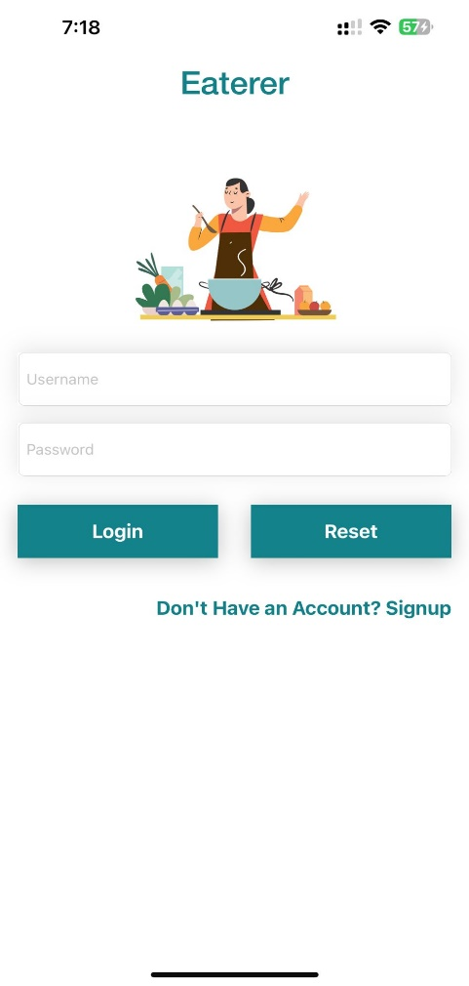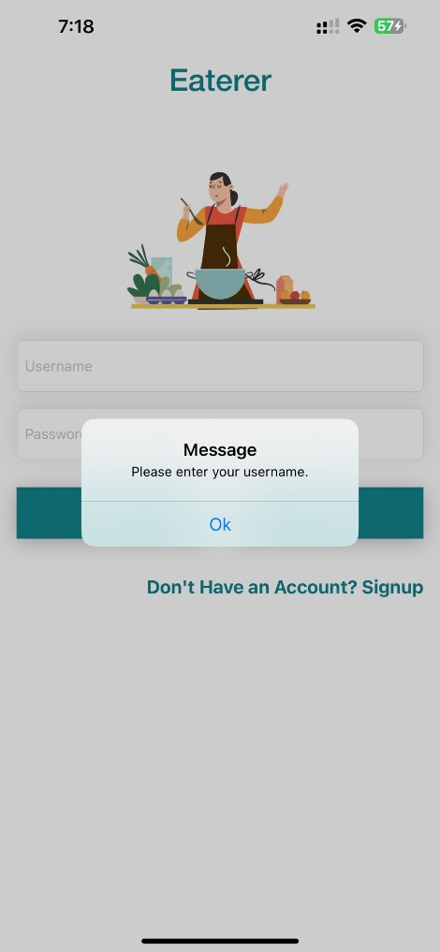 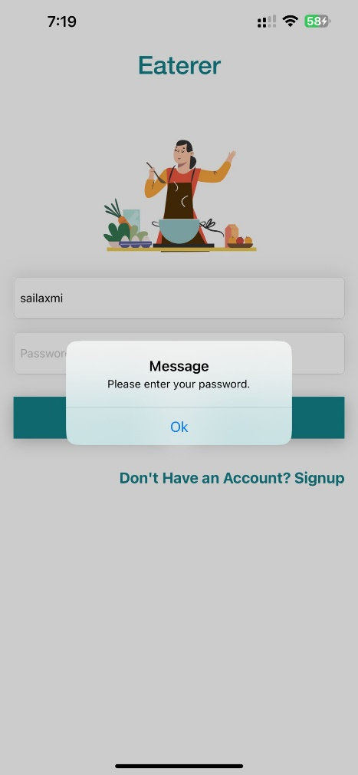

**Home Screen:**

This is the home page. It opens when the user is logged in successfully. This page consists of different categories of foods, available offers and a variety of Restaurants to choose from.

We have used the Package of AnimatedGradientView for figure 3.0. It looks amazing when a vibrant range of colors is added to the screen in motion! Users will find the screen more entertaining and engaging because of the colors' seamless changes.

(Figure 3.0)

**Profile Screen:**

This is the Profile page (figure 4.0). It opens when the user clicks on the profile button in the home page (Figure 3.0). This page consists of details like first name, last name, email id and phone number of the user. The user can click on the Logout button to log out from the app and redirects to figure 1.0.

(Figure 4.0)

**Category Screen:**

Clicking on any one of the categories in home scree (Figure 3.0) it will redirect to a page where the description, ingredients, and number of calories of that item is displayed (Figure 5.0). Here, to display the Calories, we have used the HealthKit Package.

By utilizing this package, our restaurant app adds a feature that helps users make healthy choices. The software offers real-time calorie counts for food products by easily communicating with HealthKit, encouraging mindful and informed dining decisions. By considering both health-conscious choices and taste preferences, this improves the user experience overall.

(Figure 5.0)

**Search Screen:**

Enter a restaurant name and click on the search button, it will redirect to the search screen (Figure 6.0). If we click on the Restaurant name, then it will be redirected to the Restaurant Detail screen (Figure 8.0).

(Figure 3.0) (Figure 6.0)

**Offers Screen:**

When the user clicks on the offers’ images on the home screen (figure 3.0), then we will navigate to the offers Screen (figure 7.0), where we can see the restaurants in which offers are presented.

(Figure 3.0) (Figure 7.0)

**Restaurant Detail:**

When the user clicks the Restaurants that are present in-home screen (Figure 3.0) then user will be navigated to the Restaurant Detail Screen (Figure 8.0) where, image of the restaurant, location (place where the restaurant is located), timings (Restaurant open timings), and rating, are displayed.

We have implemented the SD Web Image Package to display the images when the user clicks on the Request button.

(Figure 3.0) (Figure 8.0)

**Table Booking Screen:**

When user clicks on book button in Restaurant Detail screen (Figure 8.0) it will navigates to Table Booking Screen (Figure 9.0).

(Figure 8.0) (Figure 9.0)

Users can reserve a restaurant table by choosing date, time through date picker. User can also select required number of members. When the user clicks on book a table cell it will unfold the table view, so the user can be able to see the details of restaurant and amount.

(Figure 9.1) (Figure 9.2)

**Payment:**

By clicking the request button in figure 9.2, the user is redirected to the Payment screen (Figure 10.0), which is the billing page, where the user is asked to enter the debit/credit card details which includes name of the user, billing address, card number and CVV. The total amount to be paid is also displayed.

* When the user clicks on the pay button, a window appears with a message, “Booking Completed” (Figure 10.5).

(Figure 10.0)

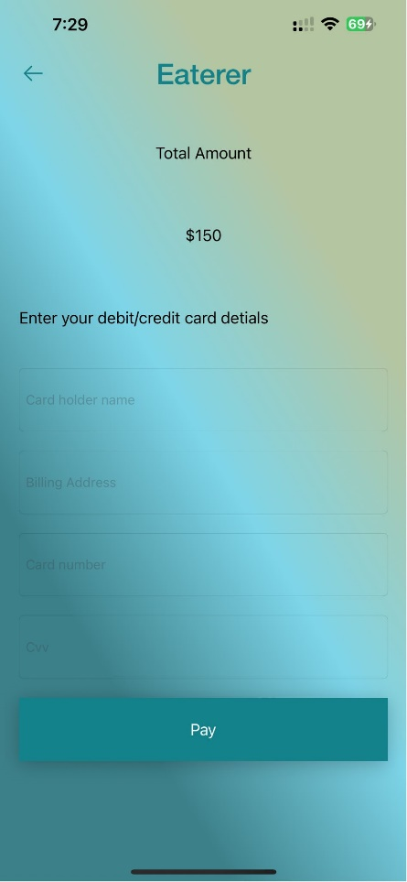

(Figure 10.1) (Figure 10.2) (Figure 10.3)

(Figure 10.4) (Figure 10.5)

**Booking Details:**

When the user clicks on ok in figure 10.5 it will redirect to figure 11.0 which is about booking details.

(Figure 11.0)

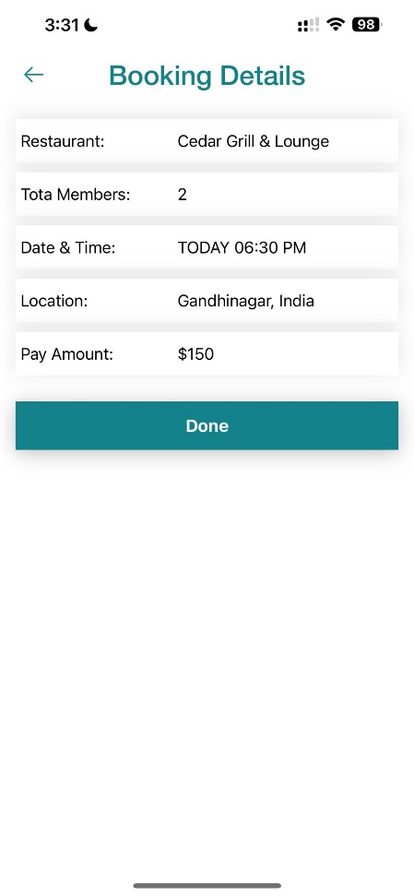

**Menu** **Using** **Core** **Motion**:

The user can click on the “Show Menu” button in figure 8.0 to see the menu. Users can explore items in a visually dynamic and engaging way as the menu changes to their phone's tilt, i.e., the user can tilt their phone, right or left, to see the different pages of the menu. For this Core Motion package has been used. The application of this package improves user engagement and gives the menu presentation an intriguing new angle.

(Figure 8.0) (Figure 12.0)

(Figure 12.1) (Figure 12.2)

(Figure 12.3) (Figure 12.4) (Figure 12.5)

After exploring the menu, the user can come back and click on the book button in figure 8.0, to book a restaurant table.

**Conclusion:**

In conclusion, the restaurant app for iOS enhances dining experiences with seamless navigation, online reservations, and simple order placing. The straightforward design ensures an easy-to-use experience, even though extra features like core motion for dynamic menu changes and HealthKit for calorie tracking offer distinct value. The app offers an experience that suits user preferences in addition to conventional functions. In the end, the restaurant app for iOS reimagines dining by skillfully fusing innovation and personalization.