**Project Milestone-02**

**Team Members:**

Shilpa Yaramala

Greeshma Jale

Sailaxmi Veldanda

**Draw the UI prototypes that are related to your app. You may draw them using pen and paper.**

**Login Page:**

This is the first screen of our app Login Page. In Login page we will have App name in the place of title, will also include the animation for the logo of the app. We will have two text fields to enter the username and password, two buttons for login and reset and we will have a link for Signup page if the user is a new user. And this page contains forget password link if in case user forgot their password. If the user clicks on signup link it will navigate to sign Up page. If the user enters valid details and clicks on login button it will redirect to home page. If they click on reset button it will reset the page. If user clicks on forgot password link it will navigate to forgot page.

**Sign Up Page:**

In the Signup Page, we will have our App name in place of the title. We will have 5 text files for username, email, phone number, password and confirm password. In these text fields, the user will enter the details to create the account to login into the app. We included a button for the signup. After entering the required information, if the user clicks on the signup button, then he navigates back to the login page. If the user has an account, then he navigates back to login page by clicking on sign in link.

**Forgot Password:**

If the user forgot the password, the user can click on the forgot password button on the login page, then the user navigates to the forgot password screen where the user can change the password. Here we will use four text fields and four labels: username, Email, new password, confirm password, and done button.

**Home Page:**

After successful login, the user enters the home screen. The home screen has different types of elements it contains Categories, Offers, Popular Restaurants, and user profile info. We have a search bar to search for restaurants. If the User enters the restaurant name and clicks on search, then he navigates to the screen where the restaurant details are displayed. If the user clicks on the profile icon it will navigate to the User Info screen. In Category, it contains different types of food items like pizza, burgers, soft drinks, etc. For the category, we have used horizontal Scrolling. When the user selects a particular category, he navigates to the screen where we have the nutritional information regarding the category user selected. If the user taps on the image of offers, then he navigates to the offers screen where he has the info regarding the item selected and the discount provided by the restaurant. If the user clicks on any item, the user navigates to the category screen. In the restaurant's section, it contains restaurant images if the user clicks those it will navigate to the Restaurant selected screen.

**User Info Page:  
**

This page contains five labels and those are username, name, email, phone, password. And it contains five text fields filled with user details. In the title place we will set out app name.

**Search Page:  
**

If the user searches for a specific restaurant on the home page, it will navigate to this page and display related restaurant images and names.

**Category Select Page:**

If the user clicks on any item in the category section, it will navigate to this page. This page contains item image, item description, ingredients list and calories, fats, proteins.

**Offers Page:**

This page contains offers image and list of restaurants providing those offers.

**Restaurant Selected Page:  
**

This page displays an image of the restaurant, its location, timings, rating, and book button. If the user clicks on the book button it will navigate to select table screen.

**Select Table Page:  
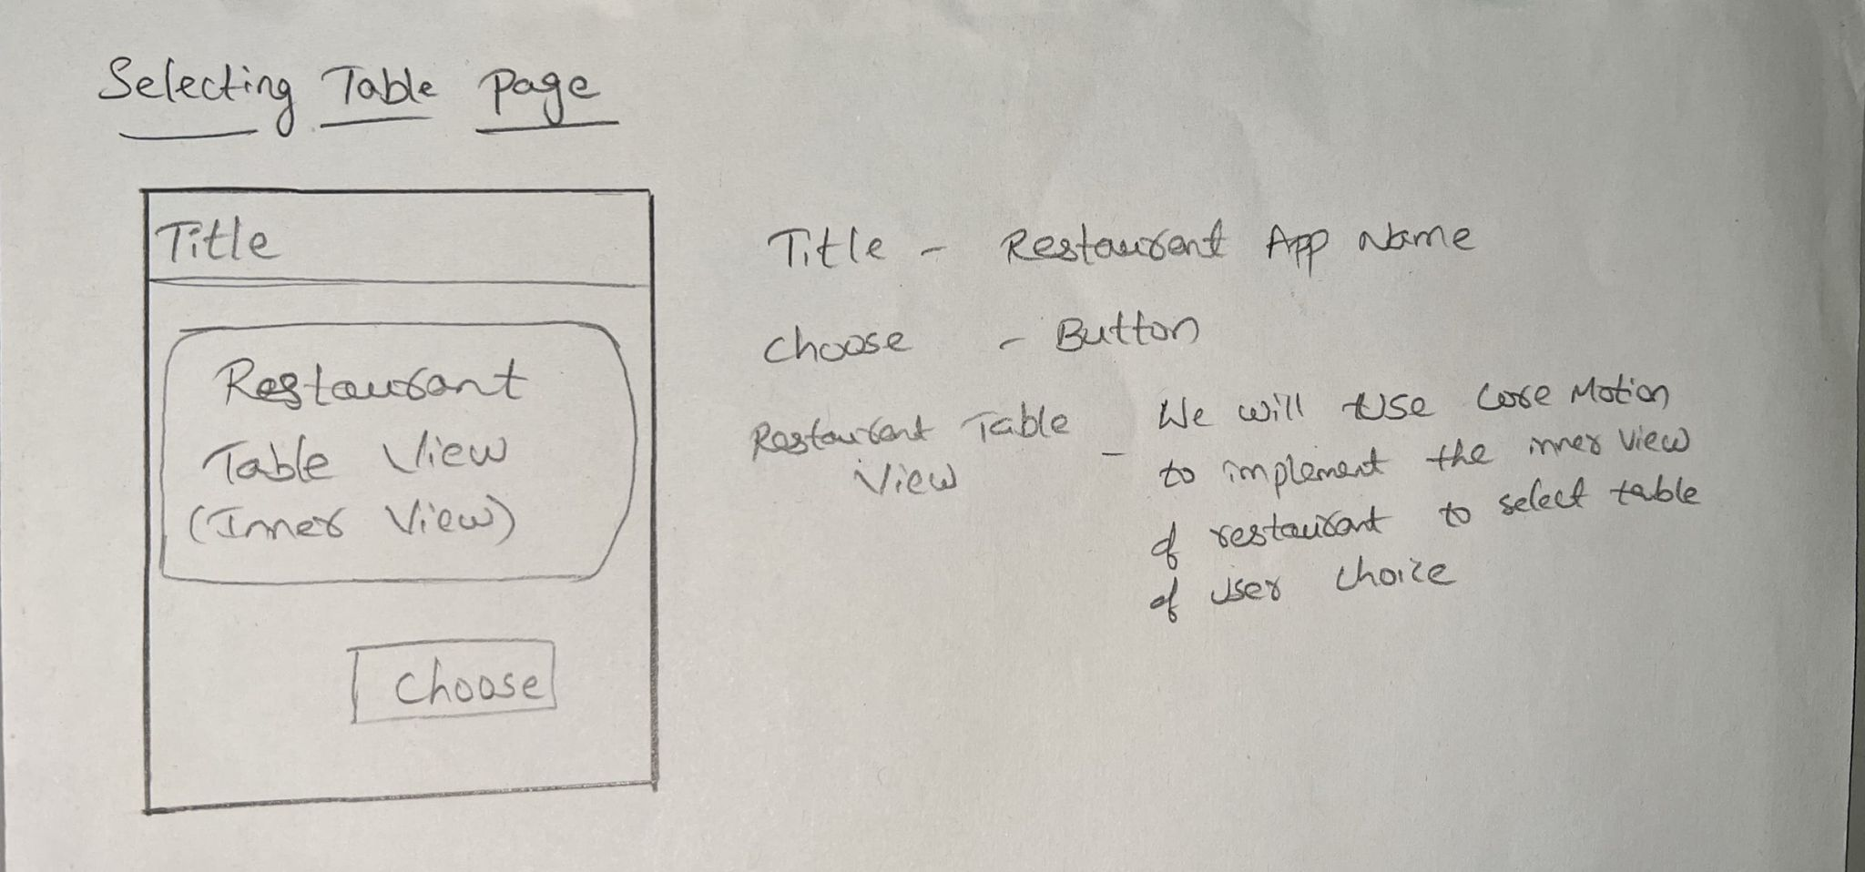**

In this screen it will show the restaurant view and tables, so user can select the table by tap gestures. For this we will implement a core motion package. If user clicks on choose it will navigate to payment screen.

**Payment Page:  
**

Final page for this app where user can enter card details, name, CVV, name and click on pay button an alert message will be shown as Booking is Confirmed