**CT: App Design: Patterns and Frameworks**

**Creating Maven Project:**

1. Choose File > New > Other to open the New Project wizard
2. Select Maven and then choose Maven Projects and click Next

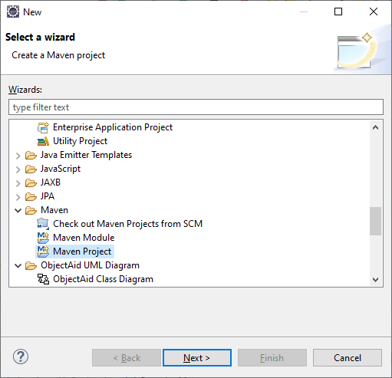

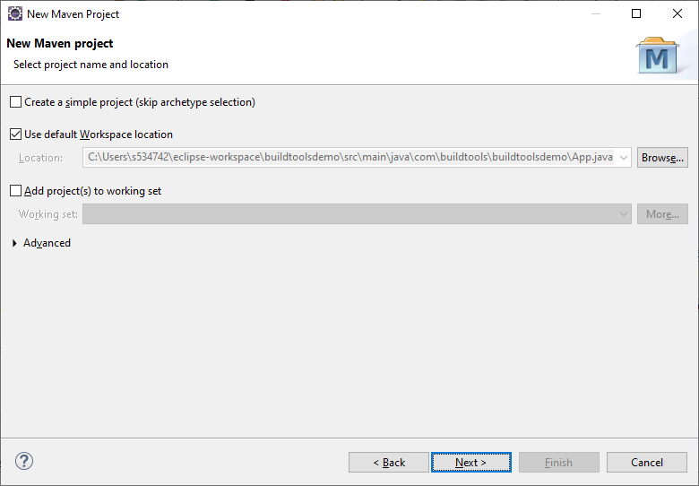

1. Leave everything as default and click Next,
2. For this project we will use **Artifact ID**: maven-archetype-quickstart. To get this enter “org.apache.maven.archetypes” in Filter and click Next.

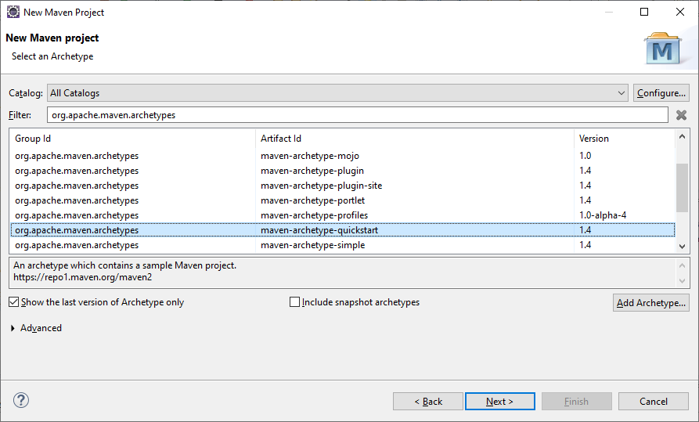

1. Now enter **Group Id** and **Artifact Id**.
2. For e.g. **Group Id:** com.buildtools
3. **Artifact Id:** demo and click Finish.

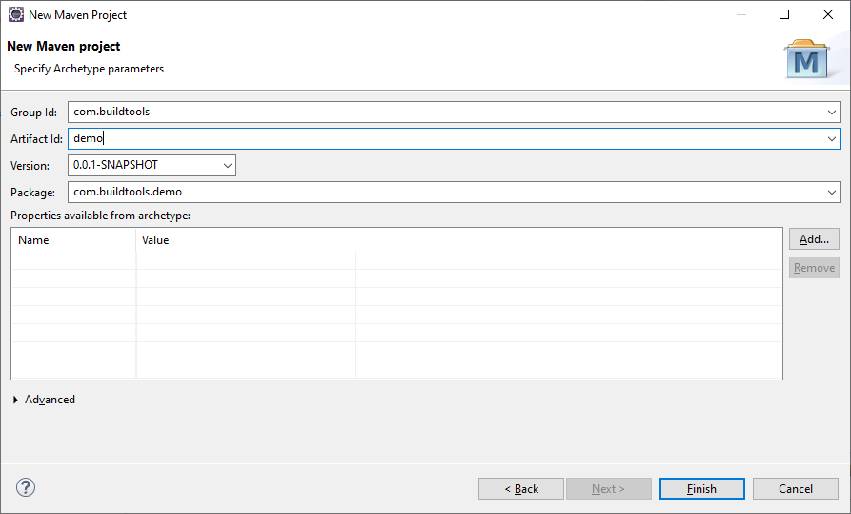

**Changing the Java version:**

1. Now you need to change JavaSE from 1.7 to 1.8
2. In the project, right click on the **JRE System Library** and click on properties.

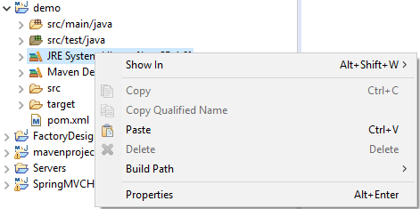

1. Now change JavaSE-1.7 to JavaSE-1.8 from the dropdown under **Execution Environment** and click Apply and close.

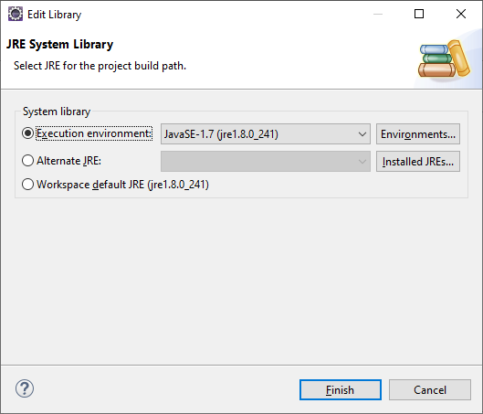

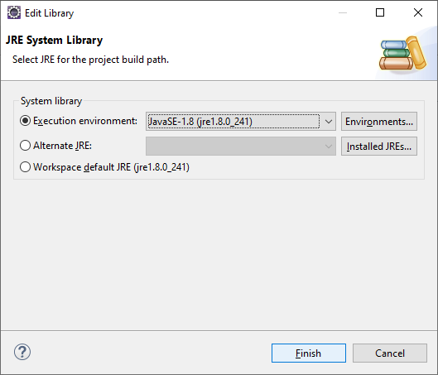

1. Create an excel file named “SampleExcel.xls” with some sample data as given below.
2. Add the file in the root folder of your project. Use Excel 97-2003 format i.e. .xls (not .xlsx) since the code we use below is complaint only with that specific format.
3. Excel data:



1. It should look like this:

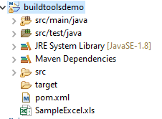

1. To read Excel data and print it in console replace main method in App.java which is an auto-generated class with below code:

public static void main(String[] args) throws FileNotFoundException, IOException {

//Create POI file system object.

POIFSFileSystem objPOIFileSystem = new POIFSFileSystem(new FileInputStream("SampleExcel.xls"));

//Create a data extractor using file system object.

ExcelExtractor datExtractor = new ExcelExtractor(objPOIFileSystem);

//Extract data using extractor and print

System.out.println(datExtractor.getText());

}

1. You get errors for which we need to add dependency

<dependency>

<groupId>org.apache.poi</groupId>

<artifactId>poi</artifactId>

<version>3.17</version>

</dependency>

1. Paste this in pom.xml under dependencies tag as shown below and build the project.

**Note**: If your file does not contain the tag, add < dependencies> </ dependencies> below the <packaging> tag and above the <properties> tag.

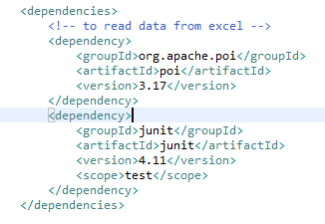

1. Make necessary imports and run the application.