44-542 Object Oriented Programming
More on Trees KEY

- Show one ordering of the integers 1, 2, 3, …20 so that, when inserted into a binary search tree in the order specified, the height of the tree is the maximum possible.
Arrange the integers in increasing order: 1 2 3 4 5 6 7 8 9 10 11 12 13 14 15 16 17 18 19 20 (there is more than one correct answer; for example, you could arrange the integers in decreasing order)
- Draw the tree resulting from your ordering of the integers.
See last page for answer:
- For the binary search tree you drew in the previous problem, show the order in which elements would be visited for each of the following traversal methods: inorder, preorder, postorder, and breadthfirst.
Inorder traversal: 1 2 3 4 5 6 7 8 9 10 11 12 13 14 15 16 17 18 19 20
Preorder traversal: 1 2 3 4 5 6 7 8 9 10 11 12 13 14 15 16 17 18 19 20
Postorder traversal: 20 19 18 17 16 15 14 13 12 11 10 9 8 7 6 5 4 3 2 1
Breadthfirst traversal: 1 2 3 4 5 6 7 8 9 10 11 12 13 14 15 16 17 18 19 20
- Show one ordering of the integers 1, 2, 3, …20 so that, when inserted into a binary search tree in the order specified, the height of the tree is the minimum possible.
There is more than one correct answer. Here are a couple of solutions:
Solution 1: 10 5 2 3 1 7 6 8 9 15 13 17 11 14 12 16 19 20 18 4
Solution 2: 13 8 17 15 19 11 4 18 20 10 14 16 12 6 7 5 2 1 3 9
- Draw the tree resulting from your ordering of the integers.
Solution 1 tree:
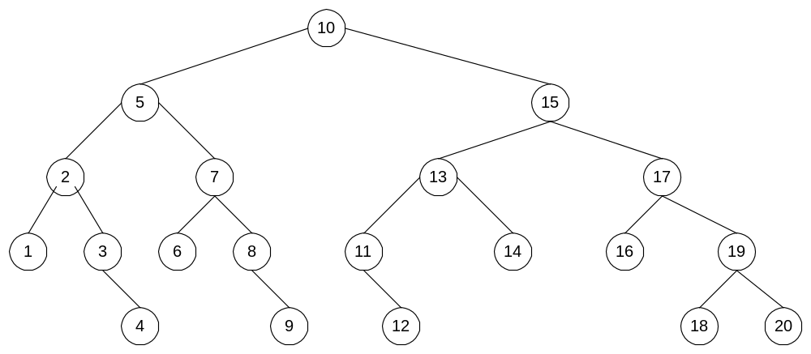
Solution 2 Tree:
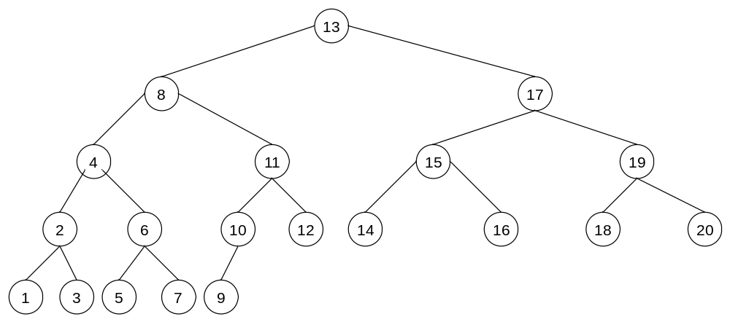

- For the binary search tree you drew in the previous problem, show the order in which elements would be visited for each of the following traversal methods: inorder, preorder, postorder, and breadthfirst.
Solution 1 tree traversals:
Inorder traversal: 1 2 3 4 5 6 7 8 9 10 11 12 13 14 15 16 17 18 19 20
Preorder traversal: 10 5 2 1 3 4 7 6 8 9 15 13 11 12 14 17 16 19 18 20
Postorder traversal: 1 4 3 2 6 9 8 7 5 12 11 14 13 16 18 20 19 17 15 10
Breadthfirst traversal: 10 5 15 2 7 13 17 1 3 6 8 11 14 16 19 4 9 12 18 20

Solution 2 tree traversals:
Inorder traversal: 1 2 3 4 5 6 7 8 9 10 11 12 13 14 15 16 17 18 19 20
Preorder traversal: 13 8 4 2 1 3 6 5 7 11 10 9 12 17 15 14 16 19 18 20
Postorder traversal: 1 3 2 5 7 6 4 9 10 12 11 8 14 16 15 18 20 19 17 13
Breadthfirst traversal: 13 8 17 4 11 15 19 2 6 10 12 14 16 18 20 1 3 5 7 9

