44-542 Object Oriented Programming
Removing Elements; Balancing Trees

- Use the algorithm in class to remove 50 from the tree shown here.
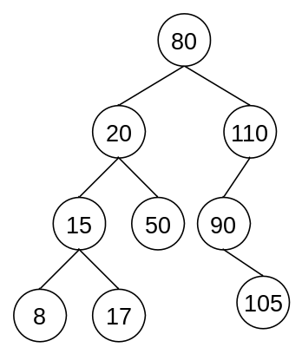
- After removing 50 from the tree above, next remove 20.
- After removing 50 and 20 from the tree above, next remove 80.
- Use the algorithm in class to remove 60 from the tree shown here.
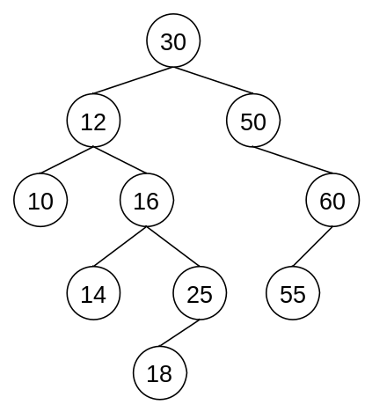
- After removing 60 from the tree above, next remove 10.
- After removing 60 and 10 from the tree above, next remove 16.
- For the tree shown below, perform a left rotation around 50.
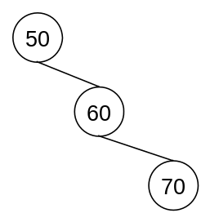

- For the tree shown below, perform a left rotation around 50.
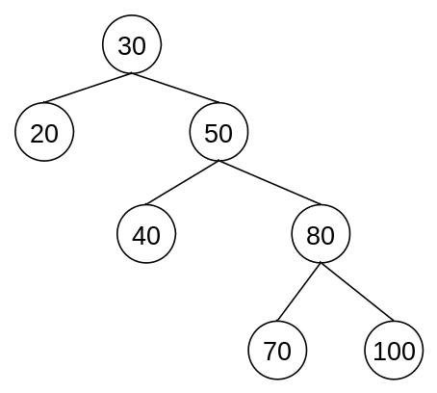

- For the tree shown below, perform a left rotation around 50.
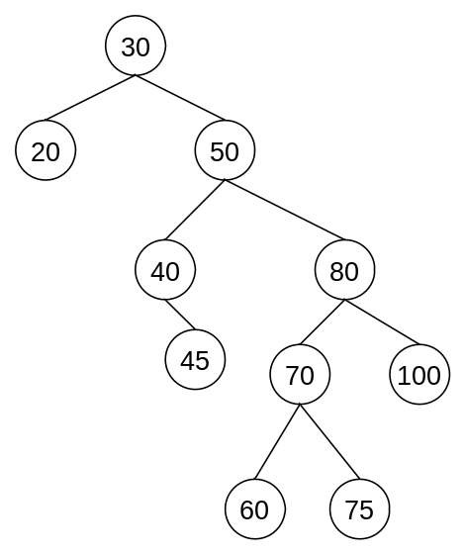

- For the tree shown below, perform a right rotation around 50.
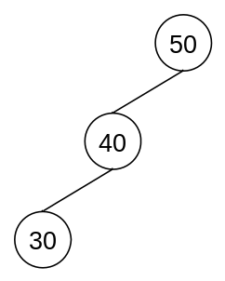

- For the tree shown below, perform a right rotation around 50.
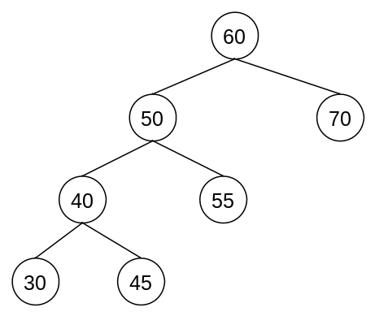
- For the tree shown below, perform a right rotation around 50.
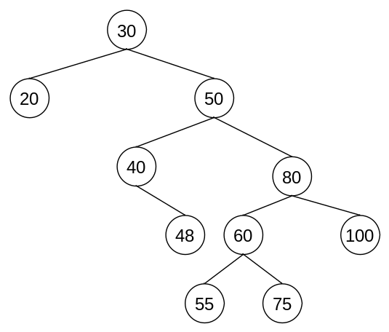
- For the tree shown below, perform a double rotation.
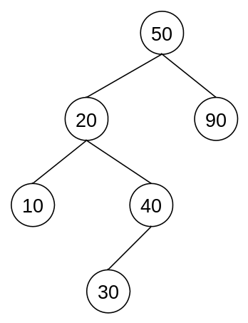
  - first a left rotation around 20
  - then a right rotation around 50

- For the tree shown below, perform a double rotation.
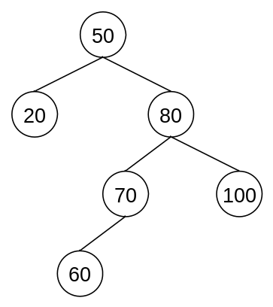
  - first a right rotation around 80
  - then a left rotation around 50

