2) Data requirements of movie industry are captured. Each movie is identified by title and

year of release. Each movie has length in minutes and classified under one genres (like action, horror etc.). Each movie has a plot outline. Production companies are identified by name and each has an address. A production company produces one or more movies. Actors are identified by id. Other details like name and date of birth ofactors are also stored. Each actor acts in one or more movies. Each actor has a role in movie. Directors are identified by id. Other details like name and date of birth of directors are also stored. Each director directs one or more movies. Each movie has one or more actors and one or more directors and is produced by a production company.

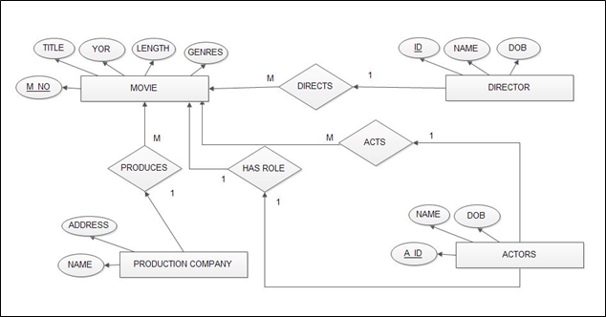

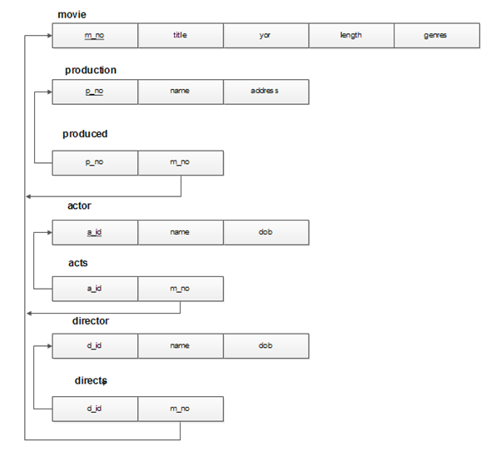

mysql> create table movie(m_no int primary key,title varchar(20),yor int,lenght int,genres varchar(10));

Query OK, 0 rows affected (0.09 sec)

mysql> insert into movie values(

001,"akasmika",1992,180,"action",121);

Query OK, 1 row affected (0.03 sec)

mysql> insert into movie values( 002,"six-fivetwo",2012,150,"horror",122);

Query OK, 1 row affected (0.03 sec)

mysql> insert into movie values( 003,"kalla-malla-sulla",2012,150,"comedy",123)

Query OK, 1 row affected (0.04 sec)

mysql> insert into movie values( 004,"super",2010,150,"action",124);

Query OK, 1 row affected (0.03 sec)

mysql> insert into movie values( 005,"nagarahavu",1991,150,"mystery",121);

Query OK, 1 row affected (0.03 sec)

mysql> select * from movie;

mysql> create table production(p_no int primary key,name varchar(20),address varchar(20));

Query OK, 0 rows affected (0.10 sec)

mysql> insert into production values(121,"vajreshwari","bangalore");

Query OK, 1 row affected (0.02 sec)

mysql> insert into production values( 122,"old_films","madras");

Query OK, 1 r ow affected (0.03 sec)

mysql> insert into production values( 123,"raj_movies","madras");

Query OK, 1 row affected (0.02 sec)

mysql> insert into production values( 124,"sri_movies","bangalore");

Query OK, 1 row affected (0.03 sec)

mysql> insert into production values( 125,"golden_movies","bangalore");

Query OK, 1 row affected (0.04 sec)

mysql> select * from production;

mysql> create table actor(a_id int primary key,name varchar(10),dob date);

Query OK, 0 rows affected (0.09 sec)

mysql> insert into actor values(101,"raj_kumar",19470424);

Query OK, 1 row affected (0.03 sec)

mysql> insert into actor values(102,"shankar_nag",19470602);

Query OK, 1 row affected, 1 warning (0.02 sec)

mysql> insert into actor values(103,"vishnuvardhan",19620505);

Query OK, 1 row affected, 1 warning (0.02 sec)

mysql> insert into actor values(104,"ambareesh",19600525);

Query OK, 1 row affected (0.04 sec)

mysql> insert into actor values(105,"upendra",19700515);

Query OK, 1 row affected (0.04 sec)

mysql> insert into actor values(106,"srk",19800516);

Query OK, 1 row affected (0.04 sec)

mysql> select * from actor;

mysql> create table acts(a_id int,m_no int,foreign key(a_id) references actor(a_id),foreign key(m_no) references movie(m_no));

Query OK, 0 rows affected (0.11 sec)

mysql> insert into acts values(101,1);

Query OK, 1 row affected (0.02 sec)

mysql> insert into acts values(102,2);

Query OK, 1 row affected (0.02 sec)

mysql> insert into acts values(103,3);

Query OK, 1 row affected (0.03 sec)

mysql> insert into acts values(104,4);

Query OK, 1 row affected (0.03 sec)

mysql> insert into acts values(105,5);

Query OK, 1 row affected (0.03 sec)

mysql>insert into acts values(106,5);

Query OK, 1 row affected (0.03 sec)

mysql> select * from acts;

mysql> create table director(d_id int primary key,name varchar(10),dob date);

Query OK, 0 rows affected (0.08 sec)

mysql> insert into director values(333,"puttanna",19700424);

Query OK, 1 row affected (0.03 sec)

mysql> insert into director values(334,"siddayya",19700424);

Query OK, 1 row affected (0.03 sec)

mysql> insert into director values(335,"bhargava",19700425);

Query OK, 1 row affected (0.03 sec)

mysql> insert into director values(336,"kumar",19700525);

Query OK, 1 row affected (0.02 sec)

mysql> insert into director values(337,"bangaru",19700516);

Query OK, 1 row affected (0.03 sec)

mysql> insert into director values(338,"upendra",19890516);

Query OK, 1 row affected (0.02 sec)

mysql> select * from director;

mysql> create table directs(d_id int,m_no int,foreign key(d_id) references director(d_id),foreign key(m_no) references movie(m_no));

mysql> insert into directs values(333,1);

mysql> insert into directs values(334,2);

Query OK, 1 row affected (0.03 sec)

mysql> insert into directs values(335,3);

Query OK, 1 row affected (0.03 sec)

mysql> insert into directs values(336,4);

Query OK, 1 row affected (0.03 sec)

mysql> insert into directs values(337,5);

Query OK, 1 row affected (0.03 sec)

mysql> insert into directs values(338,4);

Query OK, 1 row affected (0.02 sec)

mysql> select * from directs;

**Queries:**

a)List the details of horror movies released in 2012 and directed by more than 2 directors.

**mysql> select m.title from movie m ,director d1,directs d where m.m_no=d.m_no and d.d_id=d1.d_id and m.genres="horror" and yor=2012 group by m.title having count(d.m_no)>2;**

**+-------------+**

**| title |**

**+-------------+**

**| six-fivetwo |**

**+-------------+**

**1 row in set (0.00 sec)**

b) List the details of actors who acted in movies having same titles but released before 2000 and after 2010.

**select distinct a.a_id,a.name,a.dob,m.title from actor a,acts ac, acts ac2,movie m,movie m1 where a.a_id=ac.a_id and ac.m_no=m.m_no and m.yor<=2000 and m1.yor>=2010 and m.m_no=ac.m_no and m1.m_no=ac2.m_no;**

**+------+-----------+------------+------------+**

**| a_id | name | dob | title |**

**+------+-----------+------------+------------+**

**| 106 | srk | 1980-05-16 | nagarahavu |**

**| 105 | upendra | 1970-05-15 | nagarahavu |**

**| 101 | raj_kumar | 1947-04-24 | akasmika |**

**+------+-----------+------------+------------+**

**3 rows in set (0.00 sec)**

c) List the details of production companies producing maximum movies.

**select count(p.pid),p.name from production p, movie m where p.pid=m.pid group by p.name order by count(p.pid) desc limit 2;**

**+--------------+------+**

**| count(p.pid) | name |**

**+--------------+------+**

**| 2 | vaj |**

**| 1 | oldf |**

**+--------------+------+**

**2 rows in set (0.00 sec)**

d) List the details of movies where director and actor have same date of birth.

**select m.title,d1.name,a.name from movie m,directs d,director d1,acts ac,actor a where m.m_no=d.m_no and d.d_id=d1.d_id and m.m_no=ac.m_no and ac.a_id=a.a_id and a.dob=d1.dob;**

**+----------+----------+-----------+**

**| title | name | name |**

**+----------+----------+-----------+**

**| akasmika | puttanna | raj_kumar |**

**+----------+----------+-----------+**

**1 row in set (0.00 sec)**

e)  Retrieve  the  names  of  directors  directed  all  the movies  produced  by  any  one  production company.

**mysql> select name from director where d_id=(select d.d_id from production p,produced p1,directs d where p.name="vajreshwari" and p.p_no=p1.p_no and p1.m_no=d.m_no);**