## Async Programming, Multithreading

## Sai Kumaravelu A.T. 916531

**1. Multithreading - ThreadStart**

**print.cs**

using System;

using System.Collections.Generic;

using System.Linq;

using System.Text;

using System.Threading.Tasks;

using System.Threading;

namespace ConsoleApp4

{

public class print

{

public void PrintNumbers()

{

// Display Thread info.

Console.WriteLine("-> {0} is executing PrintNumbers()", Thread.CurrentThread.Name);

Console.Write("Your numbers: ");

for (int i = 0; i < 10; i++)

{

Console.Write("{0}, ", i);

Thread.Sleep(2000);

}

Console.WriteLine();

}

}

}

**program.cs**

using System;

using System.Collections.Generic;

using System.Linq;

using System.Text;

using System.Threading.Tasks;

using System.Threading;

using ConsoleApp4;

class Program

{

static void Main(string[] args)

{

Console.WriteLine("*****ThreadStart Delegate App*****\n");

Console.Write("Do you want [1] or [2] threads? ");

string threadCount = Console.ReadLine();

Thread primaryThread = Thread.CurrentThread;

primaryThread.Name = "Primary";

Console.WriteLine("-> {0} is executing Main()", Thread.CurrentThread.Name);

print p = new print();

switch (threadCount)

{

case "2":

Thread backgroundThread = new Thread(new ThreadStart(p.PrintNumbers));

backgroundThread.Name = "Secondary";

backgroundThread.Start();

break;

case "1":

p.PrintNumbers();

break;

default:

Console.WriteLine("I don't know what you want... you get 1 thread.");

goto case "1";

}

// Do some additional work.

Console.WriteLine("Hello this from main!");

Console.Read();

}

}

**OUTPUT:**

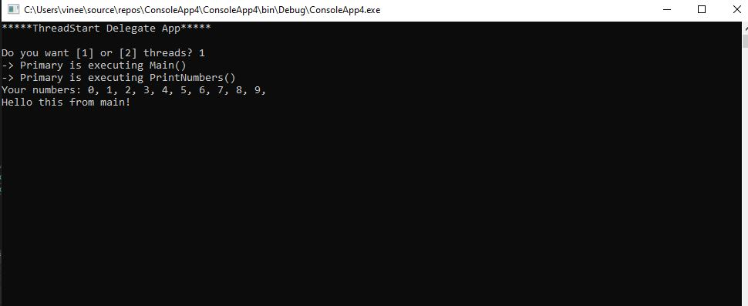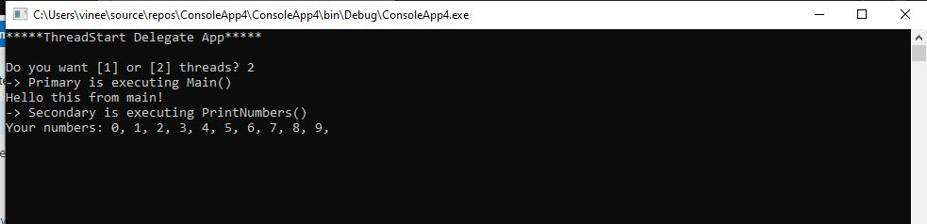

**Multithreading – ThreadStart (MultithreadingSample)**

**print.cs**

using System;

using System.Collections.Generic;

using System.Linq;

using System.Text;

using System.Threading.Tasks;

using System.Threading;

namespace ConsoleApp6

{

class Print

{

private object lockToken = new object();

public void PrintNumbers()

{

lock (lockToken)

{

Console.WriteLine("Thread-> {0} started @{1} and executing PrintNumbers() method",

Thread.CurrentThread.ManagedThreadId, DateTime.Now.ToLongTimeString());

Console.Write("Your numbers: ");

for (int i = 0; i < 10; i++)

{

Console.Write("{0}, ", i);

Thread.Sleep(500);

}

Console.WriteLine();

}

}

}

}

**program.cs**

using System;

using System.Collections.Generic;

using System.Linq;

using System.Text;

using System.Threading.Tasks;

using System.Threading;

namespace ConsoleApp6

{

class Program

{

static void PrintTheNumbers(object state)

{

Print task = (Print)state;

task.PrintNumbers();

}

static void Main(string[] args)

{

Console.WriteLine("*****Multithreading Program*****\n");

Console.WriteLine("Main thread started. ThreadID = {0}",

Thread.CurrentThread.ManagedThreadId);

Print p = new Print();

WaitCallback workItem = new WaitCallback(PrintTheNumbers);

for (int i = 0; i < 10; i++)

{

ThreadPool.QueueUserWorkItem(workItem, p);

}

Console.WriteLine("All task Queued");

Console.ReadLine();

}

}

}

**OUTPUT:**

