ENHANCED SOLAR ENERGY VEHICLE FOR THE PHYSICALLY HANDI-CAPPED

Sai Kumar Vurukonda, Naveen Kumar

*1Institute of Aeronautical Engineering College*

*Gandi-Maissamma*

*Hyderabad, 500081*

[1saikumarvurukonda@gmail.com](mailto:1saikumarvurukonda@gmail.com)

*[naveennani1612@gmail.com](mailto:naveennani1612@gmail.com)

***Abstract-* The solar powered vehicle is designed, keeping in view the difficulties faced by the physical challenged in the society and to relieve the ever-increasing demand for the conventional sources of fuel. This project focuses on creating an eco-friendly environment as well as to serve as a simpler mode of transportation for the physically challenged in the society. The conventional solar vehicles are purely driven by a single battery. Whereas this design houses two batteries, wherein one will act as an active one that drives the system and the other battery will be used as an auxiliary. The multiple battery charging technique using Arduino microcontroller is implemented in this project, which governs the parallel charging of the batteries used. Also, manual hand pedal driving is provisioned so as to run the vehicle even when there is any kind of battery outage. The motor that is used for the model is permanent magnet brushless DC motor, whose power consumption and load characteristics are feasible enough so as to minimize the overall power consumption.**

***Keywords-* Multiple battery charging technique, Arduino, permanent magnet brushless DC motor, manual hand pedal.**

## INTRODUCTION

This is the era wherein the depletion of natural resources is at an exponential rate. The need of the hour is thus the adoption of alternative resources to cope the energy needs. Since the start of the first decade of the 21st century, the world has had a lot of modifications in various sectors, including energy management.

The technological development in the methodologies of generating energy from renewable sources is increasing at a tremendous rate. The techniques are being modified accordingly to make the whole process affordable, and efficient for the community, and is made sure that it has huge longer-term benefits. It significantly increases countries’ energy security through reliance on an indigenous and inexhaustible resource. It also aims at enhancing sustainability, reduce pollution and keep fossil fuel prices lower.

The implementation of methodologies that harvest energy from inexhaustible sources has had a very great reach in the society. One of its main targets is to serve the disabled people, in a rightful and a resourceful manner, and this is effectively done through harvesting energy from sunlight. The main

reason for the widespread usage of solar energy is due to its adaptability, flexibility, economic and inexpensive features over the other renewable resources. To alleviate the adaptability and economic difficulties faced by the physically challenged, heavy investments are made in Research and Development sectors to provide optimum solutions for the same.

## SCOPE

This project envisages a broad scope and are enlisted as follows.

* To convert the solar energy to the electrical energy efficiently by using solar cells.
* To alleviate the problems faced by a handicapped while travelling and enhance their commutability.
* To find an alternative for fuel.
* To maintain the ecological balance.
* To form an economical vehicle.
* To maintain a pollution-free environment.
* To promote awareness of renewable energy resources amongst the society.

## SOLAR POWER GENERATION- THEORY

The discovery of the photovoltaic phenomenon dates back to around 1830s. It was found by a French physicist Edmund Becquerel. Harnessing of electrical energy is mainly based on the photovoltaic process.

Briefly, it states that when a material (such as Germanium, Silicon, etc.) is irradiated by a beam of photons (sunlight), there is an excitation of the molecules present in the material, thus giving rise to production of electrical energy.

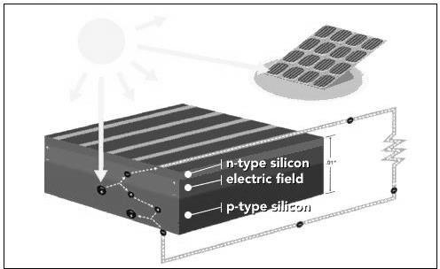

Fig. 1 The photovoltaic effect

Silicon PVs are widely used nowadays due to its cost effectiveness and availability. Chips of Silicon are framed together and made as panels for practical purpose.

There are several advantages of solar power generation over other forms of energy resources. Some of them are enlisted as follows:

* Reduced dependence on fossil fuels.
* Cleaner environment.
* Less noise associated with the production process.
* Readily scalable and versatile.
* Increased flexibility.
* Associated equipment is quantitatively less.
* Easy implementation.
* Inexpensive.
* Less maintenance cost.
* Longer lifetime.
* May attract government incentives.

## DEVELOPMENT AND DESIGN

A schematic of the design [1] [5] [8] [9] was sketched on which the model was worked upon. It is shown in Fig 2.

integrated inverter/switching power supply. [3] The PMBLDC motor is fitted with a freewheel coupling as shown in Fig. 3, which is in turn coupled with the main hind axle through another freewheel.

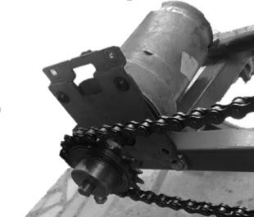

Fig. 3 Motor with drive freewheel

This motor is driven directly by a 12v battery through a MOSFET drive for better speed control.

# BATTERY

Two dry cell batteries with 12V, 7Ah rating (as shown in Fig. 4) are used, which can deliver 84VA power. On fully loaded condition, each of these batteries can drive the motor up to 3 hours continuously.

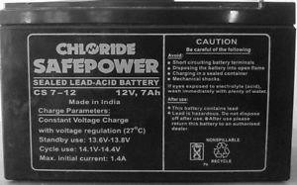

Fig. 4 Dry cell battery

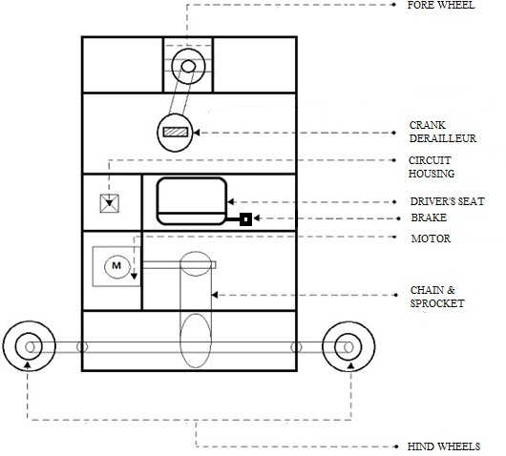

The batteries will be made to operate in two different modes namely charging and driving modes, which means that they will either drive the motor independently or will be charged by the solar panel.

Fig. 2 Fabrication layout

The design is fitted with 3 wheels (i.e. 1 fore wheel and 2 hind wheels) for a smooth and good manoeuvrability.

# FRONT WHEEL DESIGN

The fore wheel movement involves a crank derailleur with a chain, which can be used as a hand paddle to manually drive the vehicle. A good turning radius is provided for the fore wheel to enable easier and quicker manoeuver.

# MOTOR

The PMBLDC motor is used to drive the vehicle without any hassles. Brushless DC electric motors are synchronous motors that are powered by a DC electric source via an

This switchover is made possible using relays actuated by the microcontroller. The batteries are housed below the seat of the driver.

# SHAFT

Common shaft is placed on the rear most end of the vehicle to deliver the power of the motor to the two rear wheels with minimal loses.

Motor shaft has 16 sprocket free wheel and it drives a 24 sprocket freewheel on the common shaft. Two 16 sprocket freewheels are placed on both ends of the common shaft and 24 sprocket freewheels are attached to the two rear wheels. This whole system is shown below in Fig. 5, along with the housed motor and the wheels.

# GEARING

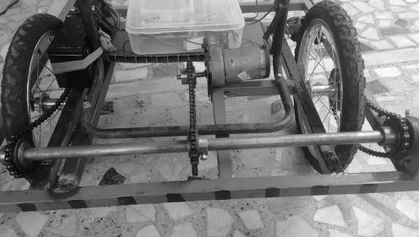

The gearing mechanism [4] [6] of the whole vehicle (along with the wheel, sprocket, and coupling) is shown in Fig 7.

Fig. 5 Hind shaft with two freewheels

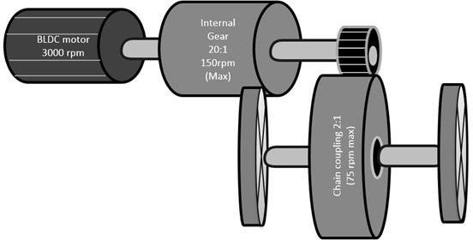

This entire mechanism is similar to the differential gearing system. This has three jobs:

1. To have good power at the wheels.
2. To act as the final gear reduction in the vehicle.
3. To transmit the power to the wheels while allowing them to rotate at different speeds.

# SEATING & PANEL POSITIONING

The driver’s seat is provided with a manual braking system and accelerometer, which is just under the hand’s reach. It enables quick braking/acceleration of the vehicle and provides easiness to the driver.

12v, 75w (0.90 x 0.65m) polycrystalline solar panel [11], of type class A is used. Panel is supported by detachable aluminium frame on four sides. It also acts as a roofing which provides shade to the driver. The panel is attached to the frame with help of wooden strips to absorb vibrations.

.

# FRAME

Frame of the vehicle is built using 1-inch square tubular MS pipe of 1.6mm thickness, as shown in Fig. 6. The limbs are welded carefully to give good strength to the vehicle and appropriate design is made to eliminate useless limbs. Also support limbs are placed at appropriate positions to enhance vehicle stability and strength.

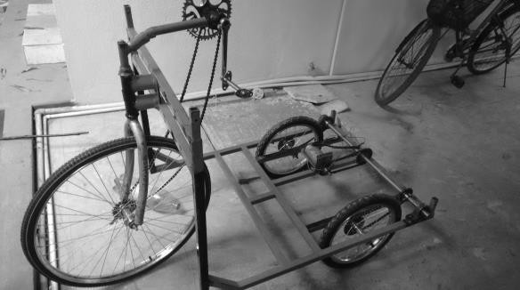

Fig. 6 Frame structure

Shaft holders, forks, motor slots and panel holders are positioned precisely, and a detachable solar panel roof is provided, such that it can be removed during maintenance period. Chair height and front pedals are also positioned precisely based on convenience.

Fig. 7 Gearing mechanism

# SPEED CALCULATION

Diameter of the rear wheel = 14 inches = 0.356 m Circumference of the wheel = 1.118 m

Maximum speed of the motor

(including internal gear) = 125 RPM Maximum speed = 125 * 1.118 = 139 m/min

= 8.385 km/hr

TABLE I DESIGN DIMENSIONS

|  |  |  |
| --- | --- | --- |
| **COMPONENT** | **PARAMETER** | **DIMENSION/ VALUE** |
| Front wheel | Diameter | 0.53 m |
| Fork stem | Length Diameter | 0.30 m  0.03 m |
| Frame | Length Breadth Thickness | 1.00 m  0.75 m  0.03 m |
| Seat support | Length Breadth Thickness | 0.30 m  0.30 m  0.01 m |
| Back wheel | Diameter | 0.36 m |
| Back freewheel | Number of teeth | 24 |
| Front freewheel | Number of teeth | 24 |
| Motor freewheel | Number of teeth | 16 |
| Common shaft freewheel  (center) | Number of teeth | 24 |
| Shaft freewheel (ends) | Number of teeth | 16 |
| Panel | Length Width | 0.90 m  0.65 m |

## DESIGN CIRCUIT

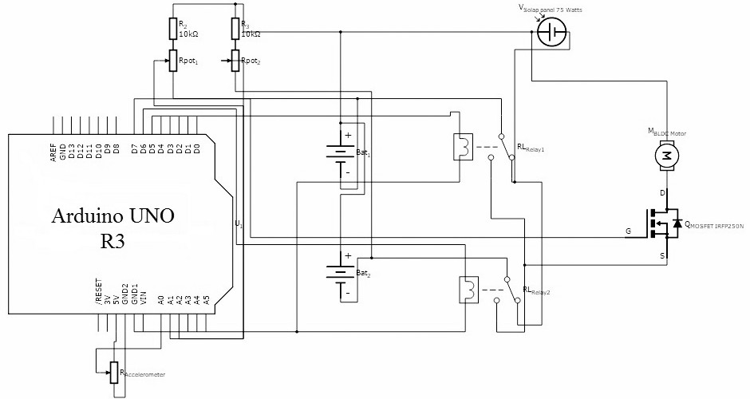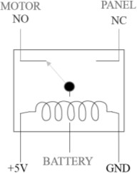

Fig. 8 Circuit diagram- Dual battery switchover technique

The circuitry includes the following components and features.

# BATTERY LEVEL MONITORING

The two 10k*Ω* potentiometers are used for battery level monitoring. The nominal voltage of the fully charged battery was found to be around 14v. But Arduino can only support a range of 0-5v. Thus, the function of the potentiometer is to correspondingly reduce it down to this suitable range, so that the voltage levels are readable by the Arduino to perform battery level monitoring via relays.

# RELAY OPERATION

There are 2 relays R1 and R2 correspondingly for batteries B1 and B2. Each of the relay is connected in the configuration shown below. The relay is by default in NC-state (as shown in Fig. 9), wherein it is connected with the panel. Thus the battery gets charged via panel.

Fig. 10 NO/Discharging state

# MOSFET DRIVE

The IRF250n is MOSFET device (as shown in Fig. 11) that can withstand voltages up to 200V. [12] The basic operation of the drive is to govern the motor speed variation with the help of Arduino.

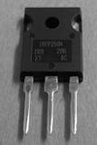

Fig. 11 IRF250n

The drain-source voltage is varied by the Arduino to vary the width of the conduction path. Accordingly, conductivity varies. If the width is high, then the conductivity is less and so, the motor’s speed is lowered. Vice versa is also possible.

# POTENTIOMETER

The Accelerometer for the vehicle is mimicked by a POT connected with A0 of the Arduino where 0-5v is equivalent to 0-1023. The potential value can be varied via the POT and this

variation is treated as the variation between 0 (throttle minimum position) and 1023 (throttle maximum position).

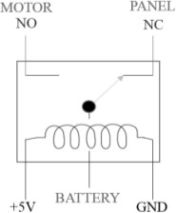

Fig. 9 NC/Charging state

When the battery is charged up to a maximum or any acceptable level, it is switched relay from NC-state to NO- state (as shown in Fig. 10), which is the discharging process towards the motor.

The other set of 2 POTs which are connected with the 2 batteries are used in battery level monitoring, as mentioned earlier.

# ARDUINO MICROCONTROLLER

The Arduino microcontroller [2] is dumped with the programming codes, using its corresponding IDE, and is used in controlling of the relays. It actuates the required relays and aids in switching of contacts between the batteries and the motor (load).

1. MULTIPLE BATTERY CHARGING TECHNIQUE The working of the whole concept [7] can be explained

with the help of the block diagram as shown in Fig. 12.

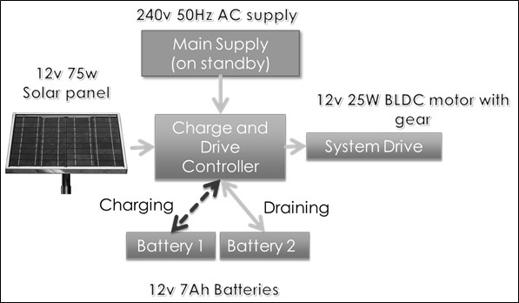

Fig. 12 Working block diagram

* When the vehicle is at standby state, AC mains can be used to charge the batteries. Both the batteries will be charged simultaneously in such a condition.
* Provisions are made such that typical laptop chargers can also be used to charge the vehicle.
* On running state, Battery 1 will be individually connected to the load (motor) through MOSFET drive. This battery will continue to supply the vehicle till it reaches 30% of its charge state.
* Then, the load will be switched over to the Battery 2 through the same drive, while the Battery 1 gets charged by the solar panel through a charge controller.
* This charge controller is designed in such a way that the Battery 1 gets charged more than 90%, before Battery 2 reaches 30% of its charge state.
* When Battery 2 reaches 30% of its charge state, load will be automatically tripped back to Battery 1.
* This cycle continues till there is sufficient light source incident on the solar panel to charge the batteries.
* In case of insufficient light source, batteries are programmed to get drained one after the other.

1. ADVANTAGES

# REDUCED STRESS

Two batteries share the load due to the switching mechanism, which evidently shows that the electrical stress on the battery is reduced significantly.

# OPERATING TIME PERIOD

If just one battery is used for the entire vehicle, then the vehicle may run out of energy source in quick time.

# INCREASED LIFETIME

If the whole circuitry and operation solely depends on a single battery, it may cause the battery to reduce its lifetime at a faster rate.

# SELF-SUSTAINABLE

The whole model is considered self-sustainable since it is driven by an abundantly available renewable source of energy (solar energy).

# ENHANCED EFFICIENCY

Usage of dual batteries involves less stress on them, which eventually makes sure that the batteries do not wear out faster or work with less efficiency.

# MANUAL DRIVING PROVISION

A provision is made for the user such that they can also manually hand-pedal the vehicle.

## FINAL MODEL

The front and side views of final vehicle respectively, are shown in Fig. 13.

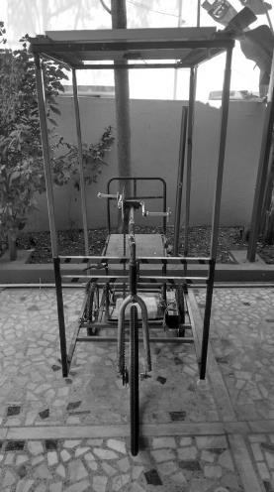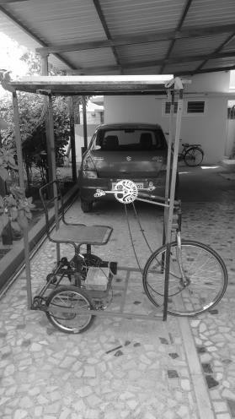

Fig. 13 Final model TABLE II

DESIGN SPECIFICATIONS

|  |  |
| --- | --- |
| **NAME** | **RATING/VALUE** |
| **SOLAR PANEL** | 75W, VOC = 21.4V |
| **PMBLDC MOTOR** | 25W, 12V, 2A |
| **DIMENSIONS**   1. **HEIGHT** 2. **LENGTH** 3. **WIDTH** | 1.83m  1.00m  0.75m |
| **DESIGN WEIGHT** | 33 Kg |
| **BATTERY** | 12V, 7Ah |

## CONCLUSION

A successful prototype model of an Optimized Solar Powered Vehicle for the Physically Handicapped is designed primarily to serve the needy, for a better living. It not only solely aims for the latter, but also to stress the importance of renewable sources of energy and promote its importance amongst the public. The features of the model such as the charging mechanism, gearing, mechanical assembly, dual battery system etc. are elucidated briefly in our thesis, so that it can even serve as a good purpose for upcoming prototypes. The model is ultimately designed with a broader perspective and a positive hope to alleviate the energy crisis in the near future.

## FUTURE SCOPE

* Obstacle avoidance sensors such as proximity sensor or ultrasonic sensors can be integrated with the microcontroller.
* Charging can also be done from the household AC supply.
* The whole system can be designed to control and manipulate even with more number of batteries.
* Disc braking can be implemented in terms of mechanical aspect.
* Battery level indicator with LCD display can be implemented.
* Mobile phone (DTMF) based vehicle control can be incorporated.
* For better UI, android interfacing can be implemented.

## ACKNOWLEDGEMENT

First and foremost, acknowledgements to of the Department and our guide, for the fullest support and guidance given throughout the course of the project. We would like to thank all the lab assistants and other staff members for assisting us in each stage of our project.

## REFERENCES

1. “Design of Solar tricycle for Handicapped person by *Sai Kumar, Naveen, Vinay, Hema. There* (IOSR Journal of Mechanical and Civil Engineering (IOSR-JMCE), e-ISSN: 2278-1684 Volume 5, Issue 2(Jan-Feb 2013), pp11.”
2. “Appliance Remote Control Using Arduino by *D. Anusha, PM.Sarma, M.N. SandhyaRani,* Vol. 2 Issue 4 July 2013, ISSN: 2278-621X.”
3. “Implementation of Solar Powered PMBLDC Motor Drive by *Deepa A. B and Maheshkanth Pawar,* IJSRD

- International Journal for Scientific Research & Development | Vol. 2, Issue 08, 2014 | ISSN (online): 2321-0613.”

1. “Power Assisted Tricycle with Drive-Train Arrangement for Disabled Persons by *K. Kalyani Radha and K.Sai Kiran,* International Journal for Research in Applied Science & Engineering Technology (IJRASET), Volume 2 Issue XI, November 2014, ISSN: 2321-9653.”
2. “Cost-Benefit Analysis of Plug-In Hybrid Electric Vehicle Technology by *Tony Markel and Andrew Simpson*, ISSN 2032-6653, The World Electric Vehicle Association Journal, Vol. 1, 2007.”
3. “Design and structural analysis of differential gear box at different loads by *C.Veeranjaneyulu and U. Hari Babu,* International Journal of Advanced Engineering Research and Studies, E-ISSN2249–8974, Vol. I/ Issue II/January-March, 2012/65-69.”
4. “Automatic Battery Charging Algorithms for Hybrid Electric Vehicles by *F.Vijay Amirtha Raj*, International Journal of Emerging Science and Engineering (IJESE), ISSN: 2319–6378, Volume-1, Issue-2, December 2012.”
5. <http://www.slideshare.net/parmarmehulkumar39/solar-> tricycle
6. <http://www.oneindia.com/2008/03/25/students-design-> solar-powered-tricycle-1206439560.html
7. <http://www.electricscooterparts.com/currieelectricsco> oterandbikeparts.html
8. <http://rcbsolar.com/our-products/solar-panels/>
9. <http://ww1.microchip.com/downloads/en/AppNotes/> 00898a.pdf