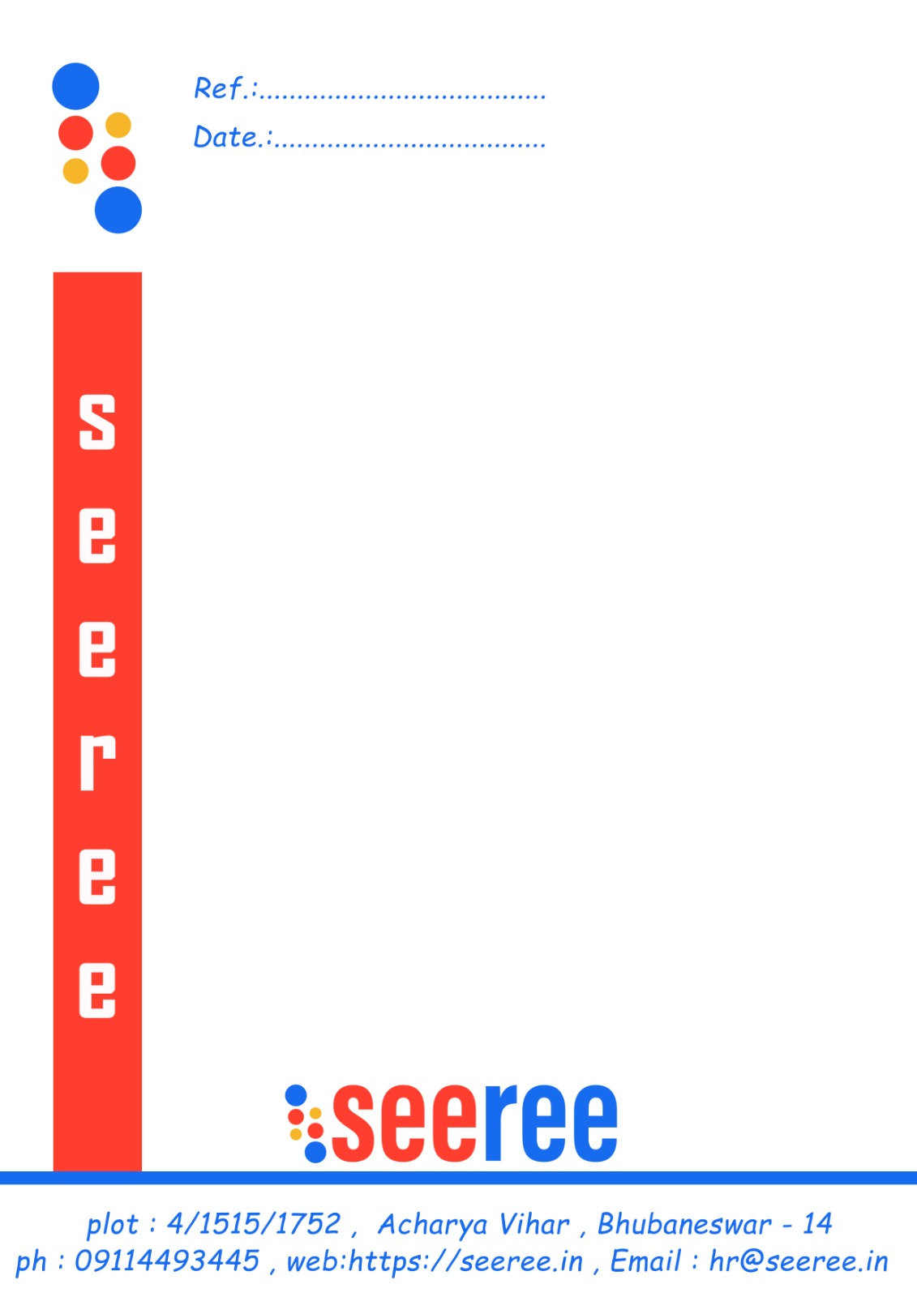

**In/seeree/00383**

**01/05/2024**

TO WHOM IT MAY CONCERN

This is to certify that **Asish Kumar Sahoo** bearing regd.no: 2205266037 MCA student of Trident Academy of Creative Technology has successfully completed project with **seeree services pvt. ltd.** from **18th January 2024** to **18­th April 2024**.

During the project, he demonstrated dedication, enthusiasm, and a strong commitment to learning and professional growth.

During his tenure at seeree services Pvt. Ltd., He excelled notably on the **Online Quiz** project, developed using **JAVA**. His practical application of theoretical knowledge was highly commendable, reflecting his deep understanding of the subject matter. We believe that his project experience will significantly contribute to his future professional endeavors.

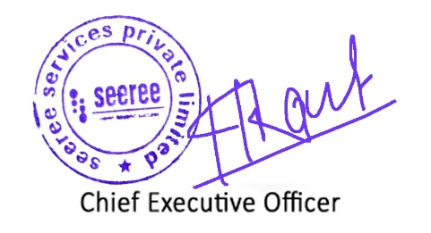

**seeree services pvt. ltd**