### Experience

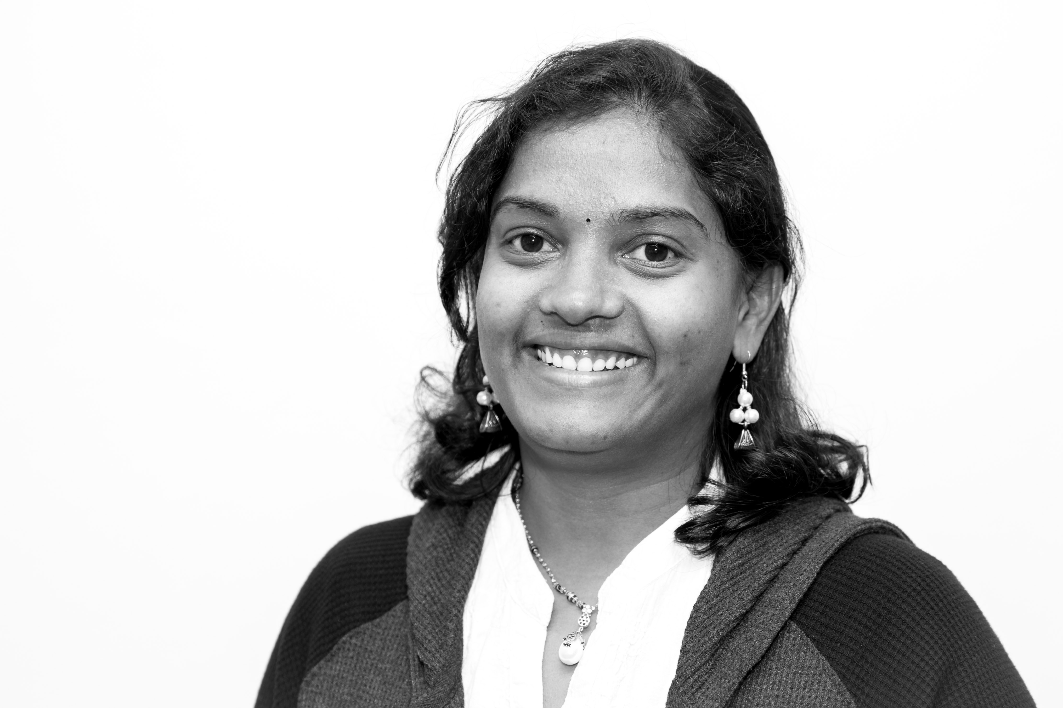

Sailaja ranga

Data Scientist

## Contact Details:

**Mobile:** **0426530 007**  
**E-mail:**

**sailaja.ranga05@gmail.com**

**Visa: Permanent Resident  
Linkedin:**[https://www.linkedin.com/in/sailaja-ranga/](https://www.linkedin.com/in/sailaja-ranga/" \t "_blank)

**Github:** [https://github.com/Sailaja-DS](https://github.com/Sailaja-DS" \t "_blank)

## Summary:

**I am a junior Data Scientist with a technical development across the insurance, healthcare and telecommunication domains. I would love to apply my data science skills in a data-driven industry for better decision-making or problem solving. I’m an ambitious person, which drives to continue to grow my career as Data Scientist where I can build data narratives and handle data using different tools and Methodologies.**

#### **Data Science Immersive Student** (Oct 2017 - Feb 2018)

#### General Assembly, Sydney, NSW

Full Time Immersive course exploring data science and its applications with main areas of study being:

* **Python**: NumPy, Pandas,SKLearn, data c leaning and visualization
* **Machine Learning**: Regression, Classification and Clustering algorithms in detail, with a thorough understanding of the mathematical and statistical justifications for their use
* **Webscraping**: Spider, XPath, BeautifulSoup4 and Selenium to scrape data from websites and processing using Python
* Neural Networks and their applications, using Tensor flow, Graphlab, OpenCVetc.

**Project:** The business problem tackled here is trying to improve customer service for "YourCabs.com". The problem of interest is booking cancellations by the company due to unavailability of a car. The challenge is that cancellations can occur very close to the trip start time, thereby causing passengers inconvenience.

#### **Network Analyst** (Oct 2014 - mar 2017)

#### Fuzenet Pvt Ltd, Sydney, NSW

* Data and voice service provisioning/activation on various networks such as FIBRE, VDSL and CABLE networks.
* Configuration and maintenance of numerous telecom systems, hardware and software applications.
* Network Monitoring and surveillance of network equipment’s on the network map
* Troubleshooting and rectifying network alarms throughout the network
* Organizing the New network connections to the premises by scheduling the jobs to the installers.
* Generating the reports on weekly basis to support the management to take appropriate decisions to resolve the issues.

**Environment:** EMS, U2000, Broadband provisioner

#### **IT Analyst** (Jan 2012 - june 2014)

#### Tata Consultancy servicces, HYDERABAD, INDIA

**Clients:** USAA Insurance, State Firm Insurance (USA), Amex Australia

* Involved in full project life cycle involving Requirement Analysis, Design, Coding, Testing and Implementation phases
* Designed/Coded new programs using COBOL, IMS DB/DC and SQL for Amex travel loyalty card application
* Modified and tested COBOL and CICS programs and JCL codes per the requests of business departments.

## Skills & Abilities:

* **Python**
* **SQL**
* **Tableau**
* **Machine Learning**
* **COBOL**
* **IMS DB, DB2, VSAM**

# Education:

#### **Full time data science immersive course** GENERAL ASSEMBLY (Oct 2017 – Feb 2018)

#### **Master of Technology** Indian Institute of technology- kanpur (July 2005 – July 2007)

#### **Bachelor of Technology**

##### jawaharlal nehru technological University

(Jun 2001 – Apr 2005)

### REFERENCES:

##### Available on request

* Analyzed the faults and specified the corrective measures to ensure non occurrence of outages
* Led team of 6 members by assigning tasks and assisted to resolve complex use cases.

**Environment:** COBOL, DB2, IMS, JCL, VSAM, TSO/ISPF, FILE-AID, IBM UTILITIES, CICS, and SPUFI

#### **Software Engineer** (aug 2007 - dec 2011)

#### Csc PVT ltd, HYDERABAD, INDIA

**Clients:** Kaiser Permanente healthcare (USA), Zurich Insurance

* Analyzed production data and executed data cleanups.
* Identified code modules impacted by production issues and provided permanent fixes.
* Involved in Analysis, design, coding and testing for minor/major enhancements.
* Responsible for internal quality audits for several modules
* Responsible for leading the team for Monthly release activities and financial year-end special activities.
* Provided 24/7 Production Support for all the regions providing immediate fix for the production problems, suggest permanent fix for the problems.

**Environment:** COBOL, DB2, JCL, VSAM, TSO/ISPF, FILE-AID, IBM UTILITIES,