Architectural Diagram :

Data Pipeline Creation:

Ingest data into the chosen source:

Data Factory : Data integration service that enables you to create, schedule and manage pipelines and efficient data movement and transformation between various sources and destinations in Azure.

Data lake Gen 2 : Data lake solution that combines the capabilities of a data lake with a power of azure blob storage allow to store and analyse large volumes of structured and unstructured data.

Azure Data bricks: Data Bricks is a unified platform built on top of Apache spark designed to help data engineers and data scientists collaborate on big data processing and machine learning tasks.it provides tools for data exploration, data processing and building machine learning models.

Synapse analytics: it combines big data and data warehousing into a single integrated form, allowing organization to analyze and process large volumes of data for BI and data analytics purposes.

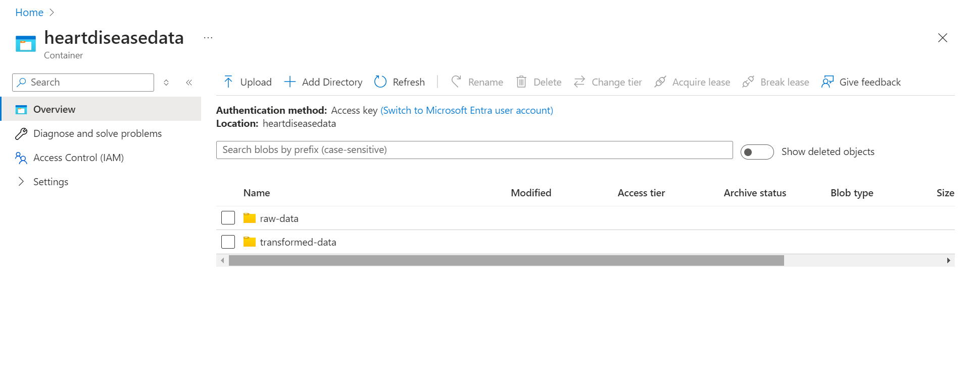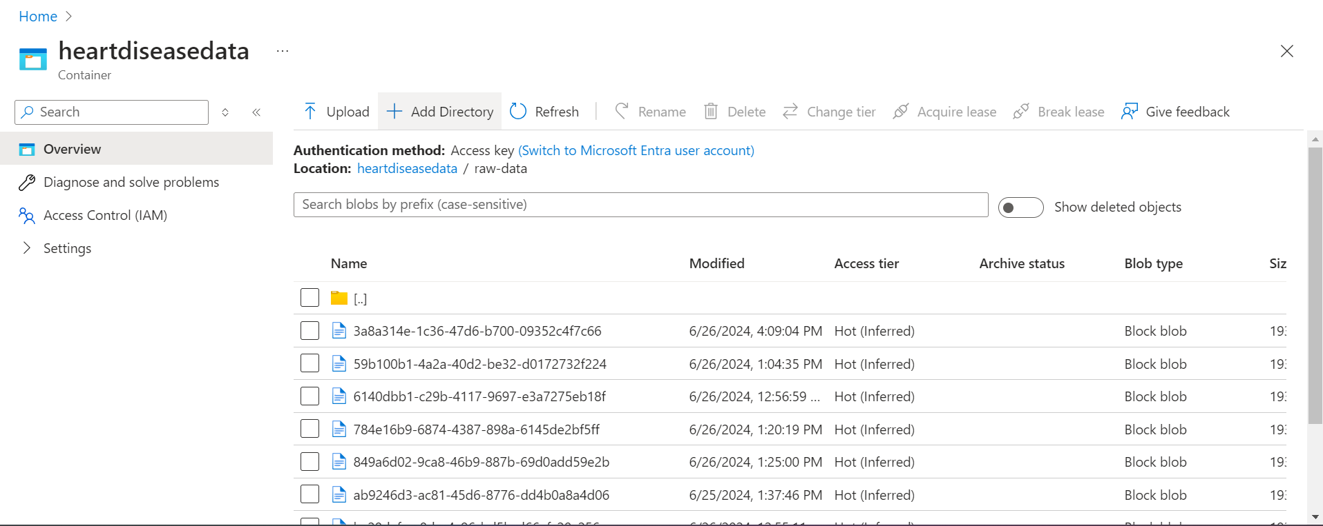

Data factory pipeline creation:

Azure DataBricks:

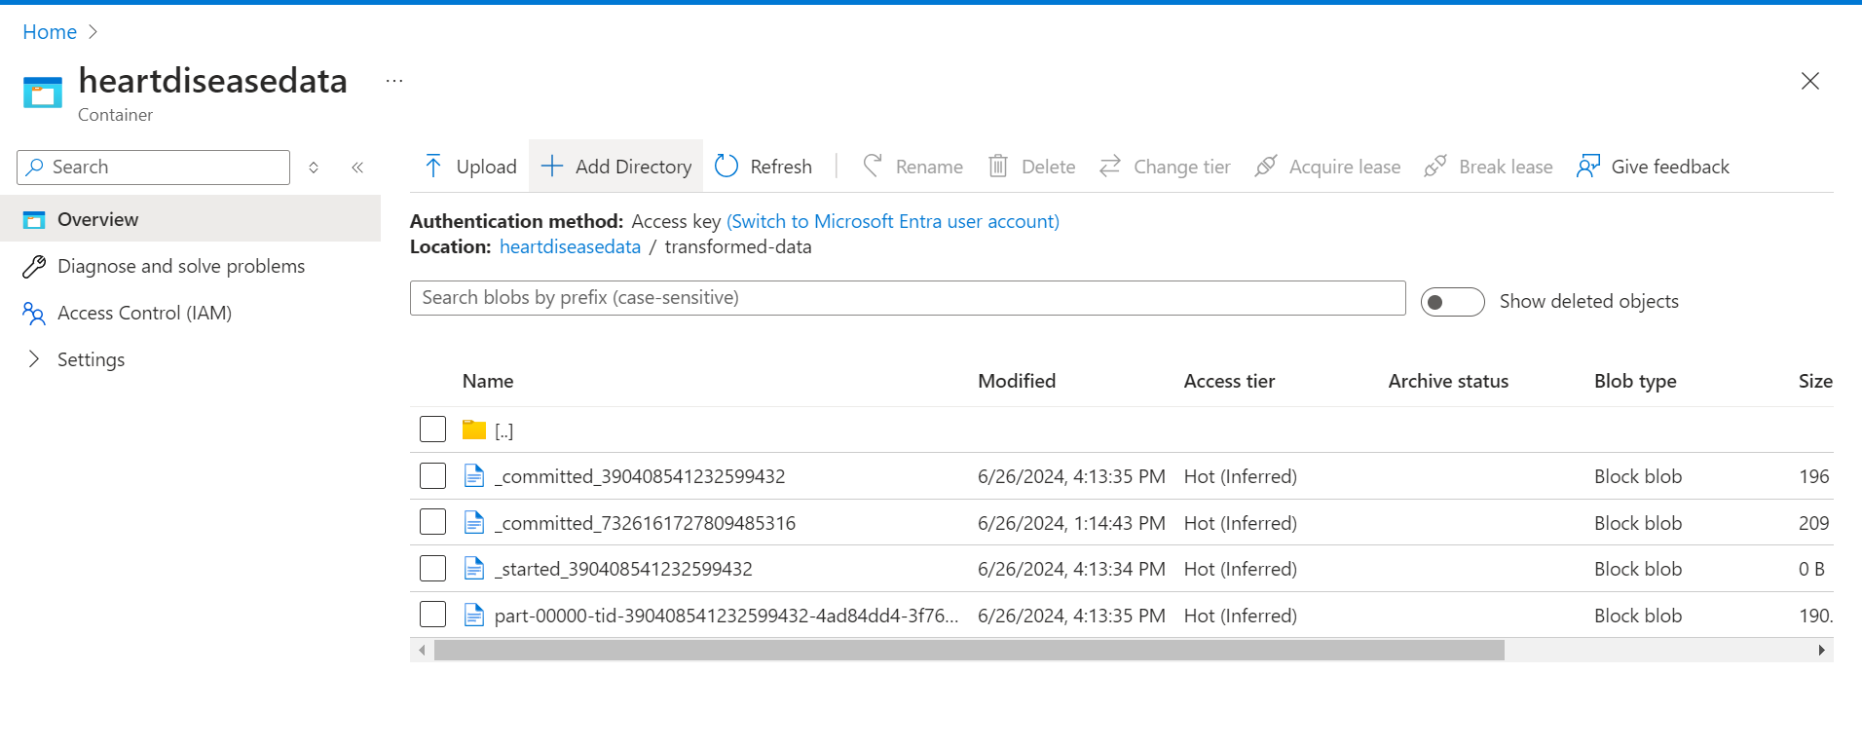  
Synapse Analytics:



