* **Lab_1**

1. .**Write a Java program to print "Hello, World!" to the console.**

**Code:**

**package** lab_1;

**public** **class** hello {

**public** **static** **void** main(String[] args) {

System.***out***.println("Hello World");

}}

**Output:**

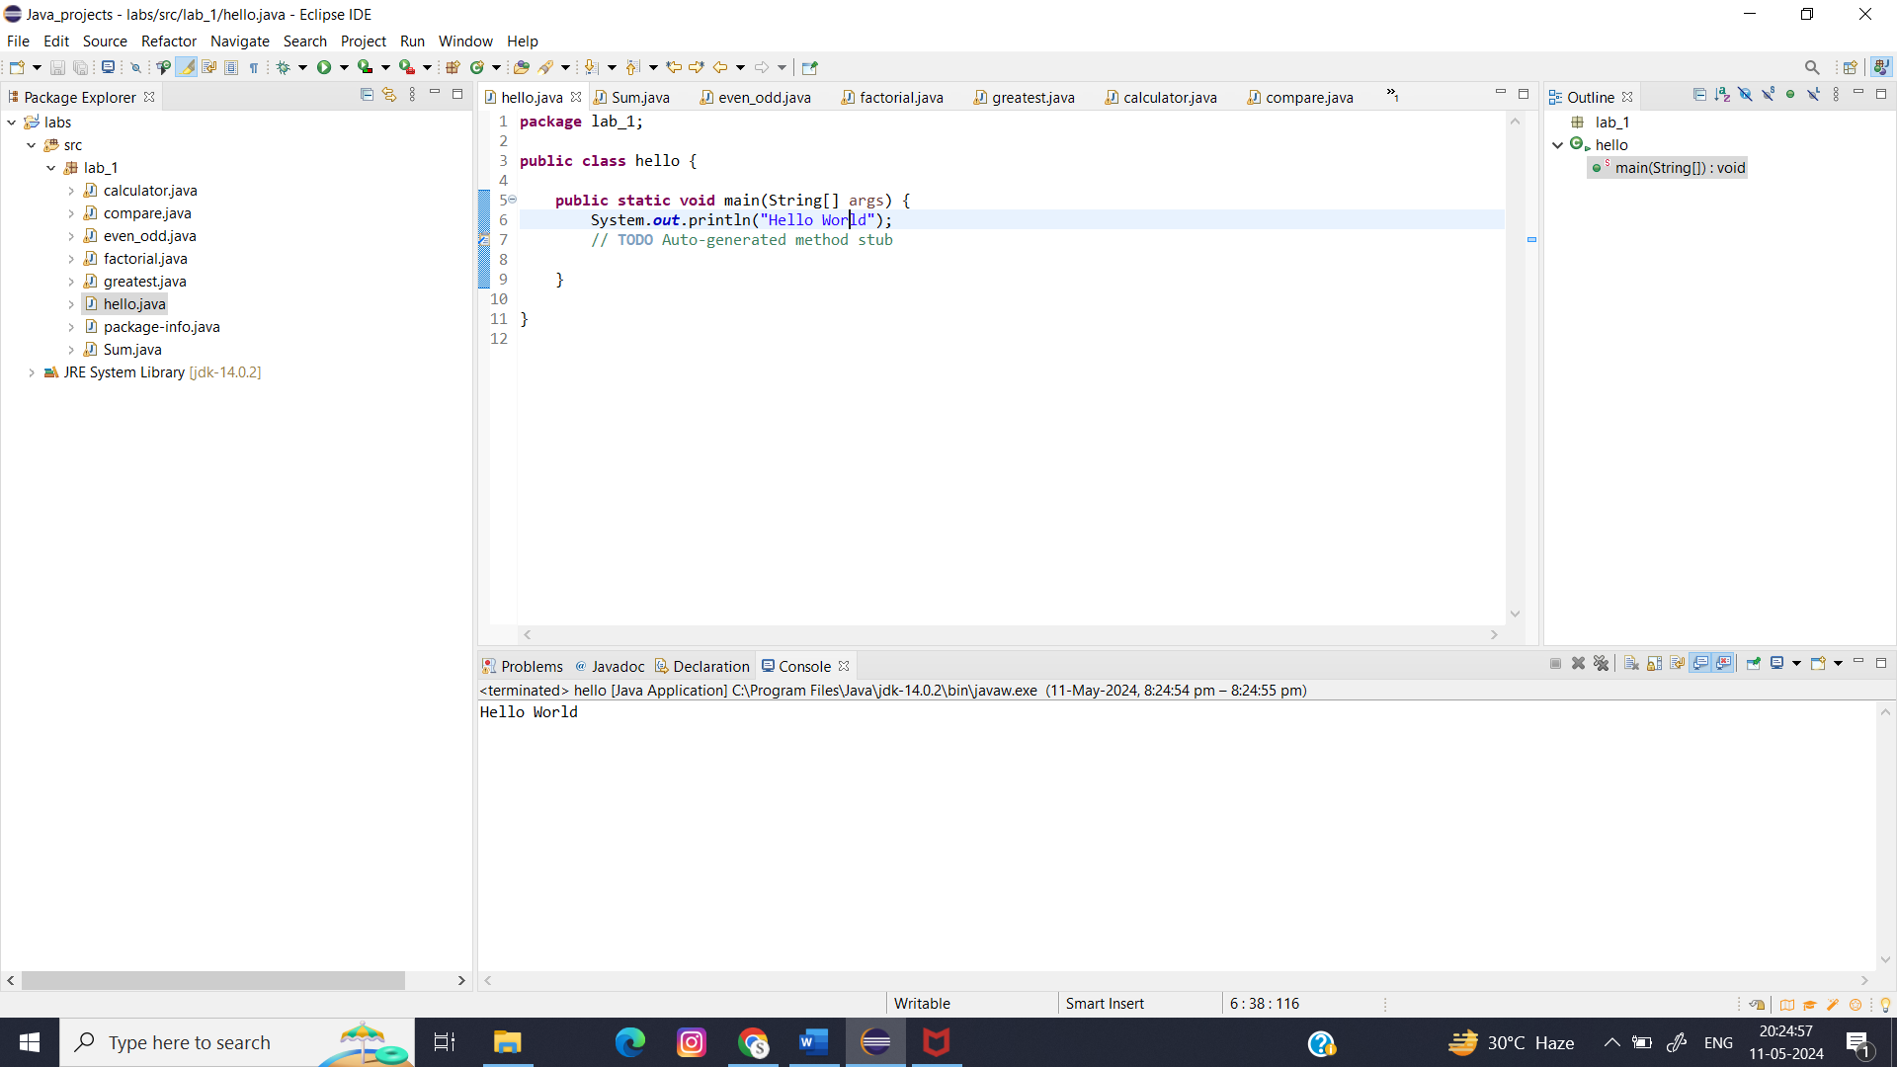

1. **Write a program to find the sum of two numbers entered by the user.**

**Code:**

**package** lab_1;

**import** java.util.Scanner;

**public** **class** Sum {

**public** **static** **void** main(String[] args) {

**int** x, y, sum;

Scanner sc = **new** Scanner(System.***in***);

System.***out***.print("Enter the first number: ");

x = sc.nextInt();

System.***out***.print("Enter the second number: ");

y = sc.nextInt();

sum = *sum*(x, y);

System.***out***.println("The sum of two numbers x and y is: " + sum);

}

**public** **static** **int** sum(**int** a, **int** b)

{

**int** sum = a + b;

**return** sum;

}

}

**Output:**

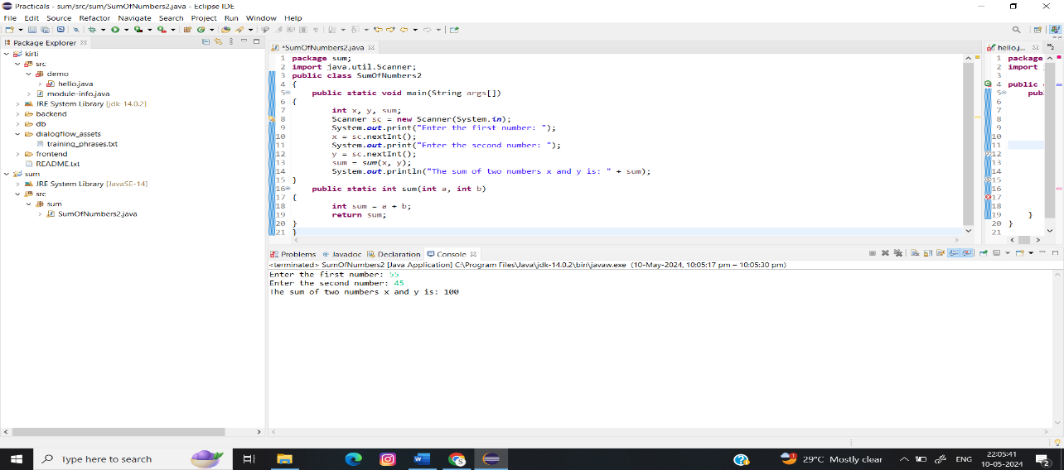

1. **Write a Java program to check whether a given number is even or odd.**

**Code:**

**package** lab_1;

**import** java.util.Scanner;

**public** **class** even_odd {

**public** **static** **void** main(String[] args) {

// **TODO** Auto-generated method stub

Scanner reader = **new** Scanner(System.***in***);

System.***out***.print("Enter a number: ");

**int** num = reader.nextInt();

**if**(num % 2 == 0)

System.***out***.println(num + " is even");

**else**

System.***out***.println(num + " is odd");

}

}

**Output:**

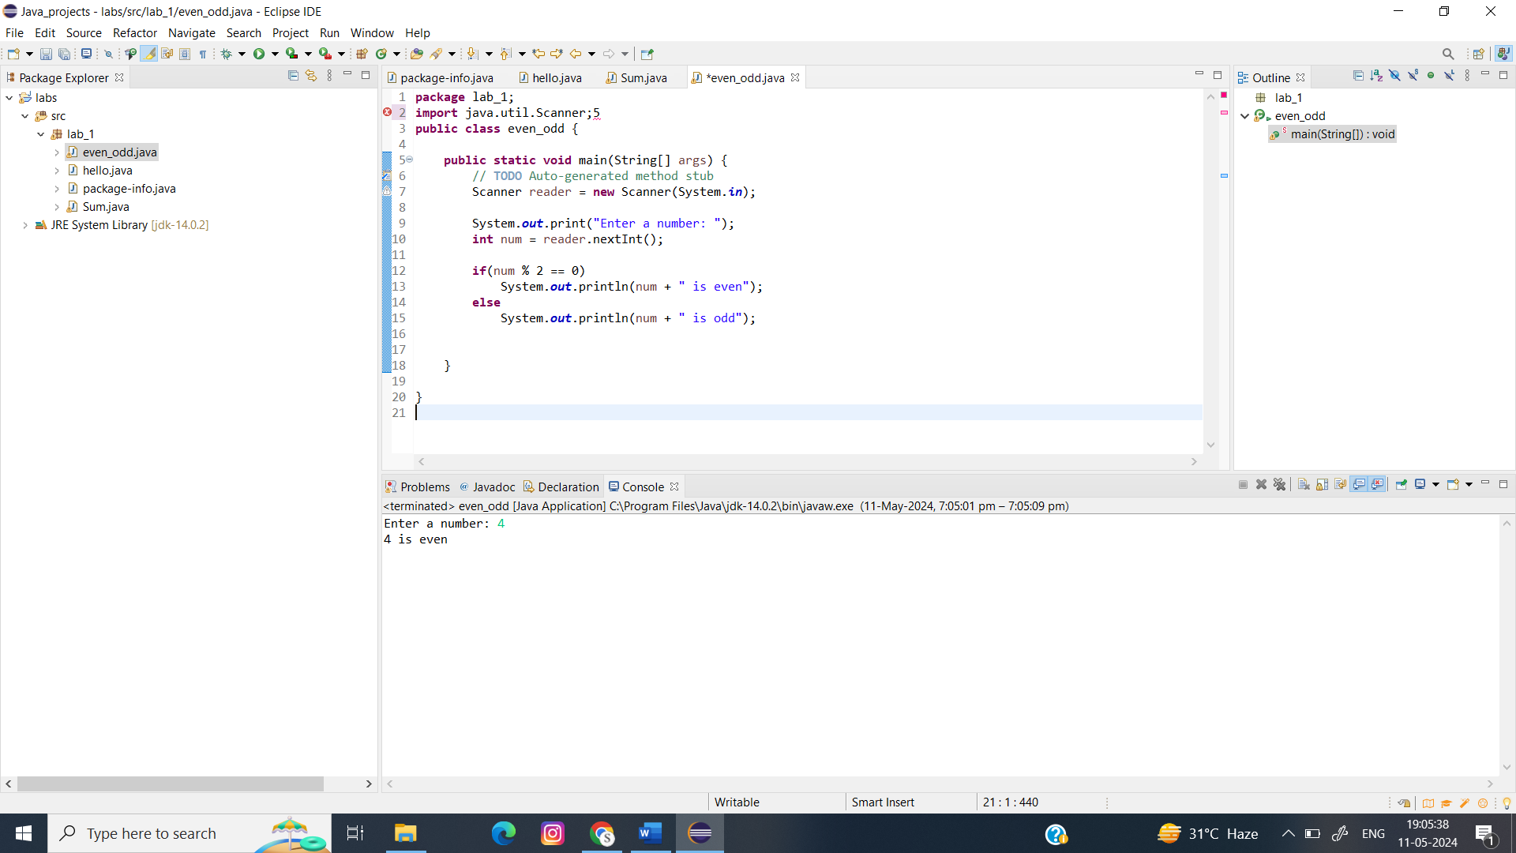

1. **Write a program to calculate the factorial of a number using recursion.**

**Code:**

**package** lab_1;

**import** java.util.Scanner;

**public** **class** factorial {

**public** **static** **void** main(String[] args) {

// **TODO** Auto-generated method stub

Scanner reader = **new** Scanner(System.***in***);

System.***out***.print("Enter a number: ");

**int** num = reader.nextInt();

**long** factorial = *multiplyNumbers*(num);

System.***out***.println("Factorial of " + num + " = " + factorial);

}

**public** **static** **long** multiplyNumbers(**int** num)

{

**if** (num >= 1)

**return** num * *multiplyNumbers*(num - 1);

**else**

**return** 1;

}

}

**Output:**

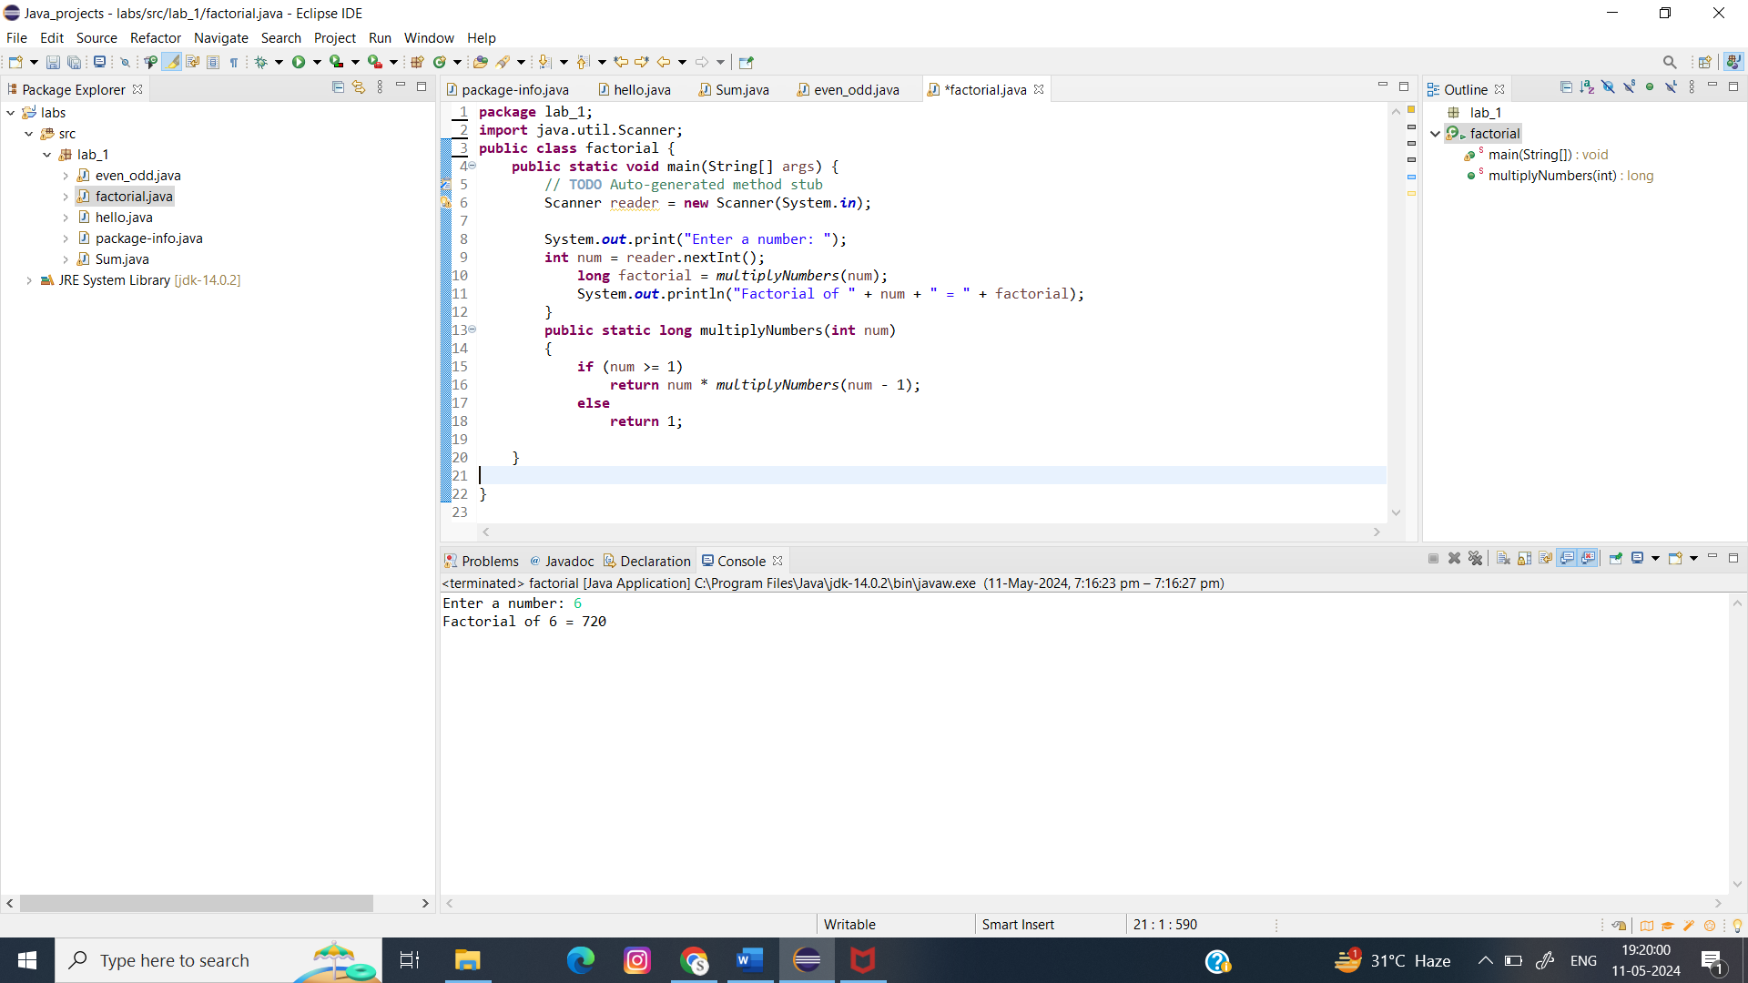

1. **Write a java program to find greatest of 2 numbers.**

**Code:**

**import** java.util.Scanner;

**public** **class** greatest {

**public** **static** **void** main(String[] args) {

// **TODO** Auto-generated method stub

**int** x,y;

Scanner sc = **new** Scanner(System.***in***);

System.***out***.print("Enter the first number: ");

x = sc.nextInt();

System.***out***.print("Enter the second number: ");

y = sc.nextInt();

System.***out***.println("Greatest Number is:"+*GreatestOfTwo*(x, y));

}

**public** **static** **int** GreatestOfTwo(**int** x, **int** y) {

**return** (x>y) ? x:y;

}

}

**Output:**

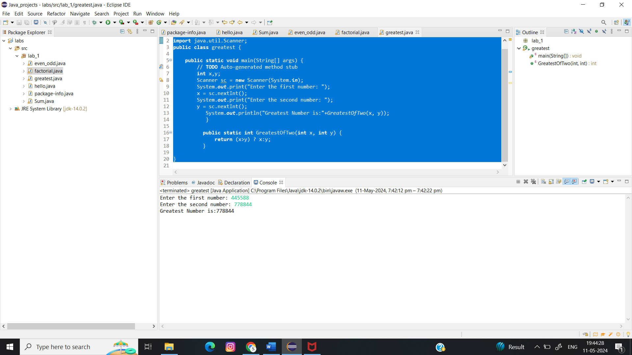

1. **Write a program to implement a basic calculator that takes input as a string expression and evaluates it.**

**Code:**

**package** lab_1;

**import** java.io.*;

**import** java.lang.*;

**import** java.lang.Math;

**import** java.util.Scanner;

**public** **class** calculator {

**public** **static** **void** main(String[] args) {

**double** num1, num2;

// Take input from the user

Scanner sc = **new** Scanner(System.***in***);

System.***out***.println("Enter the expretion:");

// Take the inputs

num1 = sc.nextDouble();

num2 = sc.nextDouble();

System.***out***.println("Enter the operator (+,-,*,/):");

**char** op = sc.next().charAt(0);

**double** o = 0;

**switch** (op) {

// case to add two numbers

**case** '+':

o = num1 + num2;

**break**;

// case to subtract two numbers

**case** '-':

o = num1 - num2;

**break**;

// case to multiply two numbers

**case** '*':

o = num1 * num2;

**break**;

// case to divide two numbers

**case** '/':

o = num1 / num2;

**break**;

**default**:

System.***out***.println("You enter wrong input");

}

System.***out***.println("The final result:");

System.***out***.println();

// print the final result

System.***out***.println(num1 + " " + op + " " + num2

+ " = " + o);

}

}

**Output:**

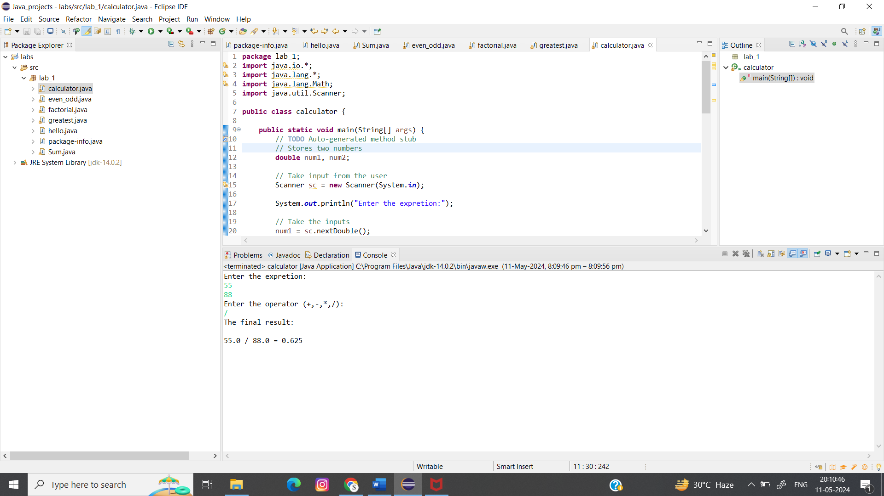

1. **Write a Java program to check if a given number is even or odd.**

**Code:**

**package** lab_1;

**import** java.util.Scanner;

**public** **class** even_odd {

**public** **static** **void** main(String[] args) {

// **TODO** Auto-generated method stub

Scanner reader = **new** Scanner(System.***in***);

System.***out***.print("Enter a number: ");

**int** num = reader.nextInt();

**if**(num % 2 == 0)

System.***out***.println(num + " is even");

**else**

System.***out***.println(num + " is odd");

}

}

**Output:**



1. **Create a Java program that compares two numbers and prints the larger one.**

**Code:**

**package** lab_1;

**import** java.util.Scanner;

**public** **class** compare {

**public** **static** **void** main(String[] args) {

// **TODO** Auto-generated method stub

Scanner scanner = **new** Scanner(System.***in***);

System.***out***.println("Enter the first number:");

**int** num1 = scanner.nextInt();

System.***out***.println("Enter the second number:");

**int** num2 = scanner.nextInt();

**if** (num1 > num2) {

System.***out***.println(num1 + " is larger than " + num2);

} **else** **if** (num2 > num1) {

System.***out***.println(num2 + " is larger than " + num1);

} **else** {

System.***out***.println("Both numbers are equal.");

}

}

}

**Output:**

