* Lab_2

1. Write a program that takes a student's score as input and outputs the corresponding grade based on the following scale:

A: 90-100; B: 80-89; C: 70-79; D: 60-69; F: 0-59

**Code:**

**package** lab_2;

**import** java.util.Scanner;

**public** **class** student_score {

**public** **static** **void** main(String[] args) {

Scanner scanner = **new** Scanner(System.***in***);

// input from user for the student's score

System.***out***.print("Enter the student's score: ");

**int** score = scanner.nextInt();

// Determine the grade based on the score

**char** grade;

**if** (score >= 90 && score <= 100) {

grade = 'A';

} **else** **if** (score >= 80 && score <= 89) {

grade = 'B';

} **else** **if** (score >= 70 && score <= 79) {

grade = 'C';

} **else** **if** (score >= 60 && score <= 69) {

grade = 'D';

} **else** **if** (score >= 0 && score <= 59) {

grade = 'F';

} **else** {

System.***out***.println("Invalid score. Please enter a score between 0 and 100.");

**return**;

}

// Output the grade

System.***out***.println("The grade is: " + grade);

}

}

**Output:**

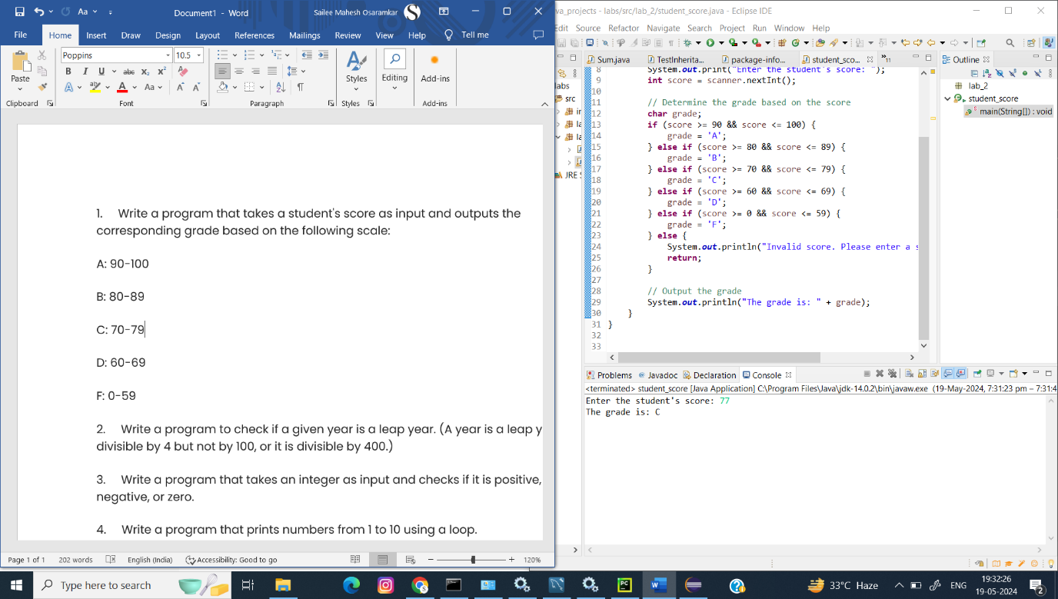

1. Write a program to check if a given year is a leap year. (A year is a leap year if it is divisible by 4 but not by 100, or it is divisible by 400.)

**Code:**

**package** lab_2;

**import** java.util.Scanner;

**public** **class** Leap_Year_Identifier {

**public** **static** **void** main(String[] args) {

Scanner scanner = **new** Scanner(System.***in***);

// input from user for the year

System.***out***.print("Enter a year: ");

**int** year = scanner.nextInt();

// Check if the year is a leap year

**boolean** isLeapYear = **false**;

**if** (year % 4 == 0) {

**if** (year % 100 != 0 || year % 400 == 0) {

isLeapYear = **true**;

}

}

// Output the result

**if** (isLeapYear) {

System.***out***.println(year + " is a leap year.");

} **else** {

System.***out***.println(year + " is not a leap year.");

}

}

}

**Output:**

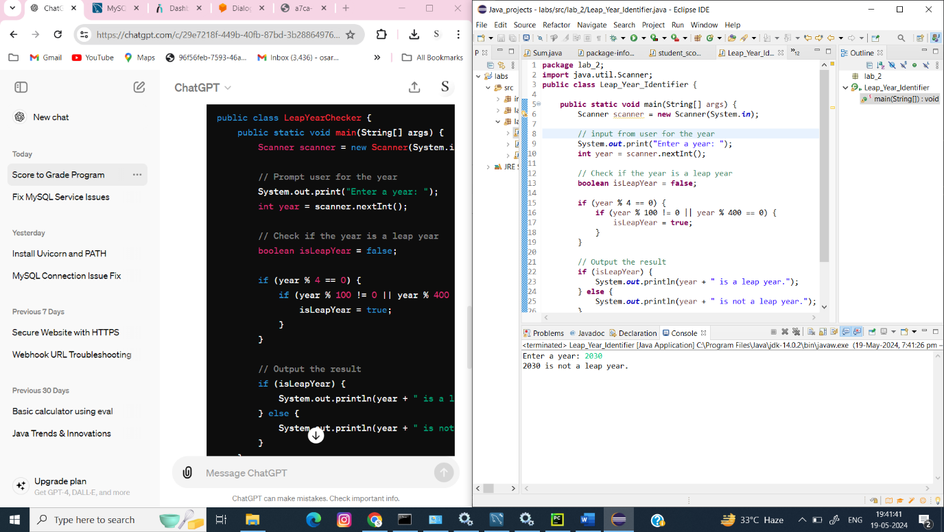

1. Write a program that takes an integer as input and checks if it is positive, negative, or zero.

**Code:**

**package** lab_2;

**import** java.util.Scanner;

**public** **class** number_pve_nve {

**public** **static** **void** main(String[] args) {

Scanner scanner = **new** Scanner(System.***in***);

// Prompt user for an integer

System.***out***.print("Enter an integer: ");

**int** number = scanner.nextInt();

// Check if the number is positive, negative, or zero

**if** (number > 0) {

System.***out***.println("The number is positive.");

} **else** **if** (number < 0) {

System.***out***.println("The number is negative.");

} **else** {

System.***out***.println("The number is zero.");

}

}

}

**Output:**

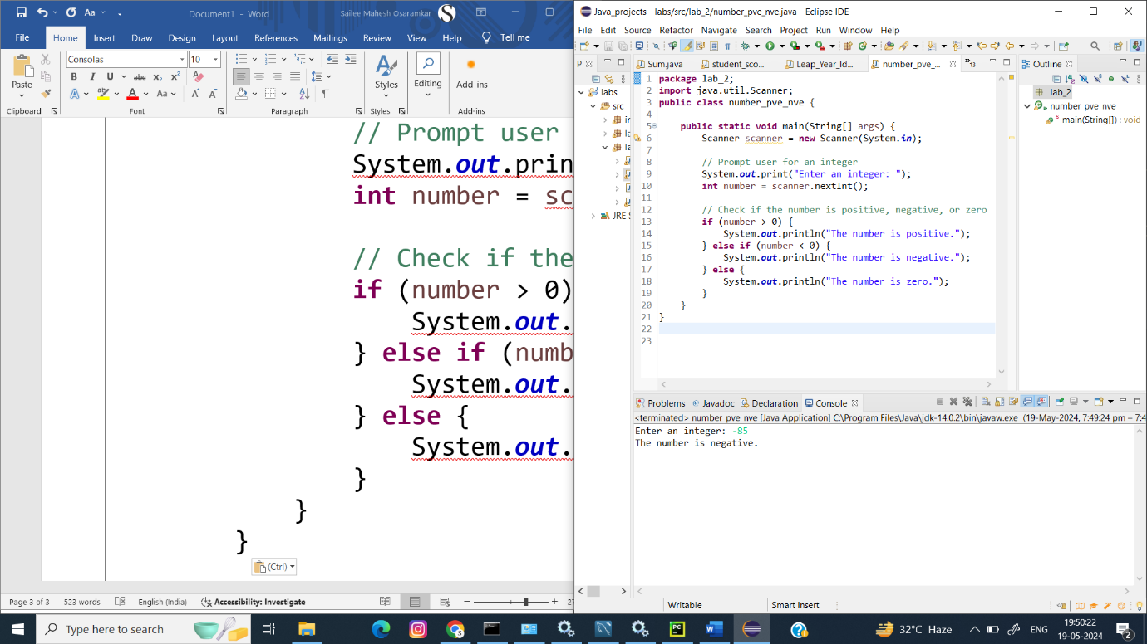

1. Write a program that prints numbers from 1 to 10 using a loop.

**Code:**

**package** lab_2;

**public** **class** loop {

**public** **static** **void** main(String[] args) {

**for** (**int** i = 1; i <= 10; i++) {

System.***out***.println(i);

}

}

}

**Output:**

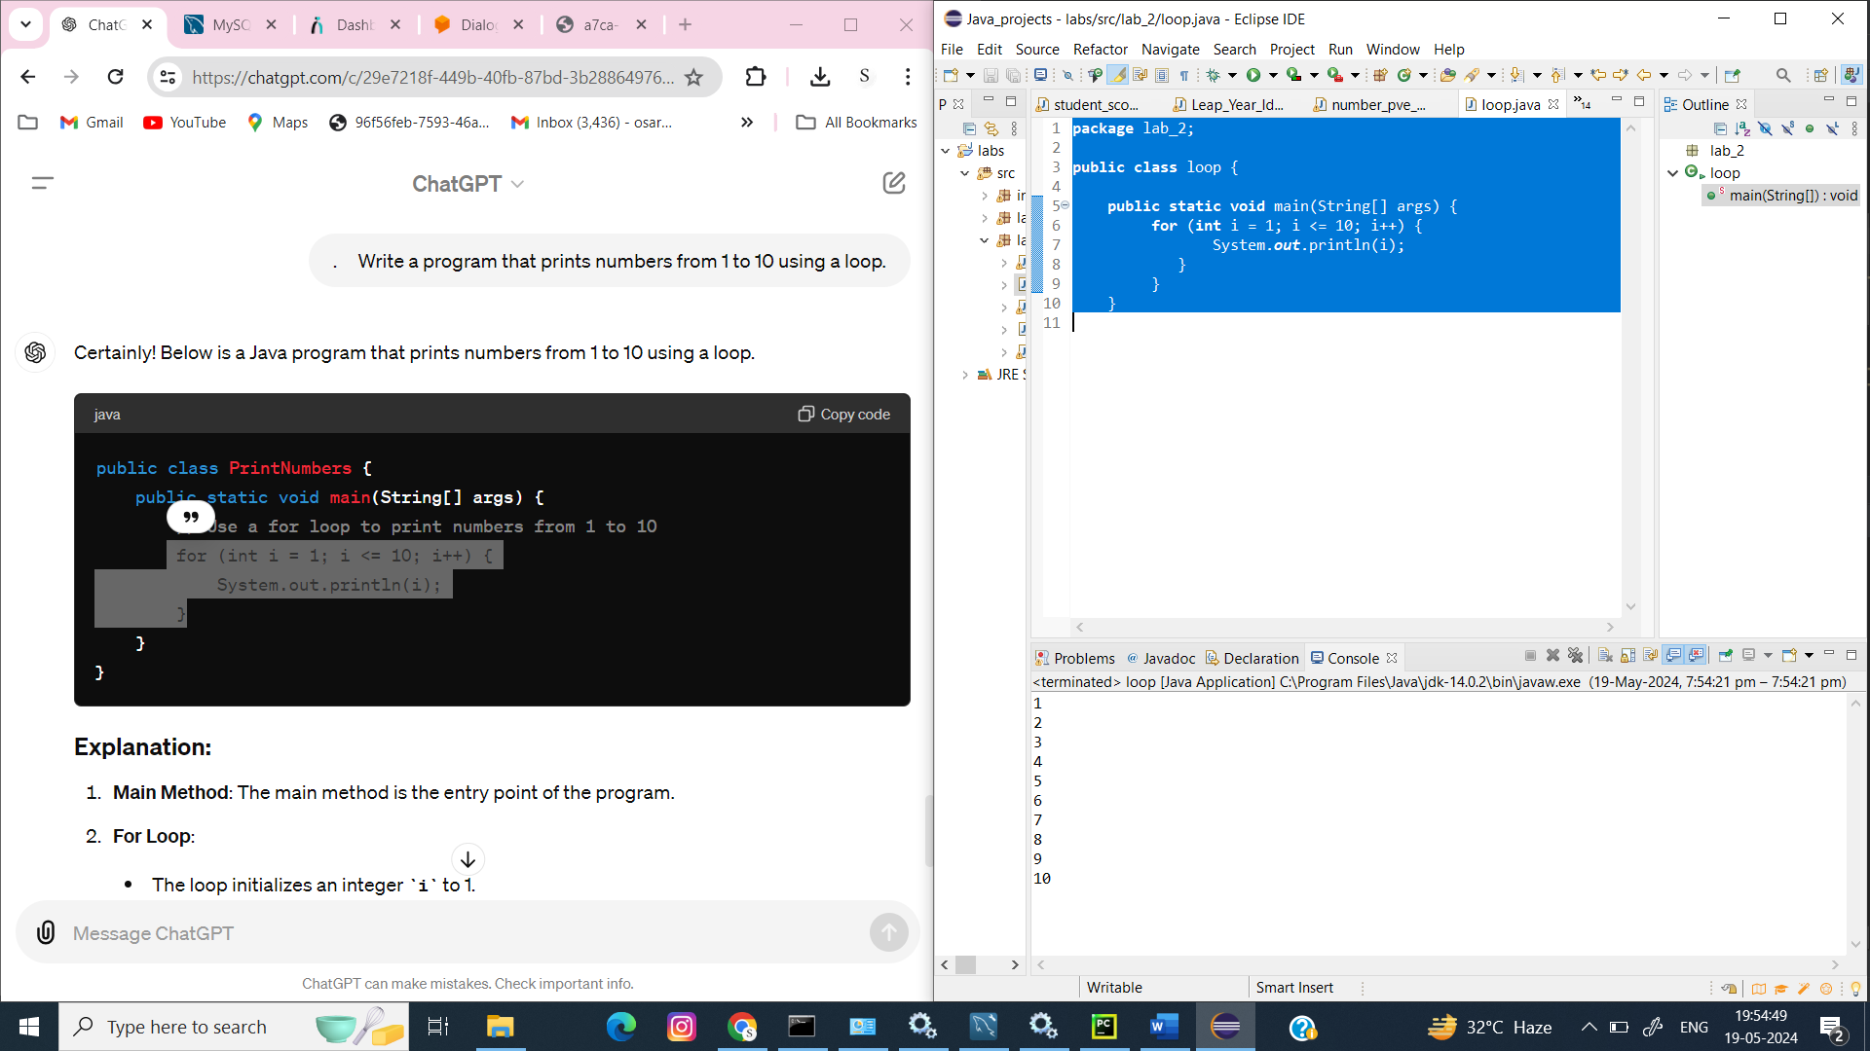

1. Write a program that takes an integer N as input and calculates the sum of entered numbers.

**Code:**

**package** lab_2;

**import** java.util.Scanner;

**public** **class** SumOfNumbers {

**public** **static** **void** main(String[] args) {

Scanner scanner = **new** Scanner(System.***in***);

// Prompt user for the number of integers to sum

System.***out***.print("Enter the number of integers to sum: ");

**int** N = scanner.nextInt();

// Initialize sum to 0

**int** sum = 0;

// Loop to take N integers as input and calculate the sum

**for** (**int** i = 1; i <= N; i++) {

System.***out***.print("Enter integer " + i + ": ");

**int** number = scanner.nextInt();

sum += number;

}

// Output the result

System.***out***.println("The sum of the entered numbers is: " + sum);

}

}

**Output:**

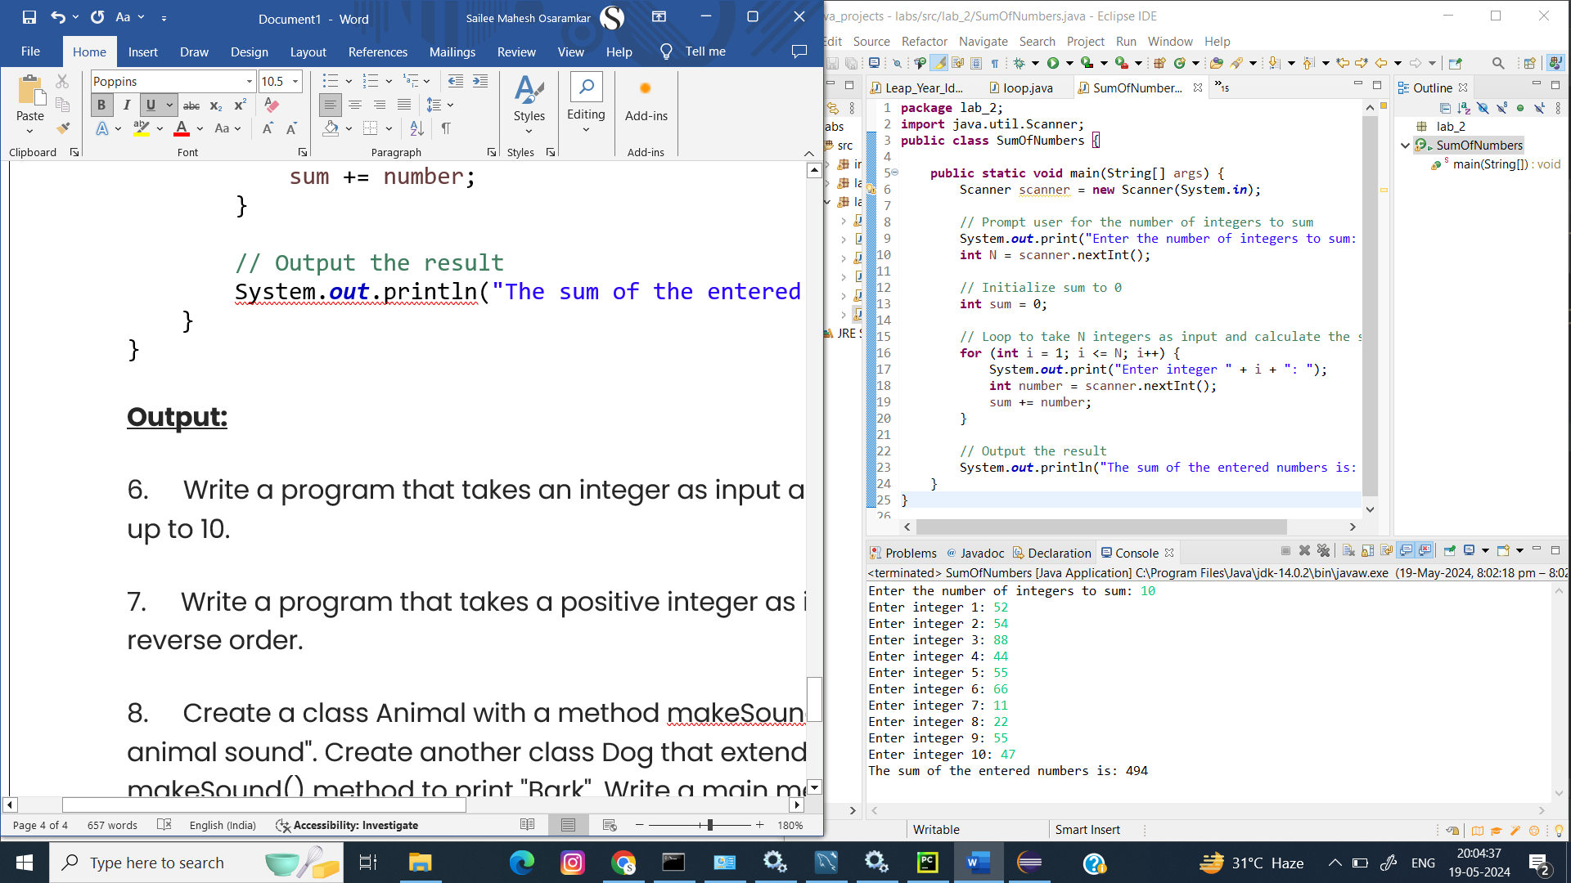

1. Write a program that takes an integer as input and prints its multiplication table up to 10.

**Code:**

**package** lab_2;

**import** java.util.Scanner;

**public** **class** MultiplicationTable {

**public** **static** **void** main(String[] args) {

Scanner scanner = **new** Scanner(System.***in***);

// Prompt user for an integer

System.***out***.print("Enter an integer: ");

**int** number = scanner.nextInt();

// Print the multiplication table for the entered integer

System.***out***.println("Multiplication table for " + number + ":");

**for** (**int** i = 1; i <= 10; i++) {

System.***out***.println(number + " x " + i + " = " + (number * i));

}

}

}

**Output:**

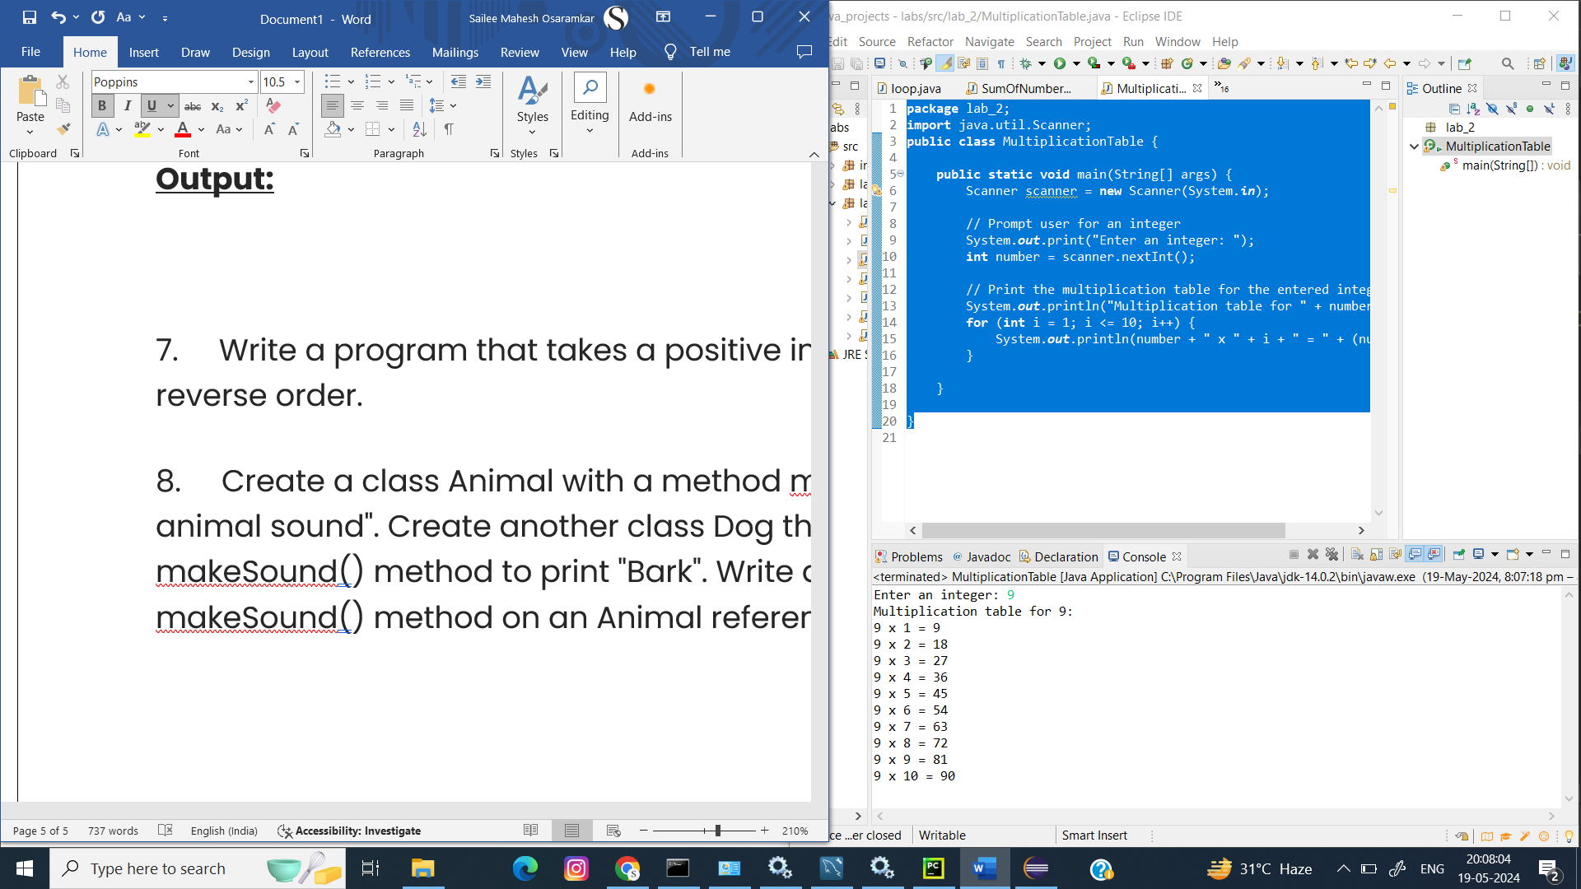

1. Write a program that takes a positive integer as input and prints its digits in reverse order.

**Code:**

**package** lab_2;

**import** java.util.Scanner;

**public** **class** Reverse {

**public** **static** **void** main(String[] args) {

Scanner scanner = **new** Scanner(System.***in***);

// Prompt user for a positive integer

System.***out***.print("Enter a positive integer: ");

**int** number = scanner.nextInt();

// Check if the input is a positive integer

**if** (number < 0) {

System.***out***.println("Please enter a positive integer.");

**return**;

}

// Print the digits in reverse order

System.***out***.print("Digits in reverse order: ");

**while** (number > 0) {

**int** digit = number % 10; // Get the last digit

System.***out***.print(digit); // Print the digit

number /= 10; // Remove the last digit

}

System.***out***.println(); // Move to the next line after printing all digits

}

}

**Output:**

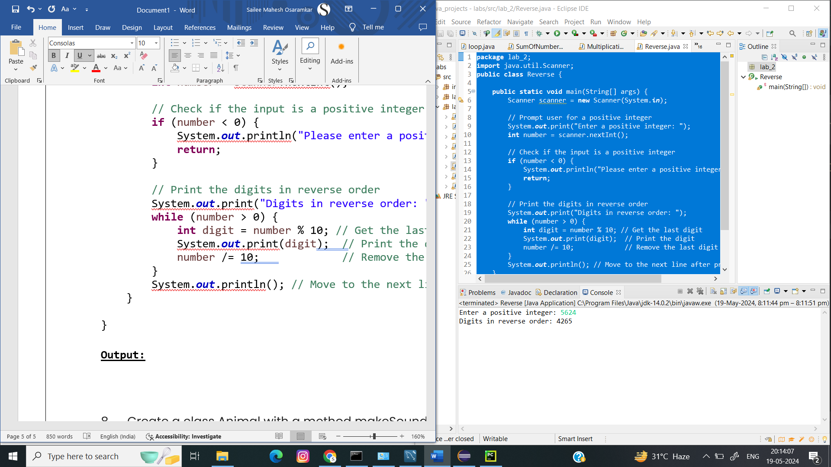

8.Create a class Animal with a method makeSound() that prints "Some generic animal sound". Create another class Dog that extends Animal and overrides the makeSound() method to print "Bark". Write a main method to demonstrate calling the makeSound() method on an Animal reference holding a Dog object

**Code:**

**package** lab_2;

**class** Animal {

// Method to make a generic animal sound

**public** **void** makeSound() {

System.***out***.println("Some generic animal sound");

}

}

**class** Dog **extends** Animal {

// Override the makeSound method to provide a specific sound for Dog

@Override

**public** **void** makeSound() {

System.***out***.println("Bark");

}

}

**public** **class** main {

**public** **static** **void** main(String[] args) {

// Create an Animal reference holding a Dog object

Animal myDog = **new** Dog();

// Call the makeSound method on the Animal reference

myDog.makeSound();

}

}

**Output:**

