In Silico Evaluation of Bioactive Compounds from Bufo gargarizans as Potential Therapeutic Agents Against Breast Cancer
The global burden of cancer among women is significant and increasing, with over 9 million new cases and 4.4 million deaths in 2020, projected to rise by 44% and 60% respectively by 2040 (Bizuayehu et al., 2023). Breast, cervical, and colorectal cancers are among the most common types (Torre et al., 2017). Low- and middle-income countries (LMICs) face higher mortality rates despite lower incidence, due to inadequate early detection and treatment (Torre et al., 2017; Coughlin & Ekwueme, 2009). Cancer control priorities include primary prevention, especially in LMICs, through measures like tobacco control, HPV vaccination, and screening (Islami et al., 2017). The Mortality to Incidence Ratio, a proxy for survival, is higher in countries with low Human Development Indexes (69%) compared to those with very high ones (30%) (Bizuayehu et al., 2023). Addressing this global health concern requires expanding universal health coverage, early screening, and strengthening medical infrastructure to improve cancer control and outcomes (Bizuayehu et al., 2023).
Reproductive cancers in women, including cervical, ovarian, uterine, and breast cancers, pose a significant global health burden. Breast cancer accounted for 11.6% of all new cancer cases worldwide in 2022, while cervical cancer remains prevalent in many regions (Bray et al., 2024). The incidence of gynecological cancers is highest in Asia, followed by Africa, with rates predicted to rise in the coming years (Khashia Sayed, 2021). Cancer treatment often impairs fertility in reproductive-age women, necessitating fertility preservation strategies (Franasiak & Scott, 2016). Implementing effective interventions such as HPV vaccination, screening programs, and tobacco control could substantially reduce the burden of reproductive cancers globally (Torre et al., 2017; Bray et al., 2024). Projections indicate that new cancer cases may reach 35 million by 2050, emphasizing the urgent need for prevention and control measures (Bray et al., 2024). Breast cancer remains a significant global health concern, particularly affecting women worldwide (Salman, 2023; Cumber et al., 2017). It is the most frequently diagnosed cancer in women and ranks second among cancer-related deaths (Ullah, 2019). Challenges in breast cancer management include medical imaging technology limitations, financial constraints, and poor prognosis in triple-negative breast cancer (Cumber et al., 2017; Ullah, 2019). However, advancements in screening, diagnosis, and treatment have improved clinical outcomes (Ullah, 2019). Emerging technologies such as AI, 3D bioprinting, and nanotechnology show promise in addressing challenges like metastatic disease management and global disparities in outcomes (Sonalika et al., 2023). Despite progress, equal worldwide access to therapeutic advances remains a significant challenge (Salman, 2023), necessitating the development of novel therapeutic approaches.
Recent research has focused on peptides derived from bacteria, marine organisms, and plants as potential anti-breast cancer agents. Marine peptides have shown promise in targeting cancer cells through various mechanisms, including apoptosis induction and angiogenesis suppression (Ahmed et al., 2021). Similarly, plant protein-derived peptides exhibit anti-cancer activities by inhibiting proliferation, migration, and invasion of breast cancer cells (Zhang et al., 2025). These peptides offer advantages such as low toxicity, high specificity, and the ability to overcome drug resistance. (Beheshtirouy et al., 2020). Toxins from toad's parotoid or skin glands have been reported to have significant therapeutic value for various diseases (Yang et al., 2015). Traditional use of toad toxins in East and Southeast Asian countries has shown efficacy in treating pain, inflammatory diseases and cancer.
A recent analysis of the effectiveness of Huachansu capsules, which are made from the venom of Bufo gargarizans, as an adjuvant therapy for breast cancer found that they prolong overall survival, modulate immune function, inhibit tumor progression and lessen adverse chemotherapeutic effects on individuals (Wu et al., 2025). A recent study identified cinobufagin, a natural product derived from Bufo gargarizans, as having significant effect on breast cancer signature gene set following a chemical structure and transcriptional regulatory analysis of traditional Chinese Medicines (Li et al., 2025). Also, cinobufagin, has be reported to have antitumor effect through vasculogenic mimicry and M2 macrophage polarization inhibition in ovarian cancer cells (Wang et al., 2025).
Bufadienolides and indole alkylamines are two main groups of compounds with therapeutic potential in toad toxins, with reported effects on tumour cell growth, inhibition and apoptosis induction. Recent studies have explored in silico approaches for designing anti-breast cancer therapeutics using bacterial metagenomes. These studies
demonstrate the potential of bacterial metagenomes and their metabolites in identifying novel anti-breast cancer therapeutics through in silico approaches.
The development of peptide-based therapies and nanoparticle delivery systems shows promise for more effective and targeted breast cancer treatments, potentially addressing the limitations of traditional chemotherapeutic agents. Therefore, this research was designed to investigate the in silico therapeutic potential of bioactive compounds of Bufo gargarizans in the treatment of breast cancer.

Materials and Method
Source of Bufo gargarizans Bioactive Compounds from Databases
Bufo gargarizans bioactive compounds were collected from articles published in PubMed database. The chemical structures, molecular weight, 2D structure, chemical number, and physicochemical properties of the bioactive compounds were confirmed using PubChem (https://pubchem.ncbi.nlm.nih.gov/).

Pharmacokinetic Evaluation of the Bioactive Compounds of Bufo gargarizans
The bioavailability of the 16 compounds from Bufo gargarizans was determined by SwissADME (http://www.swissadme.ch/index.php), while the drug-likeness score (DL) was predicted with molsoft (https://molsoft.com/mprop/). The toxicity of the compounds was predicted using a virtual tool known as ProTox-II (https://tox-new.charite.de/protox_II/index.php?site=compound_input). All the bioactive compounds were screened for bioavailability (F), drug-likeness score (DL) and toxicity. Only compounds that met the ADME standards, which include F (>0.55), DL (>0.18), and toxicity class 4 and 6 were screened further.

Potential Breast Cancer target genes
The Online Mendelian Inheritance in Man (OMIM) (http://omim.org/) database was utilised to identify breast cancer-related target genes. Bioinformatics and Evolutionary Genomics tools (https://bioinformatics.psb.ugent.be/webtools/Venn/) were used to determine the intersection of genes associated with the selected compounds and target genes related to breast cancer.

Networks and Kegg Pathway Construction and Analyses
The Swiss target prediction database was used to examine the integrative efficacy of the compounds (Daina et al., 2019). The STRING database (https://stringdb.org) was used to construct a network analysis based on the interactions of targets with high scores (≥0.9). The species selection was limited to Homo sapiens. The PPI network discovered was then visualised and subjected to additional analysis using the Cytoscape software 3.10.1. Further analysis of the network was achieved using the cytoHubba plugin App, and the top 10 genes were chosen based on their degree value. The signalling pathways based on the Gene Ontology (GO) and Kyoto Encyclopaedia of Genes and Genomes (KEGG) databases (https://www.genome.jp/kegg/pathway.html) were assessed using Database of Annotation, Visualisation and Integrated Discovery (DAVID, https://david.ncifcrf.gov/).

Protein and ligand preparation
The Protein Data Bank (PDB) repository provided the crystal structures of the four selected target proteins: LCK (PDB ID: 2OFV), JAK1 (PDB ID: 6GGH), MTOR (PDB ID: 7PED), and PIK3CD (PDB ID: 6PYR). The protein structures were prepared and saved in PDBQT format for molecular docking. The 2D structure of the ligand Resibufogenin was obtained in Structure Data File (SDF) format from the PubChem database (https://pubchem.ncbi.nlm.nih.gov/). Discovery Studio was used for ligand preparation and conversion to PDB format. The ligand was prepared by defining rotatable bonds and saved in PDBQT format. AutoDockTools v1.5.2 was used for the preparation of the ligand and protein structures for molecular docking.

Molecular docking
Grid boxes containing the target protein-ligand complex with a reference root mean square deviation (RMSD) value less than 3Å were chosen. AutoDockTools software (AutoDock, USA) was used to carry out the docking procedure.

Results:
Selection of Active Compounds using ADME Screening:
Sixteen phytochemical compounds derived from Bufo gargarizans (the Asiatic toad or Chusan Island toad) were utilised for network pharmacology analysis. Compounds were screened according to established criteria, including a bioavailability score (F) of at least 0.55, a drug-likeness (DL) score of at least 0.18, and classification of toxicity. Active components were selected based on ADME criteria (absorption, distribution, metabolism, and excretion) and toxicity class, leading to the identification of one active compound “Resibufogenin” (Table-1, 2). Although other compounds showed favorable F and DL score, they were excluded because of their higher predicted toxicity profile.
Active Compound | Bioavailability score (F) | Drug-likeness (DL) | Toxicity class | LD50
Resibufogenin | 0.55 | 0.5 | 6 | 59800mg/kg
Table-1: Screening profile of Resibufogenin
Identification of Hub Genes and PPI Network:
Analysis of the protein–protein interaction (PPI) network, complemented by CytoHubba topological ranking, revealed ten hub genes exhibiting high degree centrality: LCK, JAK1, JUN, MTOR, HDAC1, BSG, PTPN22, CSK, PIK3CD, and EMB, indicating their pivotal roles in disease-related molecular networks.
Subsequent target prediction research indicated that Resibufogenin was linked to four of the ten identified hub genes: LCK, JAK1, MTOR, and PIK3CD. From the compound–target intersection, these four hub genes were chosen for molecular docking research to assess the binding affinity and interaction stability of Resibufogenin with critical disease-associated targets. This implies that a single active molecule can function as a single ligand and interact with several disease associated targets.
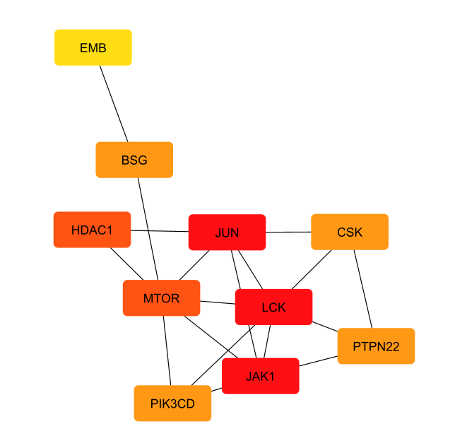
Figure-1: Top 10 Hub genes related to Breast Cancer identified from Cytoscape
GO Enrichment and KEGG Pathway Analysis of Selected Hub Genes:
Gene Ontology (GO) enrichment study of the four selected hub genes (LCK, JAK1, MTOR, and PIK3CD) revealed substantial participation in protein phosphorylation, ATP binding, and protein tyrosine kinase activity, emphasising their crucial functions in intracellular signal transduction. Analysis of biological processes indicated an enrichment in T-cell activation, immune receptor signalling, and inflammatory response, demonstrating their significance in immunological-mediated regulation systems. KEGG pathway enrichment analysis revealed that these hub genes were strongly linked to many cancer-related and immunological signalling pathways, including the PD-L1 expression and PD-1 checkpoint pathway, JAK–STAT signalling system, PI3K–Akt signalling route, and pathways in cancer. Enrichment was detected in breast cancer-related pathways, indicating the functional significance of the chosen hub genes in tumour growth and immune regulation. Comprehensive GO and KEGG analyses indicate that the identified hub genes are involved in critical oncogenic and immunological regulatory pathways, establishing a robust functional foundation for subsequent molecular docking and target-ligand interaction studies.

Molecular Docking:
Molecular Docking of Resibufogenin with LCK:
The molecular docking study of Resibufogenin with the LCK protein (PDB ID: 2OFV) showed significant binding affinity in multiple poses. The most favorable poses exhibited binding energies ranging from −12.41 to −10.92 kcal/mol, with the top score of −12.41 kcal/mol corresponding to a predicted inhibition constant (Ki) of 0.80 nM. This low Ki value, derived from the leading poses, indicates strong and stable interactions between the ligand and protein. Furthermore, the ligand efficiency values ranged from −0.44 to −0.39, further supporting the efficiency of the binding process. Structural visualization reinforced these findings by showing that Resibufogenin occupies a specific binding pocket within the active site of LCK. Overall, the results suggests that Resibufogenin displays a robust and persistent affinity towards LCK, suggesting its potential as a strong inhibitor of this protein.

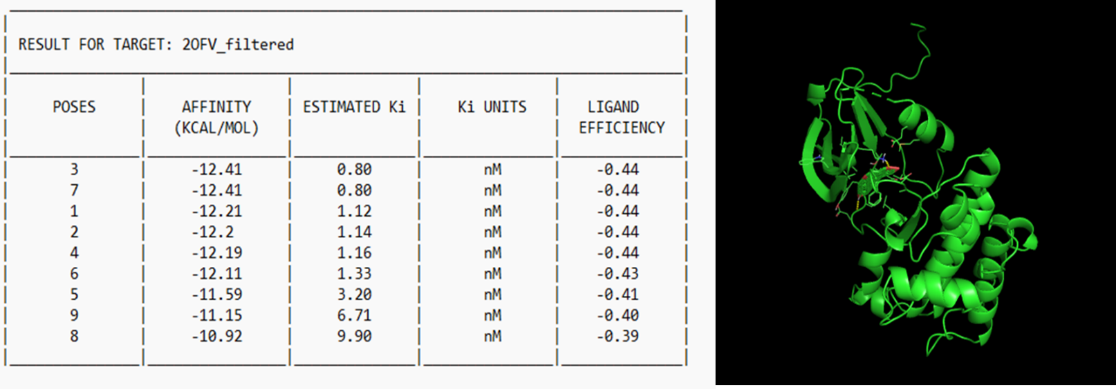
Figure-2: Molecular Docking of Resibufogenin with LCK

Molecular Docking of Resibufogenin with JAK1:
The molecular docking study of Resibufogenin with JAK1 (PDB ID: 6GGH) revealed multiple favorable binding orientations, with the highest-ranked pose exhibiting a binding energy of −11.58 kcal/mol, which translates to an estimated Ki of 3.25 nM, indicating a strong interaction potential. The docking scores ranged from −11.58 to −7.46 kcal/mol, predominantly suggesting Ki values in the low nanomolar range. The ligand efficiency values, which fell between −0.41 and −0.27, reflect effective binding relative to the size of the molecule. Structural visualizations confirmed the stable binding of Resibufogenin within the JAK1 binding site. Overall, the findings strongly suggest that Resibufogenin has a robust and persistent binding affinity for JAK1 (Figure-3).

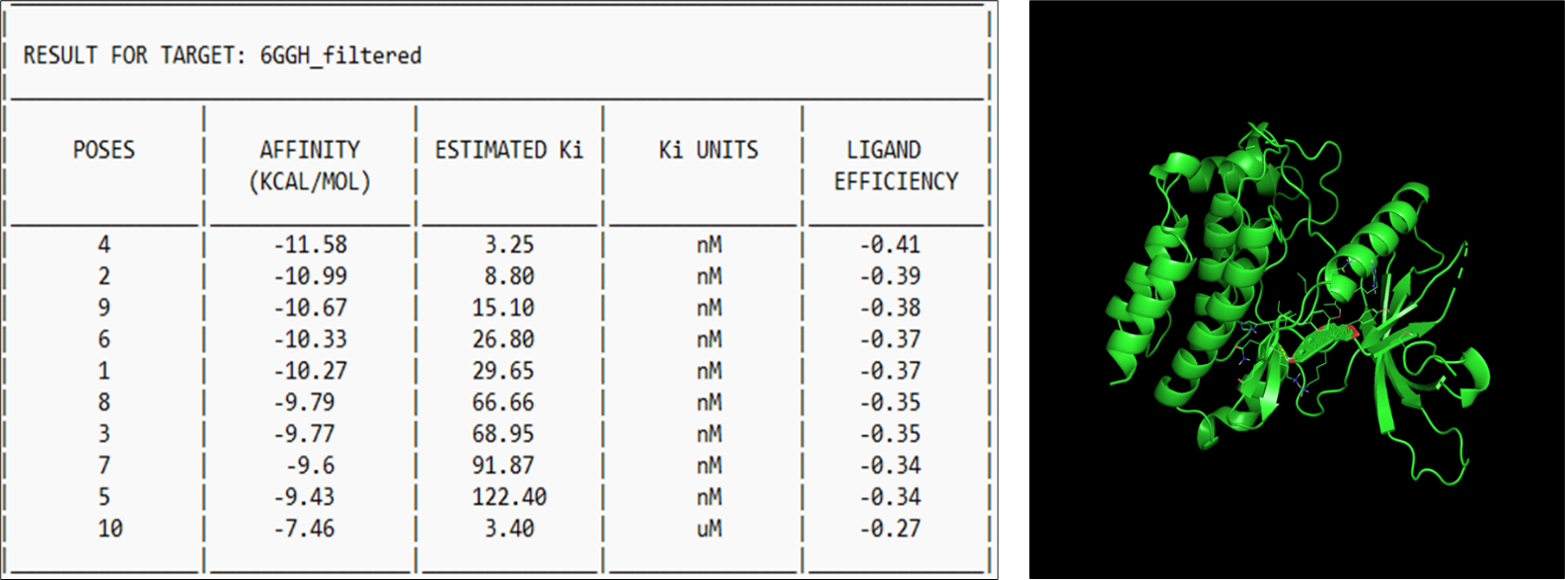
Figure-3: Molecular Docking of Resibufogenin with JAK1

Molecular Docking of Resibufogenin with MTOR:
The molecular docking study of Resibufogenin with the MTOR (mammalian target of rapamycin) protein, specifically with the PDB ID 7PED, revealed a strong binding affinity across various poses examined. Notably, the top-scoring pose exhibited a binding energy of −11.44 kcal/mol, correlating to an estimated inhibition constant (Ki) of 4.12 nM, indicating a significant interaction strength. Overall, the docking scores ranged between −11.44 and −8.78 kcal/mol for the majority of poses, with predicted Ki values largely falling within the low nanomolar scale. The ligand efficiency values, ranging from −0.41 to −0.31, further suggested effective and stable interactions between the ligand (Resibufogenin) and the MTOR protein. Structural visualisation of the docking poses confirmed that Resibufogenin fits suitably within the binding site of MTOR. Collectively, these findings highlight that Resibufogenin demonstrates a robust and durable binding affinity for MTOR, which could have significant implications for its potential therapeutic applications (Figure-4).

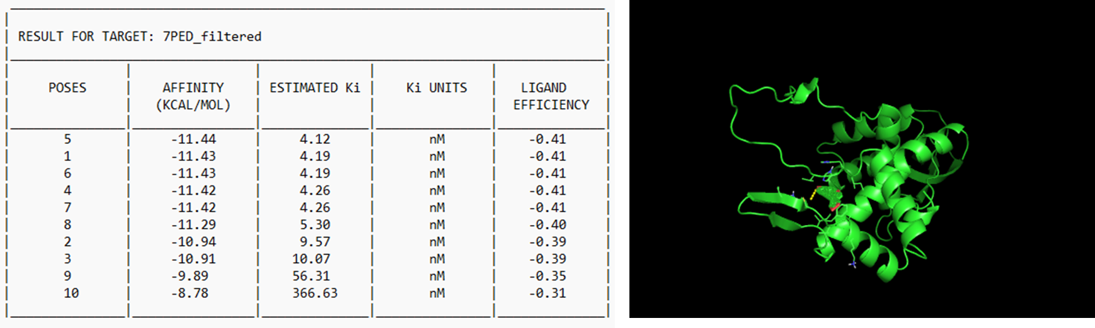
Figure-4: Molecular Docking of Resibufogenin with MTOR

Molecular Docking of Resibufogenin with PIK3CD:
The molecular docking study of Resibufogenin with PIK3CD (PDB ID: 6PYR) revealed significant binding affinity across various configurations. The top-ranked pose showed a binding energy of −13.53 kcal/mol, which corresponds to an estimated dissociation constant (Ki) of 0.12 nM, indicating strong binding potential. The docking scores of the leading poses ranged from −13.53 to −10.78 kcal/mol, with Ki values predominantly within the sub-nanomolar to low nanomolar range. Ligand efficiency values were recorded between −0.48 and −0.38, further confirming the effectiveness and stability of the ligand–protein interactions. Visualization of the docked complex confirmed the stable positioning of Resibufogenin within the binding site of PIK3CD. Overall, the findings suggest that Resibufogenin has the highest binding affinity for PIK3CD compared to other evaluated hub gene targets.

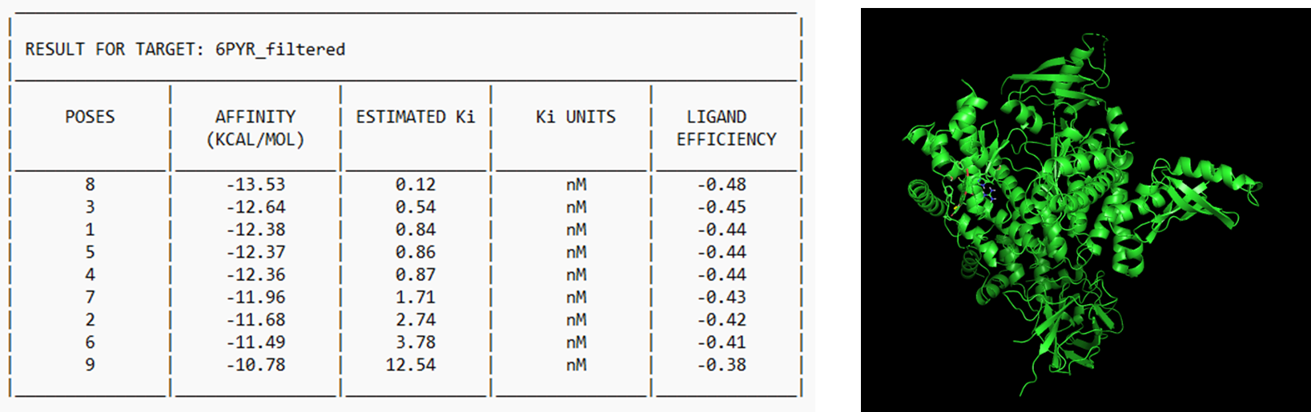
Figure-5: Molecular Docking of Resibufogenin with PIK3CD

The comparative molecular docking analysis demonstrated that Resibufogenin displayed a favourable binding affinity for all four selected hub gene targets (LCK, JAK1, MTOR, and PIK3CD), with binding energies consistently in the low nanomolar range. Of the targets examined, PIK3CD had the most robust interaction, evidenced by the lowest binding energy (−13.53 kcal/mol) and a predicted Ki in the sub-nanomolar range (0.12 nM), signifying the highest binding affinity. The subsequent values were LCK (−12.41 kcal/mol; Ki = 0.80 nM), JAK1 (−11.58 kcal/mol; Ki ≈ 3.25 nM), and MTOR (−11.44 kcal/mol; Ki ≈ 4.12 nM). These data indicate that Resibufogenin exhibits robust interactions with all four targets, with PIK3CD emerging as the most advantageous binding target, highlighting its potential significance in Resibufogenin-mediated therapeutic mechanisms.

Conclusion and Discussion:
Network pharmacology prioritises the detection of physiologically pertinent and pharmacologically viable compound-target interactions above the comprehensive docking of all potential candidates. The current analysis prioritised compounds based on preliminary safety and drug-likeness evaluations, acknowledging that numerous natural products fail in subsequent phases of drug development due to intolerable toxicity profiles. The integration of in silico ADMET and toxicity screening before docking is widely advocated to enhance translational relevance and minimise false-positive leads. Resibufogenin was chosen as the primary chemical due to its lowest expected acute toxicity (class 6) while exhibiting advantageous pharmacokinetic and drug-likeness characteristics. Limiting molecular docking to hub genes identified as probable targets of Resibufogenin (LCK, JAK1, MTOR, and PIK3CD) facilitated a mechanistically coherent and physiologically significant investigation, aligning with known network pharmacology methodologies. Hub genes without anticipated interactions with the chosen drug were omitted from docking to prevent uninformative binding predictions. Compounds removed for adverse toxicity profiles may retain therapeutic promise if optimised by formulation tactics like nano-encapsulation or targeted delivery systems, which have been shown to reduce toxicity and enhance the bioavailability of bioactive compounds. These methodologies signify potential pathways for further research outside the current study's parameters.

References
- Qi J., Tan C., Hashimi S.M., Zulfiker A.H.M., Good D., Wei M.Q. Toad glandular secretions and skin extractions as anti-inflammatory and anticancer agents. Evid.-Based Complement. Altern. Med. 2014;2014 doi: 10.1155/2014/312684
- Qi, J., Zulfiker, A. H. M., Li, C., Good, D., & Wei, M. Q. (2018). The Development of Toad Toxins as Potential Therapeutic Agents. Toxins, 10(8), 336. https://doi.org/10.3390/toxins10080336
- Yuan B., He J., Kisoh K., Hayashi H., Tanaka S., Si N., Zhao H.-Y., Hirano T., Bian B., Takagi N. Effects of active bufadienolide compounds on human cancer cells and CD4+ CD25+ Foxp3+ regulatory T cells in mitogen-activated human peripheral blood mononuclear cells. Oncol. Rep. 2016;36:1377–1384. doi: 10.3892/or.2016.4946
- Islami, F., Torre, L. A., Drope, J. M., Ward, E. M., & Jemal, A. (2017). Global Cancer in Women: Cancer Control Priorities. Cancer epidemiology, biomarkers & prevention : a publication of the American Association for Cancer Research, cosponsored by the American Society of Preventive Oncology, 26(4), 458–470. https://doi.org/10.1158/1055-9965.EPI-16-0871
- Liu M., Feng L.-X., Hu L.-H., Liu X., Guo D.-A. Advancement in research of anti-cancer effects of toad venom (ChanSu) and perspectives. World J. Tradit. Chin. Med. 2015;1:12–23. doi: 10.15806/j.issn.2311-8571.2014.0024
- Ram Kumar, A., Rajagopal, K., Meenambiga, S. S., & Kumaresan, S. (2020). In Vitro and In Silico Anti-Breast Cancer Analysis of Bioactive Metabolites of Bacillus subtilis Isolated From Soil. Saudi Journal of Pathology and Microbiology, 05(04), 220–229. https://doi.org/10.36348/sjpm.2020.v05i04.006
- Yang Q., Zhou X., Zhang M., Bi L., Miao S., Cao W., Xie Y., Sun J., Tang H., Li Y. Angel of human health: Current research updates in toad medicine. Am. J. Transl. Res. 2015;7:1.
- Gao H., Zehl M., Leitner A., Wu X., Wang Z., Kopp B. Comparison of toad venoms from different Bufo species by HPLC LC-DAD-MS/MS. J. Ethnopharmacol. 2010;131:368–376. doi: 10.1016/j.jep.2010.07.017

- Kibria, M. K., Ali, M. A., & Mollah, M. N. H. (2024). Exploring bacterial key genes and therapeutic agents for breast cancer among the Ghanaian female population: Insights from In Silico analyses. PloS one, 19(11), e0312493. https://doi.org/10.1371/journal.pone.0312493
- Rajagopal, K., Kalusalingam, A., Bharathidasan, A. R., Sivaprakash, A., Shanmugam, K., Sundaramoorthy, M., & Byran, G. (2023). In Silico Drug Design of Anti-Breast Cancer Agents. Molecules (Basel, Switzerland), 28(10), 4175. https://doi.org/10.3390/molecules28104175
- Bizuayehu, H. M., Dadi, A. F., Hassen, T. A., Ketema, D. B., Ahmed, K. Y., Kassa, Z. Y., Amsalu, E., Kibret, G. D., Alemu, A. A., Alebel, A., Shifa, J. E., Assefa, Y., Tessema, G. A., Sarich, P., Gebremedhin, A. F., & Bore, M. G. (2024). Global burden of 34 cancers among women in 2020 and projections to 2040: Population-based data from 185 countries/territories. International journal of cancer, 154(8), 1377–1393. https://doi.org/10.1002/ijc.34809
- Coughlin, S. S., & Ekwueme, D. U. (2009). Breast cancer as a global health concern. Cancer epidemiology, 33(5), 315–318. https://doi.org/10.1016/j.canep.2009.10.003
- Kim, J., Harper, A., McCormack, V. et al. Global patterns and trends in breast cancer incidence and mortality across 185 countries. Nat Med (2025). https://doi.org/10.1038/s41591-025-03502-3
- Zhu, B., Gu, H., Mao, Z., Beeraka, N. M., Zhao, X., Mahesh Padukudru Anand, Zheng, Y., Zhao, R., Li, S., Prasath Manogaran, Fan, R., Nikolenko, V. N., Wen, H., Basappa Basappa, & Liu, J. (2024). Global burden of gynaecological cancers in 2022 and projections to 2050. Journal of Global Health, 14. https://doi.org/10.7189/jogh.14.04155
- Alizadeh-Navaei, R., Hedayatizadeh-Omran, A., Ashrafi, M., Ghazizadeh, Z., Mousavi, R., Shekarriz, R., Jouybari, M., Zaboli, E., Janbabaei, G., Moradi, S., Aarabi, M., Moosazadeh, M., & Eslami, P. (2018). Epidemiology of female reproductive cancers in Mazandaran Province (Northern Iran): Results of the Mazandaran population-based cancer registry. Clinical Cancer Investigation Journal, 7(3), 87. https://doi.org/10.4103/ccij.ccij_11_18
- Bray, F., Laversanne, M., Sung, H., Ferlay, J., Siegel, R. L., Soerjomataram, I., & Jemal, A. (2024). Global Cancer Statistics 2022: GLOBOCAN Estimates of Incidence and Mortality Worldwide for 36 Cancers in 185 Countries. CA: A Cancer Journal for Clinicians, 74(3), 229–263. https://doi.org/10.3322/caac.21834
- Torre, L. A., Islami, F., Siegel, R. L., Ward, E. M., & Jemal, A. (2017). Global Cancer in Women: Burden and Trends. Cancer Epidemiology Biomarkers & Prevention, 26(4), 444–457. https://doi.org/10.1158/1055-9965.epi-16-0858
- Franasiak, J. M., & Scott, R. T. (2016). Demographics of Cancer in the Reproductive Age Female. Current Clinical Urology, 11–19. https://doi.org/10.1007/978-3-319-27711-0_2
- Sayed, K. (2021). Global burden of gynecological cancers. LIAQUAT MEDICAL RESEARCH JOURNAL, 3(4), 86–89. https://doi.org/10.38106/lmrj.2021.3.04-01
- Sawant, L., & Udar, A. B. (2023). BREAST CANCER OPPORTUNITIES AND CHALLENGES. Semantic Scholar; Medicine. https://www.semanticscholar.org/paper/BREAST-CANCER-OPPORTUNITIES-AND-CHALLENGES-Sawant Udar/7a074bcea83ef58fa484eea734e3c3fe81102945
- Masoud, V., & Pagès, G. (2017). Targeted therapies in breast cancer: New challenges to fight against resistance. World Journal of Clinical Oncology, 8(2), 120. https://doi.org/10.5306/wjco.v8.i2.120
- Isha Shah, & Nensi Raytthatha. (2021). A Brief Review on Breast cancer treatment and current challenges. World Journal of Current Medical and Pharmaceutical Research, 27–31. https://doi.org/10.37022/wjcmpr.vi.170
- Fahad Ullah, M. (2019). Breast Cancer: Current Perspectives on the Disease Status. Advances in Experimental Medicine and Biology, 1152, 51–64. https://doi.org/10.1007/978-3-030-20301-6_4
- Cumber, S. N., Nchanji, K. N., & Tsoka-Gwegweni, J. M. (2017). Breast cancer among women in sub-Saharan Africa: prevalence and a situational analysis. Southern African Journal of Gynaecological Oncology, 9(2), 35–37. https://doi.org/10.1080/20742835.2017.1391467
- Ali Salman, R. (2023). Prevalence of women breast cancer. Cellular, Molecular and Biomedical Reports, 3(4), 185–196. https://doi.org/10.55705/cmbr.2023.384467.1095
- Sonalika, S., Mishra, S. S., Mahapatro, S., & Sahoo, D. (2023). Advancements and Challenges in Breast Cancer: A Comprehensive Review. Medical Research Archives, 11(6). https://doi.org/10.18103/mra.v11i6.3944
- Ahmed, S., Mirzaei, H., Aschner, M., Khan, A., Al-Harrasi, A., & Khan, H. (2021). Marine peptides in breast cancer: Therapeutic and mechanistic understanding. Biomedicine & Pharmacotherapy, 142, 112038. https://doi.org/10.1016/j.biopha.2021.112038
- Samad Beheshtirouy, Farhad Mirzaei, Shirin Eyvazi, Vahideh Tarhriz, Recent Advances in Therapeutic Peptides for Breast Cancer Treatment, Current Protein & Peptide Science; Volume 22, Issue 1, Year 2021, . DOI: 10.2174/1389203721999201117123616
- Zhang, D., Yuan, Y., Zeng, Q., Xiong, J., Gan, Y., Jiang, K., & Xie, N. (2025). Plant protein-derived anti-breast cancer peptides: sources, therapeutic approaches, mechanisms, and nanoparticle design. Frontiers in Pharmacology, 15. https://doi.org/10.3389/fphar.2024.1468977
- Hopkins AL. Network pharmacology: the next paradigm in drug discovery. Nat Chem Biol, 2008.
- Ekins S et al. Computational toxicology: applications and limitations. Chem Res Toxicol, 2014.
- Li S, Zhang B. Traditional Chinese medicine network pharmacology. Chin J Nat Med, 2013.
- Pires DEV et al. ADMET prediction in drug discovery. Brief Bioinform, 2015.
- Wu, Q., Xu, X., Liu, H., Zhang, J., Zhang, Q., & Zhang, D. (2025). Efficacy and safety of Huachansu capsule as adjuvant therapy for breast cancer: A systematic review and meta-analysis of randomized controlled trials. Journal of Ethnopharmacology, 353, 120464. https://doi.org/10.1016/j.jep.2025.120464
- Li, S., Zhang, L., Zhang, W., Chen, H., Hong, M., Xia, J., … Lu, D. (2025). Identifying traditional Chinese medicine combinations for breast cancer treatment based on transcriptional regulation and chemical structure. Chinese Medicine, 20(1). https://doi.org/10.1186/s13020-025-01074-5
- Wang, N., Yang, Y., Wang, H., Li, Y., Wang, M., & Li, Q. (2025). Cinobufagin modulates vasculogenic mimicry and tumor-associated macrophages to inhibit ovarian cancer progression. European Journal of Pharmacology, 987, 177157. https://doi.org/10.1016/j.ejphar.2024.177157

