

**A project Report on**

**INSURANCE WEBSITE USING AUTOMATION TOOL SELENIUM WEBDRIVER WITH JAVA.**

**By**

**Saileela V**

**Batch-EON (2021-5216)**

**Under the Guidance of,**

**Priyanka Desle**

**(Technical Trainer)**

**EduBridge India Pvt. Ltd.**

**Introduction:**

This Project aims to do overall testing like functional testing, GUI testing on insurance website to check quality of application using selenium web driver. It helps to improve quality of website and saves time for manually doing this testing.

In this project our main focus is to test the Health Insurance Module and Car Insurance Module. Health Insurance is type of insurance that offers coverage to the policyholder for medical expenses in case of health insurance. Car Insurance Policy is contract between the motor insurance company and a car owner that provides on-road protection against any loss or damages arising due to an accident.

**Software Requirements:**

Operating System: Windows 10

Browser: Latest version of Google Chrome

Platform: Eclipse IDE

Automation Tool and Language: Selenium WebDriver, Java

Files: JDK, Selenium Jar files, Common IO file

1. **HEALTH INSURANCE MODULE**

**TC01:** Launch the browser and open Policy bazaar website.

**Selenium WebDriver Test Script:**

WebDriver d = **new** ChromeDriver();

d.manage().window().maximize();

d.get("https://www.policybazaar.com/");

Thread.*sleep*(3000);

d.getCurrentUrl();

System.***out***.println("Current URL IS:" + d.getCurrentUrl());

d.getTitle();

System.***out***.println("Title of page is:" + d.getTitle());

**TC02:** To verify the functionality of Health Insurance module of Policy bazaar website.

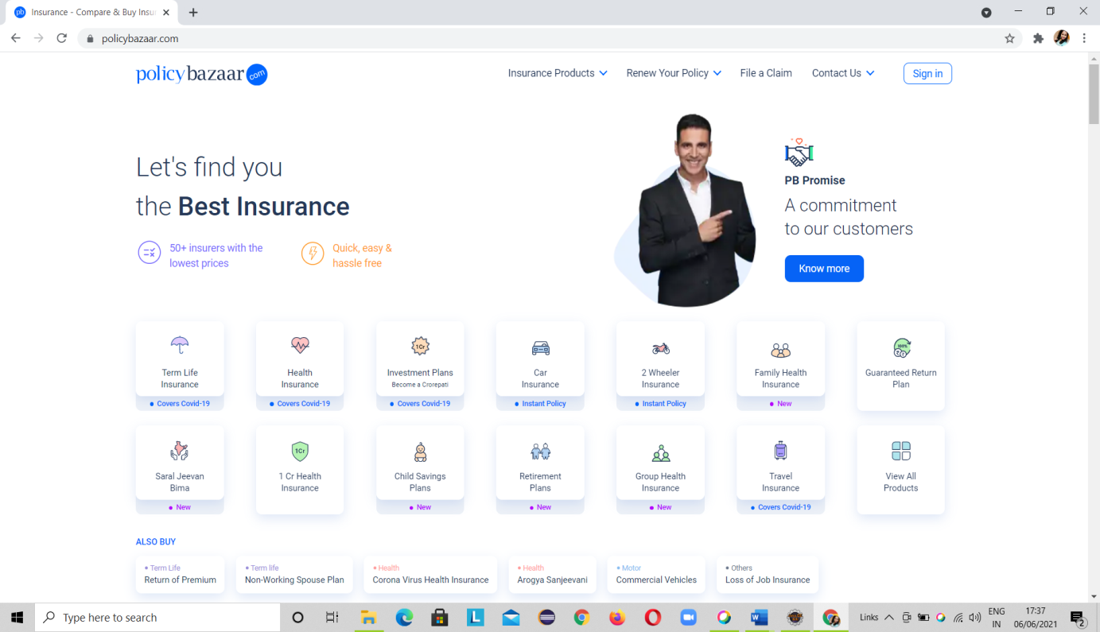

**Selenium WebDriver Test Script:**

d.findElement(By.xpath("//body/cclink[1]/main[1]/div[2]/section[1]/div[2]/a[1]/div[1]")).click();

**TC03:** To verify and display the URL of Current page of browser.

**Selenium WebDriver Test Script:**

d.getCurrentUrl();

System.***out***.println("Current URL IS:" + d.getCurrentUrl());

**TC04:** To verify and display the Title of the current page.

**Selenium WebDriver Test Script:**

d.getTitle();

System.***out***.println("Title of page is:" + d.getTitle());

**TC05:** To verify the functionality of continue button with valid gender, valid full name and mobile number of first page of module.

**Selenium WebDriver Test Script:**

d.findElement(By.*xpath*("//body[1]/div[1]/div[1]/div[3]/div[1]/div[2]/div[3]/form[1]/div[1]/div[1]/div[1]/label[2]/p[1]")).click();

d.findElement(By.*id*("fullname")).sendKeys("Rohi");

d.findElement(By.*id*("pmobile")).sendKeys("8888888888");

Thread.*sleep*(2000);

d.findElement(By.*className*("btn")).click();

**TC06:** To verify the functionality of Me from profile and select age from dropdown and continue button.

**Selenium WebDriver Test Script:**

d.findElement(By.*xpath*("//body[1]/div[1]/div[1]/div[3]/div[1]/div[2]/form[1]/div[1]/label[1]/p[1]")).click();

WebElement age=d.findElement(By.*id*("eldestMemberAge"));

Select s=**new** Select(age);

s.selectByValue("26");

d.findElement(By.*className*("btn")).click();

**TC07:** To verify the functionality of continue button by entering city.

**Selenium WebDriver Test Script:**

d.findElement(By.*id*("txtcity")).sendKeys("Pune");

Thread.*sleep*(3000);

d.findElement(By.*className*("active")).click();

**TC08:** To verify the functionality of No button and view plans by clicking on it.

**Selenium WebDriver Test Script:**

d.findElement(By.id("nopedselection")).click();

**TC09:** To verify the apply button by selecting low premium in Sort By functionality.

**Selenium WebDriver Test Script:**

d.findElement(By.*id*("QuoteSorting")).click();

d.findElement(By.*id*("SortLow")).click();

Thread.*sleep*(2000);

d.findElement(By.*className*("apply_button")).click();

**TC10:** To verify the functionality of Insurers by selecting Bajaj Allianz and click on Apply.

**Selenium WebDriver Test Script:**

d.findElement(By.*id*("ClickInsurerList")).click();

d.findElement(By.*xpath*("(//*[contains(@id,'SelectOneInsurer')])[2]")).click();

d.findElement(By.*xpath*("(//*[contains(@class,'apply_button')])[1]")).click();

**TC11:** To verify the functionality of Cover by selecting 3-5 Lacs range and click on Apply.

**Selenium WebDriver Test Script:**

d.findElement(By.*xpath*("//*[contains(@id,'SumInusredFilter')]")).click();

d.findElement(By.*xpath*("//span[contains(text(),'₹ 3 - ₹ 5 Lacs')]")).click();

d.findElement(By.*id*("ApplySIFilter")).click();

**TC12:** To verify the functionality of Features by clicking on Covered after 2 years in Pre-Existing Condition section and At least 2000/day or more in Hospital Room Eligibility section and click on apply.

**Selenium WebDriver Test Script:**

d.findElement(By.*id*("FeaturesFilter")).click();

d.findElement(By.*xpath*("//body/div[@id='root']/div[1]/div[3]/div[4]/div[2]/div[2]/div[1]/div[1]/div[1]/label[1]/span[1]")).click();

d.findElement(By.*xpath*("//body/div[@id='root']/div[1]/div[3]/div[4]/div[2]/div[2]/div[1]/div[2]/div[1]/label[1]/span[1]")).click();

d.findElement(By.*xpath*("(//*[contains(@class,'apply_button')])[3]")).click();

**TC13:** To verify the functionality of Premium.

**Selenium WebDriver Test Script:**

d.findElement(By.*id*("ClickOnPremiumFilter")).click();

d.findElement(By.*xpath*("//span[contains(text(),'₹ 300 - ₹ 500')]")).click();

Thread.*sleep*(2000);

d.findElement(By.*xpath*("(//*[contains(@class,'apply_button')])[4]")).click();

**TC14:** To verify the functionality of plan type by selecting Base Plans.

**Selenium WebDriver Test Script:**

d.findElement(By.*xpath*("(//*[contains(@id,'ClickonPlanFilter')])[2]")).click();

d.findElement(By.*xpath*("(//span[contains(text(),'Base Plans')])[2]")).click();

**TC15:** Take the Screenshot of displayed premium plans per month for of Health Insurance.

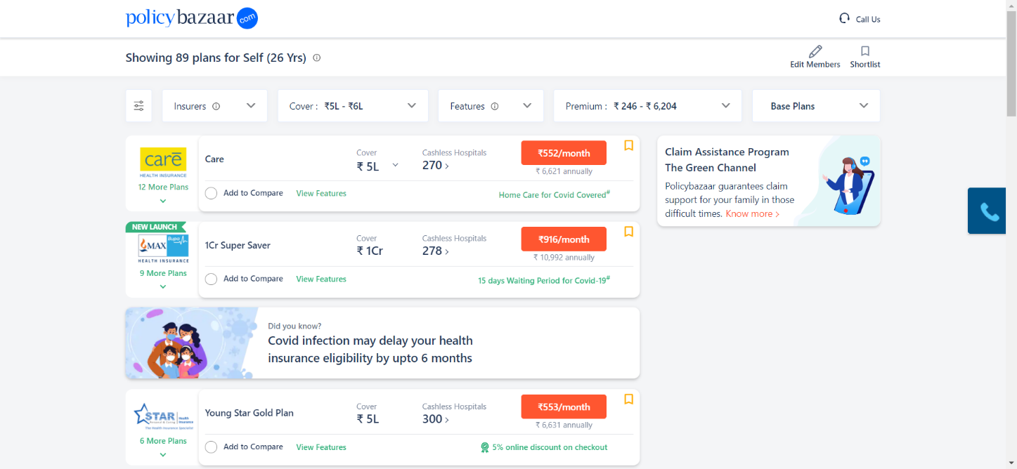

**Selenium WebDriver Test Script:**

TakesScreenshot t=(TakesScreenshot)d;

File scr=t.getScreenshotAs(OutputType.***FILE***);

Files.*copy*(scr, **new** File ("C:\\Users\\Ashok\\Pictures\\Saved Pictures\\picture.png"));

**TC16:** To verify the functionality of Edit Members button.

**Selenium WebDriver Test Script:**

d.findElement(By.*xpath*("(//*[contains(@class,'edit_insured_member')])[1]")).click();

d.findElement(By.*xpath*("(//*[contains(@class,'close_button')])[1]")).click();

**TC17:** To Test the functionality of Call Us Icon.

**Selenium WebDriver Test Script:**

Actions A=**new** Actions(d);

A.moveToElement(d.findElement(By.*xpath*("//*[contains(@class,'toll-link')]"))).perform();

**TC18:** To verify the functionality of scroll down and scroll up of the displayed page.

**Selenium WebDriver Test Script:**

JavascriptExecutor js =(JavascriptExecutor)d;

js.executeScript("window.scrollTo(0, document.body.scrollHeight)");

Thread.*sleep*(2000);

js.executeScript("window.scrollTo(document.body.scrollHeight, 0)");

**TC19:** To verify and display the number of links available on page.

**Selenium WebDriver Test Script:**

List<WebElement> Links= d.findElements(By.*tagName*("a"));

**int** Total_links=Links.size();

System.***out***.println("Total links are:" + Total_links);

**TC20:** To verify and display the number of buttons available on page.

**Selenium WebDriver Test Script:**

List<WebElement> button= d.findElements(By.*tagName*("input"));

**int** Total_buttons=button.size();

System.***out***.println("Total buttons are:" + Total_buttons);

**TC21:** To verify the functionality of 552/month button.

**Selenium WebDriver Test Script:**

d.findElement(By.*xpath*("(//*[contains(@id,'ProceedToProduct')])[1]")).click();

**TC22:** To verify the navigation to go back to previous page.

**Selenium WebDriver Test Script:**

d.navigate().back();

**TC23:** To verify that browser is able to close.

**Selenium WebDriver Test Script:**

d.close();

**Final Output of Console Window:**

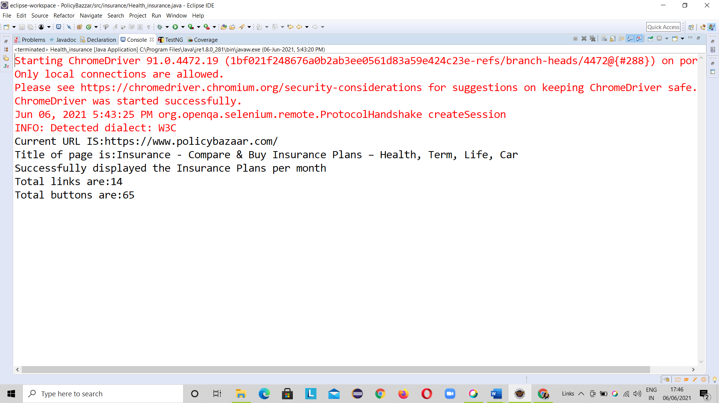

**2.CAR INSURANCE MODULE**

**TC01:** To Launch the browser and open Policy bazaar website.

System.*setProperty* ("webdriver.chrome.driver","C:\\Users\\Tonbo\\Desktop\\selenium jar\\chromedriver_win32\\chromedriver.exe");

WebDriver w = **new** ChromeDriver ();

w.manage ().window ().maximize ();

w.get ("https://www.policybazaar.com/");

Thread.*sleep* (2000);

**TC02**- To test the functionality of Policy Bazaar Website open.

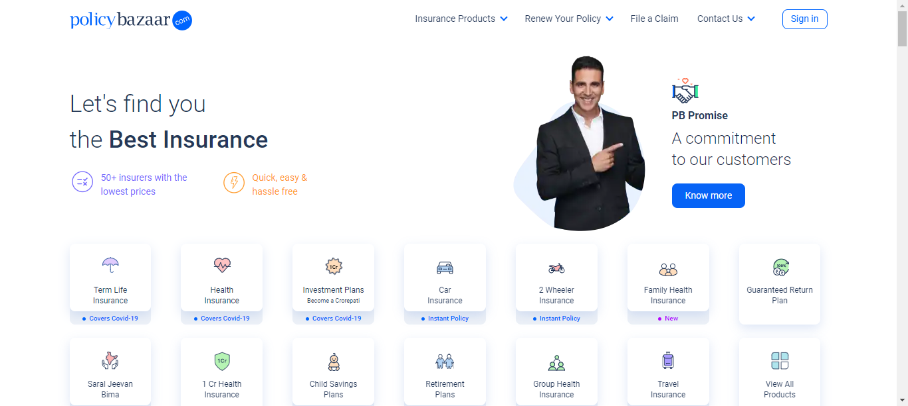

**TC03-** To verify the functionality of continue with Proceed Button.

w.findElement(By.*xpath*("//body[1]/cclink[1]/main[1]/div[2]/section[1]/div[4]/a[1]/div[1]/p[1]")).click();

Thread.*sleep* (3000);

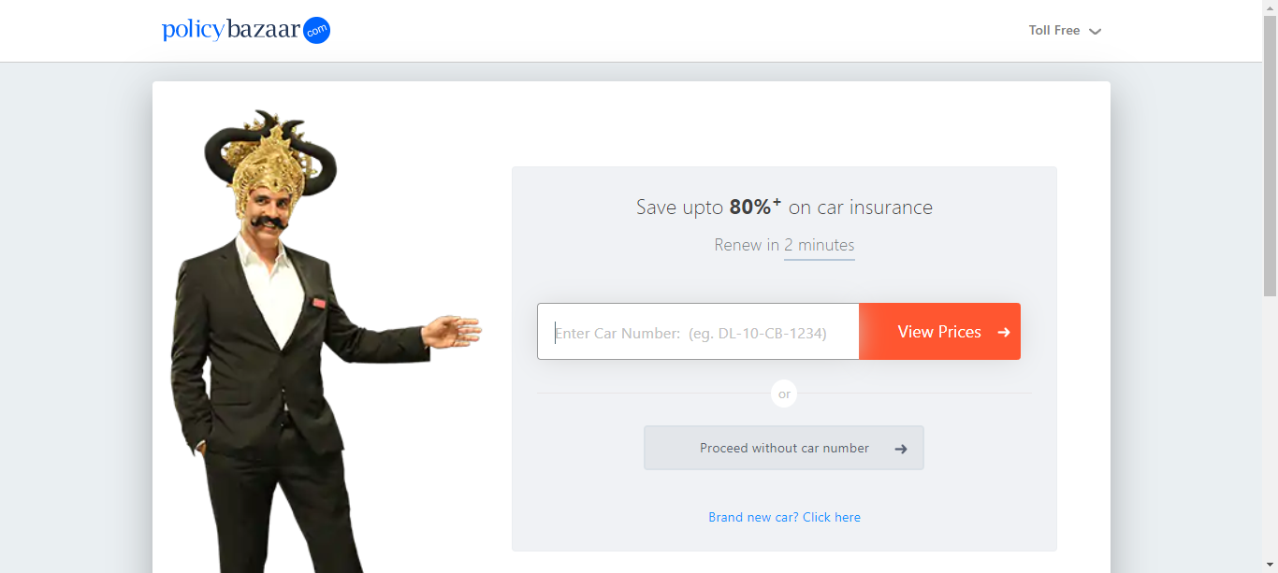

**TCO4:** To verify the functionality of continue button on city and Registration Number.

w.findElement(By.*className*("btn-proceed")).click();

w.findElement(By.*xpath*("//*[@id=\"dvRTO\"]/h3")).click();

w.findElement(By.*xpath*("//*[@id=\"spn3\"]")).click();

w.findElement(By.*xpath*("//span[contains(text(),'KA01')]")).click();

Thread.*sleep*(3000);

**TC05:** To verify the functionality on the Brand Button and click.

Actions a = **new** Actions(w);

a.moveToElement(w.findElement(By.*xpath*("//*[contains(text(),'MAHINDRA')]"))).click().perform();

Thread.*sleep*(3000);

**TC06:** To verify the functionality on select the model and proceed Button.

a.moveToElement(w.findElement(By.*xpath*("(//*[contains(@class,'col-sm-6 col-xs-6 ')])[1]"))).click().perform();

Thread.*sleep*(3000);

**TCO7:** To verify the functionality on Diesel Button and proceed**.**

a.moveToElement(w.findElement(By.*xpath*("//*[contains(@id,'Diesel')]"))).click().perform();

Thread.*sleep*(3000);

**TC08:** To verify the functionality on variant Button and proceed.

a.moveToElement (w.findElement(By.*xpath*("(//*[contains(@class,'col-sm-6 col-xs-12')])[2]"))).click().perform();

Thread.*sleep*(3000);

**TC09:** To verify the functionality on Registration Year and click Button.

a.moveToElement(w.findElement(By.*xpath*("(//*[contains(@class,'col-sm-4 col-xs-4 ')])[2]"))).click().perform();

Thread.*sleep*(3000);

**TC10:** To verify the functionality of continue button on valid Full Name, valid Email, valid phone Number.

w.findElement(By.*xpath*("//*[contains(@id,'name')]")).sendKeys("Sai");

w.findElement(By.*xpath*("//*[contains(@id,'email')]")).sendKeys("sai123@gmail.com");

w.findElement(By.*xpath*("//*[contains(@id,'mobileNo')]")).sendKeys("9876543217");

w.findElement(By.*xpath*("//*[contains(@id,'btnLeadDetails')]")).click();

Thread.*sleep*(3000);

**TC11:** To verify the functionality of continue Button on valid Date and Expire Date and click on it.

a.moveToElement(w.findElement(By.*xpath*("(//*[contains(@class,'ui-state-default')])[61]"))).click().perform();

Thread.*sleep*(3000);

**Tc12:** To verify the functionality on radio buttons and click on it**.**

w.findElement(By.*xpath*("(//*[contains(@class,'radio_text')])[3]")).click();

Thread.*sleep*(3000);

**Tc13:** To verify the functionality on insurance button and view all buttons.

w.findElement(By.*xpath*("//body/div[@id='app']/div[1]/div[1]/div[1]/div[2]/div[2]/div[1]/div[1]/div[1]")).click();

Thread.*sleep*(3000);

w.findElement(By.*xpath*("//label[contains(text(),'Select All')]")).click();

Thread.*sleep*(3000);

System.***out***.println("To click on all");

w.findElement(By.*xpath*("//button[contains(text(),'Close')]")).click();Thread.*sleep*(4000);

**TC14 :** Take the screenshort on view plans of the car insurance.

TakesScreenshot t =(TakesScreenshot) w;

File src = t.getScreenshotAs(OutputType.***FILE***);

Files.*copy*(src, **new** File("D:\\screenshot\\sai.png"));

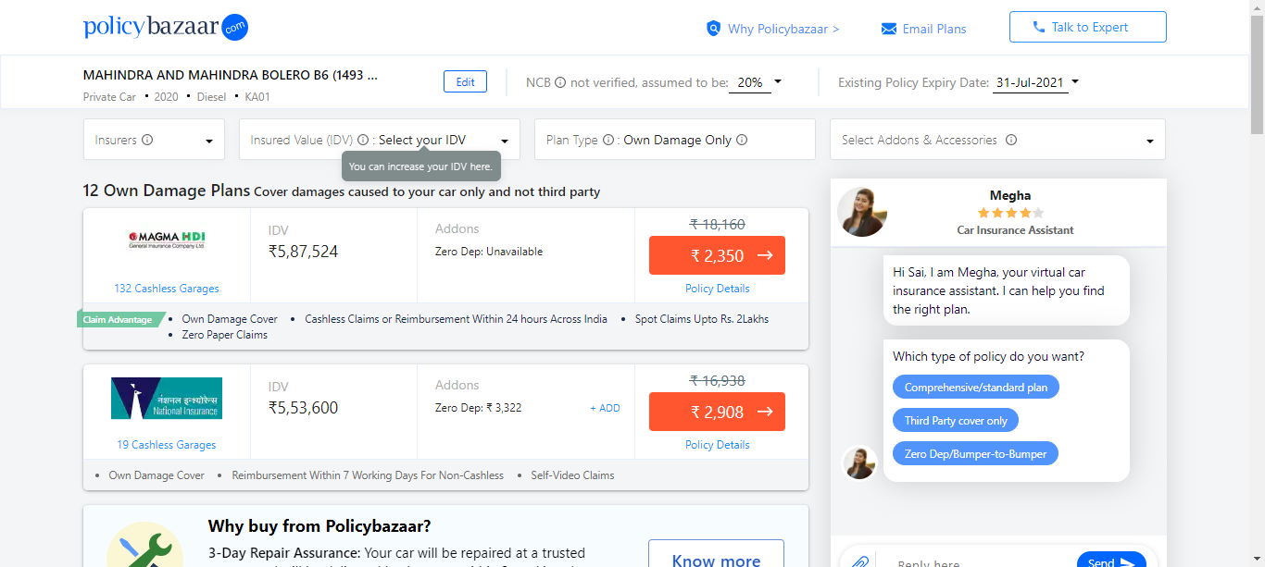

**TC15:** To verify the functionality of the Edit the car insurance.

w.findElement(By.*xpath*("//body/div[@id='app']/div[1]/div[1]/div[1]/div[2]/div[1]/div[1]/div[1]/div[1]/div[1]")).click();

Thread.*sleep*(3000);

w.findElement(By.*xpath*("//button[contains(text(),'Edit')]")).click();

Thread.*sleep*(3000);

w.findElement(By.*xpath*("//button[contains(text(),'Close')]")).click();

**TC16:** To verify the functionality Scroll down on the view plans and scrollup the first page.

JavascriptExecutor js =(JavascriptExecutor)w;

js.executeScript("window.scrollTo(0,document.body.scrollHeight)" );

Thread.*sleep*(3000);

js.executeScript("window.scrollTo(document.body.scrollHeight,0)");

**TC17:** To verify the functionality of the not verified, assumed to be the percentage values.

w.findElement(By.xpath("//body[1]/div[1]/div[1]/div[1]/div[1]/div[2]/div[1]/div[1]/div[2]/div[1]")).click();

Thread.sleep(3000);

w.findElement(By.xpath("//button[contains(text(),'Yes')]")).click();

Thread.sleep(3000);

w.findElement(By.xpath("//button[contains(text(),'20')]")).click();

w.findElement(By.xpath("//button[contains(text(),'Close')]")).click();

**TC18 :** To verify the functionality of the insurance IDV and updated the prices.

w.findElement(By.xpath("//body/div[@id='app']/div[1]/div[1]/div[1]/div[2]/div[2]/div[1]/div[2]/button[1]")).click();

**TC19**: To verify the functionality of the why we have take policy in bazaar.

w.findElement(By.*xpath*("//button[contains(text(),'Why Policybazaar >')]")).click();

Thread.*sleep*(3000);

w.findElement(By.*xpath*("//body/div[@id='app']/div[1]/div[1]/div[1]/div[1]/div[1]/div[1]/div[1]/div[1]/div[2]/span[1]")).click();

**TC20:** To verify the functionality of the Email plans and verify and close.

w.findElement(By.*xpath*("//button[contains(text(),'Email Plans')]")).click();

Thread.*sleep*(3000);

w.findElement(By.*xpath*("//body/div[@id='app']/div[1]/div[1]/div[1]/div[1]/div[1]/div[1]/div[1]/div[2]/div[1]/span[1]")).click();

**TC21:** To verify the functionality of the number of the lists and buttons to check the insurance.

List<WebElement> Links=w.findElements(By.*tagName*("a"));

**int** Total_links=Links.size();

System.***out***.println("Total links are: " + Total_links);

List<WebElement> button=w.findElements(By.*tagName*("input"));

**int** Total_buttons=button.size();

System.***out***.println("Total buttons are: " + Total_buttons);

**TC22:** To verify the functionality of the Talk to Expert members.

w.findElement(By.*xpath*("//a[contains(text(),'Talk to Expert')]")).click();

Thread.*sleep*(3000);

System.***out***.println("policy bazzar is sucessfull Done");

w.close();

}

}

**Final Output of Console Window:**

