Home Work Assignment – 6

*WeatherPy – API Assignment*

**Data Analytics and Visualization**

**Rice University**

Dr. Sailendra Mahapatra

The following are observations based on analysis done in OpenWeather dataset in Python by utilizing API data retrieval, utilizing pandas, datetime, request and numpy libraries (attached file “HW-6-Weather API Assignment in jupyter notebook and generating the files in .png via mapplotlib).

The cities for this weather analysis were generated randomly with Latitude/Longitude values up to 1500 occurrences and from OpenWeatherMap using its API for data retrieval.

The results of the present analysis are plotted (see the figures below)

* There is no correlation observed in cloudy sky today. However, data for -60 to -90 degrees latitude (Southern Hemisphere) appears to be blank. This may be due to lack of placement of sufficient weather station in that range. We tried several times with randomly selecting the stations in that range but the result was same (see figure below).

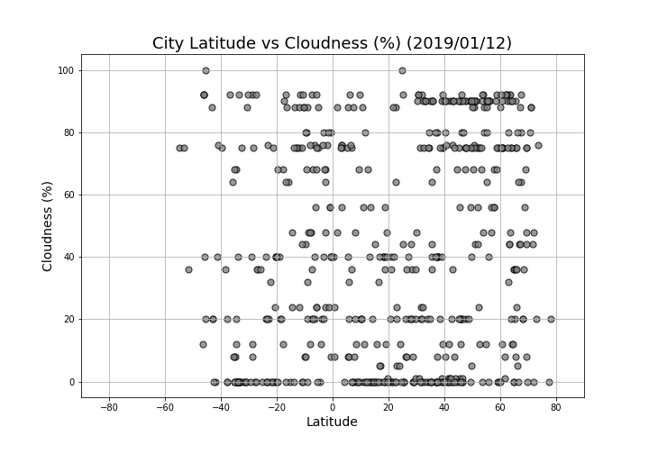

* The humidity does not show any regular geographic trend. However, its more in 60-degree latitudes in both hemisphere (see the figure below).
* The wind speed appears to be phenomenal between -40- and +70-degree latitude with a maximum of 20% upto 20 degrees from the equator as expected. Again, the data beyond -50 degrees is missing, may be due to lack of sufficient weather centers.
* The temperature data shows subsequent rise away from equator as expected.

