**Tribhuvan University**



Faculty of Humanities and Social Sciences

A PROJECT PROPOSAL

Submitted to

Department of Computer Application

**Asian College of Higher Studies**

In partial fulfillment of the requirements for the Bachelors in Computer Application

Submitted by

Sailendra Shrestha [190629]

Bipul Tamang [190606]

Under the Supervision of

# List of Figures

Figure 3.1: Waterfall Model 7

Figure 4.1 System Use Case 10

Figure 5.1 Gantt Chart 11

Contents

1. Introduction 4

1.1 Introduction 4

1.2 Problem Statement 4

1.3 Objectives 5

1.4 Scope and limitation 5

Scope 5

**Limitation** 5

2. Literature Review 6

3. Methodology 7

3.1 System analysis 8

**Functional Requirements** 8

**Non-Functional Requirements** 8

3.2 Feasibility Study 9

3.3 Tools 9

4. System Design 10

**4.1 Use case** 10

5. Gantt Chart 11

6. Conclusion 12

7. Expected Outcome 12

References 13

# **Introduction**

## **1.1 Introduction**

The majority of food recipe websites accessible today are ineffective in presenting food recipes in an easy and clear manner, and users must acquire a premium pass to have access to other features. For some people, they do not have a user-friendly UI. For our project, we propose creating a food recipe website with a user-friendly interface that allows users to bookmark their favorite recipes, select recipes based on food sensitivities, and search for food dishes using customized ingredients. The user has full access to all of the food recipes, and our main goal is to delight clients by giving all of the features in a user-friendly interface.

## **1.2 Problem Statement**

Many food recipe websites on the internet are poorly optimized and do not efficiently give food recipes for users to follow. Food recipe websites on the internet feature foods that the user may be sensitive to, and they don't supply any alternate flavors or substitutions for the given recipe, which is an issue for someone who is just learning to cook. Most of the available websites also fail to provide information on the amount of difficulty of cooking and the abilities required to prepare specific cuisines, leaving the user unaware of the foods that they can prepare.

Users will be unable to use the website functions efficiently and effectively if the website is not optimized. The paid option for showing recipes and using specific features is also a turn off for user who’s interested in cooking. Some websites won’t specify the cooking skills required so it will be difficult for the user to choose a food dish that they can cook and prepare if the cooking difficulty is not specified. (piu@sheffield.ac.uk, 2021)

## **1.3 Objectives**

The main objectives of this project is to provide users the recipe and information on food in a simple understandable way and bookmark it for future use too.

* Provide all required ingredients for the food.
* Exclude foods or ingredients that are allergic to user.
* Search for recipes based on customized ingredients.
* Specify the difficulty level of the food recipe and choose recipe based on the cooking skills.
* Save favorite food recipe and will be able to access easily when logged in again.

## **1.4 Scope and limitation**

### Scope

* Save time.
* Easy to bookmark recipe.
* Free special features.
* No limits on bookmark and recipe.

### **Limitation**

* This system is used for online basis only.
* No email alerts are send to user if new recipe is added.
* No follow up video directions.

# Literature Review

For this project, we researched and reviewed some of the related websites and applications. Throughout the search, we got to find out that there are very few websites or applications related to food recipe. So, the users can’t get the quality information. The examples are: myfridgefood.com, veggiesouls.com etc.

If some websites are available for users, we found the websites are looking many features regarding the food recipes. Especially, the users are not convinced with the quality facilities given to them.

# Methodology

We are going to use Waterfall methodology during the development of website. The project is short and cast is low and the risk is minimum so we’re going to use waterfall methodology the requirements and features are clear and fixed and it’ll not change in upcoming future during the period of the project development so this method will be used.

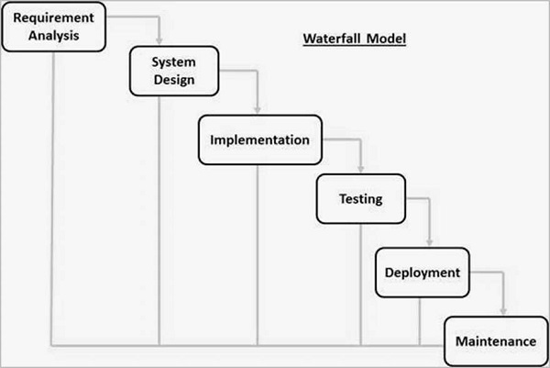

Figure 3.1: Waterfall Model

The Waterfall methodology is the most straightforward way to manage a project. It is the most traditional method for managing project where participant has clear defined role and none of the phases or goals are expected to change. Waterfall project works best for project with detailed plans that require a single timeline. (Wrike, 2021)

## **3.1 System analysis**

### **Functional Requirements**

1. Users will be able to register and login.
2. Users will be able to bookmark their favorite recipe.
3. Administrator will be able to add verify users account and give them right to access the right.
4. Administrator will be able to add new recipe and update existing recipe.
5. Users will be able to update their personal information.

### **Non-Functional Requirements**

1. Availability

It will be available online.

1. Security

This system will be secure and the user information won’t be shared and available for others for user privacy.

1. Simplicity

This system will have a simple UI and easy to navigate around and saves time.

1. Performance

This system will be designed for smooth performance with good optimization and good response.

1. Reliability

It will be reliable for the user. (kushwaha, 2020)

## **3.2 Feasibility Study**

In Feasibility Study analysis and evaluation of projects is done including economic, technical, legal and operational feasibility. Feasibility Study also helps to determine the risk and several steps and best practices that should be considered before moving forward during the project development phase.

1. Technical feasibility

In order to design this system, it uses existing technologies, software and hardware hence there’s no technical problem that might arise to build this system.

1. Economic feasibility

The system does not require extra software and hardware i.e. it uses open-source technologies. So there is no recurring cost.

1. Operational feasibility

This system uses simple technologies to design. So it is user friendly.

1. Legal feasibility

This system is completely legal and should not face any problem regarding illegal issues. (INVESTOPEDIA, 2021)

## **3.3 Tools**

For the front end development HTML, CSS, and JavaScript will be used.

For the back end development My SQL and PHP will be used.

## **System Design**

### **4.1 Use case**

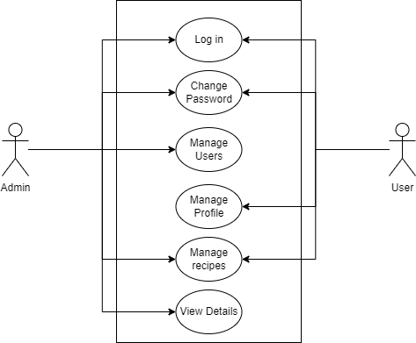

Figure 4. System Use Case

On the diagram above, we can see a use case of both an admin and a user on a system, as well as the features they can access. Both the admin and the user, as shown in the diagram, have some common qualities such as logging in, changing passwords, managing recipes. However, the user is restricted from accessing all of the services, such as managing users, viewing user information, updating recipes. Only the administrator has access to such functions.

# Gantt Chart

Figure 5.1 Gantt Chart

The Gantt chart shown above is for our project, which will be managed using the waterfall project management method. Because there is a lot of work to be done throughout these phases, we have spent extra time on system design, implementation, and coding. When compared to implementation, system planning and analysis require less time. Also, testing time is very limited and had to be lowered because it does not require as much time as other phases, and problems and features must be verified and corrected during maintenance in order to meet deadlines.

# Conclusion

As a result, the user will be able to search for and bookmark their favorite food recipe on this website, as well as easily reload the stored food recipe when logged in. They will also be able to search for meal recipes based on ingredients and exclude foods or ingredients to which they are sensitive.

# Expected Outcome

When the project is completed, the users will be able to create a free account and log in to our website and search and bookmark their favorite food recipe. They will be able to filter out the food ingredients based on their choice and also will be able to search for food recipe based on their customized ingredients.

# References

<https://www.sheffield.ac.uk/polopoly_fs/1.440722!/file/HowtoWriteaProblemStatement.pdf>

<https://www.wrike.com/project-management-guide/faq/what-is-waterfall-project-management/>

<https://drive.google.com/file/d/1ugIDahM9GluK54f3XbtJrlPnTXiq-U8Q/view?fbclid=IwAR035Tj_cKKx73EFioWe2L3oSfsjL99XAdG9EekBq1G4FsD_ezXAcWatPSo>

<https://www.investopedia.com/terms/f/feasibility-study.asp#:~:text=A%20feasibility%20study%20is%20an,of%20completing%20the%20project%20successfully>