using System;
using System.Collections.Generic;
using System.ComponentModel;
using System.Data;
using System.Drawing;
using System.Linq;
using System.Text;
using System.Threading.Tasks;
using System.Windows.Forms;

namespace Cancule
{
public partial class Form1 : Form
{
public Form1()
{
InitializeComponent();
}

string a,op,b;
int res;
private void button1_Click(object sender, EventArgs e)
{

if (textBox1.Text == "0")
textBox1.Clear();
if(res==1)
{
textBox1.Text = button1.Text;
res = 0;
}
else
textBox1.Text += button1.Text;
// a += button1.Text;

}

private void button6_Click(object sender, EventArgs e)
{
if (textBox1.Text == "0")
textBox1.Clear();
if (res == 1)
{
textBox1.Text = button6.Text;
res = 0;
}
else
textBox1.Text += button6.Text;
// a += button6.Text;
}

private void button7_Click(object sender, EventArgs e)
{
if (textBox1.Text == "0")
textBox1.Clear();
if (res == 1)
{
textBox1.Text = button7.Text;
res = 0;
}
else
textBox1.Text += button7.Text;
// a += button7.Text;
}

private void button2_Click(object sender, EventArgs e)
{
if (textBox1.Text == "0")
textBox1.Clear();

if (res == 1)
{
textBox1.Text = button2.Text;
res = 0;
}
else
textBox1.Text += button2.Text;
// a += button2.Text;
}

private void button5_Click(object sender, EventArgs e)
{
if (textBox1.Text == "0")
textBox1.Clear();

if (res == 1)
{
textBox1.Text = button5.Text;
res = 0;
}
else
textBox1.Text += button5.Text;
// a += button5.Text;
}

private void button9_Click(object sender, EventArgs e)
{
if (textBox1.Text == "0")
textBox1.Clear();

if (res == 1)
{
textBox1.Text = button9.Text;
res = 0;
}
else
textBox1.Text += button9.Text;
// a += button9.Text;
}

private void button3_Click(object sender, EventArgs e)
{
if (textBox1.Text == "0")
textBox1.Clear();

if (res == 1)
{
textBox1.Text = button3.Text;
res = 0;
}
else
textBox1.Text += button3.Text;
// a += button3.Text;
}

private void button4_Click(object sender, EventArgs e)
{
if (textBox1.Text == "0")
textBox1.Clear();

if (res == 1)
{
textBox1.Text = button4.Text;
res = 0;
}
else
textBox1.Text += button4.Text;
// a += button4.Text;
}

private void button8_Click(object sender, EventArgs e)
{
if (textBox1.Text == "0")
textBox1.Clear();

if (res == 1)
{
textBox1.Text = button8.Text;
res = 0;
}
else
textBox1.Text += button8.Text;
// a += button8.Text;
}

private void button10_Click(object sender, EventArgs e)
{
if (textBox1.Text == "0")
textBox1.Clear();
if (res == 1)
{
textBox1.Text = button10.Text;
res = 0;
}
else
textBox1.Text += button10.Text;
// a += button10.Text;
}

private void button13_Click(object sender, EventArgs e)
{
if (textBox1.Text == "0")
textBox1.Clear();

textBox1.Text = "0";
a = " 0";
label1.Text = a;
}

private void button12_Click(object sender, EventArgs e)
{

}

private void button18_Click(object sender, EventArgs e)
{

int a;
a = (int)MessageBox.Show("Do You Want Turn On/Off?","r u sure", MessageBoxButtons.YesNo, MessageBoxIcon.Question);

if (a == 6)
{
groupBox1.Enabled = true;
}
if(a!=6)
{
groupBox1.Enabled = false;
}

}

private void button14_Click(object sender, EventArgs e)
{
a = textBox1.Text;
op = "*";
if (textBox1.Text != "0")
{
textBox1.Text = "0";
}
label1.Text = a;
}

private void button16_Click(object sender, EventArgs e)
{
a = textBox1.Text;
op = "-";
if (textBox1.Text != "0")
{
textBox1.Text = "0";
}
label1.Text = a;
}

private void button17_Click(object sender, EventArgs e)
{

a = textBox1.Text;
op = "+";
if (textBox1.Text != "0")
{
textBox1.Text = "0";
}
label1.Text = a;
}

private void label1_Click(object sender, EventArgs e)
{

}

private void button11_Click(object sender, EventArgs e)
{

a = textBox1.Text;
op = "/";
if (textBox1.Text != "0")
{
textBox1.Text = "0";
}
label1.Text = a;

}

private void button15_Click(object sender, EventArgs e)
{
b = textBox1.Text;
if (op == "/")
{
textBox1.Text = (int.Parse(a) / int.Parse(b)).ToString();

}
if (op == "*")
{
textBox1.Text = (int.Parse(a) * int.Parse(b)).ToString();

}
if (op == "+")
{
textBox1.Text = (int.Parse(a) + int.Parse(b)).ToString();

}
if (op == "-")
{

textBox1.Text = (int.Parse(a) - int.Parse(b)).ToString();

}
res = 1;
label1.Text = textBox1.Text;
}
}
}
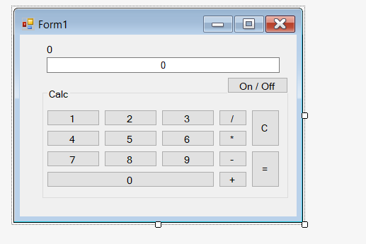
first u create the look
create int \string what easier for u I used 3 (a,b,res)
a=for first number text
b=for second number text
res=to restart that it won’t double click when u click one of the numbers
double click all buttons
and enjoy of follow the code

