#### 2024-10-24训练日志：

1. DCDR_PPO simple

DCDR的训练参数

parser.add_argument("--dr_min_ratio", type=float, default=0.8,

help="Dynamic rl min reward ratio in rl and gail reward")

parser.add_argument("--dr_max_ratio", type=float, default=0.99,

help="Dynamic rl max reward ratio in rl and gail reward")

parser.add_argument("--start_episode", type=float, default=1000,

help="Start episode for dynamic rl reward ratio increasing")

parser.add_argument("--end_episode", type=float, default=2000,

help="End episode for dynamic rl reward ratio increasing")

parser.add_argument("--train-episodes", type=int, default=3000,

help="number of time steps")（稀疏奖励）

average episode steps 25.0

agent average returns 9.9

... saving agent checkpoint ...

The best reward of agent is 9.95 when episode is 3000

2. DCDR_PPO simple

DCDR的训练参数

parser.add_argument("--dr_min_ratio", type=float, default=0.8,

help="Dynamic rl min reward ratio in rl and gail reward")

parser.add_argument("--dr_max_ratio", type=float, default=1,

help="Dynamic rl max reward ratio in rl and gail reward")

parser.add_argument("--start_episode", type=float, default=1000,

help="Start episode for dynamic rl reward ratio increasing")

parser.add_argument("--end_episode", type=float, default=1500,

help="End episode for dynamic rl reward ratio increasing")

parser.add_argument("--train-episodes", type=int, default=3000,

help="number of time steps")（稀疏奖励）

average episode steps 25.0

agent average returns 15.8

... saving agent checkpoint ...

The best reward of agent is 15.8 when episode is 3000

3. DCDR_PPO simple

DCDR的训练参数

# DCDR的训练参数

parser.add_argument("--dr_min_ratio", type=float, default=0.5,

help="Dynamic rl min reward ratio in rl and gail reward")

parser.add_argument("--dr_max_ratio", type=float, default=0.5,

help="Dynamic rl max reward ratio in rl and gail reward")

parser.add_argument("--start_episode", type=float, default=1000,

help="Start episode for dynamic rl reward ratio increasing")

parser.add_argument("--end_episode", type=float, default=1500,

help="End episode for dynamic rl reward ratio increasing")

parser.add_argument("--train-episodes", type=int, default=3000,

help="number of time steps")（稀疏奖励）

average episode steps 25.0

agent average returns 5.3

... saving agent checkpoint ...

The best reward of agent is 7.32 when episode is 3800

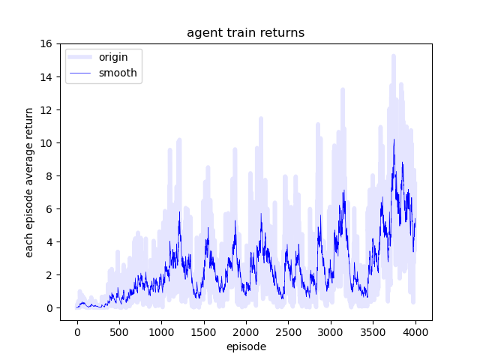

4. DCDR_PPO simple

DCDR的训练参数

parser.add_argument("--dr_min_ratio", type=float, default=0.8,

help="Dynamic rl min reward ratio in rl and gail reward")

parser.add_argument("--dr_max_ratio", type=float, default=1,

help="Dynamic rl max reward ratio in rl and gail reward")

parser.add_argument("--start_episode", type=float, default=1000,

help="Start episode for dynamic rl reward ratio increasing")

parser.add_argument("--end_episode", type=float, default=1001,

help="End episode for dynamic rl reward ratio increasing")

parser.add_argument("--train-episodes", type=int, default=3000,

help="number of time steps")（稀疏奖励）

average episode steps 25.0

agent average returns 17.2

... saving agent checkpoint ...

The best reward of agent is 19.37 when episode is 3800

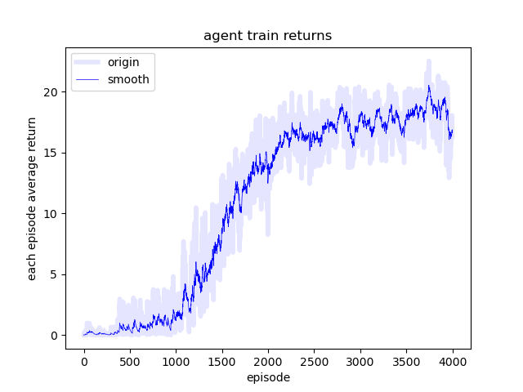

5. DCDR_PPO simple

DCDR的训练参数

parser.add_argument("--dr_min_ratio", type=float, default=0,

help="Dynamic rl min reward ratio in rl and gail reward")

parser.add_argument("--dr_max_ratio", type=float, default=1,

help="Dynamic rl max reward ratio in rl and gail reward")

parser.add_argument("--start_episode", type=float, default=1000,

help="Start episode for dynamic rl reward ratio increasing")

parser.add_argument("--end_episode", type=float, default=1001,

help="End episode for dynamic rl reward ratio increasing")

parser.add_argument("--train-episodes", type=int, default=3000,

help="number of time steps")（稀疏奖励）

average episode steps 25.0

agent average returns 16.7

... saving agent checkpoint ...

The best reward of agent is 17.29 when episode is 3900

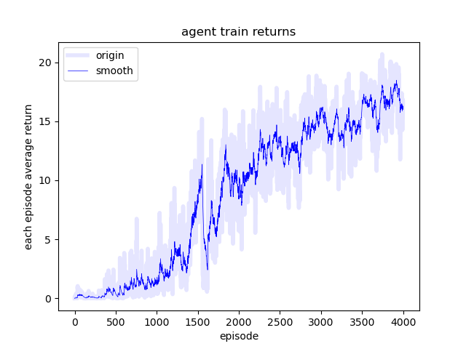

5. DCDR_PPO simple

# DCDR的训练参数

parser.add_argument("--dr_min_ratio", type=float, default=1,

help="Dynamic rl min reward ratio in rl and gail reward")

parser.add_argument("--dr_max_ratio", type=float, default=1,

help="Dynamic rl max reward ratio in rl and gail reward")

parser.add_argument("--start_episode", type=float, default=1000,

help="Start episode for dynamic rl reward ratio increasing")

parser.add_argument("--end_episode", type=float, default=1001,

help="End episode for dynamic rl reward ratio increasing")

parser.add_argument("--train-episodes", type=int, default=3000,

help="number of time steps")（稀疏奖励）

average episode steps 25.0

agent average returns 1.7

... saving agent checkpoint ...

The best reward of agent is 1.97 when episode is 3900

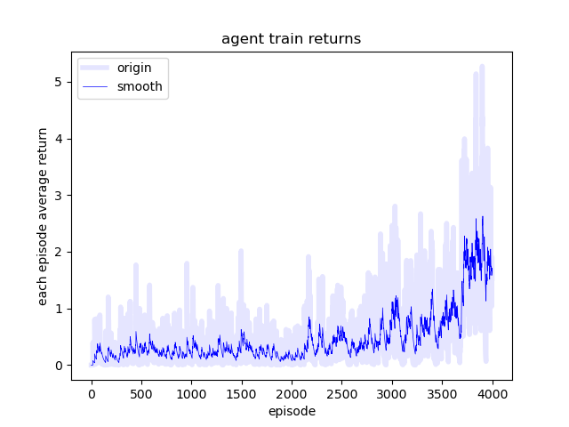

6. DCDR_PPO simple

# DCDR的训练参数

combined_ratio = 0.6

if self.episode_num % 100 == 0 and self.episode_num > 100:

agent_returns = np.array(pd.read_csv(self.data_save_path + "/agent_returns.csv"))

if np.mean(agent_returns[-self.display_episodes:]) > np.mean(agent_returns[-1000:]) * 0.99:

self.factor += 1

else:

self.factor -= 1

if np.abs(self.factor) >= 3:

combined_ratio = 1 / (1 + np.exp(-self.factor))

else:

combined_ratio = 0.8

print(np.mean(agent_returns[-self.display_episodes:]), np.mean(agent_returns[-1000:]))

print("combined_ratio", combined_ratio)

parser.add_argument("--train-episodes", type=int, default=3000,

help="number of time steps")（稀疏奖励）

average episode steps 25.0

agent average returns 6.5

... saving agent checkpoint ...

The best reward of agent is 8.3 when episode is 3800

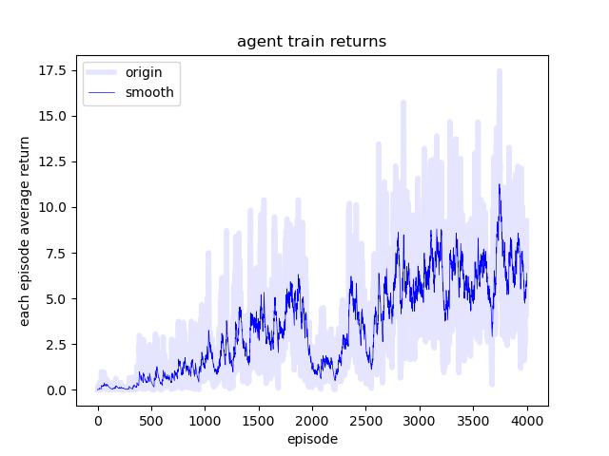

7. DCDR_PPO simple

if self.episode_num % 100 == 0 and self.episode_num > 100:

agent_returns = np.array(pd.read_csv(self.data_save_path + "/agent_returns.csv"))

if np.mean(agent_returns[-self.display_episodes:]) > np.mean(agent_returns[-1000:]) * 0.99:

self.factor += 1 / 2

else:

self.factor -= 1 / 2

self.factor = np.clip(self.factor, 0, 6)

if self.factor > 3:

combined_ratio = 1

else:

combined_ratio = 0.8

print(np.mean(agent_returns[-1000:]))

print("self.factor", self.factor)

parser.add_argument("--train-episodes", type=int, default=3000,

help="number of time steps")（稀疏奖励）

average episode steps 25.0

agent average returns 7.9

... saving agent checkpoint ...

The best reward of agent is 7.94 when episode is 4000

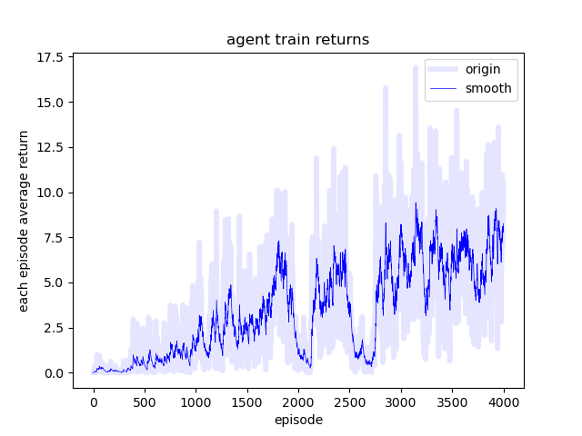

8. DCDR_PPO simple

parser.add_argument("--dr_min_ratio", type=float, default=0,

help="Dynamic rl min reward ratio in rl and gail reward")

parser.add_argument("--dr_max_ratio", type=float, default=1,

help="Dynamic rl max reward ratio in rl and gail reward")

parser.add_argument("--start_episode", type=float, default=1000,

help="Start episode for dynamic rl reward ratio increasing")

parser.add_argument("--end_episode", type=float, default=1200,

help="End episode for dynamic rl reward ratio increasing")parser.add_argument("--train-episodes", type=int, default=3000,

help="number of time steps")（稀疏奖励）

average episode steps 25.0

agent average returns 16.8

... saving agent checkpoint ...

The best reward of agent is 17.87 when episode is 3900

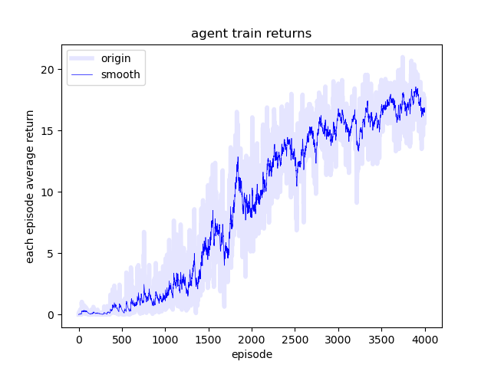

8. DCDR_PPO simple

# DCDR的训练参数

parser.add_argument("--dr_min_ratio", type=float, default=0.5,

help="Dynamic rl min reward ratio in rl and gail reward")

parser.add_argument("--dr_max_ratio", type=float, default=1,

help="Dynamic rl max reward ratio in rl and gail reward")

parser.add_argument("--start_episode", type=float, default=400,

help="Start episode for dynamic rl reward ratio increasing")

parser.add_argument("--end_episode", type=float, default=1000,

help="End episode for dynamic rl reward ratio increasing")

parser.add_argument("--train-episodes", type=int, default=3000,

help="number of time steps")（稀疏奖励）

average episode steps 25.0

agent average returns 17.3

... saving agent checkpoint ...

The best reward of agent is 19.05 when episode is 3800

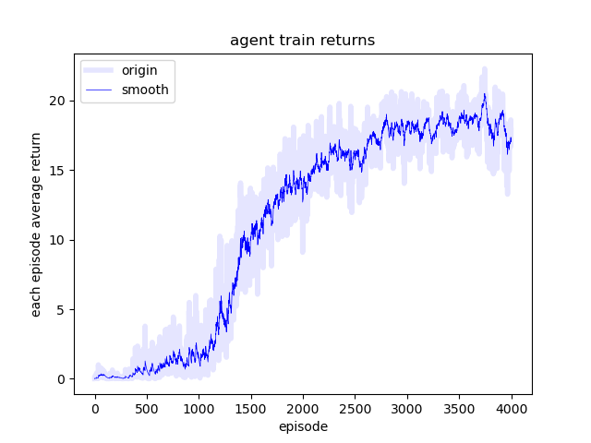

8. DCDR_PPO simple

# DCDR的训练参数

parser.add_argument("--dr_min_ratio", type=float, default=1-1e-3,

help="Dynamic rl min reward ratio in rl and gail reward")

parser.add_argument("--dr_max_ratio", type=float, default=1-1e-3,

help="Dynamic rl max reward ratio in rl and gail reward")

parser.add_argument("--start_episode", type=float, default=1000,

help="Start episode for dynamic rl reward ratio increasing")

parser.add_argument("--end_episode", type=float, default=1001,

help="End episode for dynamic rl reward ratio increasing")

parser.add_argument("--train-episodes", type=int, default=3000,

help="number of time steps")（稀疏奖励）

average episode steps 25.0

agent average returns 17.3

... saving agent checkpoint ...

The best reward of agent is 19.05 when episode is 3800

