**Create a Bucket and allow access to single user.**

1. Create 2 user testuser1 and testuser2

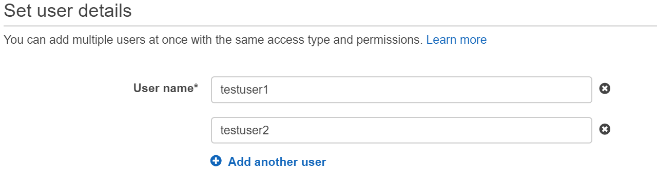

1. Assign s3 read-only permission to both user .

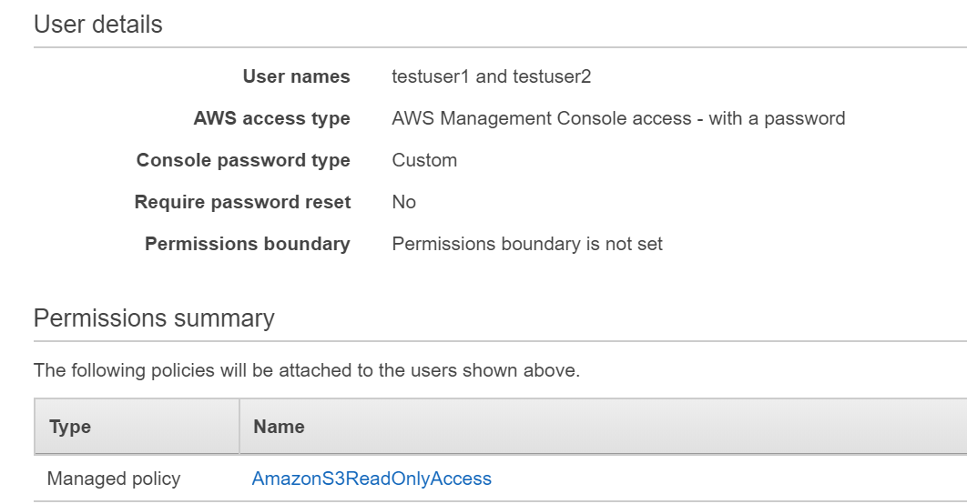

1. Login with each user (testuser1 and testuser2)on different different web browser.



And



1. Now Create a Bucket ( give the name you want)

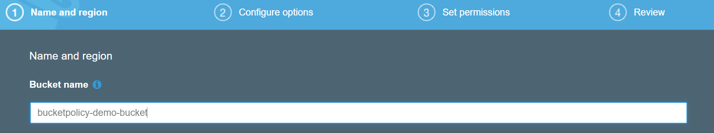

1. Copy Bucket ARN in my case it was arn:aws:s3:::bucketpolicy-demo-bucket

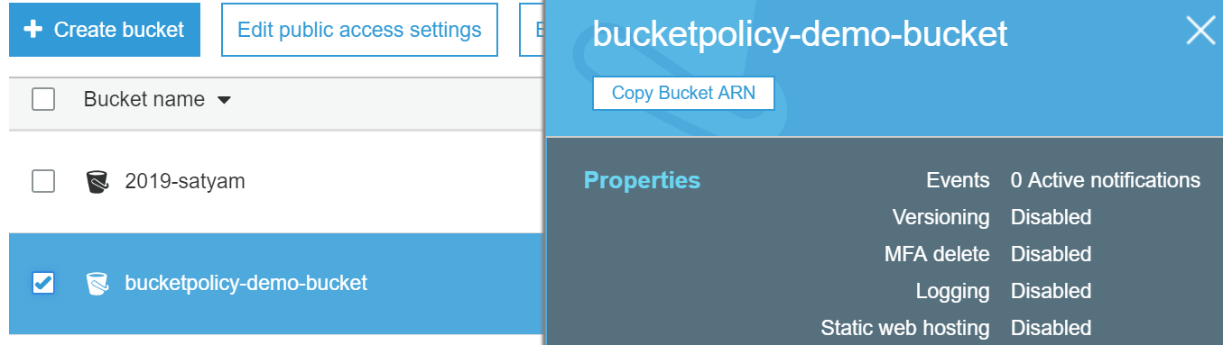

1. Remove the default permission of bucket

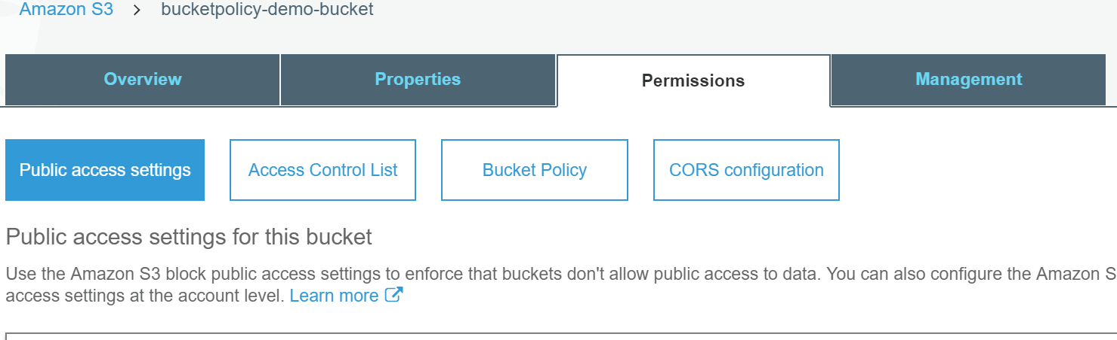

1. Now click on bucket policy

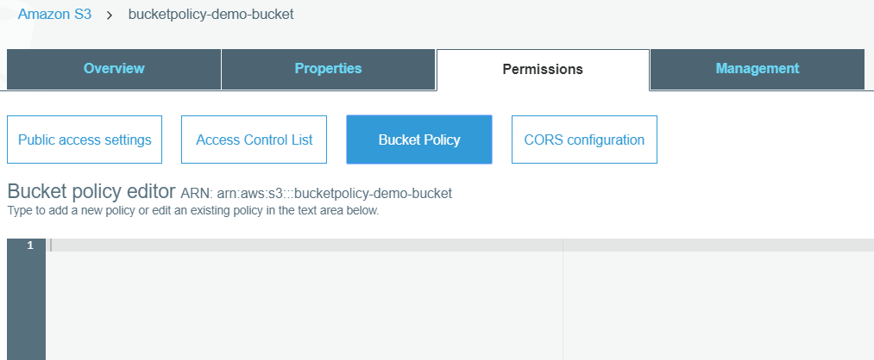

<https://awspolicygen.s3.amazonaws.com/policygen.html>

1. Go policy generator tool.
2. Select : S3 bucket Policy
3. Effect : Allow
4. arn:aws:iam::366223193853:user/testuser1 (arn of only one user testuser1)
5. Action : GetObject and PutObject
6. ARN : arn:aws:s3:::bucketpolicy-demo-bucket/* (arn of bucket)
7. Save and Generate policy.
8. Bucket Policy which get generated in my case.

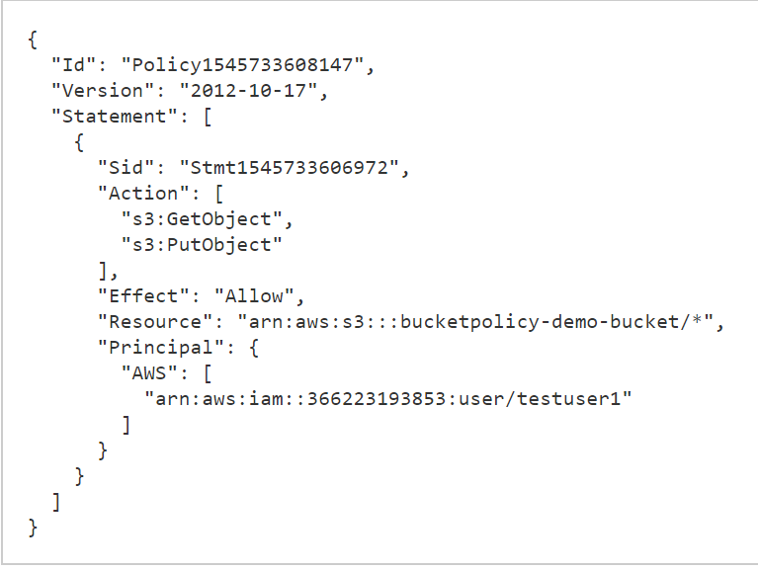

1. Copy and paste the bucket policy in Bucket policy section of bucket and save it.

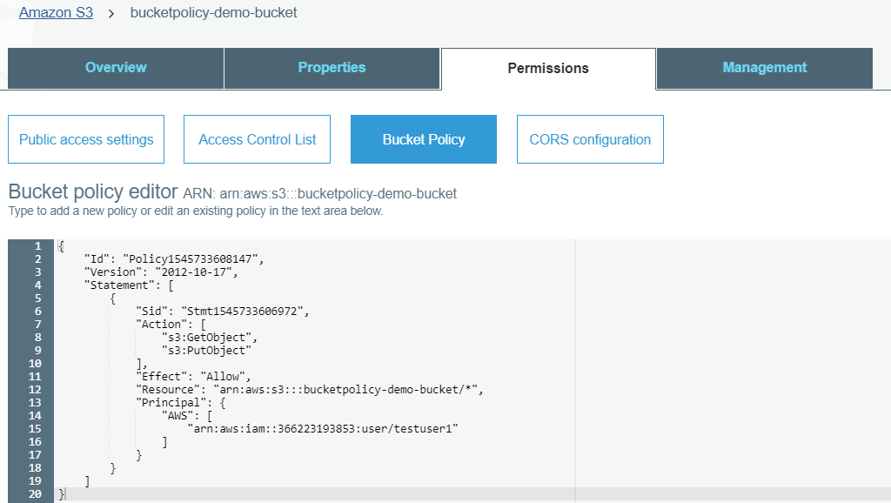

13 As we have logged in from testuser1 and testuser2 from different different browser.

Lets try uploading some file as per bucket policy access only given to testuser1.

14. Uploaded content as a root user to main bucket , uploaded successfully.

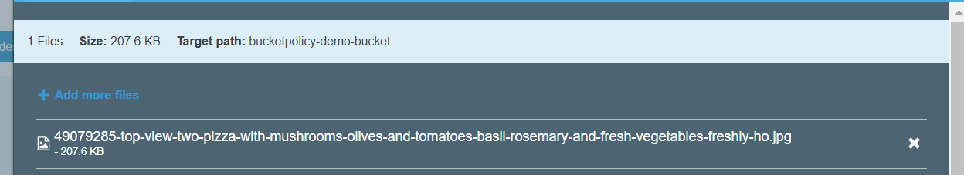

15. now lets try to upload from testuser2 which don’t have access.

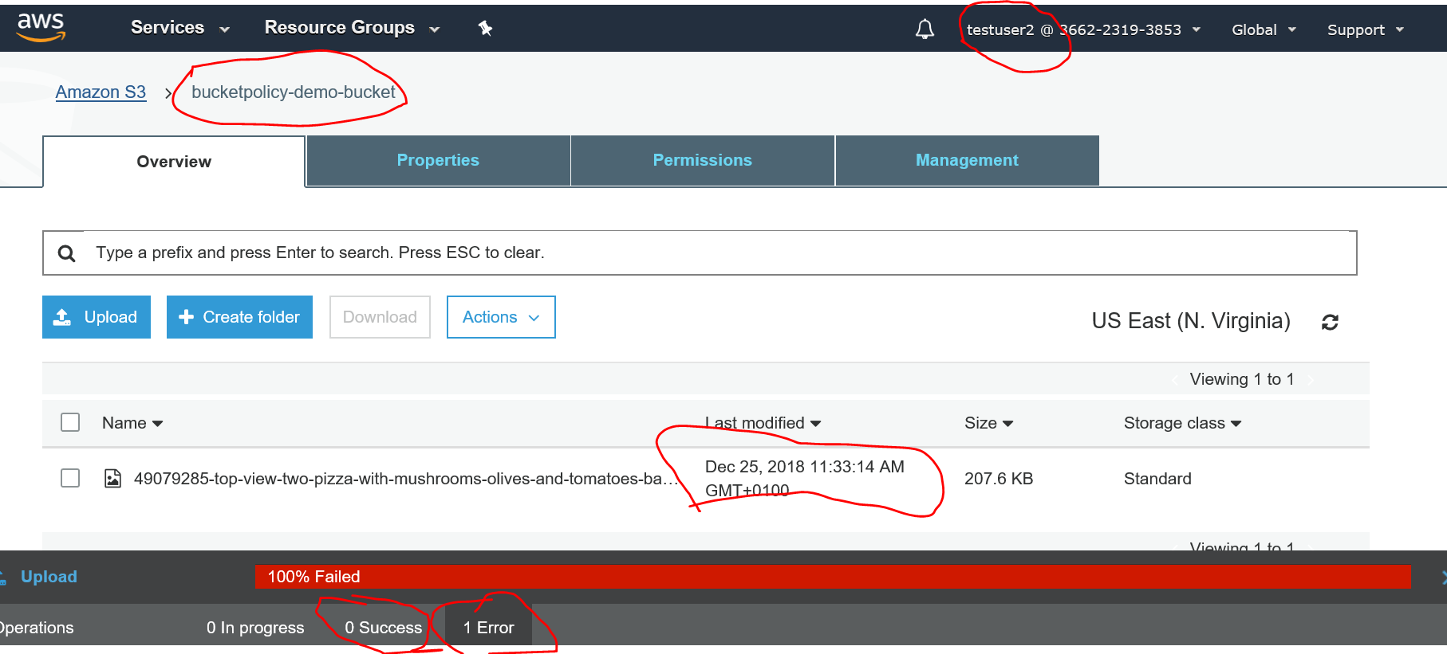

16. now lets try to upload from testuser1 which have access.

