**Implementation:**

The assignment was to develop a mobile application called an academic notification system to provide instant information related to academic parts to the students. Regarding the project development, we followed agile scrum methodology to complete our task within a given time frame. In the first week, we conducted a group meeting where we discussed the project scenario between the group members to produce the ideas. After the project idea was accepted by the teacher, we distributed our works like admin panel tasks, user management, and API development. Each Friday we held a review session within our group and with faculty to review our progress. In the second week, we almost completed the user management part like login session, user profile, etc. as well as 25 % of the API task. In the third week, we almost finished the user management and API part with some admin panel tasks. Similarly, in the fourth week, we almost completed our application development with fully functional and we reviewed from the teachers.

Working in a team always plays an important role in completing the task more effectively in an organized manner. While working in a group, we shared our ideas and plans related to the project and executed those plans with some changes if required. In each session, we presented our completed task and gathered feedback from the tutors. All the group members were fully curious about writing the codes as they all had the previous project experience in java and python languages. Due to the well-managed task distribution, it was very easy to handle the work pressure and complete the task as we thought.

For the mobile application development, we choose cross-platform because there is an extensive array of technologies available which makes it smooth for developers to release a beautiful and functional application on multiple platforms simultaneously with just one codebase. Talking about the text editor for writing the codes, we used vs code as it is light-weight, consumes less memory as well a powerful editor with an enormous number of extensions. Furthermore, to debug our application, we used an emulator as our project was mainly based on the android platform.

During the project development, we encountered problems on the GUI part as we had no prior knowledge of dart language as well as flutter framework. It took us a couple of days to become familiar with a framework so that, we design our layout as we wanted. Similarly, we faced problems on developed an API and backend part to apply the logic. Later on, most of the problems were eradicated by the self -practice as well as research, while other problems were successfully solved with the support of teachers and senior colleagues.

One of the group members faced an issue extracting the user data from the database server as he found this problem a bit complicated which was later solved with the help of a teacher.

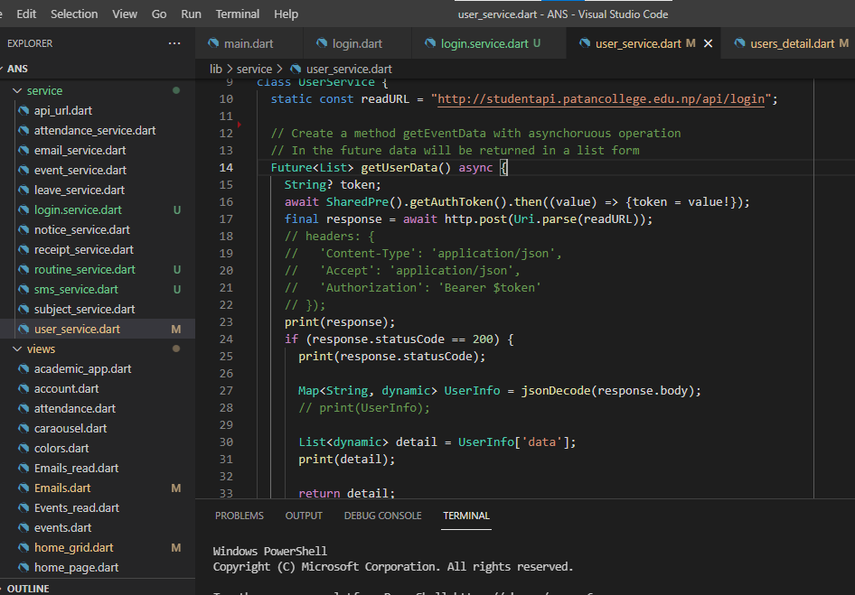

While doing the project, we experienced a lot of things there. We used to stay late at college to do the coding part. We support each other to accomplish the task that was assigned for each member. Furthermore, we got a chance to participate in a 24 hour online Bootcamp that was held by the college premises to experience the coding program. At the early stage, the framework looks complicated, but as became familiar with it some of the members decided to make a career on flutter. During the project, we performed a unique way to store the token value in an enum class as well as get and set the value separately.

**Evaluation:**

**Critical Analysis:**

Throughout the entire project development, our group encountered both positive and negative aspects. Due to the group project, it became easy to complete the project before the deadline. All the group members equally contributed their time and focus to communicate within the groups as well as support each other. Talking about the positive side, primary and secondary market research went well as we had expected and the responses from the users help us to design and implement the idea effectively. Furthermore, our continuous progress in tasks boosts our confidence level in the mobile development part. We got a chance to learn Github which help us to exchange our codes with a team member.

Similarly, On the negative side, initially, it became difficult to generate scenarios about the related projects. Few members spend more than extra time learning the GUI due to the lack of research and concentration. Furthermore, our app crashed due to the wrong code and logic parts as well as being less aware of the flutter framework. Besides this, we used to send our codes through email which was time-consuming and hectic work because some of our members experience a lack of internet services in their areas. In addition to this, we faced minor issues in the testing phase as well as in evaluating.

After the completion of the project, group members already feel more confident regarding the mobile application development field. Furthermore, we got a chance to know the vast range of cross-platform technologies and different other frameworks like react native, vuejs, etc. as well as we experienced the development of API with their uses. Due to all these reasons, we are already motivated to learn further things in the mobile development part. In the future, if we again get a chance to develop a similar kind of project, we are happy to try different approaches like choosing and integrating with different languages. Moreover, we will use artificial intelligence to make our system more robust and efficient in comparison to recent ones. The security part and the advanced system like face recognition will be our primary concerns. Besides this, further enhancements can be time limit extended for the project as we already faced time constraints situation.

**Conclusion:**

The main motive of this project was to develop an application that helps students to get instant information about their subjects, routines, notices, and many more. During the starting phase of the project, we conducted primary and secondary market research to analyze the market as well as get responses from the user. Furthermore, we developed personas and scenarios based on the target users. Besides this, we encountered problems in the development phase which were resolved later with the support of teachers and senior colleagues. At last, we were successful to develop a functional application with the proper guidance, efficient time management as well as good collaboration among team members.