**R1 NEPA Strike Teams GIS Analysis Report**

**Project Name:** South Otter

**Date: 2022-01-21**

**Date Requested By:** 20220121

**GIS Request Number:** 13 - South Otter

**Requesting Resource:** Wildlife

**Requesting Specialist:** Graham Neale

**GIS Specialist:** Jeff Erwin

**Type of analysis:** Elk Cover Analysis

**Request:** Follow Eastside Assessment Elk Habitat Models (Tech Guide TG-14-2 v.1) to calculate big game/elk cover acreages and create a .gdb/shapefiles based on tree canopy cover >40% and species PIPO. Acres will be calculated for the following: 1) entire South Otter project area (replace EHU); 2) each sale area/sub landscape; 3) 'spring/summer/fall' seasonal range (SSF) and 'winter' seasonal range (WIN), based on FWP spatial layer defined below.

Further, the model output includes Existing Hiding Cover-SSF, Existing Hiding Cover-Winter, Affected, Non-Functioning Hiding Cover (SSF-WIN). See model description in TG sent in related email (NRGG_TG_14-2_EA_ElkHabitatModels.v1).

TG Page 8: Elk Cover is determined primarily by tree canopy cover in certain tree dominance types. However, the results are constrained to an elk distribution layer (from MTFWP) and differentiated between Spring, Summer, Fall (SSF) and Winter (WIN) ranges. In addition to quantifying existing Cover (as depicted by the vintage of the VMap input data), “Affected – Non-Functioning Cover” is also determined by identifying areas that likely were Cover in the past (based on PVT) but due to disturbance prior to VMap image acquisition, are currently not providing Cover (However, these “Affected” areas could provide Cover at some point in the future. Specific parameters used in this model are identified below.

Please use the model description for data for Ashland/Sioux.

Existing Hiding Cover – SSF Range:

(DOM40 = MX-PSME, MX-PICO, MX-ABLA) and (TREECANOPY >= 40%)

***Ashland/Sioux: (DOM40 = MX-PIPO) and (TREECANOPY >= 40%)

Existing Hiding Cover - Winter Range:

Any TREE Lifeform and TREECANOPY >= 40%

***Ashland/Sioux: (DOM40 = MX-PIPO) and (TREECANOPY >= 40%)

Affected, Non-Functioning Hiding Cover (SSF & WIN):

NOT Existing Cover and (PNV = PSME1, PSME2, PSME3, PICO, ABLA1, ABLA2, ABLA3, ABLA4) and

(DISTURBED; FACTS (EA_CF_Elk_Goshawk) or MOD/SEV FIRE 1990-2005)

***Ashland/Sioux: NOT Existing Cover and (PNV = PIPO) and

(DISTURBED; FACTS (EA_CF_Elk_Goshawk) or MOD/SEV FIRE 1990-2005)

Other Forest Cover – SSF & Winter Range:

(Within FWP Distribution or within an EHU) and TREECANOPY 10-40%

The FWP spatial layer for seasonal habitats (SSF and WIN) is found here: T:\FS\NFS\Custer\Project\Ashland\SouthOtter\GIS\Workspace\gneale\Big Game\MuleDeerRange. In the TG it seems to be referred to as "ElkDistribution".

The model mentions other data layers used, and those are described in the TG document sent in my email.

**Documentation/tools:**

Data preparation: T:\FS\Reference\GeoTool\r01\Toolbox\NRGG_TG_14-1_EA_DataPrep.v1.pdf

Elk modeling: T:\FS\Reference\GeoTool\r01\Toolbox\NRGG_TG_14-2_EA_Elk.v1.pdf

T:\FS\Reference\GeoTool\r01\Toolbox\SupportingDocs\Flatten_Data_25nov2014.docx

T:\FS\Reference\GeoTool\r01\Toolbox\Eastside_Assessment_24nov2014.tbx\Elk_Models

T:\FS\Reference\GeoTool\r01\Toolbox\NRGGVMapDisturbanceUpdating.pyt\Update VMap TREECANOPY values for Disturbance

**Data Locations:**

MuleDeerRange : T:\FS\NFS\Custer\Project\Ashland\SouthOtter\GIS\Data\WildlifeAnalysis\SOElk20210331.gdb\MuleDeerRange20210405

Elk Analysis Unit (EAU): T:\FS\NFS\Custer\Project\Ashland\SouthOtter\GIS\Data\WildlifeAnalysis\SOElk20210331.gdb\SOEAUs20210405

**Steps:** Prepare data in accordance withT:\FS\Reference\GeoTool\r01\Toolbox\NRGG_TG_14-1_EA_DataPrep.v1.pdf.

1. Prepare VMAP DATA

VMAP Preparation: Clip to EAU Boundary and calculate acreage. Add and populate “District” field with Ashland. Ran r1 disturbance model on VMAP Base pulled form GI.

1. Prepare FACTS data

FACTS preparation: Clip to EAU boundary and calculate acreages. Flatten FACTS data.

1. Prepare FIRE MTBS data

MTBS: Flatten MTBS Data up to 2019. Note, anomalies in the product within the project area preclude any decisional data.

1. Ran model IAW with T:\FS\Reference\GeoTool\r01\Toolbox\NRGG_TG_14-2_EA_Elk.v1.pdf

**South Otter Elk Cover Rulesets used in:** T:\FS\Reference\GeoTool\r01\Toolbox\Eastside_Assessment_24nov2014.tbx\Elk_Models\Elk_Cover_Custer_Aug6_2014

**EX_HC_WIN – Existing HC in winter range**

"UseType" = 'GW' AND "TREECANOPY" in (4003, 4004)

**EX_HC_SSF – Existing HC in spring summer fall**

((("USETYPE" = 'G' or "ELKHERDUNIT" <> '') AND "District" = 'Beartooth' and"DOM_MID_40" in (8025, 8055, 8065) and "TREECANOPY" in (4003, 4004)) or (("USETYPE" = 'G' or "ELKHERDUNIT" <> '') AND "District" in ( 'Ashland', 'Sioux') and "DOM_MID_40" in (8015) and "TREECANOPY" in (4003, 4004))) and "cover_status"not in ( 'EX_HC_WIN')

**AFF_HC_WIN – Affected HC in winter range**

(("cover_status" not in ( 'EX_HC_WIN', 'EX_HC_SSF' ) and "UseType" in ( 'GW') and "District" = 'Beartooth' and "PNV_DESCRIP" in ( 'abla1', 'abla2', 'abla3', 'abla4','abla5', 'pico', 'psme1', 'psme2', 'psme3')) or ( "cover_status" not in ( 'EX_HC_WIN', 'EX_HC_SSF' ) and "UseType" in ( 'GW') and "District" in ( 'Ashland', 'Sioux') and "PNV_DESCRIP" = 'pipo')) and(( "DATE_COMPLETED" > date '1989-12-31 00:00:00' and "DATE_COMPLETED"< date '2006-01-01 00:00:00') or ( "year" > 1989 and year < 2006) and "Severity" in( 3 , 4 ))

Adjusted Rule – This was required do to errors in the above statement and captures what was needed for this project

cover_status NOT IN ( 'EX_HC_SSF' ,'EX_HC_WIN' ) AND USETYPE = 'GW' AND ADJUSTEDPVT = 'pipo' AND Year > 1989 AND Year < 2019 AND Severity IN( 3 , 4 )

**AFF_HC_SSF – Affected HC in spring summer fall**

(( "cover_status" not in ( 'EX_HC_WIN', 'EX_HC_SSF', 'AFF_HC_WIN' ) and ("USETYPE" = 'G' or "ELKHERDUNIT" <> '') and "District" = 'Beartooth' and "PNV_DESCRIP" in ( 'abla1', 'abla2', 'abla3', 'abla4','abla5', 'pico', 'psme1', 'psme2', 'psme3')) or ( "cover_status" not in ( 'EX_HC_WIN' , 'EX_HC_SSF' , 'AFF_HC_WIN' ) and ("USETYPE" = 'G' or "ELKHERDUNIT" <> '') and "District"in ('Ashland', 'Sioux') and "PNV_DESCRIP" = 'pipo')) and (( "DATE_COMPLETED" > date '1989-12-31 00:00:00' and "DATE_COMPLETED"< date '2006-01-01 00:00:00') or ( "year" > 1989 and year < 2006) and "Severity" in ( 3 , 4 ) )

Adjusted Rule – This was required do to errors in the above statement and captures what was needed for this project

cover_status NOT IN( 'EX_HC_SSF' , 'EX_HC_WIN' , 'AFF_HC_WIN' ) AND USETYPE = 'G' AND ADJUSTEDPVT = 'pipo' AND Year > 1989 AND Year < 2019 AND Severity IN( 3 , 4 )

**OFC-SSF - Other Forest cover in SSF**

"cover_status" not in ( 'AFF_HC_SSF' , 'AFF_HC_WIN' , 'EX_HC_SSF' , 'EX_HC_WIN' ) and ( "UseType" = 'G' and "ELKHERDUNIT" <> '') and "LIFEFORM" = 4000

**OFF-WIN - Other Forest cover winter**

"cover_status" not in ( 'AFF_HC_SSF' , 'AFF_HC_WIN' , 'EX_HC_SSF' , 'EX_HC_WIN' ) and ( "UseType" = 'GW' and "ELKHERDUNIT" <> '') and "LIFEFORM" = 4000

OFC_OutsideEH - Outside of Elk Habitat– No records returned

"cover_status" not in ( 'AFF_HC_SSF' , 'AFF_HC_WIN' , 'EX_HC_SSF' , 'EX_HC_WIN', 'OFC_SSF', 'OFC_WIN' ) and ( "UseType" = '' or "ELKHERDUNIT" = '') and "LIFEFORM" = 4000

**NotPotCover - Non potential cover**

cover_status not in ( 'AFF_HC_SSF', 'AFF_HC_WIN', 'EX_HC_SSF', 'EX_HC_WIN', 'OFC_SSF', 'OFC_WIN', 'OFC_OutsideEH') and "LIFEFORM" in ( 3100, 3300, 5000, 7000, 7100, 8600)

**Existing and affected hiding cover outside elk herd units([cover_status] &"_OutsideEH")**

"cover_status" in ( 'AFF_HC_SSF', 'AFF_HC_WIN', 'EX_HC_SSF', 'EX_HC_WIN') and "ELKHERDUNIT" =''

**MTBS Data acquisition was streaked over Elk Creek and Taylor Creek Sublandscapes. Refer to this website to verify streaking over the project area:** [**Data Explorer | MTBS (usda.gov)**](https://apps.fs.usda.gov/lcms-viewer/mtbs.html)

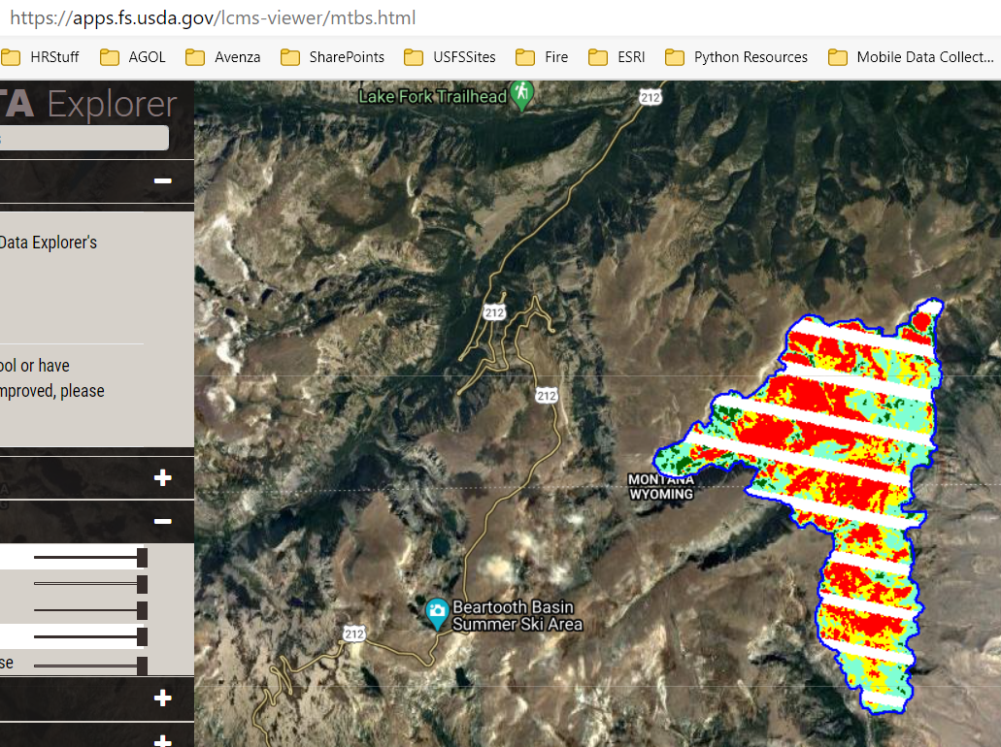

**Products:**

This document

T:\FS\NFS\Custer\Project\Ashland\SouthOtter\GIS\Documentation\Wildlife\221021ElkCoverAnalysisReport.docx

Spreadsheet with pivots

T:\FS\NFS\Custer\Project\Ashland\SouthOtter\GIS\Documentation\Wildlife\20220121SOElkCoverData.xlsx

Maps

Data:

T:\FS\NFS\Custer\Project\Ashland\SouthOtter\GIS\Data\SouthOtterNEPA.gdb\Wildlife\CNFElkCoverFinal20210412