**Cumulative Effects for Project Analysis**

# Contents

Contents 1

Description 2

Conceptual Graphic Model 2

Create Cumulative Effects Analysis Area 3

Request FS Internal Activities 3

Request External Agency Activities 3

Review Internal and External data and submit to GIS 3

Pull past and future activities from FACTS 4

Compile Non-FACTS past, present, and future activities 4

Using the Master Spreadsheet to screen actions 5

References and credits 5

APPENDIX A – Cumulative effects boundary checklist 6

APPENDIX B – Cumulative effects data query coordination guide 7

APPENDIX C - GIS Methodology for Developing Cumulative Effects Database for Project Analysis 8

APPENDIX D – Creating the Cumulative Effects Master Spreadsheet 16

# Description

This process combines past, present, and reasonably foreseeable future actions with combined analysis extents to provide a query/screening process for both on/off forest actions to be considered in cumulative effects(CE) analysis. The following outlines the steps involved with developing a project master spreadsheet for CE analysis. For detailed descriptions regarding the GIS steps and location of specific NEPA project data, please see Appendix A.

# Conceptual Graphic Model

←Layerfiles point to these datasets in ArcMap to enable staff to visually see the activities

←Table is loaded into the Cumulative Effects Master Spreadsheet. This is an excel file which has a pivot table set up for each resource.

*Note: not all resources reflected here.*

# Create Cumulative Effects Analysis Area

I. Establish Cumulative Effects spatial scale / analysis boundary by resource, and create “Combined extent” cumulative effects analysis area {IDTL, IDT members, GIS Specialist}

1. IDT members define analysis boundary for their resource using best available science and local knowledge of resource and submit to GIS.

2. GIS combine individual boundaries to create “combined extent” of all cumulative effects analysis areas for project; plot this polygon on map for use with data queries in steps II and III.

# Request FS Internal Activities

II. Query of FS Personnel / SOPA {IDTL}

1. IDTL distribute combined extent map and Excel internal activities request spreadsheet (BLANK_Internal_PastPresentFutureActivities_Query.xlsx ) to any FS unit that the combined extent overlaps with. Request population of table with any past (EXCLUDING activities already entered into FACTS database, fire, Non Recreation Special Use, and Range Improvement and allotment data), present, or reasonably foreseeable actions within the map polygon, regardless of ownership. NOTE: ensure minimum required information is populated.

2. IDTL work with District fire management specialist to ensure past and future prescribed fire activity in District files are also listed (only include activities that are NOT already listed in FACTS activities pull). Add to “BLANK_Internal_PastPresentFutureActivities_Query.xlsx “

3. IDTL query Schedule of Proposed Actions and NEPA Archive for SOPA actions that ongoing or reasonably foreseeable. Add to: “BLANK_Internal_PastPresentFutureActivities_Query.xlsx “

# Request External Agency Activities

III. Query other Agency Personnel {IDTL}

1. Distribute combined extent map and Excel **external** activities request spreadsheet (*BLANK_External_PastPresentFutureActivities_Query.xlsx* ) to any non-FS agency (BLM, MTDNRC, MTFWP, NPS, etc.) that overlaps with the combined extent polygon. Request population of table and GIS data (if available) with any past, present, reasonably foreseeable actions on lands that they manage within the combined extent map polygon. **NOTE:** **ensure minimum required information is populated**.

# Review Internal and External data and submit to GIS

IV. Review internal and external query responses and submit data to GIS{IDTL}

1. Verify all minimum required information is present for all action i.e. Activity Name, Activity Type, Year, Spatial Area (polygons, Sections, etc.), Accomplished/Proposed Acres, Activity Definition. Verify that there is spatial information listed (sections, HUC’s, pdf maps, etc.) for any activity that did NOT have a spatial layer submitted.

2. Forward query spreadsheets and any associated spatial data to GIS specialist.

# Pull past and future activities from FACTS

VI. Query of FS Corporate Database of Past and Future Activities in FACTS {GIS Specialist, Silviculture ID Team Member}

1. Using the “combined extent” analysis area (Step I), query past actions entered into FACTS using the GI “Act160” query tool for the EDW and Transactional data. With the transactional data, only query out planned activities.

2. Add Additional Columns and Identify Activities by Resource Categories (defined SQL by the Forest Silviculturist). Remove Activities not selected (i.e., drop non-pertinent activities such as “photo interp”, “stand delineation”, etc.).

3. If needed, forward this FACTS “pull” to project Silviculturist to review/refine/consolidate/clean.

# Compile Non-FACTS past, present, and future activities

VII. Compile gathered past, present, and future activities into cumulative effects database and create “Cumulative Effects Master Spreadsheet” {GIS Specialist}

1. Collect all non-FACTs spatial data. On the HLC, automatic data pulls are brought forth from the R1 Fire Occurrence and Perimeter Data, NRM Allotment and Pasture Data, HLC non Recreation Special Use, and HLC Range Improvements. Add common attribute table columns and populate as needed/required. Merge all these datasets together (you may have three – point, line, and polygon). , perform the GIS steps listed in Appendix A, “GIS Methodology for Developing Cumulative Effects Database for Project Analysis.”

2. Using the “cleaned” FACTs and non-FACTs data, perform the GIS steps listed in Appendix A, “Developing Cumulative Effects Database for Project Analysis.” Final output will be one data table.

3. Export the one tabular record in excel as pivot tables, creating separate tabs for each individual cumulative effects analysis area (This is the Cumulative Effects Master Spreadsheet). This ensures a custom report output of actions that occur only within the spatial scale polygon of each resource. The easiest way to accomplish this is alter a preexisting CE Master Spreadsheet from another project. Steps outlined in Appendix D.

4. Update “Activity definitions” tab in Master Spreadsheet listing all activities with definitions found in report. Need clarity regarding a FACTS code? See the NRM reference document located at: T:\FS\Reference\GeoTool\r01_hlc\Toolbox\NEPAProjectTools\CummulativeEffects_Analysis

5. Submit Cumulative Effects Master Spreadsheet to IDTL for review and distribution to team members.

# Using the Master Spreadsheet to screen actions

VIII. Specialist Screening of Actions in Master Spreadsheet to Create Actions List {IDT members}

1. Specialist clicks on their tab within Master excel spreadsheet.

2. Specialist refer to “definitions” tab and work with FACTS manager to interpret activity codes.

3. Using “slicer” pick list tool within spreadsheet tab, specialist chooses which activities to display based on the potential for that activity to affect an indicator for their resource.

4. Specialist and ID team discuss the activities as a group to better understand the potential effects of these activities including whether the activity is still displaying effects on the ground based on time since implementation.

5. Specialist copies activities selected using “slicer” which are still displaying effects (overlapping with potential direct effects in time) and adds these to “actions” list in report.

6. Specialist can copy table to use in resource report(s). Export or formatted view of the table used should be exported in pdf or copy/pasted into word document following steps outlined by Writer-Editor for the project record.

# References and credits

Material in this guide was compiled by the NEPA Strike Team GIS from several sources including the Helena – Lewis and Clark and Beaverhead – Deerlodge NF.

Questions: [jeffrey.erwin@usda.gov](mailto:jeffrey.erwin@usda.gov)

# APPENDIX A – Cumulative effects boundary checklist

This checklist should be completed prior to any GIS work.

|  |  |  |
| --- | --- | --- |
| Specialist | Resource | Area |
|  | Wildlife |  |
|  | Soils |  |
|  | Transportation -Engineering |  |
|  | Hydrology |  |
|  | Aquatics |  |
|  | Botany |  |
|  | Range - Invasives |  |
|  | Scenery |  |
|  | Silv – Old Growth |  |
|  | Recreation |  |
|  | Fuels |  |
|  |  |  |
|  |  |  |
|  |  |  |
|  |  |  |
|  |  |  |
|  |  |  |
|  |  |  |
|  |  |  |
|  |  |  |

# APPENDIX B – Cumulative effects data query coordination guide

|  |  |  |  |
| --- | --- | --- | --- |
| Project or Activity | Source | Past, Present, or Foreseeable | Who |
| Past Veg and Fuels activities on FS Lands (aggregated) | FACTs | Past | GIS |
| On-going FS Veg Projects | FACTs | Present and foreseeable | GIS, IDTL |
| Past Veg and Fuels on non-FS lands | Various (other agency data sources, local knowledge contacts within District) | Past | GIS, IDTL, LRD |
| Any foreseeable project on non-FS lands | Scoping notices or local knowledge, BLM, state | Foreseeable | IDTL, LRD |
| Past natural ignition wildfires (if not in FACTS) | Regional Database; polygon data and ERWIN fire point locations | Past | GIS |
| Grazing allotments on FS Lands | GIS | Past, present and foreseeable | GIS |
| Grazing Activities on private | Qualitative | Present | IDTL |
| Little Belt Travel Plan | ROD | Present | IDTL |
| All Types of SUPs | GIS | Present | GIS, Lands |
| Watershed improvements | GIS and Decision docs | Past, present, foreseeable | IDTL, GIS, Hydro |
| Personal use firewood cutting on FS lands | Qualitative | Past, Present | IDTL |
| Christmas Tree cutting | Qualitative, permit tally | Past, Present | IDTL |
| NFS winter and summer trails | GIS | Past, Present | GIS |
| Noxious weed treatment | GIS | Past, Present | GIS, Weed |
| Grizzly Bear Amendment | Qualitative | Present | IDTL |
| Forest Plan Amendment | Qualitative | Foreseeable | IDTL |
| Developed Sites | GIS | Present | GIS |
| Dispersed sites | GIS / Qualitative | Present | GIS, IDTL, LRD |
| Mining Activities | Qualitative | Past and present | IDTL, LRD |

LRD = Local Ranger District

# APPENDIX C - GIS Methodology for Developing Cumulative Effects Database for Project Analysis

*Conceptual graphic model is located at the end of this appendix.*

*Toolbox is located at: T:\FS\Reference\GeoTool\r01_hlc\Toolbox\NEPAProjectTools\CummulativeEffects_Analysis*

*It is recommended you copy this toolbox into your <Project>NEPA\Tool folder.*

1. Set-Up Your Workspace. Final geodatabase output should be placed in <Project>NEPA\Data. Spatial QAQC mxds should point to final output data in this location. Having all the data in this workspace will enable specialists to ‘follow along’ and double-check datasets at the end. It is recommended to create a feature dataset for each step of the process:

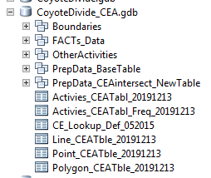

Boundaries: All resource boundaries and Union boundary dataset for intercepts.

FACTS_Data: Original and combined data pulls from database.

OtherActivities: Group up various datasets and fill in attributes accordingly.

PrepData_BaseTable: Combined FACTS and Non-FACTS Datasets. These are the dissolved products with refined attribute tables.

PrepData_CEAintersect_NewTable: Contains spatial final products of data, which can be used in mxd for specialists.

Tables: Bottom 3 tables are combined into the ‘Activities_CEATbl.’ The frequency table is what gets loaded in the excel (final product).

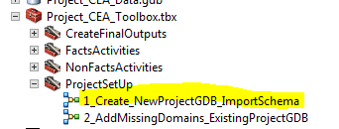 <- Do this easily, run this tool!

Throughout the rest of this document, this geodatabase will be referred to as “*CEA.gdb*”

If you have already created a gdb and started on this process, run the second tool to add the required domains.

1. Create your Cumulative Effects Analysis Union Dataset. Start with a feature class of each specialists’ individual cumulative effects area. It is recommended to keep a set list, and verify this with the IDTL. See Appendix B for an example from the Horsefly NEPA project.

Individual boundaries should be placed at: *CEA.gdb\Boundaries*

For each unique boundary (some may be shared more than specialist), add a field to the table with a unique name or resource name (i.e., “ProjectArea”, “WildlifeLynx”, “WildlifeElk,” “Watershed”). Attributes should be either the name of the boundary “ProjectArea” or individual HUC names, Elk Herd units, timber compartment numbers, for example. **The field names must be unique for each feature class as they will be combined later** (see example below). Ideally there will be only this one column of data representing this CEA resource boundary. UNION all the individual layers together into a single feature class; delete all the other ‘messy columns’ either before or after the Union. This will be the “**Specialists’ CE Boundaries**” Feature Class. It is recommended to create one column at this time which designates the Project Area verses the donut ring of the rest of the Combined Extent Polyon. This columne will be used to tease out statistics easily for the IDTL. Do a QAQC: Watch for ‘Gaps’ within the datasets with multiple polygons which will need to be preserved. Also check for slivers of resource data which are not aligned to the current PLSS along our FS boundary lands.

DISSOLVE the “**Specialists’ CE Boundaries**” feature class (dissolve on ALL) to create the Cumulative Effects (CE) “**Combined Extent Polygon**” feature class. This will be used for cartographic products later.

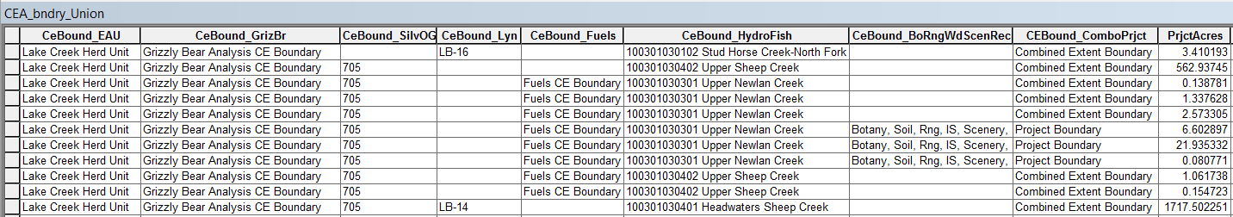

*Notice ‘Query all’ attributes for Grizzly Bear and fuels, but specific values for elk herd, watershed, timber compartments, and Lynx. The final column aids you to easily tease out the project area verses the combined analysis extent.*

1. Make a map showing the “**Combined Extent Polygon**” feature class on the Forest Visitors Map base for the IDTL to send out with data request spreadsheets to FS District(s) and the external agencies that the CE area covers (request spreadsheet templates named “*BLANK_Internal_PastPresentFutureActivities_Query.xlsx*” and “*BLANK_External_PastPresentFutureActivities_Query.xlsx*”

**HLC NEPA Project Notes**: In the past, a word document table was sent out to capture requests. This table contained many of the same fields as the B-D tables cited above. After review of project workflow with the Horsefly NEPA, it was determined it would be cleaner to use the B-D tables cited above on the next HLC NEPA project. The final tables to be populated do not have to be the separate word tables as used before. It was determined pdf documents could be created from the final output, the CE Master Excel Document (finals figures from Pivot tables) for the NEPA Project Record.

1. Create the FACTS activities feature class. This dataset will be combination of two data-pulls from FACTS.
   1. *Pull Data from the Geospatial Interface.*

(Dataset 1): In the GI, load the “FACTS Activity Polygons – EDW” feature class (this will include the weed treatment activities), select by location the activity polygons that intersect with the combined extent polygon from above, and run the GI query “Activity160.” The “Any Activity, Any Year” code does not include the ‘PURPOSE_CODE’ which is needed to tease out activities. Export this data to your CEA.gdb.

(Dataset 2): In the GI, load the “FACTS Activity Polygons – Transactional” feature class (this will include future activities), select by location the activity polygons that intersect with the combined extent polygon from above, and run the GI query “Activity160.” To insure there are no duplicate data between the two datasets, select out (keep) features which the following selection: DATE_COMPLETED IS NULL.

Field Calculation is needed: If NBR_UNITS_ACCOMPLISHED is NULL; bring in value within NBR_UNITS_PLANNED

**MODELS for the steps below and STEP 6 need to be reviewed, and refined! Items at Step 7 and after are good to go at this time.**

* 1. *Merge datasets together and reduce dataset by key data fields*. Use the Tool in the Toolbox. Merge the two datasets together and DISSOLVE this “raw” FACTs dataset by; **SUID**, **ACTIVITY_CODE, ACTIVITY, NBR_UNITS_ACCOMPLISHED, UOM, DATE_PLANNED, DATE_COMPLETED**, **SALE_NBR, SALE_NAME, PURPOSE_CODE, KEYPOINT,** and **ACTIVITY_SUB_UNIT_NAME**.
  2. Select out and delete the Activity Codes which are not important for analysis. This SQL query is located at: T:\FS\Reference\GeoTool\r01_hlc\Toolbox\NEPAProjectTools\CummulativeEffects_Analysis

Reducing the data by the core codes will make this dataset easier to handle.

Code includes activities not included for analysis and the following:

1) Delete ACTIVITY_CODE = ‘1130’ (Burning of Piles Material) AND PURPOSE_CODE = ‘FTI’

2) Delete [ACTIVITY_CODE = ‘2341’ (Range Cover Manipulation) OR ACTIVITY_CODE = ‘2360’ (Range Control Vegetation) ] AND (KEYPOINT = NULL)

5. Send the dissolved dataset to the project silviculturist to review and refine as needed the activities appropriate for the project and analysis needs by all project specialists. When reviewing the dataset, are there additional activities planned which are not in FACTS but in the USFS decision space? Ex: Adjacent NEPA, Historic Units within old NEPA which are not in FACTS?

**HLC NEPA Project Notes:** There is value to reviewing the lists of activities (especially planned) with specialists. For example, for Horsefly NEPA there were prescribed fire activities which would not be implemented, thus deleted from dataset. Review the ‘Accomplished Acres’ to make sure there are acres in this location. If NULL, calculate GIS acres.

If an adjacent NFMA/NEPA project is in the works in your Combined Extent Cummulative Effects area, do not forget to consider those planned units into your analysis data. Example: Middleman and Boulder Baldy NFMA projects, a portion of each’s proposed units may be within each other’s combined cumulative effects boundary.

1. Add and populate analysis fields. Use \Tool\Project_CEA_Toolbox>FactsActivities>2_AddFields then 3_PopulateFields:
   1. **Complete_Year** (Short). This is populated through python script with completed year of project (which is used in Decade break out below). Note that FY in FACTs is not used.
   2. **Decade** (Text 30)- Populate with the decade completed, using the following codes:
      1. Decade accomplished (1940’s, 2000’s, 2010’s, etc)
      2. “All Decades” (for anytime in history)
      3. “Ongoing/Future” (for existing and/or future)
   3. **UnitOfMeasureType** (Text 30) – Populate with the type of measurement that the “NBR_UNITS_ACCOMPLISHED” value represents:
      1. “Accomplished” for activities that have been completed
      2. “Planned” for ongoing or future activities
      3. “Undetermined/Varies” for unknown or unmeasurable planned or accomplished activities.
   4. **JoinID** (Short Integer) – leave blank for now.
   5. **ResourceGroup** (Text 255). Used modified Milburn 2013 Activity code list per group for FACTs data. FUELS, TIMBER (Regeneration, Intermediate, No Regeneration Required), WEED, WILDFIRE. See pdf located at: T:\FS\Reference\GeoTool

\r01_hlc\Toolbox\NEPAProjectTools\CummulativeEffects_Analysis

* 1. **Description** (Text255) – populate with any additional info describing the particular activity.

Next Step: This FACTs Data gets combined with Other Polygon ‘Non-FACTs’ data within Step #9.

1. Gather and combine all the non-FACTS data. A portion of the HLC Forest’s standardized datasets have models created to extract, add fields, and automatically populate fields.

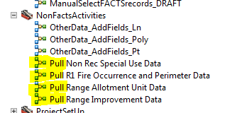

* 1. Non-Recreation Special Use Point, Line, Polygon; Helena-Lewis and Clark Central Data. Output creates files that are ready for the merge and dissolve step #9
  2. Fire Occurrence (Point) and Fire Perimeter (Polygon) Data; Northern Region Central Data. You need to do one manual step before this data is ready for Step #9. Join the datasets together by the ‘SUID’ id. This is the unique IRWIN id. Delete any Point datasets with the matching ID from the polygon dataset. This will keep you from duplicating Wildfire Acres.
  3. Range Grazing Allotments and Pastures. Polygon; NRM Helena-Lewis and Clark Central Data. Output creates files that are ready for the merge and dissolve step #9.
  4. Range Improvement Point, Line, Polygon; Helena-Lewis and Clark Central Data. Check to see if the polygon dataset has any features for your analysis area (could be empty, the data is limited). Also check to see if the data is duplicative of line data (possibly a grazing exclusion monitoring area, etc). Output creates files that are ready for the merge and dissolve step #9.

1. You may have other datasets which can be added into the analysis. This could be the actual polygon OR representative polygons such as sections, project area boundaries, or the Forest Boundary. Point and Line datasets can also be included. For representative polygons it is recommended to use a shape with the approximate number of Acres/Miles. To more easily review and manage field calculation edits within attributes, it is recommended to:
   1. In the YourCEA.gdb\OtherActivities feature dataset. Import the datasets of non-FACTs activities. Tip: When you import data disable the M and Z values.
   2. 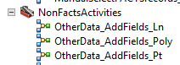Add the needed columns to each dataset. Use \Tool\Project_CEA_Toolbox>NonFactsActivities

These tools add the following. You will need to

populate these fields as best you can from the

other values in the existing dataset.

* + 1. **SUID** (Text255) This is a unique identifier if available (not required)
    2. **ACTIVITY_CODE** (Text255) Auto populates with “Non-FACTs”
    3. **ACTIVITY** (Text255) with the specific activity (If not FS, denote the ownership of activities by using “State-”, “BLM-”, “PVT-“, etc., preceding the activity. i.e. “BLM-Prescribed Fire”)
    4. **NBR_UNITS_ACCOMPLISHED** (Double) Use polygon GIS acres, Line Miles, or ‘1’ if point data.
    5. **UOM** (Text255); Auto-populated by tool ACRES [polygon], COUNT [point], MILES [line]. If your point data represents ‘ACRES’ you will need to recalculate the field with this value.
    6. **Complete_Year** (Short). Fill in for year (if known).
    7. **Decade** (Text 30). If year is known, use the VB code in the field calculator (Left( [Complete_Year],3)&"0s") If not known use “All Decades”. If planned use “Ongoing/Future”
    8. **UnitOfMeasureType** (Text 30) Usually populated with “Accomplished” for activities that have been completed. “Planned” for ongoing or future activities
    9. **JoinID** (Short Integer) – leave blank for now.
    10. **ResourceGroup** (Text 255) Populate with: RECREATION, REC SPECIAL USE, NR SPECIAL USE, WILDFIRE, MINERALS, RANGE, etc. You may have to add a value to the domain (if needed).
    11. **Description** (Text255) – populate with any additional info describing the particular activity. Permit name holder, etc may be useful to staff for example.

**HLC NEPA Project Notes:** Various datasets can be identified to bring into the CEA effort. An example of which data can be found from which databases are recorded in Appendix C (From Horsefly NEPA). In addition to the core HLC datasets (decribed above), the following were included:

**Recreation**: Sites (Infra and HLC SDE Forest data), Special Use outfitter polygons, Special use points (Recreation residences, ski area locations) and Tracts (Cabins). Recreation type was placed into Activity, Decade was defined as ‘All Decades’ and UnitOfMeasureType was Ongoing/Future.

**Minerals**: Black Butte Copper Project location. Took Lat/Long and created a polygon representing 1,888 acres. Moved the location slightly so it did not intersect USFS surface lands.

1. Create the “Base Table” Data. Use the ‘Part One’ model located here: 

Within this model, you are merging all the like shape types together (Point, Line, Polygon). Combine your FACTs and non-FACTs polygon data! The data is dissolved by core attributes: **SUID**, **ACTIVITY_CODE, ACTIVITY, NBR_UNITS_ACCOMPLISHED, UOM, Complete_Year**, **Decade, UnitOfMeasureType, JoinID, ResourceGroup,** and **Description.** The Join ID field is then populated to equal the Object ID. (Join ID = Object ID). This will be the unique ID to connect the parent activity area (of the Base Table) in a join within the Part Two model. These feature classes are stored in YourCEA.gdb\PrepData_BaseTable feature dataset**.**

*\*\*\* It is recommended to review the output datasets before running ‘Part Two.’*

1. Create the “New Table” Data; combine and export outputs. Use the ‘Part Two’ model depicted above. These feature classes are stored in YourCEA.gdb\PrepData_CEAintersect_NewTable feature dataset and within YourCEA.gdb**.** The model does these steps:
   1. With each Base Table dataset (point, line, polygon) INTERSECT the **“Base Table”** feature class with the “**Specialists’ CE Boundaries**” feature class from Step 2. The resulting feature class is the **“New Table”.**
   2. For Polygon and Line Data ONLY:
      1. Calculate the NBR_UNITS_ACCOMPLISHED field in the **“New Table”** feature class to equal 0 for all rows.
      2. JOIN the **“Base Table”** to the **“New Table”** on the fields “JoinID”. Calculate the NBR_UNITS_ACCOMPLISHED in the **“New Table”** to be *pro-rated* based on polygon size i.e., the calculation is: ((**New Table**.shparea / **Base Table**.shparea ) * **Base Table**. NBR_UNITS_ACCOMPLISHED)). For polyline datasets, the modified calculation would be: ((**New Table**.shplength / **Base Table**.shplength ) * **Base Table**. NBR_UNITS_ACCOMPLISHED)).
   3. Un-join “**New Table**”. Tables are exported to the YourCEA.gdb, then merged to create the Activities_CEATbl.
   4. For a more efficient pivot table in EXCEL, the merged Activities_CEATbl is run through a FREQUENCY geoprocess, retaining:

* ‘ACTIVITY_CODE’, ‘ACTIVITY’, ‘SALE_NBR’, ‘SALE_NAME’, ‘Decade’, ‘UnitofMeasureType’, ‘Description’, ‘ResourceGroup,’ ‘UOM,’ and each Specialist CE Boundary field as the “**Frequency Fields.**” Note that these need to be selected by the user of the geoprocessing model from the list!
* And ‘NBR_UNITS_ACCOMPLISHED’ as the “**Summary Field**”

NOTE: This step removes/combines the individual SUID numbers. Export the resulting frequency table to EXCEL as the pivot source table in the *Cumulative Effects Master Spreadsheet.xlsx*

* 1. Exports the Activities_CEATbl_frequency table to an excel in the users defined location. It is recommended for you to export it to the <NEPA Project/GIS/Products folder.

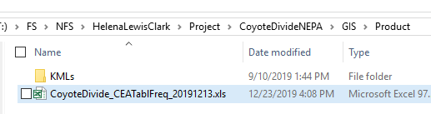

1. See Appendix D for steps to modify a template Cumulative Effects Master Spreadsheet.xlsx with your project data which was exported as an excel to <NEPA Project/GIS/Products folder.
2. (*OPTIONAL*) Create a ‘working mxd’ of the CE Data. There was a request from HLC Resource Specialists to explore/view the spatial side of the CEA for the Horsefly NEPA project. Therefore a map was created, with various grouped layerfiles with built in definition queries, enabling specialists to see the activities within their CEA boundaries. Creating a spatial map does take time, but it give specialist the piece of mind where all the acres are coming from if they are hesitant about the excel output product.

It is recommended to create one ‘model output’ group, then copy and paste it, changing the Specialist CE boundary in the definition query within each copy.

An example grouped-grouped layerfile is saved at: T:\FS\Reference\GeoTool\r01_hlc\Toolbox\NEPAProjectTools\CummulativeEffects_Analysis\Layerfiles Example CEA NewTable Data

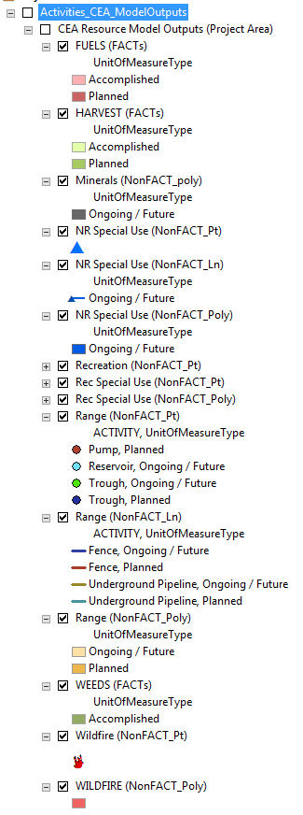 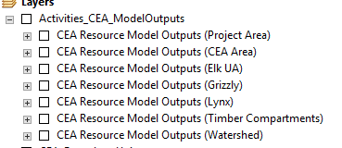

# APPENDIX D – Creating the Cumulative Effects Master Spreadsheet

*Excel document located at T:\FS\Reference\GeoTool\r01_hlc\Toolbox\NEPAProjectTools\CummulativeEffects_Analysis*

*It is recommended you copy this into your <Project>NEPA\Product folder.*

Tab: Spatial Area Selector

* 1. Replace the jpeg with the one from your project. This was Step I in the Process, Roles, and Responsibilities.
  2. Review the Resource CEA boundary types. Do you have something different? Rename the text and corresponding tab. Note: you have to replace/update the hyperlink when you change the text on tabs. Have an additional boundary? : Make a copy of a tab, rename it, then add it to this list (it functions as a Table of Contents).

Tab: CE_DATA_NOTES

1. Update the data and text as needed. This tab is important since it functions as Metadata for the product. Resource specialists can also use the information on this tab to document the tablature data for their reports or project record. Keep it at the 8x11 portrait extent so it exports easily into a pdf (if needed).

Tab: CE_Activities_DATA

1. Select all data in this table and delete. (Use top-left cell to easily select all). Replace this data with your combined and streamlined Activities table.

**Horsefly NEPA**: Activities_CEATbl_Frequency

1. Use the Filter Feature to review the values in the table to ensure 1) everything is filled out which needs to be 2) Double-check values for font, spacing, and other differences which are different. These not being consistent will keep the pivot table output from working elegantly. Main columns to review are: **ACTIVITY, UOM, Decade (check “All Decades”), UnitOfMeasureType, ResourceGroup** 3) Any rogue records which should be deleted? Ex: Range Improvement Line: Dense Vegetation, Terrain Barrier, etc.

Modifying all the main CEA Boundary Area Tabs

1. 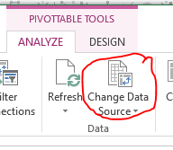Once a pivot table is created, that data is stored ‘somewhere else.’ Pivot table do not automatically update when the parent table is changed. For each tab, you will have to update the extent of the pivot table used. To do this, click on the pivot table in a tab and choose ‘Change Data Source.’ You can either navigate to that table in the wizard or type out the table extent then press enter. Do this for each of the colored tabs (they should all have pivot tables).
2. Update/Review the Filter in each tab. Click on the pivot table and bring in the correct attribute column for that CEA resource boundary into the filter box (Pivot Table Fields, aka Properties box). In the Excel pivot table, make sure only that label is selected (not {blank}) for boundaries that are presence/absence i.e.: Project Area, Grizzly Bear Analysis, etc. For Resources that have multiple areas within their analysis area they wish to quantify, make sure the {blank} are not selected. Place a red directions label to notify the specialist how to customize this setting. Example is below.

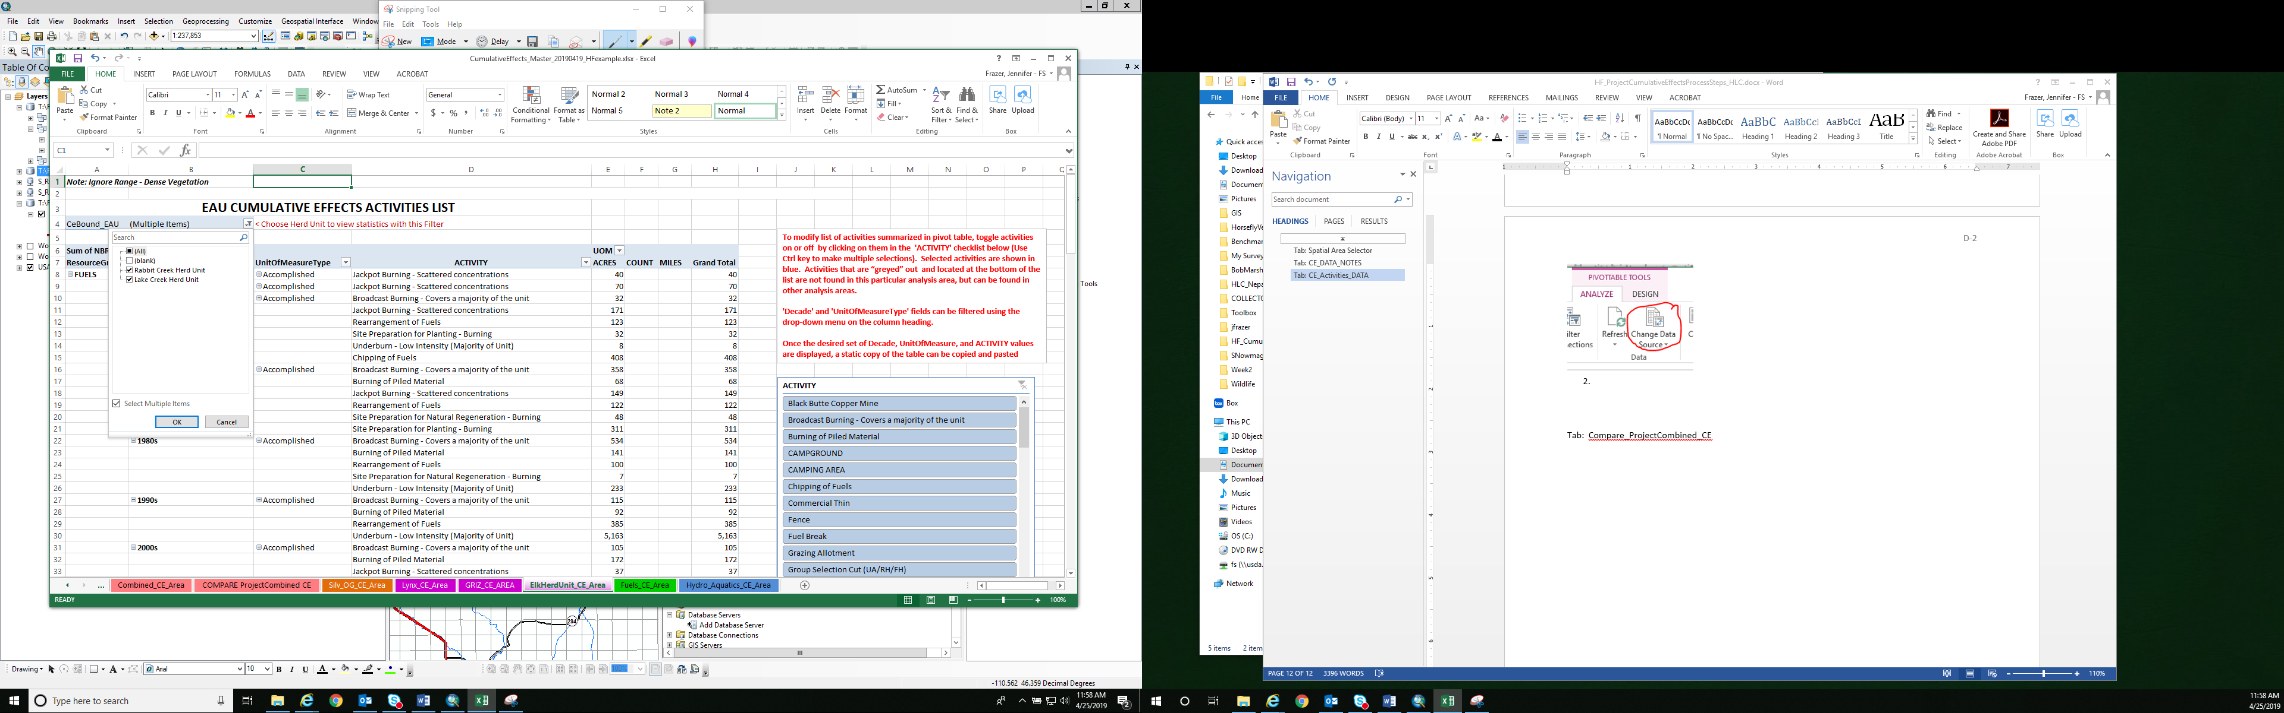

Tab: Compare_ProjectCombined_CE

This tab’s purpose it to compare the activities and acres within the NEPA project boundary and outside the project boundary (Combined Extent Boundary). Both of these figures equal the CE area.

1. Update the Pivot Tables source, if you haven’t done so already.
2. Inform the IDTL that they may want to remove ‘ACTIVITY’ from the row grouping in the Pivot Table Fields/properties window to make the table/acres cleaner for some categories.