**OUTPUT SCREEN SHOTS WITH DESCRIPTION.**

**Home Page:**

Here user view the home page of anomalous behaviour prediction web application.

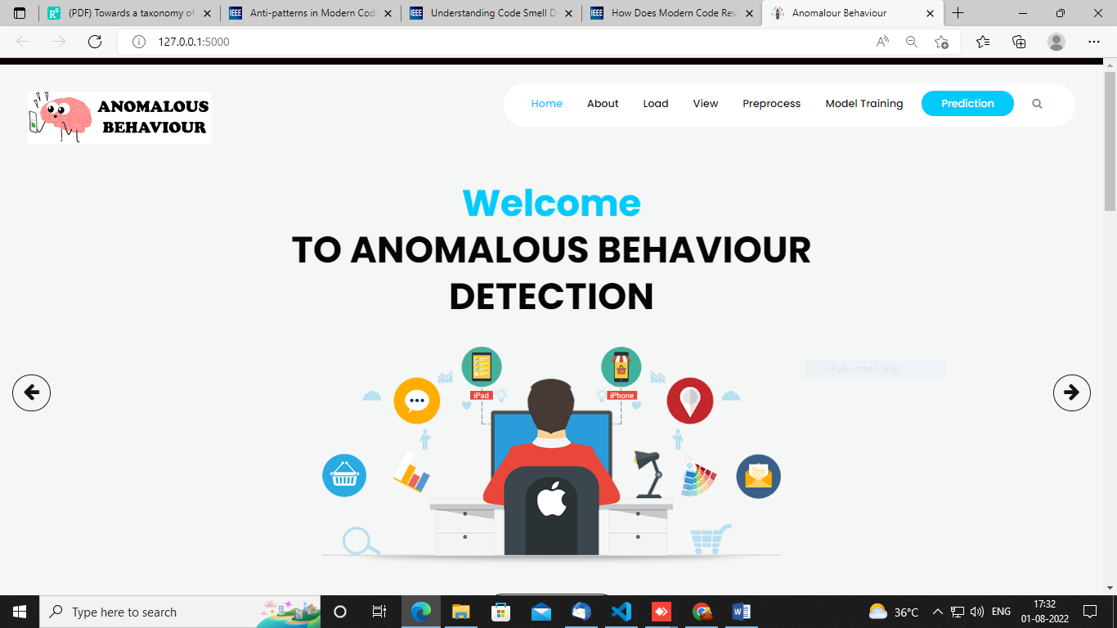

**Fig1**: Home Page

**Load:**

In the load page, users can load the anomalous behaviour dataset.

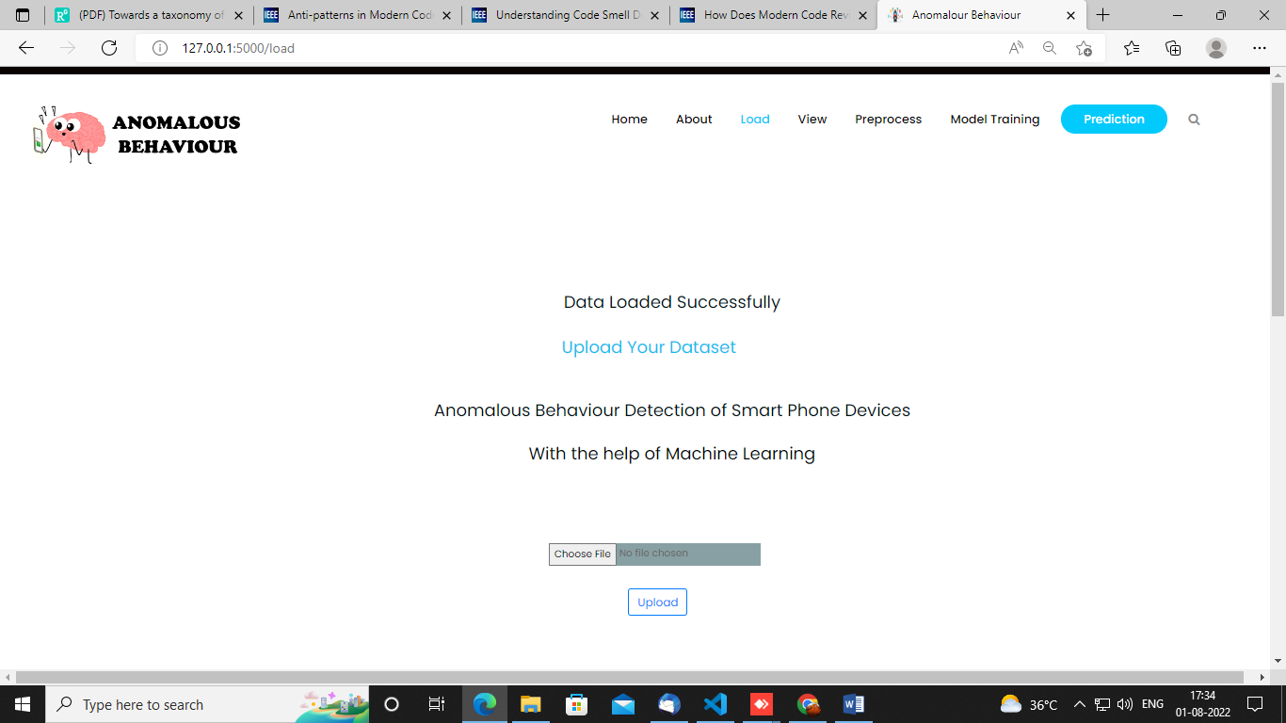

**View:**

Here we can see the uploaded data set.



**Pre-process:**

Here we can prepare our data in such a way that our system should understand i.e, we will make our data noise free.

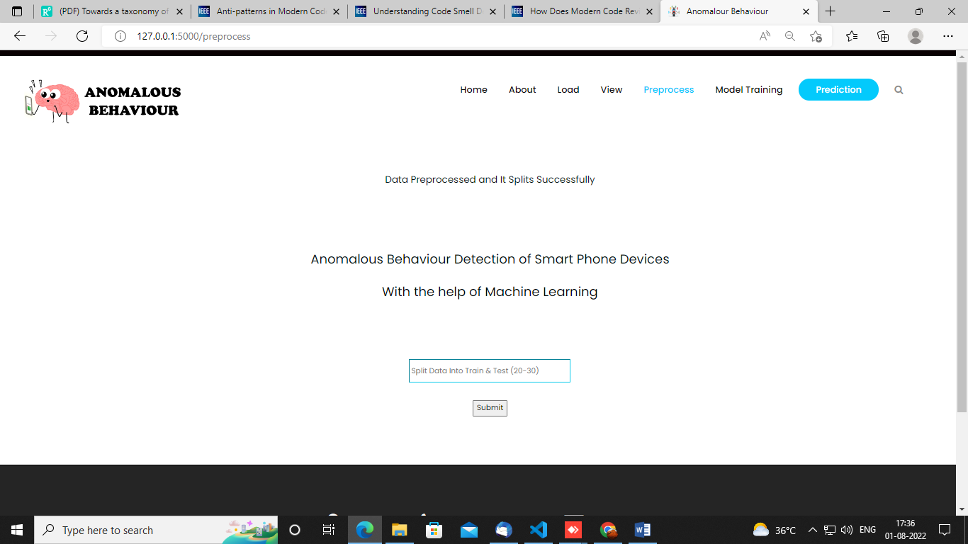

**Model:**

Here we can train our data using different algorithm.

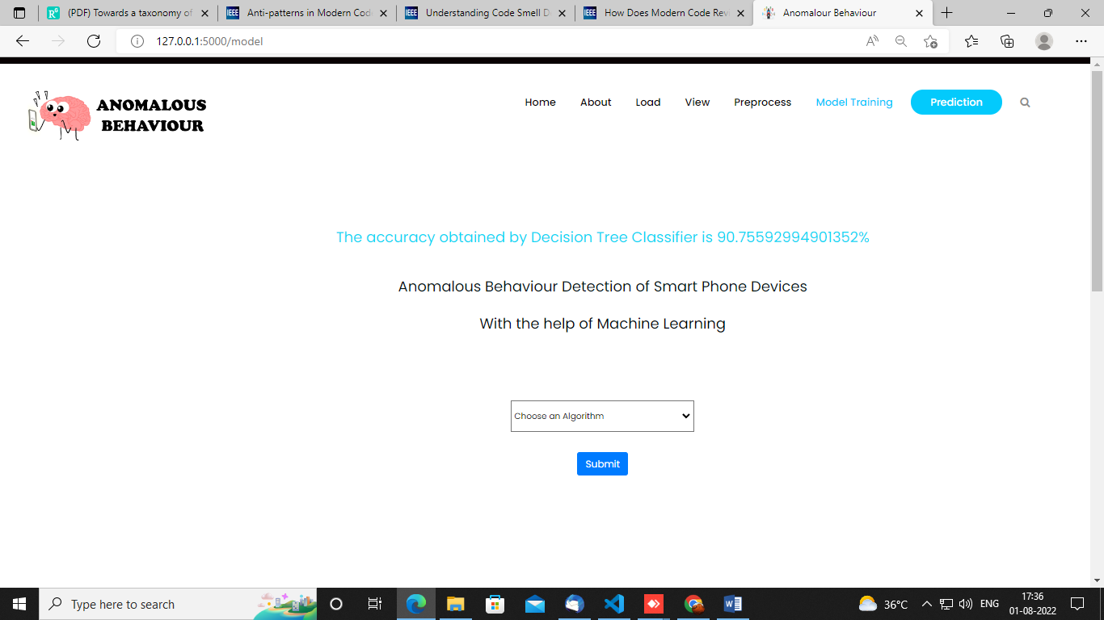

**Prediction:**

This page show the detection result of the anomalous prediction data.

