**Encryption and Decryption of Text**

**Mini Project Report**

of

# Open Source Technology Lab

# by

**Saily Jayraj Kini (33)**

**Shrutika Kudalkar (34)**

Supervisor:

**Prof. Dnyaneshwar Bhabad**



**Computer Engineering Department**

# VIVA Institute of Technology University of Mumbai

**2018-2019**

**Aim:** Mini project report onEncryption and Decryption Project.

**Theory:** This project is about simple encrypt and decrypt technique use for transforming secret information from one person to another person. The main objective of our project is to encrypt/decrypt the textual files for personal and professional security. The title of this project is Encryption and Decryption. The purpose of this project was to develop the program to encrypt and decrypt the text. This project has been used the built-in feature and functional of PYTHON to provide the data for program development. Therefore, the major concentration was focused on application of data encryption and decryption system development. The program coding was written by using the PYTHON programming language.

Encryption is the process of transforming information so it is unintelligible to anyone but the intended recipient. Decryption is the process of transforming encrypted information so that it is intelligible again. A cryptographic algorithm, also called a cipher, is a mathematical function used for encryption or decryption. In most cases, two related functions are employed, one for encryption and the other for decryption.

With most modern cryptography, the ability to keep encrypted information secret is based not on the cryptographic algorithm, which is widely known, but on a number called a key that must be used with the algorithm to produce an encrypted result or to decrypt previously encrypted information. Decryption with the correct key is simple. Decryption without the correct key is very difficult, and in some cases impossible for all practical purposes.

There are generally two different keys:

* **Symmetric key:**

With symmetric-key encryption, the encryption key can be calculated from the decryption key and vice versa. With most symmetric algorithms, the same key is used for both encryption and decryption

* **Public key (asymmetric encryption):**

Public-key encryption (also called asymmetric encryption) involves a pair of keys-a public key and a private key-associated with an entity that needs to authenticate its identity electronically or to sign or encrypt data. Each public key is published, and the corresponding private key is kept secret. Data encrypted with your public key can be decrypted only with your private key.

**What is need of Encryption and Decryption?**

Encryption enhances the security of a message or file by scrambling the content. Phone calls, emails, online purchases, social media, and general browsing are online activities we can no longer live without. While we’re constantly looking or sharing information online, our data is fundamentally stored somewhere. Most people aren’t sure where that “somewhere” is, but that data should only be available to the service provider brokering your conversation. It could, however, be visible to the telecom companies carrying your Internet packets, and your supposedly private and secure communications could be intercepted. As many cases have proven, user and company data is increasingly being targeted by hackers and cybercriminals resulting in [data breaches](https://www.trendmicro.com/vinfo/us/security/special-report/data-breach) and [targeted attacks](https://www.trendmicro.com/vinfo/us/security/threat-intelligence-center/targeted-attacks). This reason alone should serve as enough warning to those who haven’t considered protecting their communications via encryption.

**What is the Goal of our Project?**

The goal of this project is to encrypt text using simple logic before it can be stored in a file or be send to any receiver. Most of the users do not realize that the information we send or the information we store can be easily accessed by anyone. This project will help to encrypt text so that access to the original text by any third party may not be possible. This simple application will allow users to encrypt any text using be it passwords, usernames or e-mails that may contain confidential data.

**Requirement:** Pycharm software and Packages.

**Important code:**

def encrypt():  
 newmessage = ''  
 mystring = var1.get()  
 for character in mystring:  
 if character in alphabet:  
 position = alphabet.find(character)  
 newposition = (position + int(key)) % 26  
 newcharacter = alphabet[newposition]  
 newmessage += newcharacter  
 else:  
 newmessage += character  
 var2.set(newmessage)  
 return  
  
  
def decrypt():  
 newmessage = ''  
 mystring = var3.get()  
 for character in mystring:  
 if character in alphabet:  
 position = alphabet.find(character)  
 newposition = (position - int(key)) % 26  
 newcharacter = alphabet[newposition]  
 newmessage += newcharacter  
 else:  
 newmessage += character  
 var4.set(newmessage)  
  
 return  
  
b1 = Button(a, text="Encrypt", command=encrypt).grid(row=6, column=3)  
b2 = Button(a, text="Decrypt", command=decrypt).grid(row=10, column=3)  
Button(a, text="Close", command=a.quit).grid(row=15, column=2)  
mainloop()

**Screenshots:**

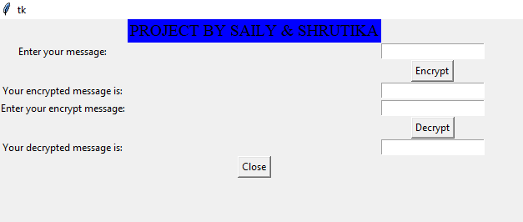

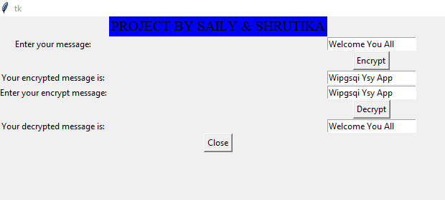

**Conclusion:**

As we toward a society where automated information resources are increased and cryptography will continue to increase in importance as a security mechanism. Electronic networks for banking, shopping, inventory control, benefit and service delivery, information storage and retrieval, distributed processing, and government applications will need improved methods for access control and data security. The information security can be easily achieved by using Cryptography technique. Cryptography may be groovy technology, but since security is a human issue, cryptography is only as good as the practices of the people who use it.