Bash Scripting
(Deep Dive)

Difference between interpreter And Compiler
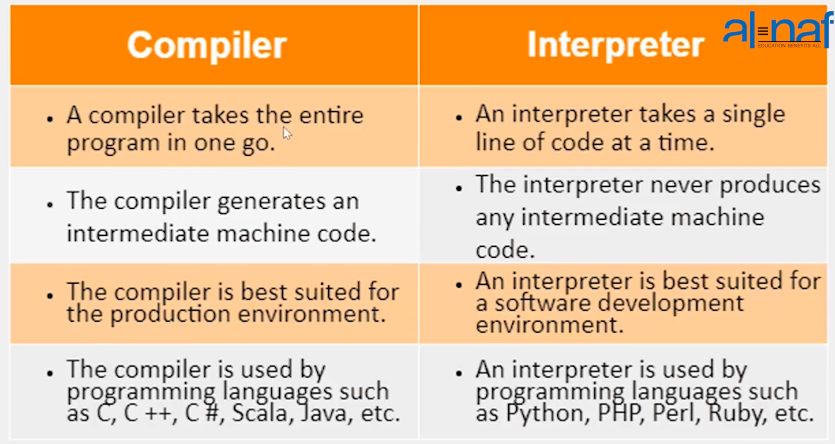

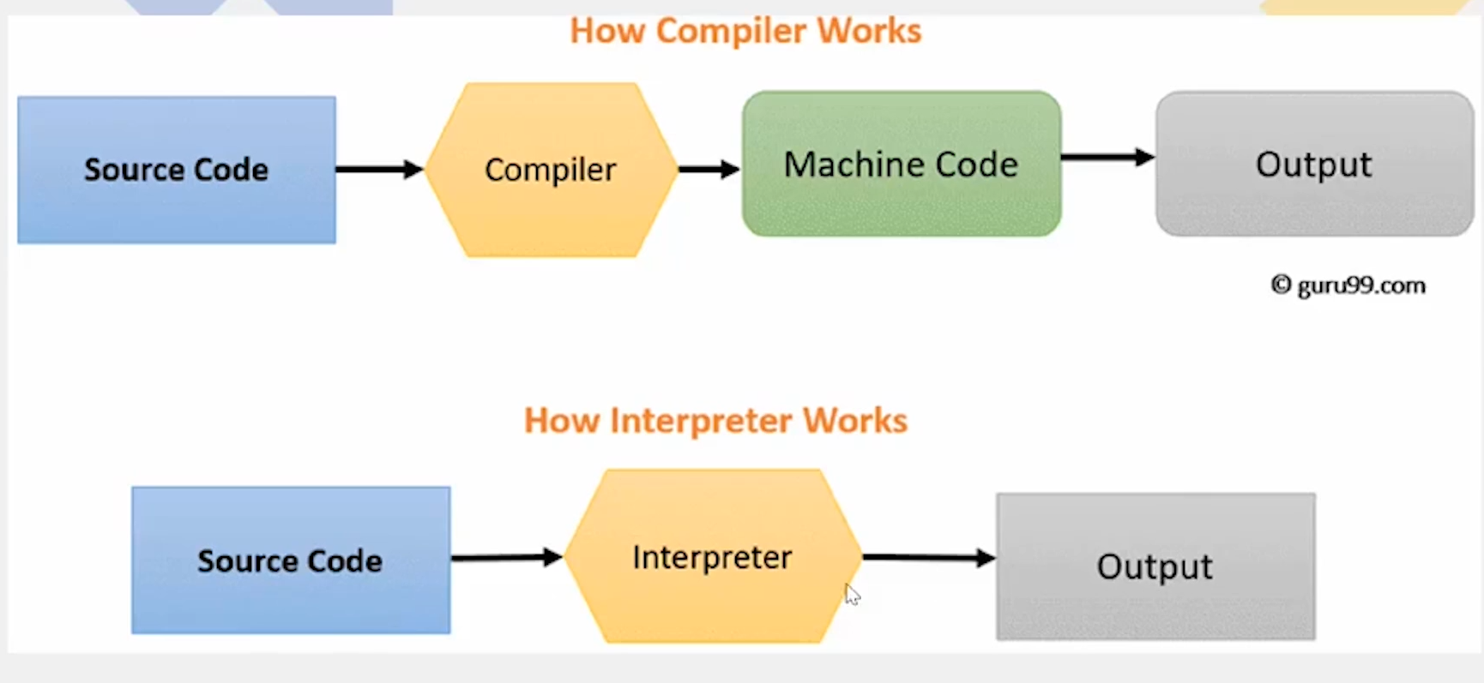
Difference Between Scripting Languages and Programming Languages

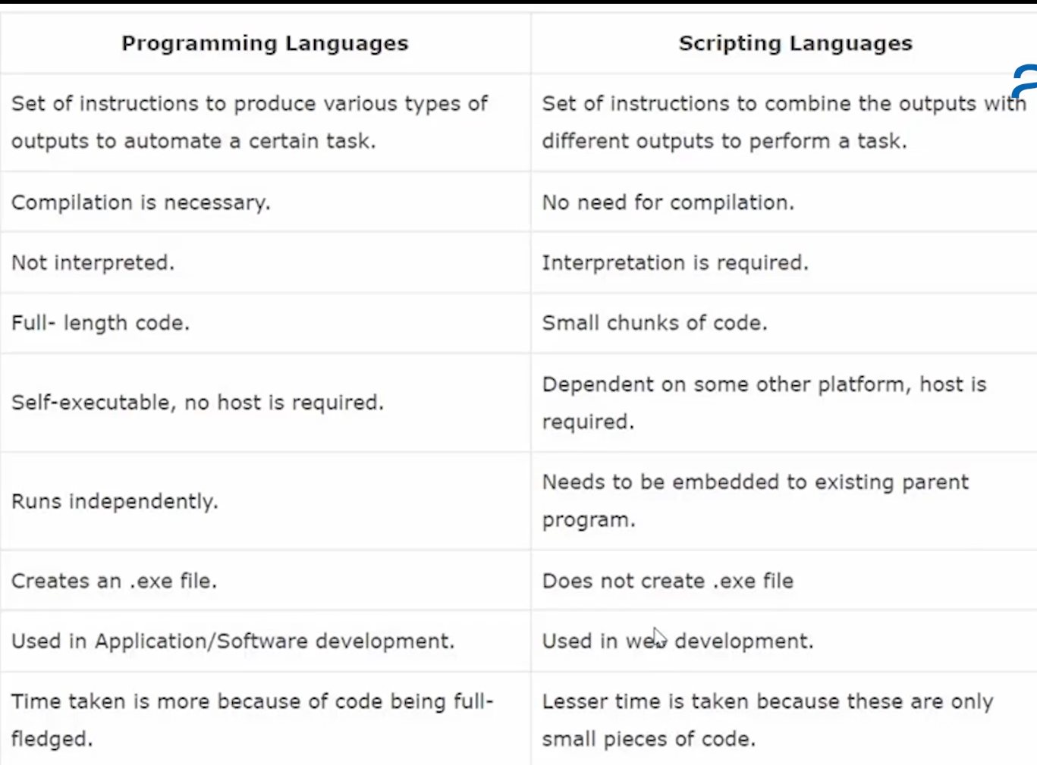
Steps for writing a bash script:
1. First you need to gather information
2. You need to know manual command for shell scripting
3. you need to mentioned shebang language (#!/bin/bash)
4. Creating file using .sh script,Write your command in your script
5. set permission and run the script using ./<script name>/<full path script>

Chsh command:
This command is used if you want to change the if you want to change your shell
Notes: could check the available shells in the machine by either reading the /etc/shells and could check the existing shell working on by either firing echo $SHELL command or reading etc/passwd

Variables:
In variable you store a value, it could be a command a name and anything
for example
a=$(ls)
echo a ======> after this variable is assign it will show us the same value as ls
Note: the files created after variable is assigned will not be shown

Read Command
This command is use to assign a variable
Syntax: read <variable name>
for example:
command=read name
saim
command=echo $name
output=saim

second example
command=read -p "Enter your name: " name
output=Enter your name: saim
command= echo $name
output= saim

third example
read -n5 -p "press any key to exit" ===> by pressing any key we will exit and n5 represents the number of keys we will press so we could get an exit
Note: by default if does not have a variable assign in the read command so by default the value is stored in default $REPLY variable

Debugging Mode:
(we on debugging mode so it become easier to trouble shoot)
commands
set -x = enable
set +x = disable
Example:
bash -x myscript.sh =======> this will enable debugging for myscript.sh file
Notes: If want to change the location in the command line as mentioned so run the script using source command # source myscript.sh

File editors in linux:
1. vi/vim/nano/gedit ===> Editor ====> we can edit It
2. touch: it will create empty file and open it
3 cat
Filters:
1): tr filter (use for replacement)
syntax: tr <find> <replace>
- can use replace the space by running following command.
# cat data | tr ‘ ‘ ‘\n’
example df -h | grep /dev/nvme0n1p2 | awk ' {print $5}' | tr '%' ' '
2): xargs (use for making colmuns)
- can make columns by running the follow commands
# cat data | tr ‘ ‘ ‘\n’| xargs -l3

Example:
ls /bin | xargs wc ==> if want to know number of lines words and character in each files
3): sequence (use to display a range of number in sequence)
syntax =======> <last number in the range><the gaps of number between the numbers> <number starting from>
for example
# seq 10 -2 1 =============> this will display number 1 to 10 that all are even
# seq -s ‘$’ 5 ===result ==> 1$2$3$4$5

How to check that the previous commad has been run sucessfully?
We can run (# echo $?) command to see that if the previous command Is fired succesfuly if received 0 so means command run sucessfully otherwise command is failed

Comparision operators:
equal to operator
# [“abc” == “def”]; echo $? ====> this will result the output to be 1 means that - abc is not equal to def
# [“abc” == “abc”]; echo $? ===> this will result the output to be 0 that means that
abc is equal to abc
not equal to operators
# [ “abc” != “abc” ]; echo $? ==> Now this is a false statement and will get 2 outpu
# [ “abc” != “anc” ]; echo $? ==> this is a false statement

greater then and greater then equal to operators
# [ 4 -gt 4 ]; echo $? ======> -gt represents greater then and this is false
# [ 4 -ge 4 ]; echo $? ======> -gt represents greater then and this is true
Conditional Statements in Bash Scripting

Syntax:
if <condition>
then
<statement>
else
<statement>
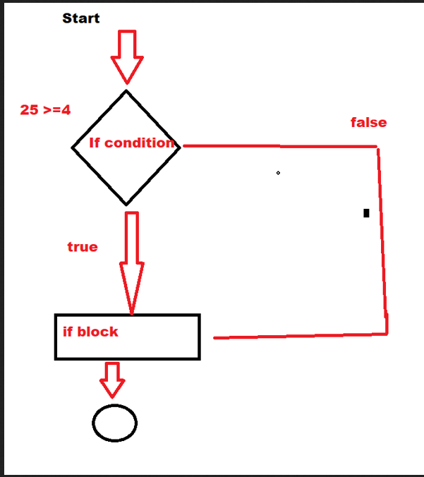
fi ====> to end

Note About syntax:
if ==> has then and fi
else ==> has no then and fi
elif ==> has then only
example script
#!/bin/bash
echo -n "Enter any number of your choice"
read NUM

if [[ $NUM -gt 5 ]]
then
echo "the number is greater then 5"
else
echo "the number is less then 5"
fi

example 2 =======> this script will check the biggest value
GNU nano 6.2 large.sh
#!/bin/bash
echo -n "Enter a number: "
read a
echo -n "Enter b number: "
read b
echo -n "Enter the c number: "
read c
if [[ $a -gt $b ]] && [[ $a -gt $c ]]
then
echo "a is the biggest number"
elif [[ $b -gt $a ]] && [[ $b -gt $c ]]
then
echo "b is the biggest number"
elif [[ $a == $b ]] && [[ $a == $c ]] && [[ $b == $c ]]
then
echo "all the number are equal"
else
echo "c is the biggest number"
fi

Note:- the first condition will always be true

example 3
GNU nano 6.2 check_service.sh
#!/bin/bash
echo "enter a service which want to check installed"
read service_name
command=$(which $service_name)
status=$(echo $?)
#echo $command
#echo $status
if [[ $status -eq 0 ]]
then
echo "$service_name is installed"
echo "$service_name is: $($service_name -v)"
else
echo "$service_name is not installed"
fi
example 4 (nested loop)
echo -n "enter the first number: "
read var1
echo -n "enter the second number: "
read var2
echo -n "enter the third number: "
read var3
if [[ $var1 -gt $var2 ]]
then
if [[ $var1 -gt $var3]]
then
echo "$var1 is the greatest number"
else
echo "$var3 is the greates number"
fi
else
if [[ $var2 -gt $var3 ]]
then
echo "$var2 is the greatest number"
else
echo "$var3 is the greatest number"
fi
fi

Real time example:
#!/bin/bash
echo "enter a password"
read pass

len="${#pass}"

if [[ $len -gt 8 ]]; then
if echo "$pass" | grep -q '[a-z]'; then
if echo "$pass" | grep '[A-Z]'; then
echo "You have entered strong password"
else
echo "Password must contain one uppercase letter"
fi
else
echo "Password must contain one letter"

fi
else
echo "password must have 9 characters"
fi

Positional Parameter (important as interview point of view)
$0 ======> for program or script name
$1 - …...9 =====> parameter passed
$# ====> count total number of parameters
$* ==> display the parameter names that has passed passed
$@ ===> same as $* but used to fetch argument when have double quotes are used
$$ ====> provide the PID of the shell
$? ====> show the excecuted status of the last command

example:
#!/bin/bash
echo "This is a positional parameter" $0
echo "Hello my name is:" $1
echo "Here is " $2
echo "This is" $3
echo "Total count value is " $#
echo "Display the parameter the passed " $*
echo "Fetched information" $@
echo "pid of current shell" $$
echo "Exit staus of last excetuted command" $?

COMMAND to execute: # ./test.sh King Quenn "Prince" Saim abd
Output:-
This is a positional parameter ./test.sh
Hello my name is: King
Here is Quenn
This is Prince
Total count value is 5
Display the parameter the passed King Quenn Prince Saim abd
Fetched information King Quenn Prince Saim abd
pid of current shell 171398
Exit staus of last excetuted command 0

example 2

#!/bin/bash
#echo "Enter a service name you want to check: "
#read service_name
#echo"Enter the status: "
if [[ $# -ne 2 ]]
then
echo "hey admin as per below instructions"
echo "Usage example: $0 <service name> <Action to be excecuted>"
echo "Action valid : status, stop start, restart"
echo "$0 docker status"
else
service_name=$1
status=$2
sudo systemctl $status $service_name
fi

Difference $@ and $*

Positional Parameter With Shift Commands:
(We use shift command so we could shift the positional parameters)
example 1 (single position shift)
#!/bin/bash
echo "$1 $2 $3 $4 $5"
echo "count $#"
shift========> this is the main command and the letter next to it
echo "$1 $2 $3 $4 $5"
echo "count $#"

result:-
# ./shift.sh Abdeali Dodiya Ali
count 3
Abdeali Dodiya Ali
Dodiya Ali
count 2

example2 (Multi position shift)
#!/bin/bash
echo "$1 $2 $3 $4 $5"
echo "count $#"
shift 2========> this is the main command and the number next to it
echo "$1 $2 $3 $4 $5"
echo "count $#"

result:-
# ./shift.sh Abdeali Dodiya Ali ABd Kazim
count 5
Abdeali Dodiya Ali ABd Kazim
Ali ABd Kazim
count 3

Loops (very useful)
(If want to implement a repeated task we should use loops)

what is loop?
A loop is a sequence of instruction that is continually repeated until certain condition is reached

Type of Loops
1. For loop (very much important and practice needed)
2. While loop (very much important and practice needed)
3. Until loop
4. Salect case Loop

For loop:
Syntax
for <variable in list>
do
echo “statement”
done

example 3 ==> real time
#!/bin/sh
for each in $(ls)
do
if [[ -x $each ]]
then
echo "$each is having the excecution permission"
else
echo "$each is not having the excecution permission"
fi
done

example 4 ==> real time
#!/bin/sh
for each in $(ls)
do
if [[ -f $each ]]
then
echo "$each is file"
else
echo "$each is a direcotry"
fi
done

While loop:
Infinity Loop:- when there is not limit in your condition
(While the condition is true the loop will not start and when the condition become false loop will stop)
syntax
while condition
do
statement
done

example1 (infinity loop)
while true
do
echo "Saim"
done

example2 ===(print some thing 10 times)
#!/bin/bash
start=10
while [[ $start -ge 1 ]]
do
echo "saim:$start"
((start--))
done

Real time example1 ==> this will read the file content (interview question)
#!/bin/bash
file="name.txt"
while read each_line
do
echo "$each_line"
done < $file

#!/bin/bash
file="name.txt"
cat name.txt | while read each_line
do
echo "$each_line"
done

Advanced things in While loop:
IFS:- internal field separator (csv files)

Syntax:
while syntax with IFS
while IFS=”Seperator” read variable1 variable2 variabl3
do
statement
done < filename
OR
command | while IFS=”Seperator” read variable1 variable2 variabl3
do
statement
done

real time example 1 ===> ifs, this will only read the variable 3 in the csv file
#!/bin/bash
file="server.csv"
cat $file | while IFS="," read var1 var2 var3 =====> in the ifs keyword we could write the any seperator in file
do
echo "$var3"
done

Until Loop:
Syntax
Until <condition>
do
statement
done

Note:-
until ====> false to true
while ====> true to false

Example1:
#!/bin/bash
start=1
until [[ $start -ge 5 ]] # false statement once the true then will return
do
echo "Num is: $start"
((start++))
done

Difference: the main difference is that while loops are designed to run a condition is satisified and the terminated once that condition return false. On the other end until loop is designed to run while the condition return false and only terminate when the condition return

Select Loop: (Very Useful for menu driven program where have options)
Syntax
case <variable> in
pattern )
statement
;;
pattern )
statement
;;
*)
statement
;;
esac

example 1 (basic)
#!/bin/bash
echo "Please enter the number beetweem 1 to 3"
read num

case $num in
1)
echo "You have enter the one number"
;;
2)
echo "You have enter two"
;;
3)
echo "You have enter three"
;;
esac

example 2 (real time basic)
#!/bin/bash

clear
echo "Enter your file extension: "
read ext

case $ext in
"txt")
ls -ltrh *.txt
;;
"sh")
ls -ltrh *.sh
;;
"*")
echo "sorry have enter invalid file extension"
esac

example3 (real time basic)
#!/bin/bash
echo -e "\n1. Operating system information\n"
echo -e "\n2. Host name information\n"
echo -e "\n3. Memory details\n"
echo -e "\n4. My disk usagn\n"
echo -e "\n5 exit\n"

echo "Enter your choice"
read choice

case $choice in
1)
echo "Your linux system information: $(uname -a)"
;;
2)
echo "Host name is: $(host name)"
;;
3)
echo "$(free -g)"
;;
4)
echo "$(df -h)"
;;
5)
echo "Bye Bye"
exit 1
;;
esac

Echo command flags: (Advanced)
1) “-e” this flag is used so we can execute advanced commands for example:- # echo -e “Num is $a \n and Num2 is $b”
this command will generate output in two different lines
What options open when use this flag
- “\” this is used if you want to add a special character
for example
echo -e “/$abd : $abd”
output:- $abd:12
example2
echo -e "My name is \"Saim"\", I am from karachi
My name is "Saim", I am from karachi
- “\b” this will backspace
- “\a” this will make a sound of bell
- “\c” this will supress the text after it
- “\n” put text in new line
- “\f” clear your screen
- “\t” horizontal tab
- “\v” vertical tab
Note: If want to know about the length of a string run the following command
# echo ${#msg}

cat << ABD command (use to write text in multiple lines)
Example 1:-
cat << ABD
My name is saim
I am from karachi
Output
My name is saim
I am from karachi

tr command (it is used so we can convert our text into capital letters)
Example 1:-
echo “We are learning bash” | tr [a-z] [A-Z]
Output :- WE ARE LEARNING BASH

Example2:-
tr [a-z] [A-Z] <<< $(docker version)

Comments (Used so others can understand the code and the comments would not excecute)
1): Single line comments
2): Multi line comments

Single line Comments:
example 1
# name saim
# script name : comments.sh

Multi line Comments:
example 2
<< ABD ==========> no need for hash symbol
name: saim
Script name: comments.sh
ABD
echo "Hi"

Example 2:-
: "
Name: Abdeali dodiya
Script name: comments.sh
Script purpose : for education
"
Single quotation could also be used

Control and Break statement:-
Control VS Break statement
Break:-
It is used for exit your loop
Break will terminate /exit your Loop.
Continue:-
Continue will use to skip the current then continue next

example 1:- (this loop will break when the I will equal 5)
echo "Starting the Loop"
for i in $(seq 1 10)
do
if [[ $i -eq 5 ]]
then
break ===> this is the main command word which
breaks the loop
else
echo $i
fi
done
echo "Ending the loop"

example 2:- (this loop will continue and skip the 5)
echo "Starting the Loop"
for i in $(seq 1 10)
do
if [[ $i -eq 5 ]]
then
continue ===> this is the main command word which
skips the existing step and continue
else
echo $i
fi
done
echo "Ending the loop"

String Operation:
How to find length of two a string?
# echo ${#msg}

How to concatenation two strings?
string1=”hello”
string2=”, World”
string3=$string1$string2
echo $string3
output= “Hello, World”

How to cap your string
echo “${string3^^}” =====> hello world
echo “${string}” | tr [a-z] [A-Z]
How to small your string
echo “${string}” | tr [A-Z] [a-z]

How to replace words in a string
syntax:-
<variable string></Find or search/><replace>

Character Replace:-
name=”Raza”
echo “${name/R/r}” ======= “raza”

Character trimming
echo ${name:0:2} =======> Ra
echo ${name::-1} =======> Raz

What is positive and negative index in bash scripting?
Lets say we have an array as following:

cmd=(1 2 3 4 5 6 7)
so the values are: 1 2 3 4 5 6 7
and the index positive: 0 1 2 3 4 5 6
if we run the following command get the following output
# echo “${cmd[1]}” ===> output ===> 2
# echo “${cmd[2]}” ===> output ===> 3
# echo “${cmd[3]}” ===> output ===> 4

Negative index (starts from the right most):
Lets say we have an array as following:

cmd=(1 2 3 4 5 6 7)
so the values are: 1 2 3 4 5 6 7
the negative index will: -7 -6 -5 -4 -3 -2 -1
if we run the following command get the following output
# echo “${cmd[-1]}” ===> output ===> 7
# echo “${cmd[-2]}” ===> output ===> 6
# echo “${cmd[-3]}” ===> output ===> 65

Arrays
(an array is a collection of elements)

Example 1 =====> learn how to call an array
#abd=(abd saim 5 2 1)
#echo “${abd[*]}” =====> output ==> “abd saim 5 2 1”

Example 2 =====> learn how to call an array (could also use “@” sign)
#abd=(abd saim 5 2 1)
#echo “${abd[@]}” =====> output ==> “abd saim 5 2 1”

Example 3=> this will show how to get multiple specific values
cmd=(1 2 3 4 5 6)
echo “${abd[@]:1:3}” ====>output====> 2 3 4
(there could also be an empty array)

Example 4 => if want to store a command as an array
cmd2=( $(docker -v) )
echo “${cmd2[@]}”

Example 5 => Using custom index values
test=([11]=ali [12]=2 [13]=5)
echo “${test[11]}” ====> will get ali output

Example 6 => had own custom index value names
declare -A mytest
mytest=([fname]=”Saim” [lname]=”Talha” [13]=”Feroz”)
echo “${mytest[fname]}” ==> output ==> Saim
echo “${mytest[lname]}” ==> output ==> Talha
echo “${mytest[13]}” ==> output ==> Feroz

if want to check index value that is assigned we run the following command
echo "${!cmd1[@]}" =====> 0 1 2 3 4 5 6
echo "${#cmd1[@]}" ====> to know about total index value assigned =====> 7

Functions
(help in organizing a long script into manageable modules)
Methods:
1) function <functionname>()
{
statement
}
2) <function>()
{
statement
}

Variable types in functions
1) Local Variable
2) Global Variable

Local variable example
#!/bin/bash
mytest()
{
local abd=”how are you”
}
echo $abd

Note:- could also stored a function in a variable

Return value example:
#!/bin/bash

myvar()
{
local ali="10"
return $ali
}
myvar
echo "My return value is $?"
abd=$?
echo "My return value is $abd"

Argument Passing example”
#!/bin/bash

test()
{
echo "Hello $1"
}
test ali
test saim

Example 2
#!/bin/bash
add()
{

first=$1
second=$2
ans=$((first + second))
echo "$first + $second is: $ans"
}
first=10
second=20
add $first $second

abd=200
ali=20
add $abd $ali

Grep commands (use for filtering your contents)
Syntax:
file or message | grep <option>
or
grep <option> file or option

Example 1:
cat abd.txt | grep "devops" ===> show the lines that has this word
or
grep “devops” abd.txt ===> this way recommended more
output:
I am student at al nafi learning devops

some other examples:
ps -ef | grep “saim”
echo -e “\n saim \talha \feroz” | grep “saim”
cat test.txt | grep -E "[Iio]" ===> character by character search

Options and there example:
syntax:-
cat abd.txt | grep -<option> “saim” =======> this is for all options or flags
1): -i : this ignore cases W
real case example
- cat /var/log/syslog | grep -i "error" error.txt
- cat /proc/cpuinfo | grep -i "model"
2): -w: use when want to get exact output
3): -v : this ignores the option that we define and show all output instead of the value we have given
real time example:-
cat /etc/apache2/sites-available/default-ssl.conf | grep -v "#"
(this will not show the comments in the file)
4): -o : this will output only the string that you have given
5): -c : use for how many times the value is repeated defined
6) -A : use to see the line after the first match match
cat abd1.txt | grep -A 2 "Devops" ===> two lines after first match
7): -B: opposite of -A use if want to get result after first match

8): -r: find the value defined in each directory in each file for example:
grep -r “devops”
9): -l: tell the name of files where the defined value is used
10): -h: hide the file and show the content
11): -e(very useful): see the results of multiple values as shown
cat abd1.txt | grep -e "devops" -ie "karachi" -ie "saim"
cat abd1.txt | grep -iE "devops|saim"
12): -f: this is for a file which is used for advanced search. Obtain patterns from FILE, one per line. If this option is used multiple times or is combined with the -e (--regexp) option, search for all patterns given. The empty file contains zero patterns, and therefore matches nothing

Important Signs
1): ^ is use for search word from begining of your lines of the value that you have define
2): $ opposite of ^ for example: #cat abd1.txt | grep -E "course$" .
3): $^ this will define empty line
4): / this will desplay special character
5): “.” will show a character after the value
6): “/b value /b” : to dislpay only match string
7): “?”: It will be check option condition one or more a single letter
8): {N}(very useful): display word N times

Advanced things tips:
1): can also make a pattern for searching in a txt file and use it by running following command
#cat /etc/passwd | grep -f pattern.txt
make sure the txt file is line by line

Real World Use Cases:
1): list me using grep the directories in the current directory
# ls -ltrh | grep -cE “^d”
2): hello dear, my server details are as follow
my jboxx server ip address is 192.168.1.8
my docker server ip address os 192;168.1.0
my brodcat address is 255.255.255.0
Invalid ip ddress 1234.1234.12.1
We are checking only for grep example

command to run
cat myip.txt | grep -E "\b[0-9]{1,3}\.[0-9]{1,3}\.[0-9]{1,3}\.[0-9]{1,3}\b"

Cut (command use for filtering)
Cut syntax:
filename | cut <option> ===> more recommended
or
cut <option> filename

Example 1:
cat testing.txt | cut -c 1 ==> -c starts for characters

Example 2:
docker_vers=$(docker -v | cut -c 16-25)

Example 3
cat testing.txt | cut -f 1====> -f stands for field=>1st field output
-f: it is stands for outputing 1st 2nd 3rd fields that is seperated by tab

Example4
cat /etc/passwd | cut -d “:” -f 1
Notes: -d stands for delimiter which use if the fields is not seperated by tab like in this it is seperated by “:”

Example5
cat /etc/passwd | cut -d ":" -f 1-8 | grep -E "root"

Example 6
cat /etc/passwd | cut -d ":" -f 1-8 --output-delimiter="##" | grep -E "root

Note:
--ouptut-delimeter use STRING as the output delimiter the default is to use the input delimiter

Example 7:
cat /etc/passwd | cut --complement -d ":" -f 1
Note : it will show everything instead the first field

Example 8:
ps -ax | grep -v grep | grep nginx
Note: this will show that either the service is running in the system or not

AWK Commands
(use for data manipulation, searching, task run, action, data generating report)
(Advanced in comparision to grep and cut)
AWK syntax:
Filename or command | awk option ‘patter {action}’ ==> more recommended
or
awk option ‘pattern {action}’ filename’

AWK Options:
-F: field separators
example: #cat /etc/passwd | awk -F ‘:’ ‘{print $2}’
#cat userdata.txt | awk -F ' ' '/ali/{print $2}'
-f: file name you need to specify
-v : it is used to declare a variable
OFS:- Output field seperator ()
OFS example: date | awk 'OFS="-"{print$1,$2,$3}'

AWK Variables :-
1. $0, $1, $2, $3 and so on ===> this is about
sequence of fields or so called columns
for example:
cat username.txt
id Name Age username
1 Ali 27 ali
2 ABD 35 abd
3 Kazim 33 kazim
4 Abdeali 32 abdeali
so if we run following command get the following
output
#cat username.txt | awk ‘{print $1,$2,$3}’
output
id Name Age
1 Ali 27
2 ABD 35
3 Kazim 33
4 Abdeali 32

2. NR ===> number of records ==> as shown
# cat userdata.txt | awk ‘{print NR}’
# cat userdata.tct | awk ‘{print NR “==>” $1}’
output
1==>id ===> could also change this sign
2==>1
3==>2
4==>3
5==>4

# cat userdata.txt | awk NR==1 (shows the record of first field)
3. NF ===> number of fields
Examples:
# cat userdata.txt | awk ‘{print NF}’
4 ======> this commands shows number of columns in each field
4
4
4
4

# cat userdata.txt | awk ‘{print NR “==>” $0, NF}’
1==>id Name Age username DOB 5
2==>1 Alix 27 ali 11 5
3==>2 ABD 35 abd 13 5
4==>3 Kazim 33 kazim 14 5
5==>4 Abdeali 32 abdeali 15 5

Difference b/w GREP , Cut VS AWK
GREP and CUT commands :-
# apache2 -v | grep -E "version" | cut -d ":" -f 2 | cut -d "/" -f 2 | cut -d " " -f 1
OR
# apache2 -v | grep -E "version" | cut -d "/" -f 2 | cut -d " " -f 1
AWK commands :-
# apache2 -v | awk -F "/" 'NR==1 {print $2}' | awk -F " " '{print $1}'
# apache2 -v | awk -F "/" '/version/ {print $2}' | awk -F " " '{print $1}'

Real time Example:
1): systemctl status apache2 | awk ' NR==3 {print $2}' (check the status of apache2 service running?)

AWK Scripting:-
Syntax
filename | awk 'BEGIN {start_action} condition {action} END {stop_Action}'

Note:- if you want to write an awk script in a file so write #!/bin/bash

Simple example:-

1): awk 'BEGIN {print "hello world"}'

2): vim simple.awk
BEGIN {
print, "hi i am saim" ==>this will print hello I am saim
}
3): awk 'BEGIN {ali=100; print ali}' (we use semi colon if want use more than one command and no need for $ sign if want to call a variable in
awk script)
4): cat num.txt | awk '{if ($1 >= 50) print $1}' (have used if condition)
5): awk ' \ (used for loop)
6): awk 'BEGIN {i=1; while (i<=10) {print "saim", i++}}' (used while loop)
7): ls -ltrh | awk -v OFS='\t' 'BEGIN {printf "%s\t\t\%s\n", "Name", "Size" }{print $9,$5}'

Real time example:-
cat /etc/passwd | awk -F ":" '$3 >= 1000{print $1,$3,$6}' > mycurrentuser.txt
(this will redirect the information of the active users in given file)

SED Commands
(is one of the useful filter and one kind of stream editor)
Where we use SED?
Display contents
Find
Replace
Modification

SED Syntax
filename or command | sed [options]
sed [options] filename

Options:
-n : only show the defined lines
-i (very dangerous and important): this input or make changes in your file for example
sed -i ‘10,20d’ users.txt (this will delete 10 till 20 lines in your file)
-i.bck (as -i is dangerous always use this as it will also create a backup of you file)
-E used for advance input

Some Simple Examples:
1): cat myusers.txt | sed -n ‘4p’ (show fourth line one time)
2): cat -n myuser.stxt | sed -n '$p'
3): cat -n myusers.txt | sed -n ‘1,5p’ (shows the range of line from one till five)
4): cat -n users.txt | sed -n ‘0~1p’ (shows the odd lines only)
5): cat -n user.txt | sed -n ‘/saim/$p’ (this will show till last line after the first saim is matched)
6): cat -n user.txt | sed -n ‘/saim/$p’
7): cat -n user.txt | sed -n “/$name/$p” (if want to call a variable use double quotation)
8): cat -n users.txt | sed ‘1,10d’ (this will show all the values instead from 1 till 10 as we have used d insteaed of p)
9): sed -i.bck '/saim/!d' user.txt (this will delete all
the content except saim line (first match) )
Note: Do not use this in the production
10): sed 's/saim/SAIM/g' user.txt (will change saim where it is in the whole file)
11): cat user.txt | sed 's/bin/BIN/2' (will change two times at two match only)
12): sed -i '1i no,Sr,IP,Hostname' data.csv (this will insert data In the file, above the first line)
13):sed -i '3a 3,192.168.100.5,server3' data/csv (this will input data after the 3rd line as we have used a after 3)
14): sed -i '/192.168.100.4/d' data.csv (will delete the line that has the following ip address)
15): #cat /var/log/auth.log | sed -n '/Jul\s16\s19\:09/p' > abdeali.txt (could be a real time examples)
16): sed -E “s/$/,$(date)/g” (will add date on the end of the line with a comma)
17): df -h | grep -v tmpfs | awk 'NR!=1' | awk '{print $1,$2,$3,$4,$5,$6}' | sed -e 's/%//g' | sed -E "s/ +/,/g"
will replace space by comma
Performing same task using awk and sed command:
What is task?
Print the lines from 3 till 8
AWK:
# cat users.txt -n | awk ‘NR >= 3 && NR<= 8 {print $0}’

SED
cat users.txt | sed -n ‘3,8p’

How to delete empty line from your file?
# sed -i '/^$/d' filename

Find Commands
(Use for searching as the name suggest)
Find Syntax:-
find <path> <action> <file or pattern>

Some useful actions:-
1):-mtime +n ===> modified more than n days ago
2):-mtime -n ==> modified less than n days ago
3):-mmin +n ===> modified more than n min ago
4):-mmin -n ==> modified less than n min ago
5): -newerm “day” ==> modified file in the given day

Simple Examples:
# find /home/saim/al-nafi-diploma-devops/bash-scripting/ -name abd1.txt
# find . -name abd.txt (this will find abd.txt in from the current machine)
# find . -name -type d grep (this will find the directories in your current directory named grep)
#find . -name -type f grep (this will find the files in your current directory named grep)
#find . -name -type f *.csv (this will list all the files that have csv format)
#find . -user root (list all the files that have made or have ownership of the root user)
#find -group root (list all the files that have made or have ownership of the root group)
# find . -type f -perm 0775 -print (find all the files that have 0775 permission )
# find . -perm /u=x (find all files that have excecutive permission)

# find /home/saim/al-nafi-diploma-devops/bash-scripting/for_loop -type f -name "*.txt" -exec rm -rf {} \; (this will exec a command that will delete the result cause by the find command)(very important)
# find . -type d -perm 777 -print -exec chmod 775 {} \; (change the directory permission)
#find . -type f -size 0 (to see empty files)
# find . -mtime 5 (shows all the files modify in the last 5 days)
# find . -mmin -120 (shows all the file modify in last 120 minutes)

Interview question:-
List files that was modify in last 24 hours?
Find . -newermt “yesterday”

Scheduling Task With bash script:-
1. login your email account.
2. Go to manage your google account
3. enable Two factor authentication option
4. Click on security option and app password.
app password :
5. Move to your ubuntu or linux machine and install packages
#apt-get update
#apt-get install sendmail mailutils
6. create auth directory and give the permissions as shown
#cd /etc/mail
# mkdir authinfo
# chmod 700 authinfo/
# cd authinfo/
7. Make a file name with following description
# cat gmail
AuthInfo: "U:root" "I:automation52786@gmail.com" "P:password"
8. Convert file into hash
# makemap hash gmail < gmail
9. Change some setting in sendmail.mc file
#cat sendmail.mc
copy after 101 line
#GMail settings:
define(`SMART_HOST',`[smtp.gmail.com]')dnl
define(`RELAY_MAILER_ARGS', `TCP $h 587')dnl
define(`ESMTP_MAILER_ARGS', `TCP $h 587')dnl
define(`confAUTH_OPTIONS', `A p')dnl
TRUST_AUTH_MECH(`EXTERNAL DIGEST-MD5 CRAM-MD5 LOGIN PLAIN')dnl
define(`confAUTH_MECHANISMS', `EXTERNAL GSSAPI DIGEST-MD5 CRAM-MD5 LOGIN PLAIN')dnl
FEATURE(`authinfo',`hash -o /etc/mail/authinfo/gmail.db')dnl

10. run make command and reload
#make
# /etc/init.d/sendmail reload

11. Send email by following command.
# sendmail automation52786@gmail.com
Test
test
.
12. Check the log file to check the process status
#less /var/log/mail.log
status=sent

Real Time Hands On:
1): for numbers df -h | awk 'NR != 1' | awk '{print NR "," $0}'
for removing percentage:-
df -h | awk 'NR != 1' | awk '{print NR "," $0}' | sed -E 's/ +/,/g' | sed -E s/%//g
for adding date:-
df -h | awk 'NR != 1' | awk '{print NR "," $0}' | sed -E 's/ +/,/g' | sed -E s/%//g | sed "s/$/,$(date +%d-%m-%y)/g"
df -h | awk 'NR != 1' | awk '{print NR "," $0}' | sed -E 's/ +/,/g' | sed -E s/%//g | sed "s/$/$(date +%d-%m-%y)/g" | sed -E s/$/,$(ifconfig | awk 'NR==43' | awk '{print $2}')/g | sed -E "s/$/,$(hostname)/g"
(final example)

2): #!/bin/bash
IP=$(cat ServerIP.csv | awk 'NR != 1' | cut -d "," -f2) ]
cone_conrt=0 ]
for i in $IP ]
do ]
ping -c 1 $i 1> /dev/null ]
status=$(echo $?) ]
if [[ $status -eq 0 ]] ] (This script will
then ] connection
echo "$i is connected" ] between the
ssh azureuser@10.0.0.5 "hostname" ] machines in a
count=$((count +1)) ] private network)
echo $count ]
]
else ]
echo "$i is not connected" ]
fi ]
done ]

2): for ensuring password is strong
len="${#password}" echo $len
if test $len -ge 8 ; then
echo "$password" | grep -q [0-9]
if test $? -eq 0 ; then
echo "$password" | grep -q [A-Z]
[ $? -eq 0 ]; then
echo "$password" | grep -q [a-z]
if test $? -eq 0 ; then
echo "Strong Password" else
echo "Weak Password -> Should include a lower case letter."
fi
else
echo "Weak Password -> Should include a capital case letter."
fi
else
echo "Weak Password -> Should use numbers in your password."
fi
else
echo "Weak Password -> Password length should have at least 8characters."
fi

Important things to Note:
- We can check the number of the shell in your machine by reading the etc/shells
path
- When ever you put +x permissions in the script file so then it will start to run
- Whenever calling any variable use $ sign
- When ever storing any command in a variable use a dollar sign
- can use bc if want to open calculator
- if want to run any command in the bash script run the command in this format $(command want to fire) ===> $(which docker)
- if want `to comment down a program just use # symbol so the command wont be executed
- use exit command to ensure that script is exited after couple of seconds as defined

