Visual/Interface Designs
I have designed wireframes for key pages.
Home Page Wireframe Description
- Top: Logo on left, navigation bar (Home, Catalogue, Producers, Account, Loyalty, Cart) on right.
- Middle: Banner image of local farm, welcome text "Buy Local at GLH".
- Below: Grid of 6 featured product cards (each with image, name, price, "Add to Cart" button).
- Bottom: Footer with links (About Us, Contact, Privacy Policy, Terms), copyright notice.
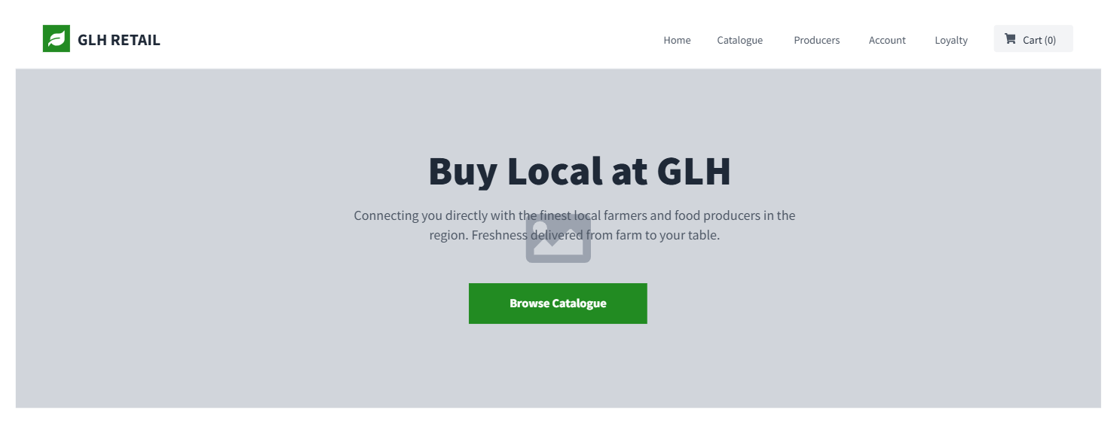
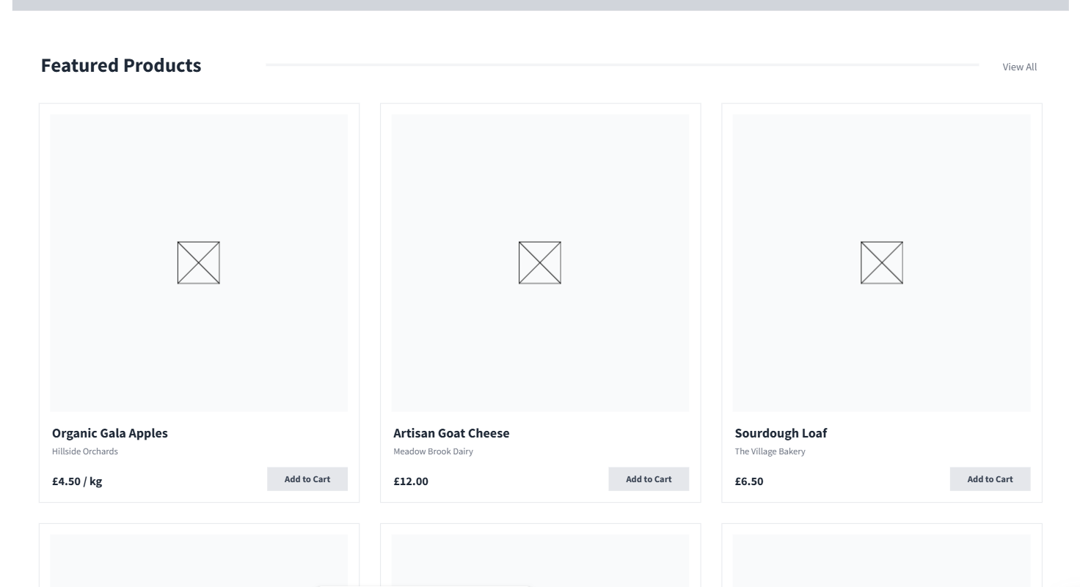
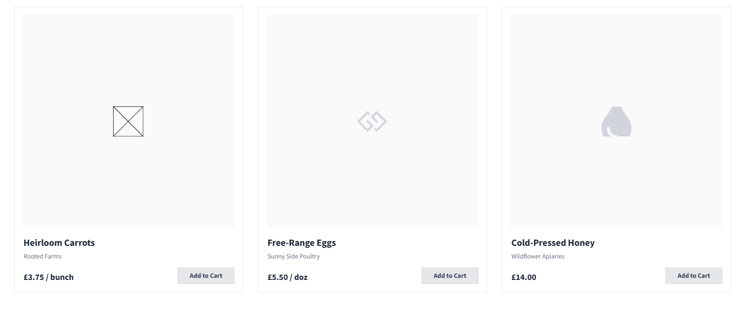
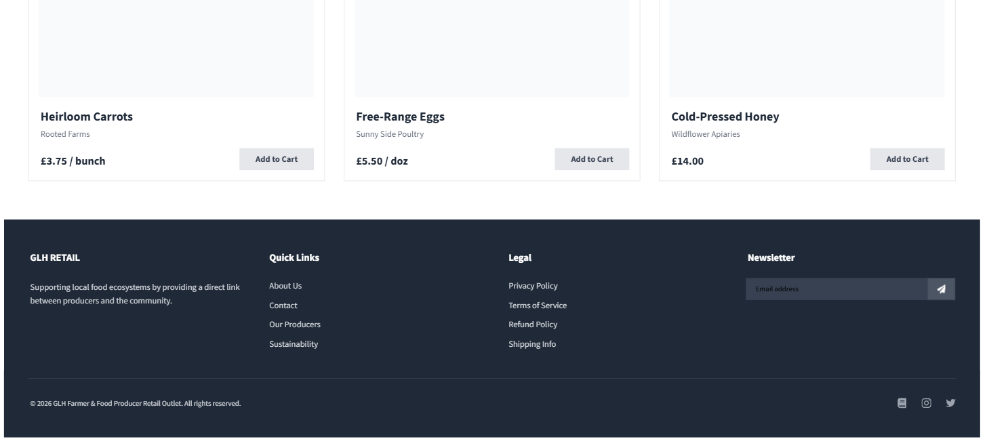

Product Catalogue Wireframe Description
- Top: Search bar centred, filters sidebar on left (categories, price range, producers).
- Middle: Grid of product cards (image, name, price, availability, "View Details" button).
- Bottom: Pagination controls (previous, next pages).
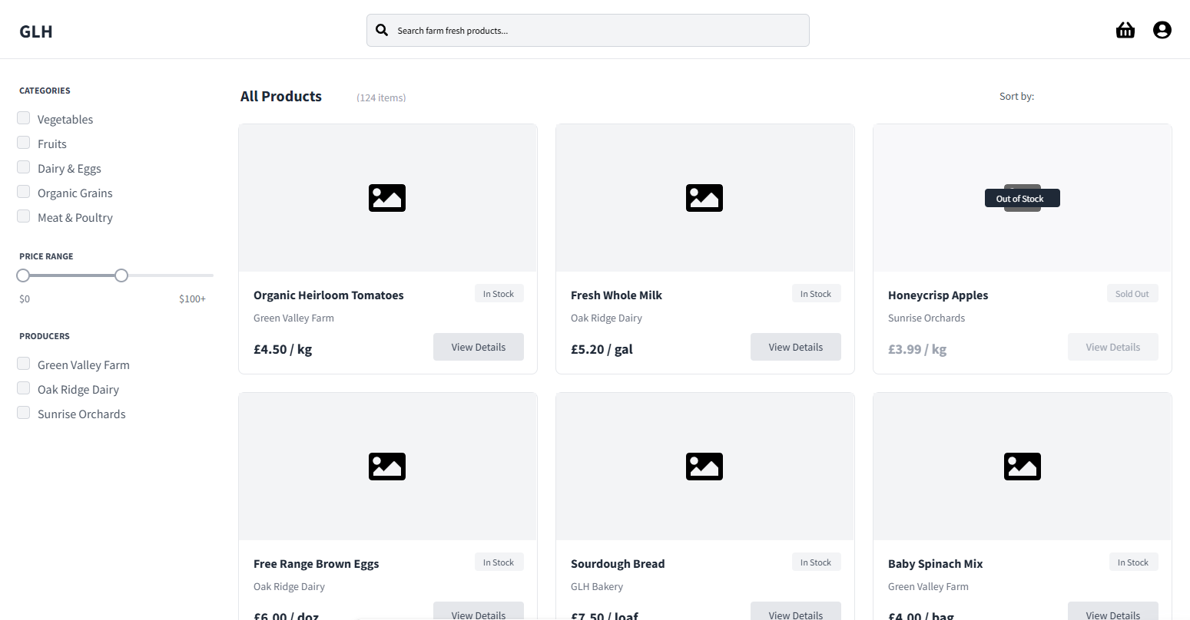
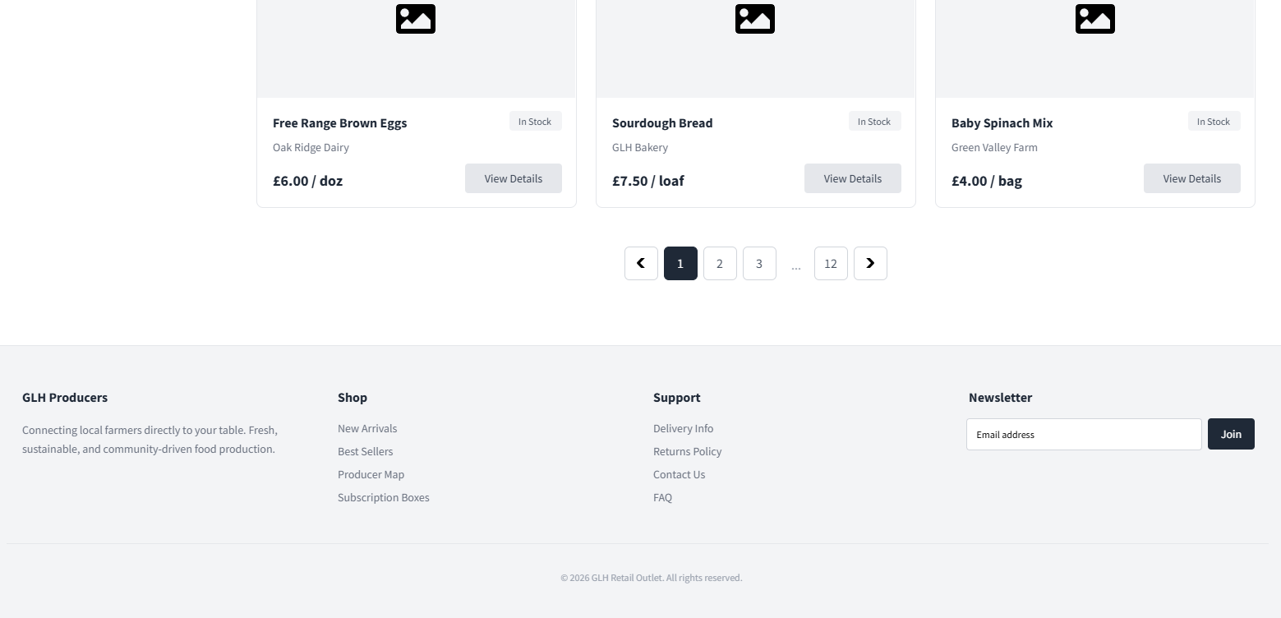
Product Detail Page Wireframe Description
- Top: Large product image on left, details on right (name, price, availability, description).
- Middle: Producer info link, "Add to Cart" button, quantity selector.
- Bottom: Reviews section with stars, comments form.
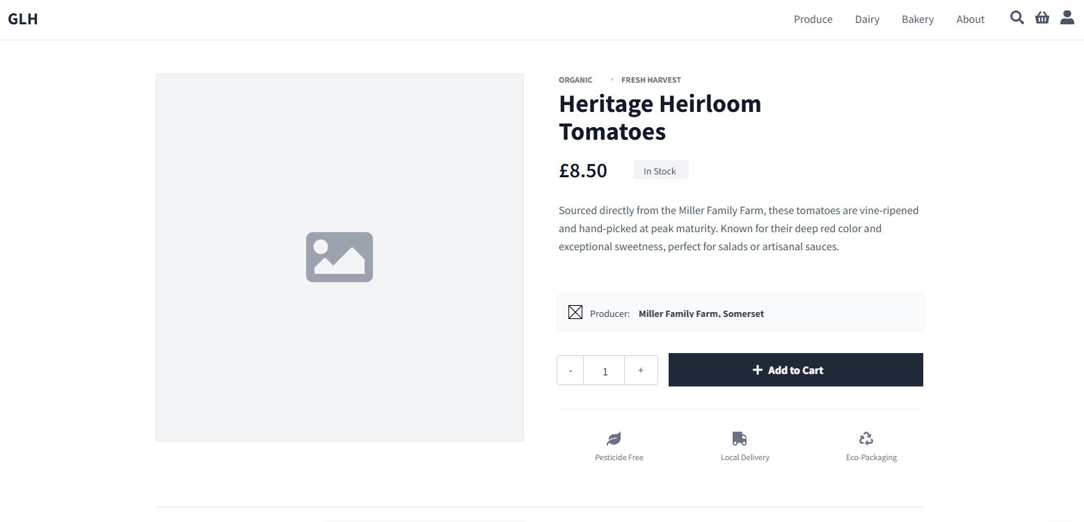
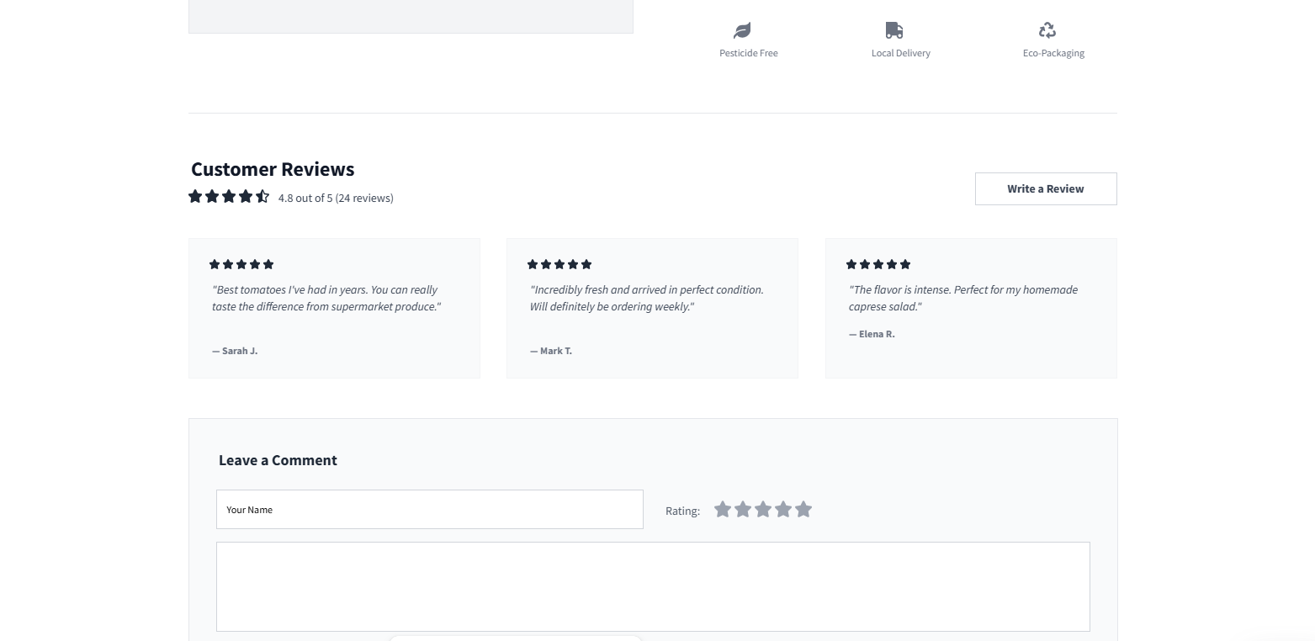
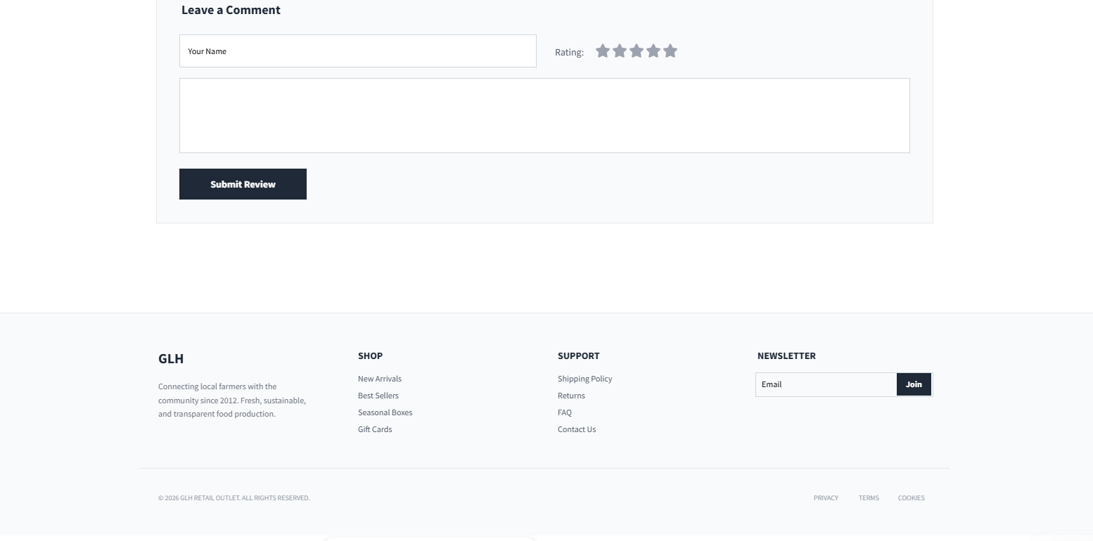
Account Profile Page Wireframe Description
- Top: User name and photo.
- Middle: Form to update details (email, address, password).
- Below: Table of order history (order ID, date, status, items).
- Bottom: Logout button.
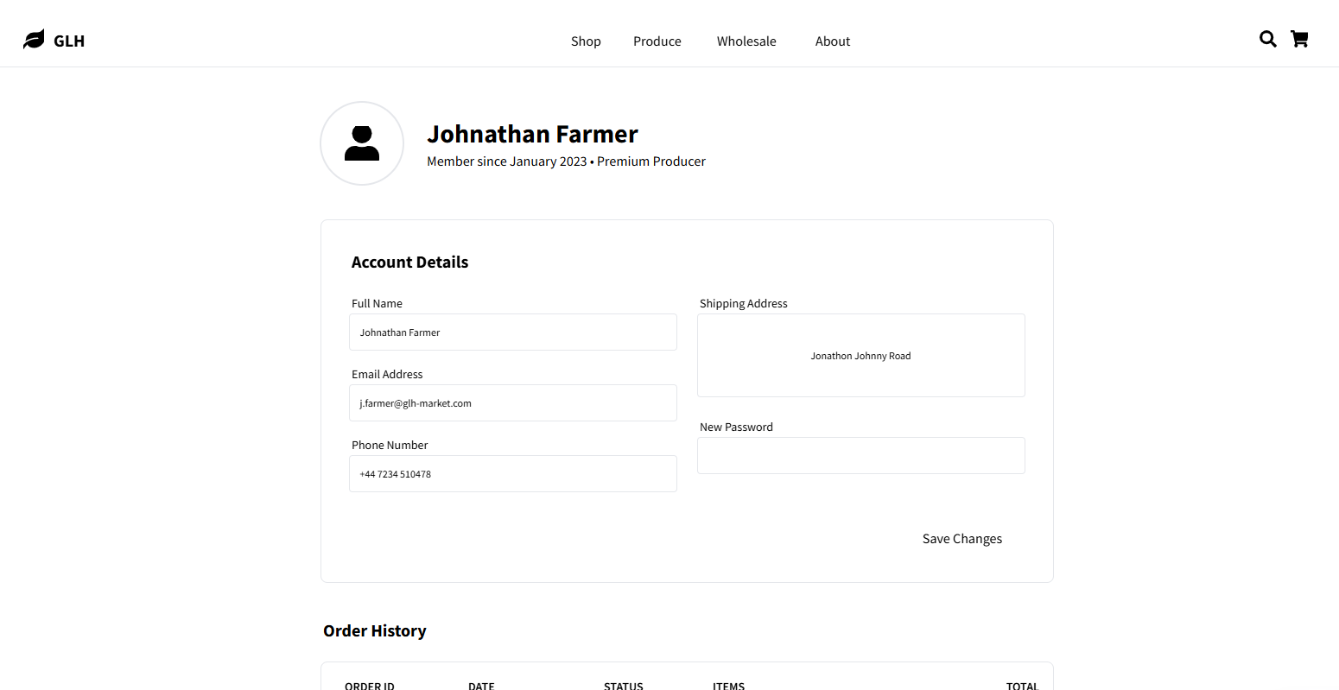
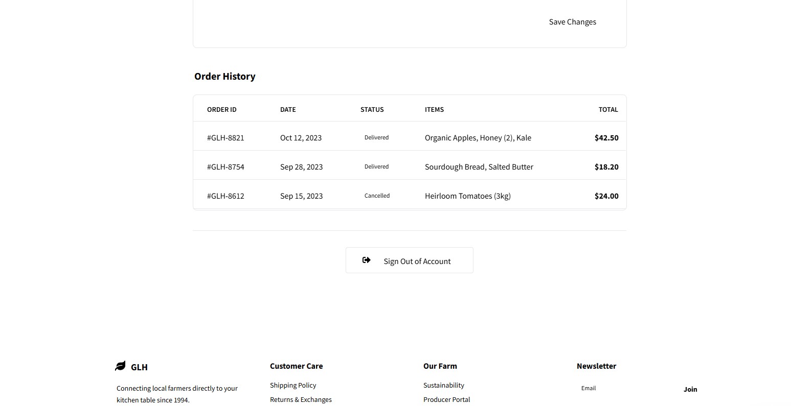


Producer Dashboard Wireframe Description
- Left: Sidebar menu (Stock, Products, Orders, Reports, Profile).
- Middle: Table of products (name, stock, price, edit button).
- Top: Alerts bar for low stock or new orders.
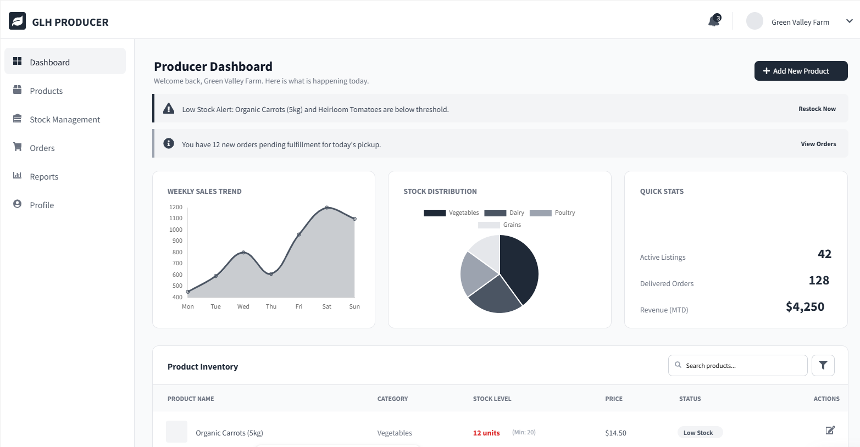
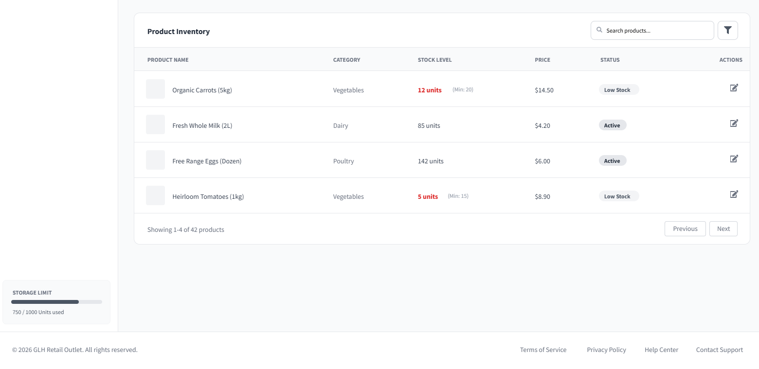
These designs use a modern theme for a fresh, new feel. They are simple and mobile-friendly.
Algorithm Designs
I have selected 5 complex problems and designed algorithms in pseudocode. For each, I include a description, pseudocode, and a flowchart.
1. Order Placement Algorithm Description: Handles adding items, checking stock, payment, and updating database.
PSEUDOCODE:
FUNCTION placeOrder(userID, items, type, time):
IF user not logged in:
RETURN error "Login required"
FOR each item in items:
IF stock < quantity:
RETURN error "Out of stock"
Calculate total price
Apply loyalty discount if applicable
Process payment
IF payment success:
FOR each item:
Update stock = stock - quantity
Create order record in database
Send confirmation email
RETURN success
ELSE:
RETURN error "Payment failed"
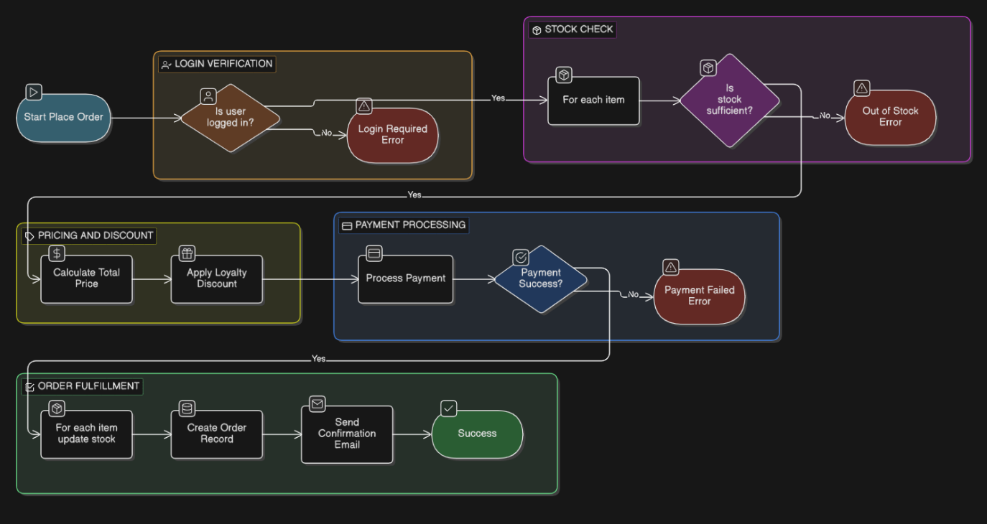

2. Stock Update Algorithm Description: Allows producers to change stock, checks authorisation, sends alerts.
PSEUDOCODE:
FUNCTION updateStock(producerID, productID, newStock):
IF producer not authorised for product:
RETURN error "Unauthorised"
Update database stock = newStock
IF newStock < 10: // Threshold
Send low stock email
RETURN success
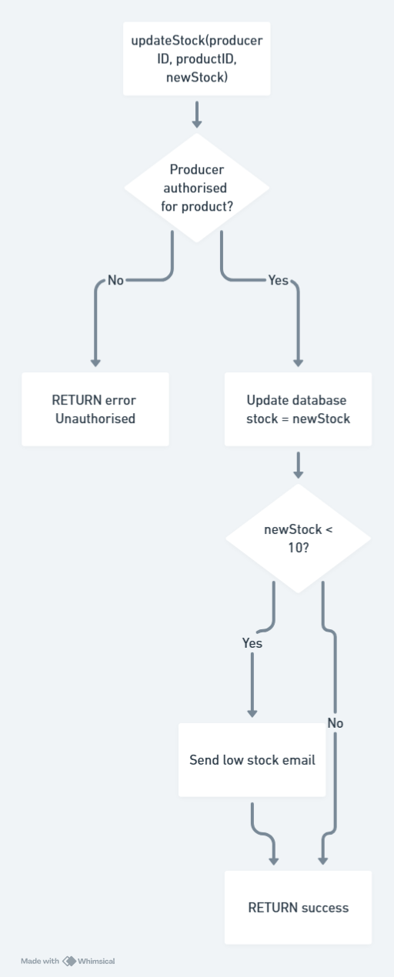

3. Loyalty Point Calculation Algorithm Description: Awards points based on order total, updates user record.
PSEUDOCODE:
FUNCTION calculatePoints(userID, orderTotal):
points = floor(orderTotal / 10) // 1 point per £10
Update user points = points + existing
IF points >= 50:
Send reward notification
RETURN points
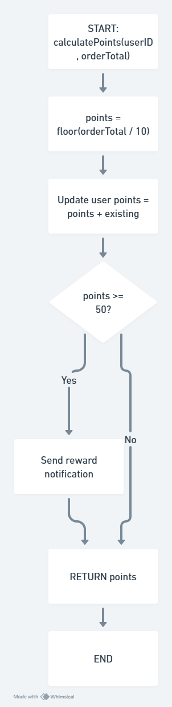

4. Search and Filter Algorithm Description: Queries database based on user input, applies filters.
PSEUDOCODE:
FUNCTION searchProducts(query, filters):
baseQuery = SELECT * FROM products WHERE name LIKE '%query%'
FOR each filter in filters:
IF filter.type == 'price':
ADD WHERE price BETWEEN min AND max
IF filter.type == 'producer':
ADD WHERE producerID = id
Execute query
ORDER BY price ASC
RETURN results
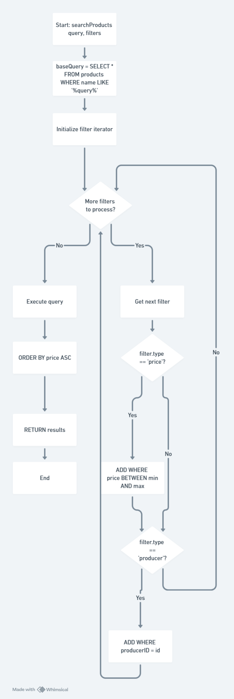

5. Order Tracking Algorithm Description: Retrieves status for a specific order, checks ownership.
PSEUDOCODE:
FUNCTION trackOrder(orderID, userID):
IF order not belongs to userID:
RETURN error "Not your order"
status = SELECT status FROM orders WHERE id = orderID
RETURN status
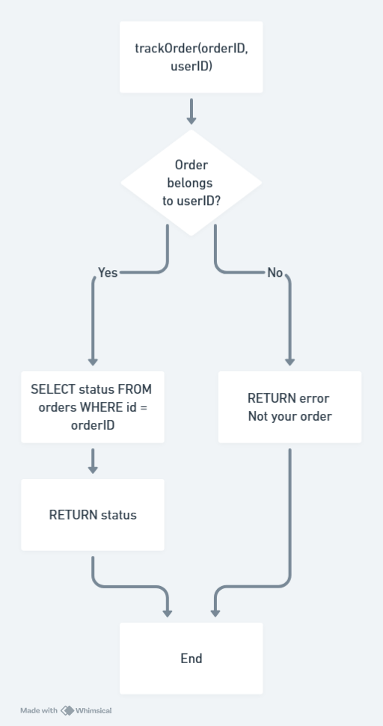
These algorithms solve key problems efficiently. They use simple logic for reliability.
Data Requirements
Entity Relationship Diagram (Text Representation)
- Users (userID PK) -- one-to-many -- Orders (orderID PK, userID FK)
- Users -- one-to-many -- Loyalty (loyaltyID PK, userID FK)
- Producers (producerID PK) -- one-to-many -- Products (productID PK, producerID FK)
- Products -- many-to-many -- Orders (through OrderItems: itemID PK, orderID FK, productID FK)
- Orders -- one-to-one -- Payments (paymentID PK, orderID FK)
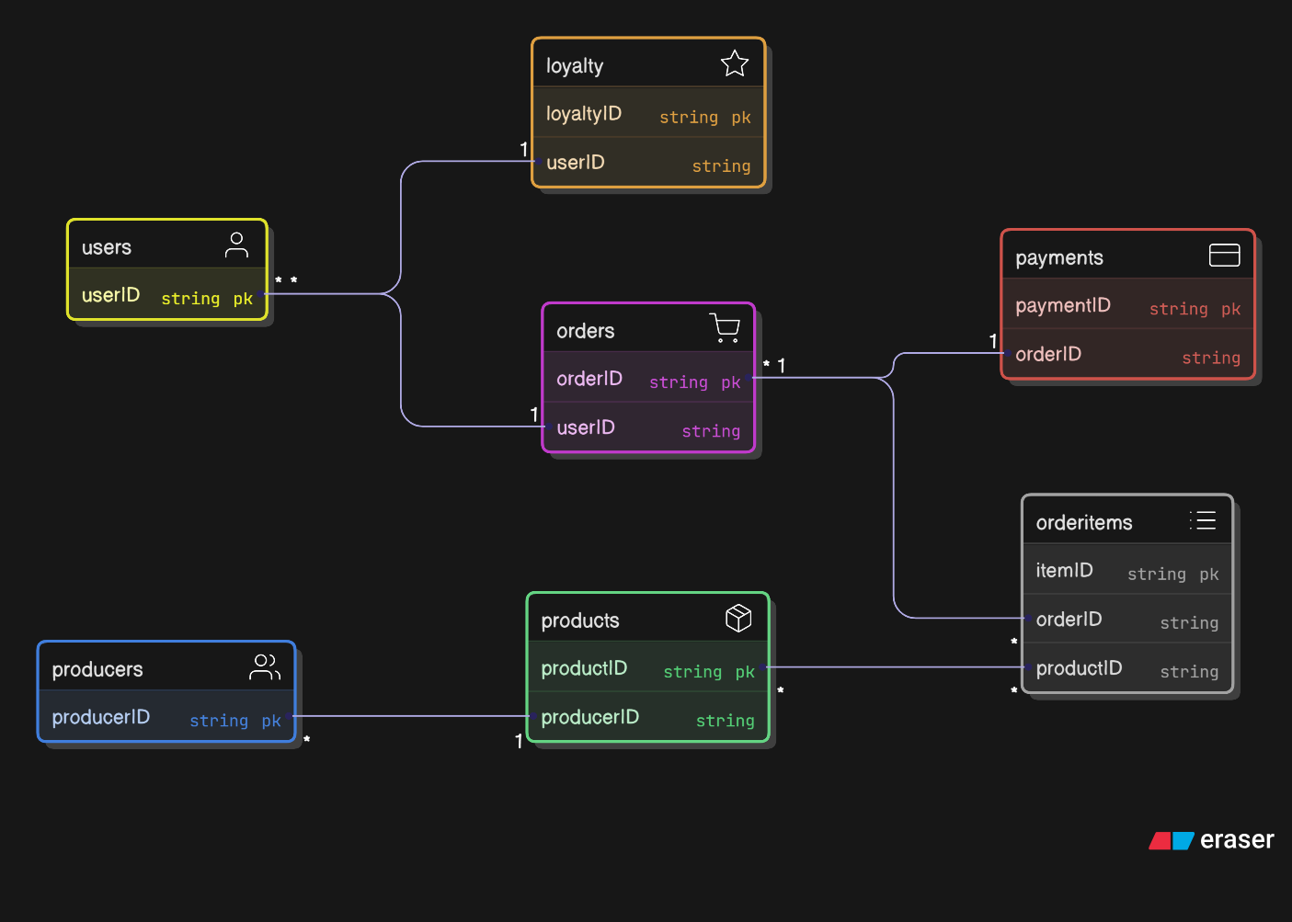
Data Dictionary The database is normalised to 3NF to avoid redundancy. Tables are listed below.
Table Name | Field Name | Data Type | Description | Constraints
Users | userID | INT | Unique user identifier | PK, Auto-increment
Users | name | VARCHAR(50) | User's full name | Not null
Users | email | VARCHAR(100) | User's email address | Unique, Not null
Users | password | VARCHAR(255) | Hashed password | Not null
Users | address | TEXT | Delivery address
Users | role | ENUM | 'customer', 'producer', 'admin' | Not null
Products | productID | INT | Unique product identifier | PK, Auto-increment
Products | name | VARCHAR(100) | Product name | Not null
Products | price | DECIMAL(10,2) | Product price | Not null
Products | stock | INT | Current stock level | Not null, >=0
Products | producerID | INT | Link to producer | FK
Products | description | TEXT | Product details
Products | image | VARCHAR(255) | URL to product image
Orders | orderID | INT | Unique order identifier | PK, Auto-increment
Orders | userID | INT | Link to customer | FK
Orders | date | DATE | Order date | Not null
Orders | type | ENUM | 'delivery', 'collection' | Not null
Orders | time | TIME | Scheduled time
Orders | status | VARCHAR(50) | 'Processing', 'Shipped', etc. | Not null
OrderItems | itemID | INT | Unique item identifier | PK, Auto-increment
OrderItems | orderID | INT | Link to order | FK
OrderItems | productID | INT | Link to product | FK
OrderItems | quantity | INT | Number of items | Not null, >0
Loyalty | loyaltyID | INT | Unique loyalty record | PK, Auto-increment
Loyalty | userID | INT | Link to user | FK
Loyalty | points | INT | Accumulated points | Not null, >=0

This structure ensures efficient data handling and scalability.
Test Strategy
Using the provided template, I have filled it with a planned test schedule. Tests are sorted by date, starting from unit to system tests.
Date of Test | Component to be Tested | Type of Test to be Carried Out | Prerequisites and Dependencies
01/04/2026 | User registration | Functional, unit test | Database set up, front-end form ready
02/04/2026 | Login system | Security, integration test | Registration tested, user data in DB
03/04/2026 | Product catalogue | Performance, usability test | Products loaded in DB
04/04/2026 | Order placement | End-to-end test | Cart and payment integration ready
05/04/2026 | Producer dashboard | Functional test | Producer role set, stock data
06/04/2026 | Loyalty scheme | Unit test | Order placement tested
07/04/2026 | Accessibility features | Accessibility test (WCAG) | All pages complete
08/04/2026 | Database integrity | Data test | All data flows set up
09/04/2026 | Error handling | Negative test | Various invalid inputs ready
10/04/2026 | Full system | System, load test | All components integrated
This strategy ensures progressive testing, building on prerequisites. Types include functional (does it work?), performance (is it fast?), etc. Dependencies prevent testing unready parts.

