# PROJECT SYNOPSIS

on

# "MICROSOFT EXCEL CLONE"

Submitted in Partial Fulfillment of the Requirements of

B.Tech. (VII Semester)

to

Faculty of Engineering and Technology, University of Lucknow Lucknow

Under the Guidance of

Er. Shruti Saxena Das

*(Assistant Professor)*

Submitted By

Saim Hur Hasan

*(180013135057)*

Rohit Kumar

*(180013135056)*

Department of Computer Science and Engineering March 2021

## TABLE OF CONTENT

1. Cover Page
2. Table of Content
3. Introduction
   1. Introduction to Project
   2. Objective
   3. Block Diagram
4. Methodology
5. Tools Stack
6. References

### INTRODUCTION OF THE PROJECT

#### Introduction

Microsoft Excel is a spreadsheet developed by Microsoft for Windows ,macOS, Android and iOS.

It features calculation, graphing tools, pivot tables and a macro programming language called Visual Basic for Application (VBA).

It has been a very widely applied spreadsheet for platform, especially since version 5 in 1993 and it has replaced Lotus 1-2-3 as the industry standard for spreadsheets. Excel forms part of the Microsoft Office suite of software.

#### History:

From its first version Excel supported end -user programming of macros (automation of repetitive tasks) and user-defined functions (extension of Excel’s built-in function library). In early versions of Excel , these programs were written in a macro language whose statements had formula syntax and resided in the cells of special -purpose macro sheets (stored with file extension .XLM in Windows). XLM was the default macro language for Excel through Excel 4.0…

Beginning with version 5.0 Excel recorded macros in VBA by default but with version 5.0 XLM recording was still allowed as an option. After version 5.0 that option was discontinued. All versions of Excel , including Excel 2010 are capable of running an XLM macro, though Microsoft discourages their use..

#### Scope of the Work:

#### Microsoft Excel has the basic features of all spreadsheets, using a grid of cells arranged in numbered rows

#### and letter-named columns to organize data manipulations like arithmetic operations . It has a battery of supplied functions to answer statistical ,engineering and financial needs. In addition, it can display data as line graphs , histograms and charts and with a very limited three-dimensional graphical display. It allows sectioning of data to view its dependencies on various factors for different perspectives (using pivot tables and the scenario manager).

#### MS-Excel also has a variety of interactive features allowing user interfaces that can completely hide the spreadsheet from the user ,so the spreadsheet presents itself as a so called Application or Decision Support system(DSS).

#### Excel application can automatically poll external databases and measuring instruments using an update schedule , analyze the results ,make a Word report or PowerPoint slide show and e-mail these presentations on a regular basis to a list of participants.

### OBJECTIVE

The main objective of the Project MS-Excel clone is to identify the different components of the Excel worksheet. Differentiate between an Excel workbook and worksheet. Use the Office Assistant. Open an existing workbook and create a new workbook. Enter text and formulas in to an Excel spreadsheet. Enhance alpha and numeric data in an Excel Worksheet. Move and Copy alpha and numeric data .The project enhance knowledge on how to construct formulas to manipulate numeric data in an Excel Worksheet, Create a spreadsheet to tabulate and record numeric values and change the appearance of an Excel spreadsheet. The project also helps in differentiate between formulas and functions in Excel, access and manipulate data using the database functions of Excel, create simple and complex macros in Excel….

Functionalities provided by venue Medical Store Management system are as follows:

* This project is about Medical store.
* In this Project we can add Medicine, Customer, Supplier Details.
* In this Project we can keep billing information.
* We can Modify and delete existing record.
* We can also search Medicine, Customer, Supplier details.
* Manage the information of payments.
* It is helpful for display stock of medicine.

## BLOCK DIAGRAM

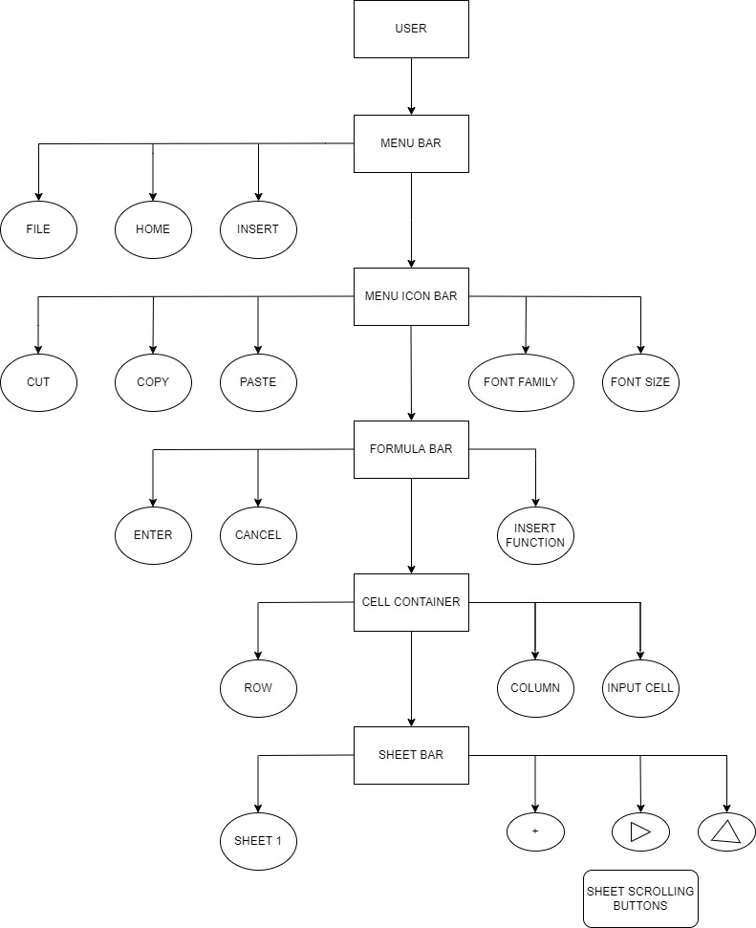

**METHODOLOGY**

#### Problem domain:

The Medical store consists of a number of customer details, Medicine details, supplier details, billing information. To save a detail of customer or supplier, the seller will need to record their data in a log book. This logistics requires a lot of manual work to maintain the records, which tends to be an error prone approach. Hence, some automated approach is preferred, and the medical store would like to have a app portal to improve the situation.

#### Scenarios:

Using the Medical Store Management system, supplier can first save the information about Medicines he/she have in stock, customer details, Supplier details, billing system. The supplier can check the medicine status, the availability. In addition, sellers can also view the supplier details where he can order stock of medicines that are going to end.

#### Functional requirements:

* Provide search facilities based on various factors. Such as Services, Payment bills, Suppliers.
* Medical Store Management System also manages the Customers details.
* Manage the information of Medicines in stock.
* Shows the information and description of Sellers and customers.
* To increase the efficiency of managing records .
* Manage the information of bill payments.
* Integration of all records of Medical Store.

#### Non-functional requirements:

* The user interface should be easy for users to operate without additional training
* The system response time should be fast (e.g. response within 5secs)
* The system should allow large number of concurrent accesses (e.g. 100 concurrent users)
* The system should provides high availability to users (e.g. <5%downtime)
* The system should be secure enough such that member’s personal data can be safely protected.

#### Target environment:

* User should be able to access to the portal via an IDE.
* The app will be running in Windows environment.

#### Deliverable and deadlines:

* The portal should be installed and online for testing at user site.
* System maintenance / instruction manual will be delivered at time.

## TOOLS USED

Microsoft Visual Basic is used as an IDE.

## REFERENCES

1. The C programming by Kemighan Brain W. and Ritchie Dennis M., Pearson Education .
2. Computer Basics and C Programming by V.Rajaraman, PHI Learning Pvt. Limited.
3. Programming in C by Kochan Stephen G. Pearson Education.
4. Computer Concepts and Programming in C by D.S. Yadav and Rajeev Khanna, New Age International Publication.