Silence or ignorance? Gender, “don’t know” responses and political awareness in Pakistan
Main-text tables and figures
Table 1. Sample characteristics by sex, WVS-7 Pakistan 2018
Variable | Men | Women
Age (mean, years) | 36.63 | 34.53
Education (mean, ISCED level 0–8) | 2.48 | 1.83
Literate (%) | 76.52 | 67.68
Income scale (mean, 1–10) | 4.59 | 4.21
Employed (%) | 89.41 | 11.00
Urban (%) | 34.38 | 32.66
Political attention index (mean of z-scores) | 0.09 | −0.11
Watches TV news at least weekly (%) | 74.00 | 70.82
Others could follow the interview (%) | 43.61 | 50.84
N | 954 | 891
Note: Complete-case sample used in the main models (N = 1,845).

Table 2. "Don't know" responses by item set and sex, WVS-7 Pakistan 2018
Item set | Items | Men (%) | Women (%) | Gap (pp) | Women ÷ men | Cohen's d | p
Domestic political | 59 | 3.29 | 7.87 | 4.57 | 2.39 | 0.48 | < .001
Non-political (placebo) | 62 | 0.74 | 0.79 | 0.05 | 1.07 | 0.03 | .537
International organisations | 8 | 21.42 | 35.06 | 13.64 | 1.64 | 0.38 | < .001
Factual knowledge | 3 | 49.86 | 64.41 | 14.55 | 1.29 | 0.35 | < .001
Within-person difference (domestic − placebo) | – | 2.55 | 7.07 | 4.52 | – | 0.51 | < .001
Note: Mean percentage of items answered "don't know" per respondent. N = 1,995 (1,037 men, 958 women). p from Welch t-tests on respondent-level counts, Holm-adjusted across the five comparisons. Within-person difference = each respondent's domestic share minus her or his non-political share.
Interpretation: Women answer "don't know" to 7.9% of domestic political questions, against 3.3% for men: 2.4 times as often. On non-political questions the two are virtually identical (0.79% vs 0.74%), which rules out general explanations such as literacy, difficulty with the questionnaire or a tendency to say "don't know" to everything. International and knowledge items produce high "don't know" rates for both sexes, where genuine unfamiliarity is plausible; they serve as a contrast. The within-person comparison gives the largest effect: the gap is specific to politics.

Table 3. Negative binomial models of "don't know" answers on 59 domestic political items
 | M0: Sex only | M1: + Resources | M2: + Awareness | M3: + Interview | M4: Town fixed effects
Woman | 2.42***  (1.85–3.17) | 1.76**  (1.25–2.48) | 1.77**  (1.25–2.49) | 1.69**  (1.21–2.35) | 2.41***  (1.81–3.22)
Age (z) |  | 1.06  (0.99–1.13) | 1.07  (1.00–1.15) | 1.07  (0.99–1.15) | Included
Education (z) |  | 0.78***  (0.69–0.90) | 0.85*  (0.75–0.97) | 0.86*  (0.75–0.98) | Included
Literate |  | 0.93  (0.73–1.18) | 0.99  (0.78–1.25) | 0.97  (0.77–1.22) | Included
Income (z) |  | 0.83***  (0.75–0.92) | 0.82***  (0.73–0.91) | 0.82***  (0.74–0.91) | Included
Employed |  | 0.84  (0.66–1.08) | 0.92  (0.72–1.18) | 0.91  (0.71–1.17) | Included
Urban |  | 1.31  (0.98–1.74) | 1.37*  (1.03–1.81) | 1.37*  (1.03–1.83) | Included
Sindh |  | 0.63*  (0.45–0.90) | 0.59**  (0.41–0.83) | 0.58**  (0.42–0.81)
Khyber Pakhtunkhwa |  | 1.31  (0.94–1.81) | 1.24  (0.90–1.70) | 1.23  (0.89–1.70)
Balochistan |  | 0.29*  (0.10–0.86) | 0.23**  (0.09–0.61) | 0.23**  (0.09–0.60)
Political attention (z) |  |  | 0.76***  (0.70–0.83) | 0.76***  (0.69–0.82)
Digital news use (z) |  |  | 0.98  (0.86–1.12) | 0.99  (0.86–1.12)
TV news use (z) |  |  | 0.81***  (0.74–0.89) | 0.82***  (0.74–0.89)
Others could follow interview |  |  |  | 1.06  (0.86–1.30)
Respondent not very interested in interview |  |  |  | 1.02  (0.84–1.24)
Interview duration (z) |  |  |  | 1.09  (0.96–1.23)
Town fixed effects | No | No | No | No | Yes
Dispersion (alpha) | 2.43 | 2.09 | 1.92 | 1.91
Log-likelihood | -3862.2 | -3781.7 | -3734.1 | -3731.2
Women − men, predicted "don't know" answers | 2.58  (1.75–3.53) | 1.63  (0.67–2.77) | 1.64  (0.67–2.70) | 1.52  (0.57–2.56)
Respondents | 1,845 | 1,845 | 1,845 | 1,845 | 1,163
Note: Incidence rate ratios with 95% confidence intervals from standard errors clustered by sampling unit (197 units). Reference province: Punjab. Empty cells indicate that a variable is not included in that model. M0–M3 use the same complete-case sample. Predicted difference = average marginal effect of being a woman on the number of "don't know" answers (out of 59), with 95% simulation interval. M4 includes the resource controls of M1 (coefficients not shown) and replaces province with fixed effects for the 24 towns in which both women and men were interviewed; its sample is all complete cases on these variables in those towns. * p < .05, ** p < .01, *** p < .001.
Interpretation: Without controls, women give 2.42 times as many "don't know" answers as men (M0). Controlling for education, income and other resources reduces this to 1.76 (M1): part of the gap reflects women's lower schooling and income. Adding political awareness (M2) leaves the gap essentially unchanged (1.77), even though attention (IRR 0.76) and TV news (IRR 0.81) strongly reduce "don't know" answers for everyone. Awareness lowers "don't know" answers, but it does not explain why women give more of them. Interview conditions (M3) change little (1.69). In practical terms, women give about 1.5 more "don't know" answers out of 59 than comparable men. This supports H1 and H3.

Table 4. Multilevel placebo models: "don't know" on political versus non-political items
 | Model 1 | Model 2: + awareness and education × item type
Woman | 0.67*  (0.49–0.93) | 0.68*  (0.48–0.96)
Political item | 4.75***  (4.21–5.36) | 4.29***  (3.42–5.38)
Woman × political item | 2.73***  (2.32–3.22) | 2.51***  (2.06–3.05)
Education (z) | 0.77***  (0.71–0.84) | 0.98  (0.85–1.13)
Literate | 0.94  (0.80–1.11) | 0.91  (0.69–1.20)
Income (z) | 0.85***  (0.80–0.92) | 0.87***  (0.81–0.93)
Age (z) | 1.06*  (1.00–1.13) | 1.05  (0.99–1.12)
Employed | 0.89  (0.74–1.07) | 0.95  (0.78–1.16)
Urban | 1.25  (0.94–1.65) | 1.35*  (1.02–1.80)
Sindh | 0.68*  (0.49–0.94) | 0.61**  (0.44–0.85)
Khyber Pakhtunkhwa | 1.71**  (1.16–2.50) | 1.63*  (1.10–2.42)
Balochistan | 0.21***  (0.11–0.42) | 0.17***  (0.08–0.36)
Political attention (z) |  | 0.86**  (0.77–0.96)
Digital news use (z) |  | 0.87*  (0.77–0.98)
TV news use (z) |  | 0.83***  (0.75–0.92)
Political item × education |  | 0.81**  (0.71–0.93)
Political item × literate |  | 1.15  (0.89–1.49)
Political item × attention |  | 0.92  (0.83–1.01)
Political item × digital news |  | 0.98  (0.88–1.09)
Political item × TV news |  | 1.05  (0.96–1.15)
Respondents / rows / sampling units | 1,845 / 3,690 / 197 | 1,845 / 3,690 / 197
Note: Odds ratios with 95% confidence intervals. Empty cells indicate that a variable is not included in that model. Each respondent contributes two observations: the share of "don't know" answers on 59 domestic political items and on 62 non-political items (weighted by number of items). Multilevel logistic models (penalised quasi-likelihood, R MASS::glmmPQL) with random intercepts for sampling unit and respondent. The key term is Woman × political item. * p < .05, ** p < .01, *** p < .001.
Interpretation: The key term, woman × political item, has an odds ratio of 2.73: compared with their own answers on non-political questions, women's odds of saying "don't know" rise about 2.7 times more than men's on political questions. The main effect for women (OR 0.67) shows that on non-political questions women are, if anything, slightly less likely than men to say "don't know". Because each respondent is compared with herself, stable personal traits such as literacy or response style cancel out. In Model 2, letting education, literacy and awareness affect political items differently barely changes the key term (OR 2.51). Education does reduce political "don't know" answers (OR 0.81), but it does not explain the gender gap. This supports H2.
Figure 1.
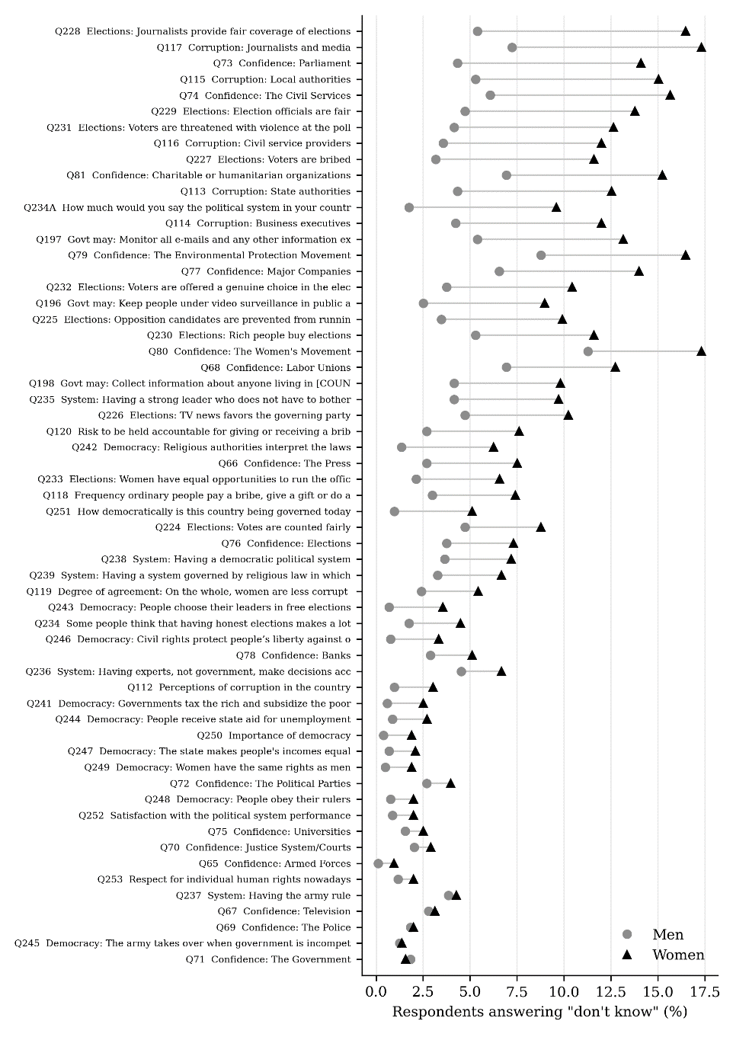

Figure 2. Predicted “don’t know” answers by political attention and sex
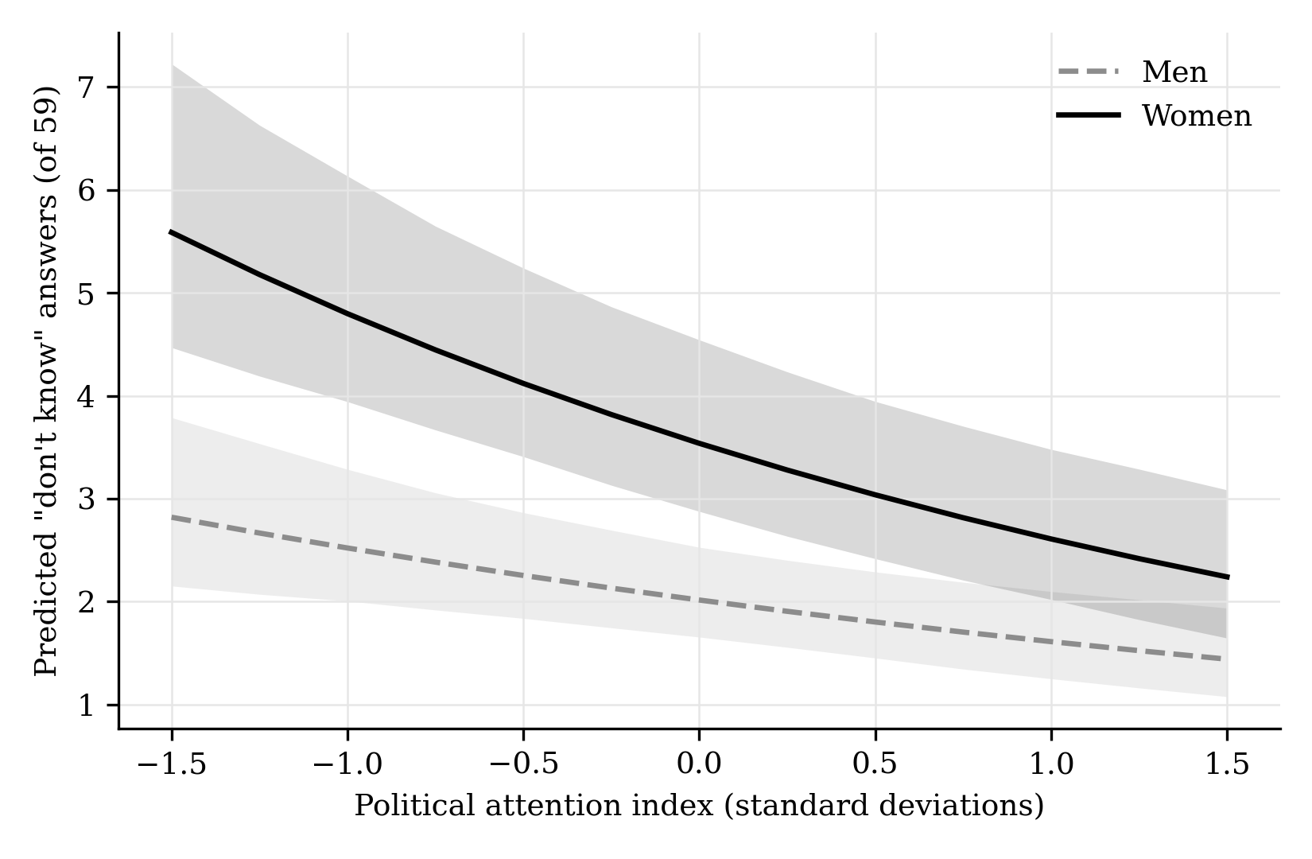
Note: Predictions from a negative binomial model with resource, awareness and province controls, in which the effect of political attention may differ for women and men (IRR for this difference 0.92; 95% CI 0.78–1.09; p = .344). Other variables are held at their observed values. Shaded areas show 95% simulation intervals from cluster-robust covariance. N = 1,845.

Figure 3. Gender gap in “don’t know” by political topic
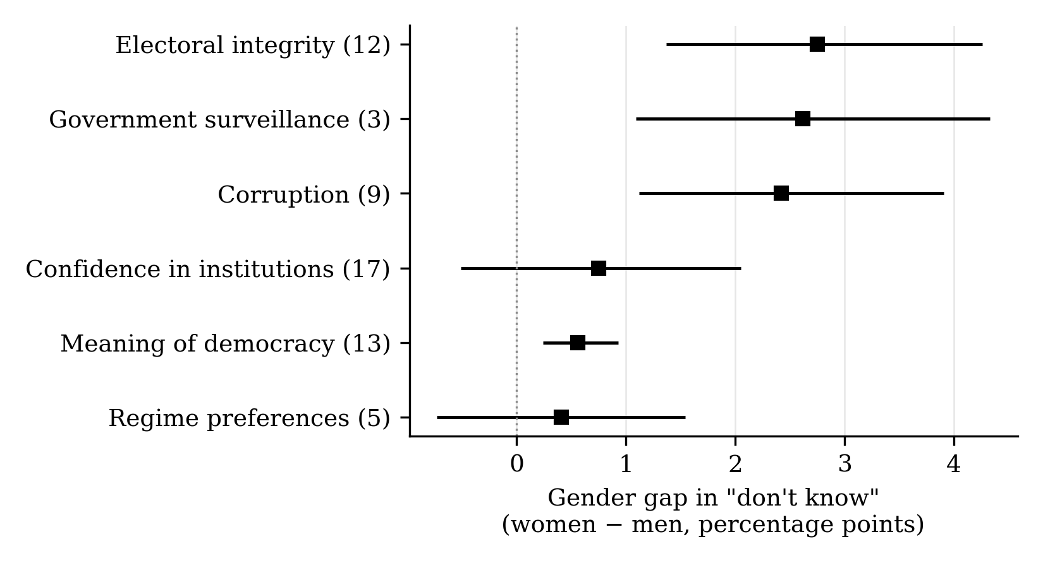
Note: Model-based gap (women − men) in the probability of a “don’t know” answer for a typical respondent, with 95% intervals; number of items in parentheses. Multilevel logistic model (R MASS::glmmPQL) with all controls, including awareness. Joint Wald test that the gap is equal across topics: χ² = 51.8, df = 5, p < .001.

Figure 4. Predicted “don’t know” answers by interview privacy and sex
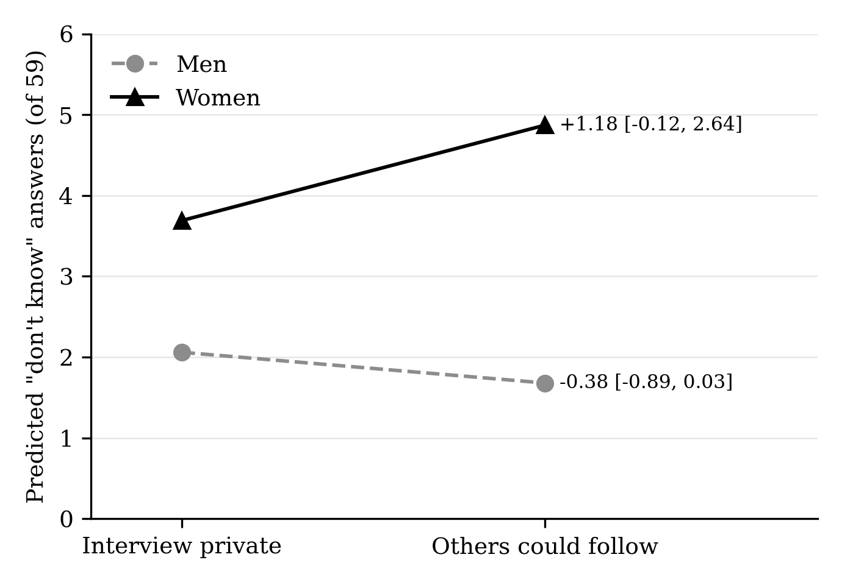
Note: Predictions from a negative binomial model with all controls, in which the effect of others being present may differ for women and men (IRR for this difference 1.62; 95% CI 1.12–2.34; p = .010). Labels show the change when others could follow the interview, with 95% intervals. N = 1,845.

