
Excel Spreadsheet Project

Syeda Saima Nasreen
01-Feb-2026
OBJECTIVE QUESTIONS

Question 1
What is the total no. of tables present in the data?

Solution:

- There is only a single table in the give data set. (AstroSage Analysis).
- Checked if there are any hidden columns or worksheet. (Not found)

Question 2
What is the total no. What is the total no. of attributes present in the data?

Solution:

- There were initially 35 columns, later while doing the analysis a few more derived columns were created. So total of 42 columns are present now.

Question 3
The data consists of some inconsistent and missing values so ensure that the data used for further analysis is cleaned?

Solution:

- Before proceeding with the analysis, went through the data knowing what each column consists of.
- Created a DATA dictionary with the column names and the type of data being stored in that. Please refer the link
- Checked for duplicated. Found None

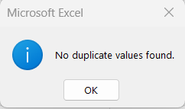

- Below is the list of new or standardized columns created

Creating new columns and standardizing help in better analysis of data
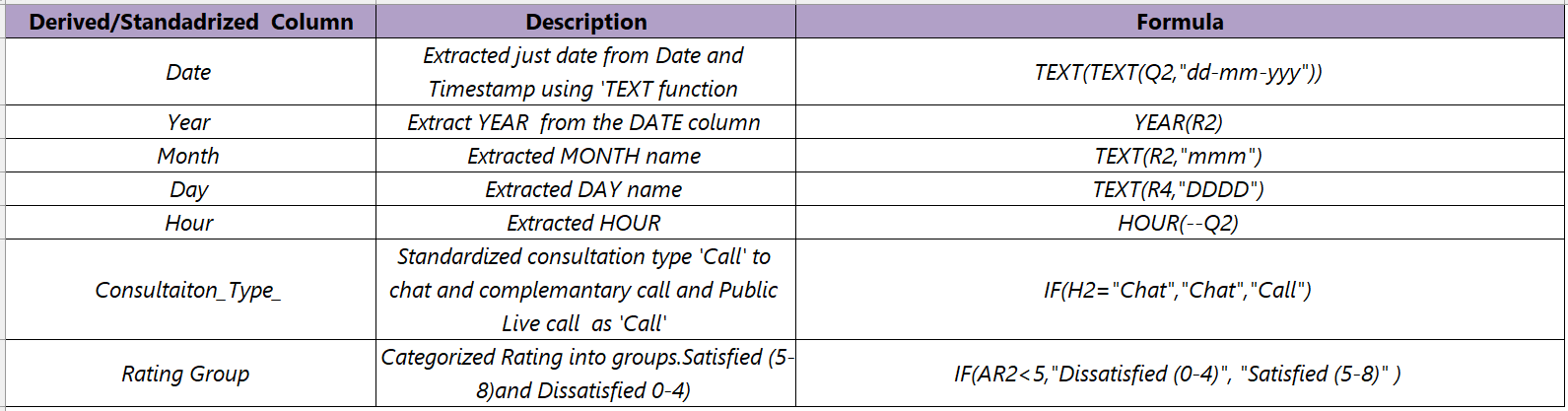

Question 4
What is the change in daily call volume day by day and also find the average daily call volume?

Approach
Created a Pivot Table to calculate Daily Call Volume
- Rows: Date
- Values: COUNT of Callsid (Call_session_id).
- Filters: Used Consultation_type_ to filter out only calls
Calculated ‘Day by Day Change’ in the daily call volume
- Manually calculated the column by subtracting the current day call volume with the previous one
Formula used to calculate the day-by-day change (simple subtraction).
- (G9-G8)
- This helped in understanding what daily change looked like
Visualisation for Daily Call Volume and Day by Change together
- Used a Line Chart to display the trend Call volume
- This shows us the change in daily volume and Day by Change

- Pivot Table
Consultation_type_ | Call
Date | Daily Call Volume | Day by Day Change
01-12-2023 | 228
02-12-2023 | 332 | 104
03-12-2023 | 383 | 51
04-12-2023 | 364 | -19
05-12-2023 | 253 | -111
06-12-2023 | 254 | 1
07-12-2023 | 254 | 0
08-12-2023 | 138 | -116
09-12-2023 | 288 | 150
10-12-2023 | 430 | 142
11-12-2023 | 424 | -6
12-12-2023 | 358 | -66
13-12-2023 | 348 | -10
14-12-2023 | 226 | -122
15-12-2023 | 276 | 50
16-12-2023 | 258 | -18
17-12-2023 | 185 | -73
18-12-2023 | 233 | 48
19-12-2023 | 209 | -24
20-12-2023 | 178 | -31
21-12-2023 | 159 | -19
22-12-2023 | 163 | 4
23-12-2023 | 241
24-12-2023 | 232 | -9
25-12-2023 | 258 | 26
26-12-2023 | 255 | -3
27-12-2023 | 242 | -13
28-12-2023 | 181 | -61
29-12-2023 | 260 | 79
30-12-2023 | 179 | -81
31-12-2023 | 158 | -21
01-01-2024 | 115 | -43
02-01-2024 | 196 | 81
03-01-2024 | 107 | -89
Grand Total | 8365 | 8258

- Visualization using Line Chart

Calculation of Average Daily Call Volume
- Used the Count of Callsid columm from the Pivot table to calculate the average call inflow per day
Formula used to calculate AVERAGE () Daily Call Volume
- =ROUND (AVERAGE (G8:G41),3)

Average Daily Call Volume | 246.029

Insights
- 10 December 2023 recorded highest calls with (430 Calls)
- 3 January 2024 recorded low calls with 107 calls may be slowdown to post holiday period.
- 8 Dec 2023 recorded what we can call second lowest no of calls
- Day by Change had negative values and major jump in calls during Dec 8-9 and drop on Dec 13-14 with -122 calls.
- Total calls are 8365 for 34 days
- AVERAGE Daily Call Volume shows 246 Calls
- These factors show and unpredictable peaks and drops in call volume. Early December show strong high volume wherein late December to early shows weakest call activity.

Question 5
Which months experienced the highest and lowest call volumes?
Approach
Created a Pivot Table to calculate Month wise Call Volume
- Rows: Months
- Value: COUNT of Callsid (Callsessionid).
- Filter: Consultation type
- Sorted the table by descending order to show highest and lowest call volume

Consultation_type_ | Call
MONTH | Count of CallSid
Dec | 7947
Jan | 418
Grand Total | 8365

Visualization
- Used a bar chart for displaying the highest and lowest call volume

Insights
- December 2023 had 7947 calls which makes up to 95% of the total calls making it the month with highest calls
- January 2024 (Jan 1-3) recorded only 418 calls making it only 5% of the total calls
- Call volume dropped from a massive 95% to 5% from December to January making it a significantly decline
- These factors show December is a peak demand period it can be due the last month of the year.
- And the reason for first 3 days of January showing low call volume can be due to the start of the year.

Question 6
What is the total operational cost for that month?
Approach
Created a Pivot Table to calculate Month Wise Operational Cost
- Rows: Consultation type (as we want both chat and call)
- Columns: Month(s)
- Values: SUM of Astrologers Earnings
Sum of astrologersEarnings | Column Labels
Consultation Type | Dec | Jan | Grand Total
Call | 73934.33278 | 3873.596667 | 77807.92945
Chat | 19851.83017 | 1486.811333 | 21338.6415
Grand Total | 93786.16295 | 5360.408 | 99146.57095

Visualization
- Used a pie chart to show the monthly operational cost

Insights
- ₹ 93786/- is the total cost for both Call and Chat in the month of December 2023 which 79% of the total cost
- Whereas, January 2023 had ₹5360/- which makes it to 21% of the entire cost. But we need to also keep in mind that we only have data for 3 days in the month of Jan
Call vs. Chat Cost Breakdown
- Coming to Call vs Chat cost breakdown, if you see the numbers, calls dominate costs
- December: Calls: ₹73,934 vs. Chats: ₹19,851
- January: Calls: ₹3,873 vs. Chats: ₹1,486
- Calls make up ~79% of astrologer earnings in Dec and ~72% in Jan. This clearly makes calls the revenue driver

Question 7
What is the average number of calls handled per agent per day?
Approach
Created a Pivot table for finding our average calls per day/per agent
- Rows: Guru Name
- Values: Count of Callsid
- Used COUNT to calculate the total number of calls handled by each agent/day.
- Pivot Table (For full Pivot please refer Objective 7& 8 Sheet in Excel)
- Top 10 agents and their calls per day
Guru Names | Count of CallSid
Astro Shalini | 1060
Tarot Gauri | 497
Astro Brejesh | 334
Dr Balkrisna | 309
Tarot Gurpreet | 300
Astro Divya | 271
Tarot Bee Riya | 262
Astro Ruchi | 238
Tarot Seema | 233
Astro Shweta | 226

Created a separate table to calculate the below:
Total Calls | 8365
No of Gurus handling Calls | 129
Total No of Days | 34
Average no of Calls | 1.907
Average Calls/Day/Agent
No of Calls made/ (Total Gurus * No of Days)
Average no of Calls | 1.907
Formulas used for the above calculation
- Total Calls: =SUM(C12:C160)
- No of Gurus handling calls: =COUNTA(B12:B140)
- Total No of Days in the data set:=COUNTA(UNIQUE(Cleaned_Data!R2:R28028))
- Average no of calls: =ROUND(F9/(F10*F11),3)
Insights
- Average is 1.97 Calls per day/agent, which is extreme low utilization
- With this we can understand that the problem is either inefficient call distribution .
- If we take ‘Astro Shalini’ is handling 1,060 calls → ~31 calls/day.
- Whereas other agents have <=1 call a day (e.g., Astro Ashok: 1 call total in 34 days).
- We have around 21 agents who haven’t taken any calls in the entire 34 days
- We have total of 129 agents and 34 days but when we see each agents handled 1.9 calls on average leaves us with idle capacity

Question 8
How many repeat callers are there, and what percentage of total calls do they represent?
Approach
Created a Pivot Table to find the repeat calls and to know their contribution to % of the total calls
- Rows: User id (User id for each caller)
- Values :Count of Callsid
- Used Count to get the count of all callsid per user
consultationType | (Multiple Items)
User_id | Count of CallSid
1
437 | 9
507 | 1
511 | 2
543 | 6
787 | 20
1103 | 4
1105 | 6
1233 | 1
1520 | 5
1555 | 2
1935 | 6
2044 | 15
2228 | 4
2329 | 10
2347 | 4
2394 | 10
2429 | 6
2727 | 2

Repeat Callers
- Callers with > 1 call counted in as repeat callers
Totals and Formulas used to calculate them
- Total Calls made = 8365
=SUM (M11:M3641)

- Total No of Callers =3631
=COUNT (UNIQUE (L11:L3641))

- Repeated Callers =1275
=COUNTIF (M11:M3641,">1")
- One-time Callers =2356
Total number of callers- Repeated Callers

- Repeated Calls =6009
Total no of calls made – One time callers
- % Repeated Callers =35
(Calls by repeat callers) ÷ (Total calls) × 100

Please refer the below table:
Calls and Callers
Total Calls made | 8365
Total no of callers | 3631
Repeated Callers | 1275
One time Callers | 2356
Repeated Calls | 6009
% of Repeated Callers | 71.835

- Visualisation: Created a Horizontal for better representation

Insights
- Repeat callers accounted for 71.8% of all calls.
- This implies that the bulk of business volume is driven by devoted customers.
- Repeat callers: 1,275 users made 6,009 calls on average (~4.7 calls per user).
- 2,356 users made 2,356 calls (average of one call) as one-time callers.
- More than three times as many calls are made per person by a small group of devoted users.
- Seventy-two percent of the 3,631 unique callers are repeat callers, making up the top 35%.
- This suggests a strong reliance on a core user base, which carries a significant risk of attrition.
- Although they make up the bulk of users (2,356 vs. 1,275), one-time callers do not generate volume.
- Possibility: Turn one-time calls into repeat ones. Even modest conversion increases will greatly increase calls.
- Issue can also be that their issue wasn’t resolved the first time ,hence a call back was made
- Improve on First call resolution
- A follow up from company’s end would also make a difference

Question 9
What are the total sales generated by the call centre for each product category?
Approach:
Created Pivot table to calculate Total sales
- Rows: Consultation Type
- Values: SUM of Net Amount
- Used SUM to get total sales through net amount

- Pivot Table
Consultation Type | Sum of net Amount
Call | ₹ 1,68,492.63
Chat | ₹ 45,494.68
Grand Total | 213987.3153

- Visualization: Used a bar chart to help it display for better understanding

Insights
- Calls accounted for ₹1,68,493 (79% of total revenue), indicating that voice consultations are the call center's main source of income.
- Based on previous data, the average revenue per call was approximately ₹20.14 with 8,365 calls.
- Without chat traffic, it is impossible to determine the average revenue per session, although given the large revenue differential, it is probably lower.
- 80% of revenue is directly impacted by any decline in call volume, thus concentrate retention on call operations.
- Examine whether cheaper price, shorter sessions, fewer users, or less features are the reasons behind chat's decreased monetization.
- Using chat as a starting point and upselling to calls, particularly for complicated questions, is one possible integration technique.
Question 10
How many calls were made for each user ID and guru ID?
Approach:
Created a Pivot Table for user and guru ID each to find out the calls they made
- Rows: id (userid) and Gid (Guruid)
- Values: COUNT of callsid
- Filters: Added a value filter on the userid and guru id column to get ‘Top 10’ for better understanding
- Used count to get total call made by each customer and guru

- Pivot table
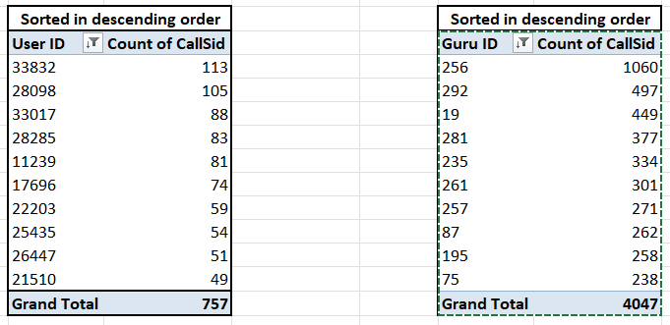
- Visualization: Created bar charts for both

Insights
- In approximately 34 days, user 33832 made 113 calls, or 3.3 calls every day.
- This is systematic everyday dependency, not only involvement. Just this user makes up about 1.3% of all calls.
- In about 34 days, Guru 256 answered 1,060 calls, or about 31 calls every day.
- This suggests a high danger of burnout, inadequate load balance, and an excessive dependence on one guru.
- 757 calls were made by the top 10 users (out of 3,631), which is highly lopsided.
- The top 10 gurus (out of 129) received 4,047 calls, which is almost half of the 8,365 calls made in December.
- Consider specifically distinguishing major accounts or offering planned slots to high-frequency customers who likely frequently call the same top experts in order to increase retention and satisfaction.

Question 11
What is the correlation between call duration and customer satisfaction?
Approach:
Created a Pivot Table first for better understanding using call duration and rating per call made
- Rows: On Call Duration
- Values: AVERAGE of Rating
- Used AVERAGE because, it indicates whether users are more or less satisfied.
- Pivot Table
On Call Duration | Average of Rating
1 | 3.166666667
2 | 3.583333333
3 | 3.214285714
4 | 3.5
5 | 3.307692308
6 | 3.576923077
7 | 3.666666667
8 | 3.444444444
9 | 3.071428571
10 | 3.424242424
11 | 3.428571429
12 | 3.7
13 | 3.3
14 | 3.5
15 | 3.945945946
16 | 3.960784314
17 | 3.56097561
18 | 3.555555556
19 | 3.64
20 | 3.142857143
21 | 3.642857143
22 | 3.34375
23 | 3.580645161

- Visualization: Created a Scatter plot as this helps with comparing the relation between two columns

Correlation between Call duration and Customer Satisfaction
-0.041279612

Insights
- Correlation coefficient: -0.041 => No meaningful linear association between call length and rating.
- Higher ratings are not a guarantee of longer calls.
- Calls that are shorter aren't automatically ranked lower.
- Factors other than duration (guru skill, query response, user expectation) are what drive satisfaction.
- Same duration, vastly different ratings: For example, a rating of 2.67 for 60 minutes and 4.67 for 64 minutes
- There are outliers: calls lasting one to more than 150 minutes get five-star ratings.
- High ratings seem to be dispersed.
Question 12
Which guru has the highest and lowest customer satisfaction scores?
Approach:
- Rows: Guru Names
- Values: AVERAGE OF ratingChats produced ₹45,495, or 21% of the total, suggesting a noteworthy but secondary source of income.

- Sorted rating by ascending and descending order to find highest and lowest satisfaction scores

Pivot Table
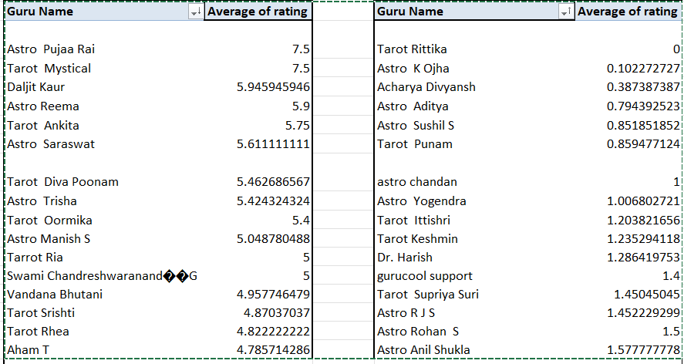
Highest Customer Satisfaction
- Astro Puja Rai
- Tarot Mystical

Lowest Customer Satisfaction
- Astro Chandan

Insights:
- It looks like the maximum rating is 7.5 rather than 5, which suggests a unique or non-standard grading system.
- This modifies the interpretation: 7.5, not 5, is a perfect score.
- Both Tarot Mystical and Astro Pujaa Rai received 7.5 (perfect) points.
- Astro Reema (5.9) and Daljit Kaur (5.95) constantly exhibit high levels of pleasure with probably higher volume.
Observation: There may be a trade-off between volume and satisfaction because highly regarded gurus are not the busiest.
- Astro K Ojha (0.10) and Tarot Rittika (0) received scores close to zero, indicating blatant service failures.
- Serious quality or expectation discrepancies are indicated by Astro Chandan (1.0) and several others below 2.0.
Observation: A large number of regularly low-rated gurus create a basis that dilutes quality, indicating that performance is systematic rather than individual.
Question 13
What is the average customer satisfaction score by month?
Approach:
- Rows: Month
- Values: AVERAGE () of rating

MONTH | Average of rating
Dec | 2.950
Jan | 2.676
Grand Total | 2.93463446

- Visualization: Used a bar chart for display

Insights
- December: 2.95; January: 2.67 (on a scale of 7.5).
- This is a monthly drop in satisfaction of 9.3%.
- Volume affects satisfaction; more volume in December was associated with marginally higher scores, defying the notion that busy times degrade quality..
Question 14
How many categorical columns are there in the data?
- Categorical Columns: Categorical columns represent qualitative data with unique groups or labels
- Continuous Columns: Measurable numerical quantities are represented by continuous columns.
Column Name | Classification
Chat_Status | Categorical
ConsultationType | Categorical
Website | Categorical
RefundStatus | Categorical
IsWhiteListUser | Categorical
Queue | Categorical
FreeCall | Categorical
FreeChat | Categorical
CallChannel | Categorical
CallIVRType | Categorical
CallStatus | Categorical
Astrologer_CallStatus | Categorical
Region | Categorical
User_Call_Status | Categorical
GuruName | Categorical
_ID | Categorical
User | Categorical
Guru | Categorical
GID | Categorical
UID | Categorical
CreatedAt | Categorical
UpdatedAt | Categorical
__V | Categorical
StatementEntryID | Categorical
ChatStartTime | Categorical
ChatEndTime | Categorical
TimeDuration | Categorical
CallSID | Categorical
Chat_Seconds | Continuous
Amount | Continuous
Astrologer_On_CallDuration | Continuous
Astrologers_Earnings | Continuous
NetAmount | Continuous
User_On_CallDuration | Continuous
Rating | Continuous

SUBJECTIVE QUESTIONS
Question 1
Should the investment be used to hire more agents, improve training programs, or upgrade call center technology?

Approach:

Observations:
- Just 27% (7,704 sessions) of all sessions had a satisfactory rating of 5 or higher, compared to 73% (20,323 out of 28,027) that received a rating of 4 or lower. This indicates that almost seven out of ten consultations result in the user being unhappy.

- Total Gurus: 129
- Average Rating: 2.93/8 (≈ 3.66/5 scale)
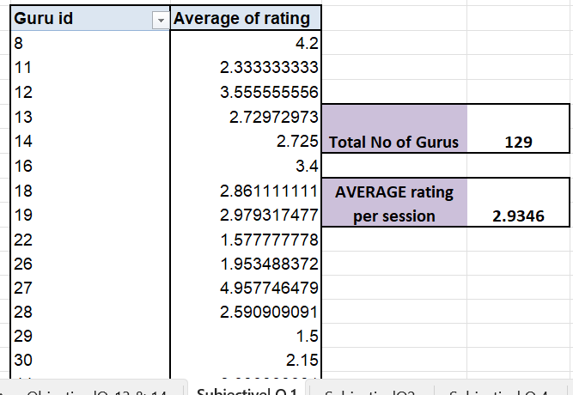
Chat Status Distribution
- Failed: 7,256
- Incomplete: 6,641
- Completed: 5,535
- Failed + Incomplete = 13,897 (71% of chats)
- Completed = 28% of chats

Call Status Distrbution
- Completed: 41%
- No-answer: 20%
- Busy: 15%
- Failed: 14%
- Incomplete: 10%

Insights:
- A 73% dissatisfaction percentage indicates that almost three out of every four clients are not satisfied. This is not a small problem.
- The average level of satisfaction is mediocre. With 129 gurus now, ratings won't rise if more are added without addressing core quality problems.
- Update on the tech chat platform is required before we think about training and hiring
- The high combined no-answer/busy (35%) and mid-call drop (24%) rates, along with the 41% completion rate, indicate a serious platform problem.

Recommendation:
- Analyze unsatisfactory ratings at the session level to find trends (by guru, consultation type, duration, tech concerns).
- Prior to making any hiring or training decisions, identify the main reason for each of the 20,323 low-rated sessions:
Guru's talent gap, Technical issue that occurred during the session ,Too short or too lengthy of a session
- Improve call routing system to reduce no-answer/busy rates. Ensure call stability to reduce in between call failures.

Question 2
What are the potential risks of each investment option (hiring, training, technology upgrades), and how can they be mitigated? Name the chart/spreadsheet function you will use for solving the problem.

Observation:
- There is a significant disparity in service quality, with ratings ranging from 0 (Tarot Rittika) to 7.5 (Tarot Mystical/Astro Pujaa Rai).
- Giving resources at all gurus equally will not be of any use y; low performers may not improve with generic training.

Mitigation:

- Based on ratings, divide agents into sections of how they have been performing (Top / Middle / Low)
- Only middle-tier gurus (ratings 2.5–4.0) should receive specific training because they have the greatest room for growth.
- Divert the low performers to different works (rating <2.0).

Observation:

- Just 41% of calls are successfully completed; 15% are busy and 20% result in no answer.
- Risk : If technology is upgraded but there aren't enough experts to take up calls, busy/no-answer failures will still occur.

Mitigation:
- Examine peak hour guru availability vs call volume prior to a tech upgrade. To distribute the load equally
- Llimited hiring during peak hours combined with a technology improvement.

Observation:
- Compared to the call failure rate (59%), the chat failure rate (72%) is
significantly greater.
- Risk: A problem in conversation platform cannot be fixed by enhancing guru
abilities.

Mitigation:
- We need to train agents to attend chats specifically and then look into the platform that we are using and try to improve there

Question 3
How does AstroSage's call center performance compare to AstroGuru's average call volume, customer satisfaction, and agent performance? Will you use any aggregation function or a visualization here to solve the problem?

Solution: Astrosage’s Data is the only source of information we have with which this whole analysis is being done. A direct comparion due to lack of data available is not possible.

Question 4
How can the call center improve its handling of peak call periods to ensure high customer satisfaction? Mention the functionality you will use for giving the suggestions, will it be any aggregated function or a visualization?

Insights:
- Between 8 AM and 7 PM (hours 4–19), call volume rises. 8–11 AM (6,724 calls) and 12–3 PM (6,585 calls) had the largest volume. After 7 PM, the volume drastically decreases.
- Most users call during morning and afternoon hours. The maximum staff must be diverted at these times.

Recommendations:

- Divert a greater number of gurus during 8 AM–7 PM shifts.
- Use automated replies during off-peak hours (after 8 PM) to make best use of resources

Insights:
- Longer calls in the evening do not mean happier customers/better ratings — in fact, satisfaction drops during those periods.
Recommendations:
- Review quality during evening shift, longer calls can conclude unresolved issues
- Training is needed for gurus to efficiently solve problems to shorten call duration without affecting rating/satisfaction.

Insights:

- Late hours (4–7 PM: 87% unsatisfied) and late morning (8–11 AM: 69% dissatisfied, 31% satisfied) have the lowest and highest levels of satisfaction, respectively. Despite longer call durations , early morning (4–7 AM) has higher satisfaction (70% unsatisfied).
- Depending on the time of day, user's state of mind, guru burnout, or service quality may vary. In terms of satisfaction, evening shifts perform poorly.

Recommendations:
- Reward and keep top-performing morning shift experts by finding out what they do well.
- Provide supervisor assistance, shorten shifts, or update PM staff training.
- Longer calls but happy users indicate that premium services could be offered during this time.

Question 5
Based on historical data, what strategic initiatives should be prioritized to improve efficiency and customer satisfaction?
Problems that are should be addresses as a priority
- 71% chat failure rate → platform unstable
- Quality crisis: 73% of users are not satisfied
- Evening shift satisfaction falls to 13% due to training gaps and guru fatigue.
- Low call completion (41%) causes problems
Technology Upgrade required
- Fix the reliability of the chat platform
- Reduce busy/no-answer rates by improving call routing
- This fix is needed first, as 71% of chats have failed, training and hiring can be done later.
Website optimization:
- Compare the average rating between the website and the app. If one is significantly lower, prioritize fixing its user experience
- Analyze where low ratings (1-3) cluster — if they are more frequent on the website, target website-specific pain points like speed, navigation, or mobile responsiveness.

Consultation type and their ratings:
Chat Analysis:
Chat ratings show extreme polarization — completed chats achieve an excellent 7.01 rating, while failed chats score 0.00 and incomplete chats average only 2.01. This wide variance pulls the overall chat average down to 2.69, masking the fact that chat has the highest satisfaction potential when sessions are successfully completed.

Call Analysis:
Call ratings are remarkably consistent across all statuses, ranging narrowly between 3.44–3.56. Unlike chats, calls never deliver exceptional satisfaction (max 3.56) but also never result in complete dissatisfaction (min 3.44), making them a reliable but mediocre channel.

Key Discrepancy:
The same guru can perform very differently across consultation types — for example, Tarot Oormika scores 7.33 on chats but only 4.00 on calls, a 3.33 point gap. This indicates that performance is medium-dependent and gurus should be assigned to channels where they excel.

Strategic Implication:
Chats offer the highest upside (7.01) but also the highest downside (0.00), while calls offer consistent but average results. The priority should be increasing chat completion rates and preventing chat failures, as each completed chat delivers 2× the satisfaction of a completed call.
Effective Guru Training
- Attention to mid-performing gurus (rating 2.5–4.0)
- A dedicated evening shift training to handle complex queries faster and more effectively
- This addresses 73% dissatisfaction for completed sessions
Optimization of Staffs in term of scheduling
- Increase gurus for peak-hour (8 AM–7 PM)
- Part-time shifts for time of high volume
- To ensure tech & training investments are fully utilized
Track and Adjust
- Monitor weekly chat completion rate, rating by shift, call volume reduction
- implement required strategies based on which metric improves slowest

Note: These recommendations are based on all the previous analysis done on the data

Question 6
What can be the key factors contributing to high customer satisfaction scores, and how can these be leveraged to improve overall performance?What is the basis for the suggestions? And mention how you decided if the satisfaction score affects the ratings.

Insights:
- Consultation Type matters
- Calls have higher satisfaction (3.50) vs Chats (2.69).
- This shows us calls have better clarity
.

Recommendations:
- Promoting calls over chats for effective resolution of complex queries and higher satisfaction
- Chat support to be used for quick and simple queries

Insights:
- Completing chats plays key role as below table shows top rated gurus eg: Astro Puja Rai , Astro Seema have completed sessions and high rating of 7.5
- On the other hand high volume and high ratings is also possible if you complete calls for eg: Daljit Kaur has 88 completed sessions with an average satisfaction rate of 6.8
Consultation_type_ | Chat

 | Column Labels
 | Completed
Guru Name | Count of _id | Average of rating
Astro Pujaa Rai | 2 | 7.5
Astro Reema | 8 | 7.25
Astro Savita S | 1 | 6
Astro Swami G | 6 | 7.166666667
Daljit Kaur | 88 | 6.852272727
Gopi Vans | 1 | 7
Tarot Ankita | 3 | 6.666666667
Tarot Mystical | 2 | 7.5
Tarot Oormika | 3 | 7.333333333
Tarot Esha | 6 | 6.666666667

Recommendations:

- Identify such high performing gurus who have great ratings and completed chats
- Use their approaches create a guide and train other gurus for better results

Insights:

- Tarot Swati and Shalini Sharma receive a score of 5.0 on failed calls because they transform unsuccessful sessions into enjoyable ones.
- Tarot Harleen receives a 5.0 on incomplete calls because she is excellent at satisfying clients even when the session ends early.
- Tarot Monika has three completed calls, an average rating of 4.67, and consistently high satisfaction.
- Acharya Shastri: 3 calls completed, average rating of 4.33, dependable quality.
- Astro Rhea has a 5.0 rating for incomplete calls and is adept at handling disruptions.
- Tarot Surbi does well in challenging circumstances, scoring 5.0 on both busy and unsuccessful calls.

 | Column Labels
 | Busy |  | Completed |  | Failed |  | Incomplete
Guru Name | Count of _id | Average of rating | Count of _id | Average of rating | Count of _id | Average of rating | Count of _id | Average of rating
Acharya Shastri |  |  | 3 | 4.33333333 | 1 | 5
Astro Anaya | 1 | 4 |  |  |  |  | 2 | 4.5
Astro Anil Shukla | 2 | 5 | 4 | 3.75 | 2 | 4
Astro Rhea | 2 | 3.5 |  |  |  |  | 2 | 5
Shalini Sharma | 3 | 3.666666667 | 1 | 5 | 1 | 5
Tarot Priya S |  |  | 1 | 5
Tarot Harleen |  |  | 4 | 4.25 | 3 | 4 | 1 | 5
Tarot Monika |  |  | 3 | 4.66666667
Tarot Surbi | 1 | 5 |  |  | 1 | 5 | 1 | 3
Tarot Swati |  |  | 6 | 4.33333333 | 1 | 4 | 1 | 5

Recommendations:
- Some gurus receive 5-star ratings even when calls encounter problems (busy, unsuccessful, or incomplete). Their abilities in rapport-building, communication, and recuperation are your untapped training resource.

Question 7
How should the call center balance the workload among agents to ensure optimal performance and avoid burnout?Mention your approach and spreadsheet function for the answer?.

Please refer the below charts :

Insights:
- Peak Overlap Crunch: 8–10 AM = peak calls + increasing chats = agents overworked.
- Extended Pressure: Chat agents burn out more quickly since chats run from 6 AM to 8 PM (14 hours), while calls run from 6 AM to 6 PM (12 hours).
- 16-Day Burnout Run: December 14-29 continuous high volume no days off.
- Top 10 Gurus Risk: They manage the highest volume and are probably already worn out.
Recommendation:
- Divert more Call Agents to 6 AM–4 PM
- Divert more Chat Agents: 10 AM–8 PM
- Overlap Shift: 10 AM–4 PM (both skills)
- Limit the agents to 12 calls or chats each hour between 8 and 10 AM and 2 and 4 PM.
- For escalation only not volume use the Top 10 Gurus.
- Meetings and training should be scheduled between 4 and 6 PM, when there are less calls but still a lot of chats, which naturally balances the load.

Question 8
What new technologies or tools could be implemented to enhance call center operations and customer service?

Skill-Based Routing Driven by AI
- We observed that agents who handled more than 1,000 calls had obvious symptoms of exhaustion.
- Based on experience, current availability, and previous satisfaction scores, an
automated routing system may match each caller with the most appropriate
astrologer.
- This keeps client satisfaction high, expedites resolutions, and avoids overwhelming individual agents.

Tool for Workforce Forecasting and Scheduling
- The data shows distinct peaks between 6 and 11 AM and 2 and 6 PM.
- Demand can be predicted and shift plans can be automatically suggested by programs like NICE WFM or Freshworks Scheduler.
- In order to balance service quality with agent wellbeing, this guarantees that you are adequately staffed during rushes and sparsely staffed during lulls.
Sentiment and Voice Analytics in Real Time
- When call volume increases, customer ratings decrease.
- sentiment analysis to identify frustration in a caller's tone.
- An agent can modify their approach in the middle of a discussion by using additionally, it offers focused coaching insights following every call, gradually raising the caliber of resolution.
Chatbots and Intelligent Self-Service
- Many calls during busy hours are for straightforward inquiries, such as booking instructions or horoscope updates.
- These can be quickly handled by a natural-language chatbot or voice-bot, freeing up human agents for more in-depth, customized consultations.
- Wait times are reduced, and your team can concentrate on areas where they are most valuable.
Knowledge Support & Live Agent Assistance
- Agents who are inexperienced or overworked can have trouble with accuracy or speed.
- During live calls, a real-time assist tool might recommend astrological references, treatments, or response templates.
- These speeds up handling time without sacrificing quality, acting as a quiet coach.
Automated QA and Call Scoring
- Manual quality reviews are uneven and take a long time.
- AI may automatically evaluate calls for compliance, empathy, and clarity before producing tailored feedback for every agent.
- This guarantees prompt, equitable assessments and transforms each conversation into a coaching opportunity.
Dashboard for Real-Time Performance
- A live dashboard provides quick access to call volume, wait times, agent status, and satisfaction ratings in place of manual charts and pivots.
- In order to maintain proactive and seamless service, managers are able to identify bottlenecks as they arise and provide assistance where it is most required.

Question 9
What metrics should be included in the final dashboard to comprehensively view call center performance and guide investment decisions?

The Final Dashboard includes the following metrics to give an overview of the AstroSage’s Call Centre Performance

KPIs
- Total Calls
- Total Chats
- Total Revenue
- Total Gurus
- Average Rating
- No of Days

Charts
Total Revenue vs Consultation type

Hourly Call Volume

Call Status Distribution

Chat Status Distribution

Rating vs Users

Top 10 Gurus vs Volume

Top 10 Gurus by Rating

Daily Call Volume

Website vs Volume

Slicers:
Slicers are added to make the dashboard more interactive and linked to all the tables
- Consultation Type
- Year
- Month
- Day
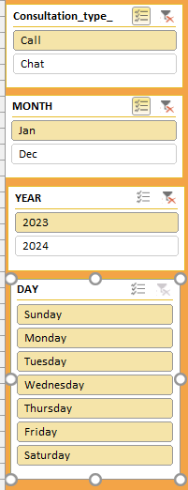

Question 10
How would you allocate a 1 crore rupee investment to optimize operational efficiency, enhance customer satisfaction, and boost profitability, and what analysis-based recommendations would you offer to support this?
Area of Investment | Allocation (in Lakhs) | Description
Technology & Automation Tools | 25 Lakhs | AI chatbots, call routing, speech analytics,  CRM integration
Hiring & Capacity Expansion | 30 Lakhs | Reduce workload on top-performing agents &  balance staffing
Performance Incentives & Retention | 10 Lakhs | Reward high performers, reduce attrition
Digital Infrastructure & Cloud Upgrades | 10 Lakhs | Faster systems, CRM optimization, secure  communication tools
Customer Feedback Tracking & Analytics | 5 Lakhs | Improve customer insights & satisfaction  tracking
Training agents and quality improvement | 20 Lakhs | Improve customer satisfaction & reduce  failed/incomplete calls

Recommendations
Automation and Technology (From ₹25L Allocation)
- Introduce a chatbot and call assistant driven by AI to handle basic questions (FAQs, password resets), saving up 30–40% of agent time for more complicated problems.
- Reduce call handling time and personalize every customer connection by implementing comprehensive CRM with caller history and intelligent recommendations.
Hiring and Optimizing Capacity (From ₹30L Allocation)
- Install a workforce management (WFM) system to optimize shifts intelligently by matching staff schedules to anticipated peaks and troughs in call volume.
- To avoid burnout among your top-performing generalist agents, assign specialized Tier-2 agents to tackle escalated cases.
Retention & Performance (From ₹10L Allocation)
- Create a real-time agent performance dashboard to monitor important parameters (CSAT, resolution rate), allowing for prompt teaching and acknowledgment.
- Provide retention incentives and productivity awards that are linked to specific, quantifiable results, such as skill-based compensation and milestone bonuses.
Infrastructure and Perspectives (From ₹10L + ₹5L Allocation)
- Make cloud-based phone and CRM optimization a top priority for system speed and remote access, making sure that agents are not slowed down by tools.
- Establish an integrated customer feedback and analytics loop where training and process updates are instantly triggered by insights from speech analytics and surveys.
Allocating Remaining ₹20L Strategically (Critical)
- To ensure ROI on technology investment, develop an ongoing training and certification program that focuses on soft skills and new tools (AI, CRM).

- Based on quarterly performance reports, create a contingency and innovation fund to test new solutions (like AI for post-call summary).

