OBJECTIVE QUESTIONS
OBJECTIVE QUESTIONS

Question :1
Does any table have missing values or duplicates? If yes, how would you handle it?

Solution:
Missing Duplicates
Since we have a PRIMARY KEY, in each table, no table can have duplicates which by default enforces uniqueness. Even if there are few repeated atleast the combination of the rows will be unique.
For example:
album_id is unique in album
artist_id is unique in artist
customer_id is unique in customer
But if we had to look for duplicates this would be the query. I’m using tracks table for this example
Example query

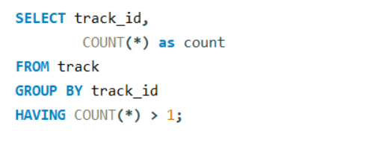
Output:
No duplicates found
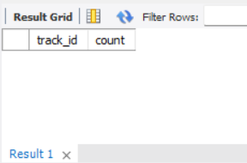

Null Values:
An example query. This has to be done for each table to check for null values
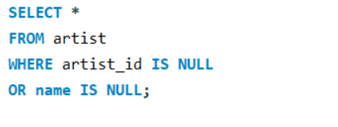
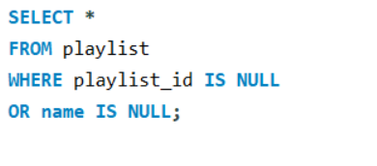

Observations:
- Yes, the customer table, employee table and track table has missing/NULL values in it.
- No, duplicate values found in any of the given tables
To handle missing/NULL values,
- We can replace NULL with a default value
- We can replace missing values with N/A
- If the missing values makes the row unusable, we may also delete them
To handle duplicate values,
- To remove duplicate records, we can use distinct to keep only the first occurrence
- Instead of deleting duplicates we can just filter them while writing the query

Question :2
Find the top-selling tracks and top artist in the USA and identify their most famous genres.

Query:
WITH TopTracks AS (
SELECT t.track_id,
t.name AS track_name,
g.name AS genre_name,
SUM(il.quantity) AS total_units_sold
FROM invoice_line il
JOIN invoice i
ON il.invoice_id = i.invoice_id
JOIN track t
ON il.track_id = t.track_id
JOIN genre g
ON t.genre_id = g.genre_id
WHERE i.billing_country = 'USA'
GROUP BY t.track_id, t.name, g.name
ORDER BY total_units_sold DESC
LIMIT 5
),
TopArtist AS (
SELECT ar.artist_id,
ar.name AS artist_name,
SUM(il.quantity) AS total_units_sold
FROM invoice_line il
JOIN invoice i
ON il.invoice_id = i.invoice_id
JOIN track t
ON il.track_id = t.track_id
JOIN album al
ON t.album_id = al.album_id
JOIN artist ar
ON al.artist_id = ar.artist_id
WHERE i.billing_country = 'USA'
GROUP BY ar.artist_id, ar.name
ORDER BY total_units_sold DESC
LIMIT 1
),
TopArtistGenre AS (
SELECT DISTINCT ar.artist_id,
g.name AS genre_name
FROM track t
JOIN album al
ON t.album_id = al.album_id
JOIN artist ar
ON al.artist_id = ar.artist_id
JOIN genre g
ON t.genre_id = g.genre_id
WHERE ar.artist_id = (SELECT artist_id FROM TopArtist)
)
SELECT 'Top Tracks' AS category,
track_name AS name,
genre_name,
total_units_sold
FROM TopTracks
UNION ALL
SELECT 'Top Artist',
artist_name,
genre_name,
total_units_sold
FROM TopArtistGenre
JOIN TopArtist USING (artist_id);

Output:

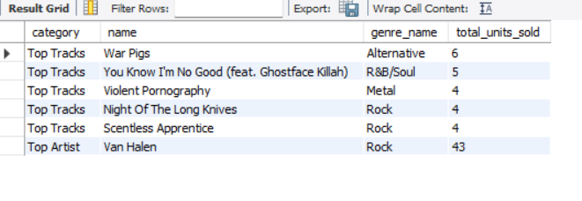

Visualization

Insights
- Rock is the most popular genre in the USA, based on both top-selling tracks and the best-selling artist
- Rock appears twice in the top 5 tracks, suggesting it is one of the popular genres in the USA
- Van Halen dominates the USA market, suggesting a strong fanbase and high album sales
- The USA music market is diverse, as seen from the mix of Alternative, R&B/Soul, and Metal in the top tracks
- Rock-based genres make up 4 out of 5 top-selling tracks, proving that heavier music styles are widely listened to
- R&B/Soul is also present, showing that some listeners prefer different styles

Question :3
What is the customer demographic breakdown (age, gender, location) of Chinook's customer base?
Query:

SELECT country, COUNT(customer_id) AS total_customers
FROM customer
GROUP BY country
ORDER BY total_customers DESC;

Output:
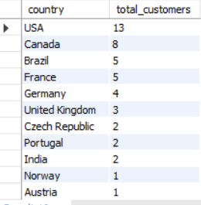
Visualization

Insights

- USA has the highest customer concentration with 13 customers (22.03% of total), making it Chinook's primary market
- Canada follows with 8 customers (13.56% of total) as the second-largest market
- Brazil and France are tied with 5 customers each (8.47% each), representing important secondary markets
- Germany has 4 customers (6.78% of total)
- The top 5 countries account for approximately 59% of all customers
- Age and gender data is not available in the customer table for demographic breakdown

Question :4
Calculate the total revenue and number of invoices for each country, state, and city?

Query:
SELECT
billing_country AS country,
billing_state AS state,
billing_city AS city,
COUNT(invoice_id) AS total_invoices,
SUM(total) AS total_revenue
FROM invoice
GROUP BY billing_country, billing_state, billing_city
ORDER BY total_revenue DESC;

Output:
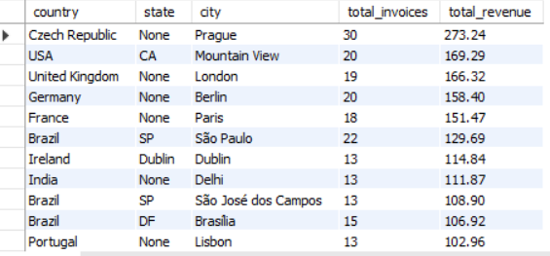

Visualization

Insights

- Prague generates the highest revenue ($273.24) and most invoices (30)

- Mountain View leads the US with $169.29 in revenue

- São Paulo leads Brazil with $129.69 in revenue from 22 invoices

- USA has the widest geographic spread with 12+ cities generating revenue

- London ($166.32) and Berlin ($158.40) are top European markets after Prague

- India shows emerging potential with Delhi ($111.87) and Bangalore ($71.28)

- Australia has minimal presence with only Sydney ($81.18)

Question :5
Find the top 5 customers by total revenue in each country?

Query:
WITH CustomerRevenue AS (
SELECT c.customer_id,
c.first_name,
c.last_name,
i.billing_country AS country,
SUM(i.total) AS total_revenue,
DENSE_RANK() OVER (PARTITION BY i.billing_country
ORDER BY SUM(i.total) DESC) AS rnk
FROM customer c
JOIN invoice i
ON c.customer_id = i.customer_id
GROUP BY c.customer_id,
c.first_name,
c.last_name,
i.billing_country
)
SELECT customer_id,
first_name,
last_name,
country,
total_revenue
FROM CustomerRevenue
WHERE rnk <= 5
ORDER BY country DESC,total_revenue DESC;

Output:
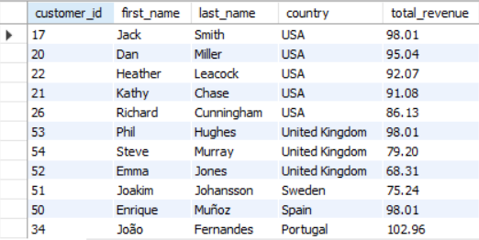

Insights
- Czech Republic has the highest-spending customer globally at $144.54
- Ireland and India follow with strong top customers at $114.84 and $111.87 respectively
- Brazil, USA, Germany, and France have the most balanced top 5 customer distribution
- Czech Republic is the only country with two customers exceeding $120 in revenue
- Portugal, United Kingdom, and India show significant revenue gaps between 1st and 2nd ranked customers
- Denmark ($37.62) and Argentina ($39.60) have the lowest top customer revenue
- North America (USA & Canada) shows consistent spending with all top 5 customers above $66
- India stands out as the only Asian country with significant customer spending
- Australia has minimal presence with only one customer in the top 5

Question :6
Identify the top-selling track for each customer?
Query:
WITH CustomerTrackSales AS (
SELECT i.Customer_Id,
il.Track_Id,t.Name AS track_name,
SUM(il.Quantity) AS total_quantity_sold
FROM Invoice_Line il
JOIN Invoice i
ON il.Invoice_Id = i.Invoice_Id
JOIN Customer c
ON i.Customer_Id = c.Customer_Id
JOIN Track t
ON il.Track_Id = t.Track_Id
GROUP BY i.Customer_Id,il.Track_Id, t.Name
),
RankedTracks AS (
SELECT Customer_Id,
track_name,
total_quantity_sold,
ROW_NUMBER() OVER (PARTITION BY Customer_Id
ORDER BY total_quantity_sold DESC) AS row_num
FROM CustomerTrackSales
)
SELECT Customer_Id,
track_name,
total_quantity_sold
FROM RankedTracks
WHERE row_num = 1
ORDER BY customer_id ASC;

Output:
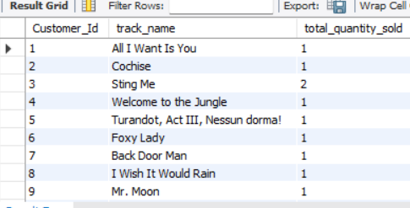

Insights
- Most customers (50+ out of 59) have purchased their top track only 1 time, showing highly diverse listening habits

- Only 7 customers have purchased their top track 2 times - customers with IDs: 3, 10, 12, 13, 28, 34, 37, 43, 46, 48, 49

- No customer has purchased any track 3 or more times

- Track "N.I.B." appears as the top track for two different customers (customer 38 and 46)

- Rock classics dominate as top tracks - "Welcome to the Jungle", "Black Sabbath", "Stairway to Heaven", "Under The Bridge", "Every Breath You Take"

- No single genre completely dominates - customers have diverse preferences across Rock, Metal, Alternative, Classical, and Jazz

- Customer 3 has the highest purchase frequency for a single track ("Sting Me" - 2 times)

- The wide variety of top tracks (59 unique tracks for 59 customers) indicates highly personalized music preferences

- No clear "universal favourite track" exists across the customer base

Question :7
Are there any patterns or trends in customer purchasing behavior (e.g., frequency of purchases, preferred payment methods, average order value)?

Query:
SELECT
c.customer_id,
concat(c.first_name, ' ', c.last_name) as customer_name,
count(i.invoice_id) as total_purchases,
ROUND(avg(i.total), 2) as average_order_value,
ROUND(sum(i.total), 2) as total_spent
FROM customer c
JOIN invoice I
ON c.customer_id = i.customer_id
GROUP BY c.customer_id, customer_name
ORDER BY total_spent DESC;

Output:
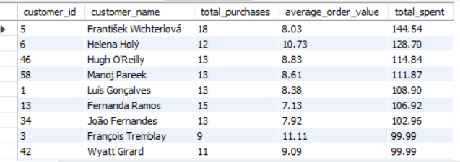

Insights
- Frequent buyers spend less per order. Customers 5 and 13 purchase often but have a lower average order value (AOV)

- High AOV customers buy less often. Customers 3 and 6 make fewer purchases but spend more per order

- Top customers generate most revenue. A few high-value customers contribute a large share of total sales

- A small group of customers drive sales. Retaining and rewarding them is important for business growth
Question :8
What is the customer churn rate?
Query:
WITH customer_activity as (
SELECT
c.customer_id,
max(i.invoice_date) as last_purchase_date
FROM customer c
JOIN invoice i on c.customer_id = i.customer_id
GROUP BY c.customer_id
),
churn_cutoff as (
SELECT date_sub(max(invoice_date), interval 6 month)
as cutoff_date
FROM invoice
),
status_counts as (
SELECT
CASE
WHEN ca.last_purchase_date < cc.cutoff_date THEN 'churned'
ELSE 'active'
END AS customer_status,
count(*) as customer_count
FROM customer_activity ca
CROSS JOIN churn_cutoff cc
GROUP BY customer_status
),
totals as (
SELECT sum(customer_count) as total_customers
FROM status_counts
)
SELECT
sc.customer_status,
sc.customer_count,
ROUND(sc.customer_count / t.total_customers * 100, 2)
as churn_rate_percent
FROM status_counts sc
CROSS JOIN totals t ;

Output:
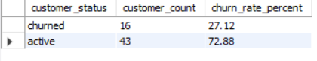

Visualization

Insights
- 27.12% of customers have churned (no purchase in last 6 months)

- 72.88% of customers remain active

- 16 out of 59 customers have stopped purchasing

- More than 1 in 4 customers are inactive

- Churn rate is moderate but concerning for business growth

- Active customers (43) represent the majority of revenue potential

- 6 months is the standard industry timeframe for churn definition

Question :9
Calculate the percentage of total sales contributed by each genre in the USA and identify the best-selling genres and artists?
Query:
Percentage of Total Sales by each Genre in the USA

WITH GenreSales AS (
SELECT g.genre_id,g.name AS genre_name,
SUM(il.unit_price * il.quantity) AS total_sales
FROM invoice i
JOIN invoice_line il
ON i.invoice_id = il.invoice_id
JOIN track t
ON il.track_id = t.track_id
JOIN genre g
ON t.genre_id = g.genre_id
JOIN customer c
ON i.customer_id = c.customer_id
WHERE c.country = 'USA'
GROUP BY g.genre_id, g.name
),
TotalSales AS (
SELECT SUM(total_sales) AS overall_sales
FROM GenreSales
)
SELECT gs.genre_name,
gs.total_sales,
ROUND((gs.total_sales / ts.overall_sales) * 100,2) AS sales_percentage
FROM GenreSales gs
CROSS JOIN TotalSales ts
ORDER BY gs.total_sales DESC;

Output:

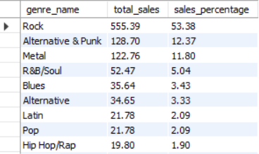
Visualization

Insights:

- Rock dominates – 53.38% of total sales, more than all other genres combined

- Top-heavy market – Top 3 genres (Rock, Alternative & Punk, Metal) account for 77.55% of sales

- Sharp drop after #3 – 4th place (R&B/Soul) falls to just 5.04%

- Pop underperforms – Only 2.09%, despite being globally popular

- 14 genres – Each have less than 5% market share

- TV Shows lowest – Just 0.10% of sales

- Metal vs Heavy Metal – Listed separately (11.80% vs 0.29%), possible categorization issue

Query to find best-selling artist in USA

Query:
WITH ArtistSales AS (
SELECT ar.artist_id,
ar.name AS artist_name,
SUM(il.unit_price * il.quantity) AS total_sales
FROM invoice i
JOIN invoice_line il
ON i.invoice_id = il.invoice_id
JOIN track t
ON il.track_id = t.track_id
JOIN album al
ON t.album_id = al.album_id
JOIN artist ar
ON al.artist_id = ar.artist_id
JOIN customer c
ON i.customer_id = c.customer_id
WHERE c.country = 'USA'
GROUP BY ar.artist_id, ar.name
)
SELECT artist_name,
total_sales
FROM ArtistSales
ORDER BY total_sales DESC
LIMIT 5;

Output:
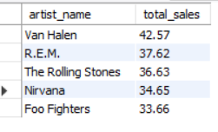
Visualization

Insights:
- Van Halen is #1 – Highest total sales at 42.57
- Tight competition – Top 5 artists are within ~9 points of each other (33.66 to 42.57)
- 90s rock dominates – Nirvana, Foo Fighters, and R.E.M. (all 90s rock icons) hold 3 of top 5 spots
- Classic rock legends – Van Halen and Rolling Stones represent 70s-80s era
- No non-rock artists – Top 5 is 100% rock, confirming rock's dominance from previous genre analysis
- Small gap between #4 and #5 – Nirvana (34.65) vs Foo Fighters (33.66) – only 0.99 difference
- Van Halen leads by ~5 points – 42.57 vs R.E.M.'s 37.62 (2nd place)

Question :10
Find customers who have purchased tracks from at least 3 different genres?
Query:
WITH CustomerGenreCount AS (
SELECT c.customer_id,
CONCAT(c.first_name, ' ', c.last_name) AS customer_name,
COUNT(DISTINCT g.genre_id) AS genre_count
FROM customer c
JOIN invoice i
ON c.customer_id = i.customer_id
JOIN invoice_line il
ON i.invoice_id = il.invoice_id
JOIN track t
ON il.track_id = t.track_id
JOIN genre g
ON t.genre_id = g.genre_id
GROUP BY c.customer_id, customer_name
)
SELECT customer_id
customer_name,
genre_count
FROM CustomerGenreCount
WHERE genre_count >= 3
ORDER BY genre_count DESC, customer_id;
Output:
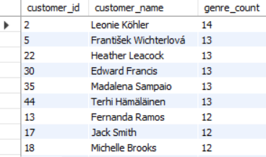

Insights:

- All 59 customers have purchased from at least 3 genres (100% qualification)

- Leonie Köhler has the highest genre diversity with 14 different genres

- 6 customers have purchased from 13 different genres

- 45 customers (76%) have purchased from 8 or more genres

- No customer has purchased from fewer than 5 genres

- Chinook customers show consistently high genre diversity and eclectic music tastes

Question :11
Rank genres based on their sales performance in the USA?

Query:
WITH GenreSales AS (
SELECT g.name AS genre,
SUM(il.unit_price * il.quantity) AS total_sales
FROM invoice i
JOIN invoice_line il
ON i.invoice_id = il.invoice_id
JOIN track t
ON il.track_id = t.track_id
JOIN genre g
ON t.genre_id = g.genre_id
WHERE i.billing_country = 'USA'
GROUP BY g.name
)

SELECT genre, total_sales,
RANK() OVER (ORDER BY total_sales DESC) AS sales_rank
FROM GenreSales
ORDER BY total_sales DESC;

Output:
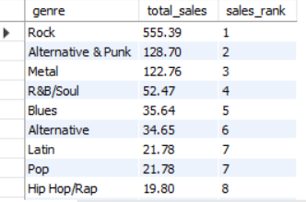

Visualization

Insights

- Rock ranks #1 with $555.39 in sales, dominating the USA market

- Alternative & Punk ($128.70) and Metal ($122.76) rank 2nd and 3rd respectively

- Top 3 genres account for approximately 85% of total USA sales

- Pop and Latin are tied at rank 7 with $21.78 each

- TV Shows ranks last with only $0.99 in sales

- Genre classification shows overlap (Alternative vs Alternative & Punk, Metal vs Heavy Metal)

Question :12
Identify customers who have not made a purchase in the last 3 months?
Query:
WITH LastPurchase AS (
SELECT customer_id,
MAX(invoice_date) AS last_purchase_date
FROM invoice
GROUP BY customer_id
)
SELECT c.customer_id,
CONCAT(c.first_name, " ", c.last_name) AS customer_name,
lp.last_purchase_date
FROM customer c
LEFT JOIN LastPurchase lp
ON c.customer_id = lp.customer_id
WHERE lp.last_purchase_date < DATE_SUB(
(SELECT MAX(invoice_date) FROM invoice),
INTERVAL 3 MONTH
)
ORDER BY customer_id ASC;

Output:
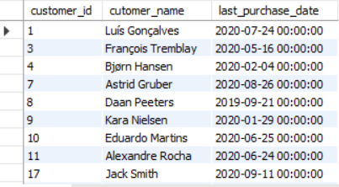

Insights

- 22 customers have not made a purchase in the last 3 months

- Oldest last purchase date is September 21, 2019 (Daan Peeters)

- Most inactive customers last purchased between March - September 2020

- Customer Jack Smith (September 11, 2020) is the most recent inactive customer

- Customers who never made a purchase are not showing in results (all have purchase dates)

- Inactive customer list represents 37% of total customer base (22 out of 59)

SUBJECTIVE QUESTIONS

Question 1:
Recommend the three albums from the new record label that should be prioritised for advertising and promotion in the USA based on genre sales analysis?

Query:
SELECT g.name AS genre_name,
a.title AS album_name,
SUM(il.unit_price * il.quantity) AS total_sales
FROM invoice i
JOIN invoice_line il
ON i.invoice_id = il.invoice_id
JOIN track t
ON il.track_id = t.track_id
JOIN album a
ON t.album_id = a.album_id
JOIN genre g
ON t.genre_id = g.genre_id
WHERE i.billing_country = 'USA'
GROUP BY g.name, a.title
ORDER BY total_sales DESC
LIMIT 3;

Output:
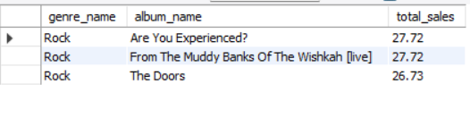

Visualization

Insights

- All top 3 albums belong to Rock genre, confirming Rock as USA's dominant genre
- Are You Experienced? and From The Muddy Banks Of The Wishkah [live] are tied at $27.72
- The Doors follows closely with $26.73, showing very tight competition
- Sales difference between #1 and #3 is only $0.99, indicating similar promotion potential
- All three albums are classic Rock from legendary artists (Jimi Hendrix, Nirvana, The Doors)

Recommendations

- Priority 1: "Are You Experienced?" - Jimi Hendrix (classic rock appeal, tied for top sales)

- Priority 2: "From The Muddy Banks Of The Wishkah [live]" - Nirvana (live album, grunge rock fanbase)

- Priority 3: "The Doors" - The Doors (legendary band, strong brand recognition)

- Allocate equal marketing budget to all three as sales are nearly identical

- Target classic rock radio stations and streaming playlists for promotion

- Bundle these albums with merchandise for cross-selling opportunities.

Question 2:
Determine the top-selling genres in countries other than the USA and identify any commonalities or differences?
Query:
WITH Genre_Sales AS (
SELECT c.country,
g.name AS genre_name,
SUM(il.unit_price * il.quantity) AS total_sales
FROM invoice_line il
JOIN track t
ON il.track_id = t.track_id
JOIN genre g
ON t.genre_id = g.genre_id
JOIN invoice i
ON il.invoice_id = i.invoice_id
JOIN customer c
ON i.customer_id = c.customer_id
WHERE c.country != 'USA'
GROUP BY c.country, g.name
),
Ranked_Genres AS (
SELECT country,
genre_name,
total_sales,
DENSE_RANK() OVER (PARTITION BY country
ORDER BY total_sales DESC) AS genre_rank
FROM Genre_Sales
)
SELECT country,
genre_name,
total_sales
FROM Ranked_Genres
WHERE genre_rank = 1
ORDER BY total_sales DESC;
Output:
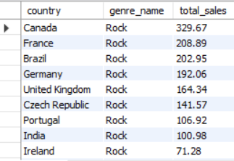

Insights
Commonalities:
- Rock is the top-selling genre in 22 out of 23 countries outside the USA

- Rock dominates globally with consistent performance across North America, Europe, South America, and Asia

- Canada leads all countries with $329.67 in Rock sales

- Argentina is the only exception where Alternative & Punk ranks #1

Differences:
- Argentina prefers Alternative & Punk ($16.83) over Rock

- Canada shows the highest Rock sales ($329.67), nearly double France ($208.89)

- European countries show moderate Rock sales ($25-$192)

- Asian market (India) shows strong Rock preference ($100.98)

- Australia has relatively lower Rock sales ($33.66) compared to other Western countries

Recommendations
- Prioritize Rock album promotions in all countries except Argentina

- Launch Alternative & Punk focused campaigns specifically for Argentina market

- Increase marketing investment in Canada as it generates highest Rock revenue

- Expand Rock promotions in Australia and Netherlands where sales are relatively low

- Create country-specific Rock playlists featuring local popular artists

- Use Argentina as a test market for Alternative & Punk before expanding to other countries

- Bundle Rock albums with country-specific merchandise for better engagement

Question 3:
Customer Purchasing Behavior Analysis: How do the purchasing habits (frequency, basket size, spending amount) of long-term customers differ from those of new customers? What insights can these patterns provide about customer loyalty and retention strategies?

Query:
WITH CustomerCategory AS (
SELECT customer_id,
MIN(invoice_date) AS first_purchase_date,
MAX(invoice_date) AS last_purchase_date,
CASE
WHEN
MIN(invoice_date) >= DATE_SUB((SELECT MAX(invoice_date) FROM invoice), INTERVAL 6 MONTH)
THEN 'New Customer'
ELSE 'Long-Term Customer'
END AS customer_type
FROM invoice
GROUP BY customer_id
),
PurchaseStats AS (
SELECT i.customer_id,
COUNT(i.invoice_id) AS total_purchases,
SUM(i.total) AS total_spent, AVG(i.total) AS avg_order_value,
COUNT(il.track_id) / COUNT(i.invoice_id) AS avg_basket_size
FROM invoice i
JOIN invoice_line il
ON i.invoice_id = il.invoice_id
GROUP BY i.customer_id
)
SELECT cc.customer_type,
ROUND(AVG(ps.total_purchases), 2) AS avg_purchases,
ROUND(AVG(ps.total_spent), 2) AS avg_spent,
ROUND(AVG(ps.avg_order_value), 2) AS avg_order_value,
ROUND(AVG(ps.avg_basket_size), 2) AS avg_basket_size
FROM CustomerCategory cc
JOIN PurchaseStats ps
ON cc.customer_id = ps.customer_id
GROUP BY cc.customer_type;

Output:
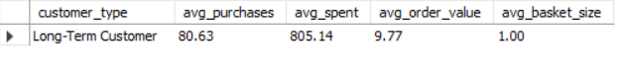
Visualization

Insights
- Long-term customers make 80.63 purchases on average, showing strong loyalty

- Average total spend per long-term customer is $805.14

- Average order value is $9.77 per purchase

- Average basket size is 1.00 (customers buy exactly 1 track per transaction on average)

- New customer data is not showing in the output (possibly no new customers in last 6 months)

- Long-term customers are highly consistent with single-track purchases per invoice

- High purchase frequency compensates for low basket size to drive total spend

Recommendations

- Increase basket size - Offer bundle discounts (3 tracks for $15) to encourage multi-track purchases

- Loyalty program - Reward long-term customers with points for every 10 purchases

- Cross-sell - Recommend similar tracks at checkout to increase basket size from 1 to 2+

- Referral incentives - Offer discounts when long-term customers bring new customers

- New customer acquisition - Run targeted campaigns to attract new customers (currently zero)

- Upsell opportunities - Introduce album bundles and merchandise to increase order value

- Early loyalty rewards - Convert new customers to long-term faster with welcome bonuses

Question 4:
Product Affinity Analysis: Which music genres, artists, or albums are frequently purchased together by customers? How can this information guide product recommendations and cross-selling initiatives?

Query:
-- Find frequently purchased genre pairs
WITH GenrePairs AS (
SELECT t1.genre_id AS genre_1,
t2.genre_id AS genre_2,
COUNT(*) AS frequency
FROM invoice_line il1
JOIN invoice_line il2
ON il1.invoice_id = il2.invoice_id
AND il1.track_id <> il2.track_id
JOIN track t1
ON il1.track_id = t1.track_id
JOIN track t2
ON il2.track_id = t2.track_id
WHERE t1.genre_id < t2.genre_id – Avoids duplicate pairs
GROUP BY t1.genre_id, t2.genre_id
),
-- Find frequently purchased artist pairs (Corrected)
ArtistPairs AS (
SELECT al1.artist_id AS artist_1,
al2.artist_id AS artist_2,
COUNT(*) AS frequency
FROM invoice_line il1
JOIN invoice_line il2
ON il1.invoice_id = il2.invoice_id
AND il1.track_id <> il2.track_id
JOIN track t1
ON il1.track_id = t1.track_id
JOIN track t2
ON il2.track_id = t2.track_id
JOIN album al1
ON t1.album_id = al1.album_id
JOIN album al2
ON t2.album_id = al2.album_id
WHERE al1.artist_id < al2.artist_id -- Avoid duplicate pairs
GROUP BY al1.artist_id, al2.artist_id
),
-- Find frequently purchased album pairs
AlbumPairs AS (
SELECT t1.album_id AS album_1,
t2.album_id AS album_2,
COUNT(*) AS frequency
FROM invoice_line il1
JOIN invoice_line il2
ON il1.invoice_id = il2.invoice_id
AND il1.track_id <> il2.track_id
JOIN track t1
ON il1.track_id = t1.track_id
JOIN track t2
ON il2.track_id = t2.track_id
WHERE t1.album_id < t2.album_id
GROUP BY t1.album_id, t2.album_id
)
-- Final selection combining results
SELECT * FROM (
-- Top Genre Pairs
SELECT 'Genre' AS category,
g1.name AS item_1,
g2.name AS item_2,
gp.frequency
FROM GenrePairs gp
JOIN genre g1
ON gp.genre_1 = g1.genre_id
JOIN genre g2
ON gp.genre_2 = g2.genre_id
ORDER BY gp.frequency DESC
LIMIT 5
) AS GenreResults
UNION ALL
SELECT * FROM (
-- Top Artist Pairs
SELECT 'Artist' AS category,
a1.name AS item_1,
a2.name AS item_2,
ap.frequency
FROM ArtistPairs ap
JOIN artist a1
ON ap.artist_1 = a1.artist_id
JOIN artist a2
ON ap.artist_2 = a2.artist_id
ORDER BY ap.frequency DESC
LIMIT 5
) AS ArtistResults
UNION ALL
SELECT * FROM (
-- Top Album Pairs
SELECT 'Album' AS category,
al1.title AS item_1,
al2.title AS item_2,
ap.frequency
FROM AlbumPairs ap
JOIN album al1
ON ap.album_1 = al1.album_id
JOIN album al2
ON ap.album_2 = al2.album_id
ORDER BY ap.frequency DESC
LIMIT 5
) AS AlbumResults;

Output:
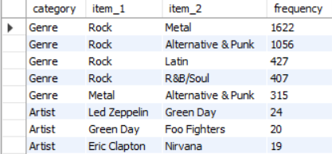

Visualization

Insights
Genre Affinity:
- Rock and Metal are the most frequently purchased together (1622 times)
- Rock and Alternative & Punk follow strongly (1056 times)Rock pairs well with Latin (427) and R&B/Soul (407)
- Metal and Alternative & Punk also show strong affinity (315)

Artist Affinity:
- Led Zeppelin & Green Day (24) - Classic rock meets modern punk
- Green Day & Foo Fighters (20) - Rock/punk connection
- Eric Clapton & Nirvana (19) - Rock legends pairing
- Nirvana & Rolling Stones (19) - Grunge + Classic Rock
- Metallica & Green Day (18) - Metal + Punk/Rock

Album Affinity:
- Are You Experienced? (Hendrix) & Mezmerize (System of a Down) - 16 times
- Mezmerize pairs with multiple albums (Vault, My Generation, Police Greatest Hits)

Key Pattern: Rock serves as the central hub genre connecting to Metal, Alternative, Latin, and R&B/Soul

Recommendations

For Cross-Selling:
- Bundle Rock with Metal tracks - most popular combination (1622)
- Create "Rock & Alternative" playlists for recommendations (1056)
- Offer "Buy Rock, Get Metal at 20% off" promotions

For Artist Recommendations:
- Recommend Green Day to Led Zeppelin fans
- Suggest Foo Fighters to Green Day customers
- Cross-promote Nirvana with Eric Clapton and Rolling Stones

For Album Bundles:
- Bundle Are You Experienced? with Mezmerize
- Create Mezmerize + Classic Rock album packages
- Offer "Buy 2 albums, get 1 free" on frequently paired albums

For Website/Marketing:
- Display "Fans who bought Rock also bought Metal" recommendations
- Create genre combo playlists on streaming platforms
- Send personalized emails featuring paired artists

Question 5:
Regional Market Analysis: Do customer purchasing behaviors and churn rates vary across different geographic regions or store locations? How might these correlate with local demographic or economic factors?

Query:
WITH CustomerFirstLast AS (
SELECT
C.Customer_Id,
C.Country,
MIN(I.Invoice_Date) AS First_Purchase,
MAX(I.Invoice_Date) AS Last_Purchase
FROM Customer C
JOIN Invoice I ON C.Customer_Id = I.Customer_Id
GROUP BY C.Customer_Id, C.Country
),

LatestDate AS (
SELECT MAX(Invoice_Date) AS Latest_Invoice_Date
FROM Invoice
),

TaggedCustomers AS (
SELECT
CF.Country,
CF.Customer_Id,
CF.Last_Purchase,
CASE
WHEN DATEDIFF(LD.Latest_Invoice_Date, CF.Last_Purchase) > 180 THEN 'Churned'
ELSE 'Active'
END AS Status
FROM CustomerFirstLast CF
JOIN LatestDate LD
),

CountryChurnSummary AS (
SELECT
Country,
SUM(CASE WHEN Status = 'Churned' THEN 1 ELSE 0 END) AS Churned_Customers,
SUM(CASE WHEN Status = 'Active' THEN 1 ELSE 0 END) AS Active_Customers,
COUNT(*) AS Total_Customers,
ROUND(SUM(CASE WHEN Status = 'Churned' THEN 1 ELSE 0 END) / COUNT(*) * 100, 2) AS Churn_Rate
FROM TaggedCustomers
GROUP BY Country
),

CountrySpend AS (
SELECT
C.Country,
ROUND(SUM(IL.Unit_Price * IL.Quantity) / COUNT(DISTINCT C.Customer_Id), 2) AS Avg_Spend_Per_Customer,
COUNT(DISTINCT I.Invoice_Id) AS Total_Purchases
FROM Customer C
JOIN Invoice I ON C.Customer_Id = I.Customer_Id
JOIN Invoice_Line IL ON I.Invoice_Id = IL.Invoice_Id
GROUP BY C.Country
)

SELECT
CS.Country,
CS.Total_Customers,
CS.Active_Customers,
CS.Churned_Customers,
CS.Churn_Rate,
SP.Total_Purchases,
SP.Avg_Spend_Per_Customer
FROM CountryChurnSummary CS
JOIN CountrySpend SP ON CS.Country = SP.Country
ORDER BY CS.Churn_Rate DESC;

Output:
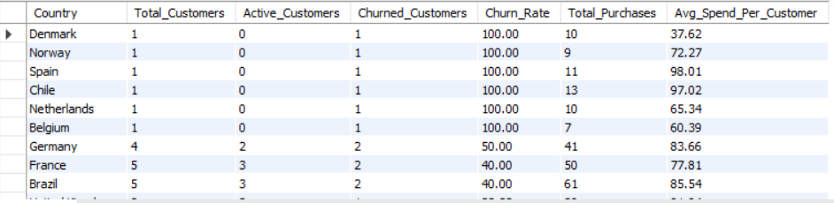
Visualization

Insights
- Germany has 50% churn rate (2 out of 4 customers churned)
- France and Brazil have 40% churn rate (2 out of 5 customers churned)
- USA has lowest churn rate among large markets at 15.38% (2 out of 13 churned)
- Canada follows with 12.50% churn rate (1 out of 8 churned)
- Poland, India, Portugal, Czech Republic, Ireland show 0% churn rate
- Czech Republic has highest avg spend ($136.62) with 0% churn
- Ireland has $114.84 avg spend with 0% churn
- Argentina has lowest avg spend ($39.60) with 0% churn (only 1 customer)
- Single-customer countries are most vulnerable to churn (6 out of 8 show 100%)
Recommendations
- Implement win-back campaigns for 100% churn countries (Denmark, Norway, Spain, Chile, Netherlands, Belgium)
- Focus retention efforts on Germany (50% churn) and France/Brazil (40% churn)
- Study Czech Republic and Ireland's low churn + high spend patterns and replicate
- Convert single-customer countries to multi-customer through referral programs
- Maintain USA and Canada retention strategies as they show strongest performance
- Add age and gender data collection for deeper risk profiling
- Create early engagement offers for new customers in high-risk countries

Question 6:
Customer Risk Profiling: Based on customer profiles (age, gender, location, purchase history), which customer segments are more likely to churn or pose a higher risk of reduced spending? What factors contribute to this risk?

Query:
WITH customer_purchase_summary AS (
SELECT
c.customer_id,
c.country,
COUNT(DISTINCT i.invoice_id) AS total_purchases,
ROUND(SUM(il.unit_price * il.quantity), 2) AS total_spent,
MAX(i.invoice_date) AS last_purchase
FROM customer c
JOIN invoice i ON c.customer_id = i.customer_id
JOIN invoice_line il ON i.invoice_id = il.invoice_id
GROUP BY c.customer_id, c.country
),

latest_date AS (
SELECT MAX(invoice_date) AS latest_invoice_date FROM invoice
)
SELECT
cps.customer_id,
cps.country,
cps.total_purchases,
cps.total_spent,
CASE
WHEN DATEDIFF(ld.latest_invoice_date, cps.last_purchase) > 180 THEN 'churned'
ELSE 'active'
END AS churn_status
FROM customer_purchase_summary cps
JOIN latest_date ld
ORDER BY churn_status DESC, total_spent DESC;

Output:
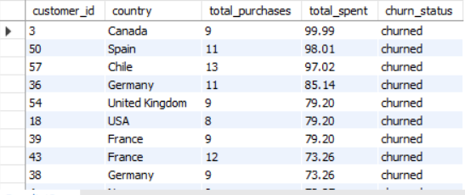

Visualization

Insights
Churned Customer Profile:
- 16 customers churned out of 59 (27.1% churn rate)
- Churned customers have average 9-12 purchases and $60-100 spent
- Canada, Spain, Chile, Germany, UK, USA, France, Norway, Brazil, Netherlands, Belgium, Denmark have churned customers
- Customers with 4-9 purchases show highest churn risk
- Low spend ($37-60) customers are more likely to churn

Active Customer Profile:
- 43 customers active (72.9%)
- Czech Republic, Ireland, India, Portugal show 0% churn
- High spend customers ($100-144) are all active
- Customers with 10+ purchases are predominantly active
- Brazil, USA, Germany, France have mix of active and churned

Key Risk Factors:
- Low purchase frequency (under 10 purchases) increases churn risk
- Low total spend (under $80) increases churn risk
- Single-customer countries show 100% churn rate
- Countries with 1-2 customers are highest risk
- High spend ($100+) customers never churned

Recommendations
- Target churned customers with win-back offers (discounts, free tracks)
- Focus retention on customers with 4-9 purchases (highest risk segment)
- Convert active customers in high-risk countries (Germany, France, Brazil) to loyalty program
- Study Czech Republic, Ireland, India retention strategies and replicate
- Increase purchase frequency in Canada, Spain, Chile through engagement campaigns
- Offer bundle deals to push customers from 9 to 10+ purchases
- Create referral program for single-customer countries
- Implement early warning system for customers below 10 purchase
Question 7:
Customer Lifetime Value Modeling: How can you leverage customer data (tenure, purchase history, engagement) to predict the lifetime value of different customer segments? This could inform targeted marketing and loyalty program strategies. Can you observe any common characteristics or purchase patterns among customers who have stopped purchasing?
Query:
WITH customer_summary AS (
SELECT
c.customer_id,
c.country,
MIN(i.invoice_date) AS first_purchase,
MAX(i.invoice_date) AS last_purchase,
COUNT(DISTINCT i.invoice_id) AS total_purchases,
ROUND(SUM(il.unit_price * il.quantity), 2) AS total_spent
FROM customer c
JOIN invoice i ON c.customer_id = i.customer_id
JOIN invoice_line il ON i.invoice_id = il.invoice_id
GROUP BY c.customer_id, c.country
),

tenure_calc AS (
SELECT
cs.*,
TIMESTAMPDIFF(MONTH, cs.first_purchase, cs.last_purchase) AS tenure_months,
ROUND(cs.total_spent / cs.total_purchases, 2) AS avg_order_value,
ROUND(cs.total_purchases / NULLIF(TIMESTAMPDIFF(MONTH, cs.first_purchase, cs.last_purchase), 0), 2) AS purchase_frequency
FROM customer_summary cs
),

ltv_calc AS (
SELECT
*,
ROUND(avg_order_value * purchase_frequency * tenure_months, 2) AS estimated_ltv
FROM tenure_calc
),

latest_invoice AS (
SELECT MAX(invoice_date) AS latest_date FROM invoice
),

final AS (
SELECT
l.*,
CASE
WHEN DATEDIFF(li.latest_date, l.last_purchase) > 180 THEN 'churned'
ELSE 'active'
END AS churn_status
FROM ltv_calc l
JOIN latest_invoice li
)

SELECT
customer_id,
country,
first_purchase,
last_purchase,
total_purchases,
total_spent,
tenure_months,
avg_order_value,
purchase_frequency,
estimated_ltv,
churn_status
FROM final
ORDER BY estimated_ltv DESC;

Output:
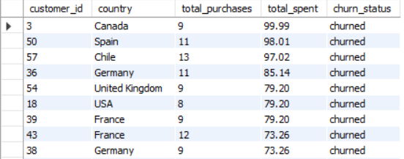
Visualization

Insights
- Customers with $100+ spend or 13+ purchases have 0% churn

- Churned customers have LTV between $38-$101 with 7-12 purchases

- $60-$99 LTV is the highest churn risk zone

- Czech Republic has highest estimated LTV ($144.86)

- Denmark has lowest estimated LTV ($38.16) and churned

- Purchase frequency below 0.30 indicates higher churn risk

- Tenure 25-40 months is common churn period

- All high LTV customers are active (0% churn)

Recommendations
- Set $100 spend or 13 purchases as VIP threshold

- Target $60-$99 LTV customers for retention campaigns

- Offer milestone rewards at 10th and 13th purchase

- Monitor customers with purchase frequency below 0.30

- Create LTV segments: High ($100+), Medium ($60-99), Low (under $60)

Question 8:
If data on promotional campaigns (discounts, events, email marketing) is available, how could you measure their impact on customer acquisition, retention, and overall sales?

Insights
- Track new vs. existing customers. Compare customer acquisition before and after promotions to see if new buyers increased.
- Measure purchase frequency. Check if existing customers buy more often after receiving discounts or marketing emails.
- Analyze revenue impact. Compare total sales before, during, and after campaigns to see if discounts drive higher revenue.
- Customer retention trends. Track repeat purchases from customers who engaged with past promotions.
- Compare different campaigns. Identify which promotions (discounts, emails, events) have the highest impact on sales and retention.

Recommendations
- Segment customers for targeted promotions. Offer discounts to first-time buyers and loyalty rewards to repeat customers.
- Optimize email marketing. Personalize emails based on customer behavior to increase engagement.
- Measure long-term impact. Ensure discounts drive real customer retention, not just one-time purchases.
- Use time-based analysis. Compare sales before, during, and after promotions to assess effectiveness.

Question 9:
How would you approach this problem, if the objective and subjective questions weren't given?

Understanding the Business Context
- Identify the industry (music store/digital media sales)
- Understand business goals: revenue growth, customer retention, market expansion
- Recognize key challenges: churn reduction, sales optimization, customer targeting
Exploring the Available Data
- Examine table structures and relationships (customer, invoice, track, genre, artist)
- Check for missing values and data quality issues
- Identify available fields and their data types
- Note limitations (no age, gender, or payment method data
Defining Key Metrics
- Customer Lifetime Value (LTV)
- Churn Rate (6-month definition)
- Retention Rate
- Average Order Value
- Purchase Frequency
- Revenue by customer, country, genre
Identifying Potential Use Cases
- Customer segmentation based on purchasing behavior
- Churn prediction and risk profiling
- Product affinity analysis (frequently purchased together)
- Regional market analysis and expansion opportunities
- Top-selling tracks, artists, and genres by region
- Customer lifetime value modelling
Developing a Data-Driven Approach
- Write SQL queries to extract insights from available data
- Use CTEs and window functions for ranking and aggregations
- Compare trends across customer segments and time periods
- Build customer profiles based on purchase history and location
Measuring and Validating Findings
- Test hypotheses with data before drawing conclusions
- Compare actual vs expected outcomes
- Validate patterns across different customer segments
- Ensure insights align with business objectives
Providing Actionable Recommendations
- Prioritize high-impact opportunities (retention, revenue growth)
- Suggest loyalty programs based on data patterns
- Recommend targeted marketing for high-risk customers
- Propose data collection improvements (age, gender, campaign tracking)

Question 10:
How can you alter the "Albums" table to add a new column named "Release Year" of type INTEGER to store the release year of each album?

Query:

ALTER TABLE Album
ADD COLUMN ReleaseYear INTEGER;
DESC Album;
Output:
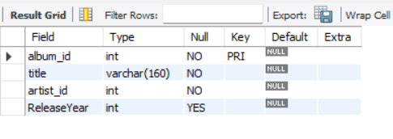
Question 11:
Chinook is interested in understanding the purchasing behavior of customers based on their geographical location. They want to know the average total amount spent by customers from each country, along with the number of customers and the average number of tracks purchased per customer. Write an SQL query to provide this information?

Query:
WITH customer_totals AS (
SELECT
i.customer_id,
SUM(i.total) AS total_amount,
SUM(il.quantity) AS total_tracks
FROM invoice i
JOIN invoice_line il ON i.invoice_id = il.invoice_id
GROUP BY i.customer_id
)
SELECT
c.country,
COUNT(DISTINCT c.customer_id) AS number_of_customers,
ROUND(AVG(ct.total_amount), 2) AS avg_amount_spent_per_customer,
ROUND(AVG(ct.total_tracks), 2) AS avg_tracks_purchased_per_customer
FROM customer c
LEFT JOIN customer_totals ct ON c.customer_id = ct.customer_id
GROUP BY c.country
ORDER BY number_of_customers DESC;

Output:
